

January 12, 2023

From the Home Office...
Greetings brethren around the world.
This is the second issue of our new weekly communication from the home office in Cincinnati, Ohio. It is designed to keep you up to date on the work around the world, as we all strive to fulfill the dual commission that Christ gave us of “preaching the gospel” and “preparing a people.”
We hope that by sharing newsworthy accounts of the work, internationally and domestically, and more of what is happening here at the home office, that you will join us in more fervent prayer for God to direct and guide us in all we do, and that His will be done. When we are doing His will, and our hearts are with Him, He will provide His blessings.

Beyond Today TV
This week, two new episodes of the Beyond Today television program were recorded in the state-of-the-art video studio we have here in Cincinnati. Beyond Today has aired continuously for the past eleven years on various television networks, but the noticeable increase in viewership has come through our apps on Roku and Amazon Fire TV, plus our Beyond Today channel on YouTube.
You can watch Beyond Today on our website at beyondtoday.tv and on YouTube at youtube.com/BeyondTodayTV—or on Roku and Amazon Fire TV or by downloading the Beyond Today app from the Apple App Store or Google Play store.

Three New BT TV Series Underway
You may have noticed there have not been many new episodes of BT airing lately, and there is a good reason for that. Over the past few months, our presenters and media department have been working on a new selection of “series” for BT. Each of the presenters are working on a series of programs that will delve into a biblical subject of world importance for several weeks at a time, exploring facets of biblical truth and how it can affect people’s lives today.
For example, Darris McNeely, looking ahead to the coronation of King Charles in Britain which will garner international attention, has recorded three programs on the importance of that throne, leading into the identity of modern-day Israel. This five-part series titled “Joseph’s Birthright” will air over five consecutive weeks this spring.
Steve Myers is in the midst of a five-part series on the false teachings of modern Christianity, titled “Unmasked.” Identifying Satan as the “god of this age,” this series will expose false teachings and direct people to the Bible, encouraging them to not be deceived, but to follow the word of truth that Christ spoke. These episodes will air in consecutive weeks this summer, encouraging people to come back the following week to hear the next topic.
Gary Petty’s series titled ”The Unknown Jesus,” discusses the “real Jesus.” The world sees Him as Savior, but has many misconceptions about Jesus Christ’s message of repentance and the Kingdom of God. He is kind, gentle, merciful and gracious, but He is King, and God has given Him all authority in heaven and earth, and He will establish His rule and way of life on this earth when He returns. For those He calls, He expects them to live that way today.

Social Media Initiatives
Later in this week’s update, Peter Eddington will describe for you a new initiative the Church is taking in social media advertising. And, of course, the second installment of the “Magnified” series, directed at young adults in society, made its debut last week and is described in an announcement below.
Please ask God to direct His Church—as we strive to offer His message to a world that is in desperate need of hope—to the wide range of audiences in the world today. God knows the way He wants this done. We need to listen closely and follow His lead.

Ministerial and Member Services
In the Ministerial and Member Services (MMS) operation area of the Church, this is the first week of a “reorganization” at the home office.
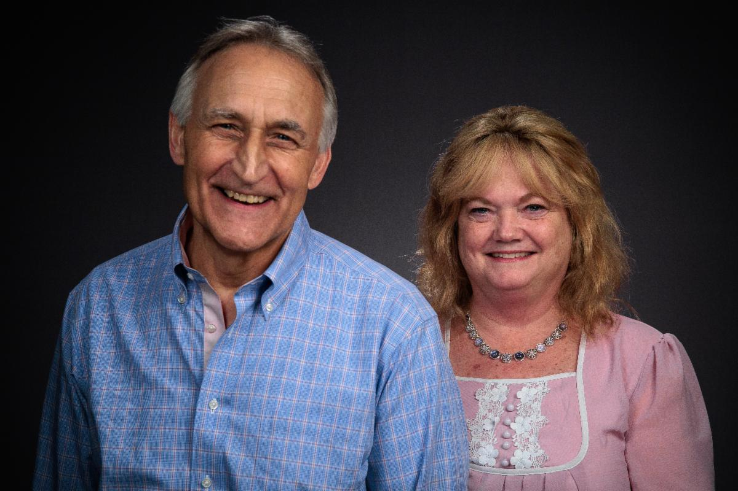
Steve and Kathe Myers
As most of you know, Steve Myers is now the operation manager of MMS. Steve is well known as a host of the Beyond Today TV program and long-time pastor of the Cincinnati congregations. He is also an instructor at Ambassador Bible College. We are excited to have Steve work with us here in the home office as we move into new challenges created by the world around us. We strive to meet the needs of our membership and navigate this age—and the many changes society is thrusting upon us—as strongly as we can.
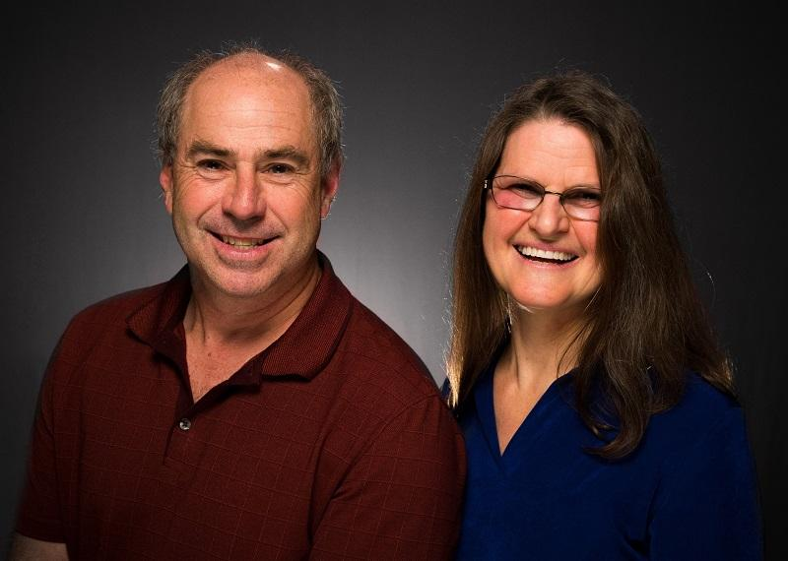
Mark and Barbara Welch
Mark Welch, who formerly headed the MMS department, is now the pastor of the Cincinnati area congregations. He has served admirably as a pastor over the years and will be a fine addition to the local congregations here.
Please pray for God’s Spirit and wisdom for these men as they move into their new roles of service. Without God leading us, our paths and efforts are futile.

International Reminders
That’s about it for now. Later in this issue, you will read of more events and a follow-up to the encouraging story of a couple from Bangladesh as they traveled to India to meet with senior pastor David Schreiber for baptism.
Have a good day, everyone, and a wonderful day of preparation and Sabbath.
In Christ’s service,

Rick Shabi

India Trip Update
I wrote earlier, asking for prayers for the safe arrival of Manik and Rita from Bangladesh. In this part of the world, just because you have a visa doesn’t mean you won’t be questioned and possibly delayed by the customs authorities.
Once again, our great God answered our prayers and Manik and Rita arrived safely in Visakhapatnam, India, shortly after I did. It was good to see them.
We spent the entire day Thursday together, searching the scriptures, talking about baptism and, with God’s help, I answered many of their Bible questions. I knew the day would be a challenge, as Manik and Rita have two small and active children. Rita is not as familiar with the English language as Manik, therefore Manik is needed to help translate when I talk with Rita. This left no one to watch the children—so we put on a cartoon video which did not need English translation for them to enjoy. In the afternoon, their 2-year-old crawled up on the hotel bed and took a nap. Truly God was present and worked things out.
After a short night’s rest, one of the Sabbath-keeping pastors in this area picked me up at 5 a.m. to go to his village. I was earnestly requested to come and say a few words at an early morning memorial service for one of their beloved church members who had just died the night before. It was about an hour drive, and I went to their home to comfort the family and my friend.
I was only able to stay for a short time before departing at 8:45 a.m. to go to the home of UCG member Ezekiel Polinati for a Bible seminar. We had previously scheduled a seminar at his home after the Feast, and I was unable to make it due to a cyclone. Those in attendance were happy to have the seminar rescheduled, since they had made plans to attend last fall. There were about 50 in attendance.
After the morning seminar, we broke for a late lunch and then resumed for an afternoon session, followed by a Q & A session. It was a profitable day.
That evening, I am happy to announce, I baptized Manik and Rita and welcomed them as our newest brother and sister in the family of God. There was much rejoicing in heaven, as well as in Visakhapatnam.
Thanks for your prayers. As I mentioned before, I greatly appreciate those praying for God’s guidance on my travels and for His blessing and protection. The scriptures tell us without God’s involvement and direction, all our plans are in vain. I join you in praying for God to open the doors He wants me to walk through to serve His people.
—Dave Schreiber, senior pastor, Sri Lanka, India, Bangladesh and Pakistan

Magnified: The Feast of Tabernacles
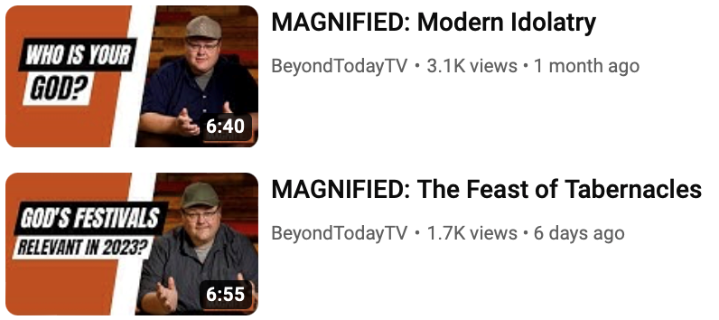
The United Church of God and Beyond Today have released a second video in the series called “Magnified.” Is the Feast of Tabernacles relevant in 2023? Observing this annual festival gives us a window into God’s thinking and shows us what’s still ahead in His plan for all people. The goal of Magnified is to produce a short video that mixes entertainment with a robust biblical education, aimed at younger audiences. You can view this second episode on YouTube at youtu.be/6pDkfPWRCKo.
—Media and Communications Services

Reminder: Video Recordings Available of ABC Class, Acts of the Apostles
A total of 12 video recordings of the Ambassador Bible College class, “Acts of the Apostles,” are now available to view at: ucg.org/ambassador-bible-college/acts-of-the-apostles-ambassador-bible-college. A new video will be released on Thursday of each week for the next eight months.
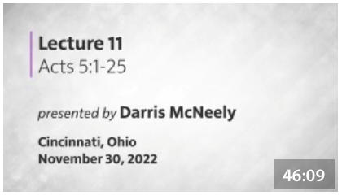
These recordings are available on our website, but also available on our UCG app, on Roku and Amazon Fire TV. Navigate to the “sermon videos” line to view on these streaming devices.
—Media and Communications Services



New Social Media Initiatives
As the Church continues to preach the gospel, a new social media advertising campaign titled “Trust that Transforms” is launching this month on Facebook and Instagram.
The message behind the “Trust that Transforms” campaign is to connect to persons looking to make a change in 2023 and willing to take the first step with God. This campaign’s advertisements will invite people to subscribe to a free weekly email focused on the amazing benefits of practicing biblical principles in one’s life and educating readers on uncompromised biblical truth.
As an incentive to sign-up, new email subscribers will receive a free Bible Memorization Guide containing 52 inspiring Bible verses—to learn one new verse weekly in 2023. This campaign will be initially advertised in 10 states in the U.S. including Florida, Georgia, Indiana, Michigan, North Carolina, Ohio, Kentucky, Tennessee, Texas and Washington to collect market research for future nationwide campaigns. This project is a great opportunity for the Church to explore modern avenues of reaching new audiences and initiate new positive connections with those seeking the truth and a relationship with God.
—Peter Eddington, Operation Manager, Media and Communications Services

Help Needed in Eastern Europe and Scandinavia
We are looking for members of the United Church of God who have native literacy in Scandinavian and Eastern European languages. The purpose is to assist the UCG ministry in working with people in these languages as the Church develops its social media efforts in these areas:
- Estonian
- Russian
- Ukrainian
- Latvian
- Lithuanian
- Polish
- Finnish
- Swedish
- Norwegian
- Danish
We need Church members who have casual, native fluency. We already have automated digital translation. However, assistance is needed to develop local language social media pages and weekly monitoring of those pages. If you have such a language capacity, then you can be on the front line of preaching the gospel to the whole world.
If you have native literacy in the above languages, please contact Tim_Martens@ucg.org, James_Ginn@ucg.org or Johnnie_Lambert@ucg.org.
—Media and Communications Services

Gear Grinder Classic Bike Ride—Fall 2023
Registration is now open for up to 50 riders to participate in the inaugural bike ride along the beautiful shores of Lake Superior on Sept. 10, 2023.
This fully supported ride will begin and end at Gooseberry Falls State Park (40 miles North of Duluth, Minnesota). Riders can choose one of three routes (28, 37 or 46 miles).
For more ride details and to register, go to eventcreate.com/e/geargrinderclassic.

Upcoming Events
Jan. 13–16 | Growing in the Faith Weekend | Stewartville, MN
Feb. 4–5 | Atlanta Ski Trip | Gatlinburg, TN
Feb. 17–20 | Wamatochick Young Adult Weekend | Prescott, AZ
Feb. 17–20 | Young Adult Winter/Ski Retreat | Pipestem, WV
Feb. 18 | “Pride and Prejudice” Formal Dance | Westford, MA
March 3–5 | Puget Sound Women’s Enrichment Weekend | Conner, WA
March 10–12 | Dallas/Fort Worth Regional Weekend | Plano, TX
March 18 | SW Missouri Women’s Enrichment Event | Ozark, MO
March 19 | ABC Charity Auction | Milford, OH
March 24–26 | Portland Women’s Enrichment Weekend | Canby, OR
April 4 | Passover Evening
April 6 | First Day of Unleavened Bread
April 8–9 | SE Formal Teen & Family Weekend | Atlanta, GA
April 12 | Last Day of Unleavened Bread

Upcoming activities may be sent to weekly_update@ucg.org. Additional calendar information is available on the members website.

