

May 25, 2023

From the Chairman . . .
Greetings brethren,
Just a few days from now we will be observing the Feast of Pentecost, and as is the case with all of God’s annual Holy Days, there are many aspects of the meaning of the day we could focus upon. The Day of Pentecost was called the Feast of Weeks or the Feast of Firstfruits in the Old Testament (Leviticus 23:15-21).
Pentecost pictures the third step in God’s master plan of salvation for all of mankind, yet the vast majority of humanity will go about their typical Sunday routines, still oblivious to the true meaning and purpose for life and God’s ultimate plan for humankind, which is to bring many children to glory (Hebrews 2:10).
In Jesus Christ’s final statement before ascending to the Father, He made a very powerful announcement: “But you shall receive power when the Holy Spirit has come upon you; and you shall be witnesses to Me in Jerusalem, and in all Judea and Samaria, and to the end of the earth” (Acts 1:8).
Jesus Christ had previously commanded the disciples to wait in Jerusalem, until they received the Holy Spirit (Acts 1:4). They were to wait for the promise of the Father, which was that Jesus would send the Holy Spirit to guide them into all truth (John 16:7, 13).
The Greek word translated “power” is dunamis, defined as “abundant, mighty, inherent power residing in a thing by virtue of its nature” (Complete Word Study Dictionary).
Jesus announced to His followers that if they remained in Jerusalem, they would receive the very divine essence of God and Christ to be in them! The Comforter, the Helper, the Holy Spirit, would empower them to be living examples, a royal priesthood, a chosen generation! They would live differently from all other people around them.
This is a promise that continues to this very day, but we don’t have to wait for the Day of Pentecost to receive the gift of the Holy Spirit. We see later in Acts 2 where Peter gives a powerful sermon causing others who were gathered there to be “cut to the heart” and ask what they must do to receive the Holy Spirit (Acts 2:37). Peter responded: “Repent, and let every one of you be baptized in the name of Jesus Christ for the remission of sins; and you shall receive the gift of the Holy Spirit. For the promise is to you and to your children, and to all who are afar off, as many as the Lord our God will call” (Acts 2:38, 39).
This is a powerful and reassuring promise to all of us who have given our lives to God and Jesus Christ. If we have repented of our sins and been baptized by immersion and had hands laid on us by the ministry of Jesus Christ, we are promised to receive the Holy Spirit!
Jesus’ disciples waited in Jerusalem, just as Jesus had commanded, until the Feast of Pentecost. They then gathered together in one place and it was then that Jesus Christ sent the Holy Spirit and the New Testament Church began!
Yet, we may overlook one important fact. Unless Jesus’ disciples had been obedient by remaining in Jerusalem to observe the Day of Pentecost in A.D. 31, they would not have received God’s Holy Spirit. Think about that. It all begins with obedience.
As we approach this upcoming Day of Pentecost, maybe we should pause to reflect on the example of those gathered in Jerusalem in A.D. 31, who were faithful and obedient. How are we doing in our own lives? Are we obedient in all things? Scripture tells us that the Holy Spirit is given “to those who obey Him” (Acts 5:32).
Have a wonderful Sabbath Day and a spiritually fulfilling Day of Pentecost.
In Christ’s service,

Len Martin

ABC Continuing Education Program 2023
The Ambassador Bible College Continuing Education program has been taking place at the home office this week. 36 students came from eight different states, including Texas and Vermont. Of course, some are local to the Cincinnati congregation. Most are seniors, and one even celebrated a 90th birthday during the program.
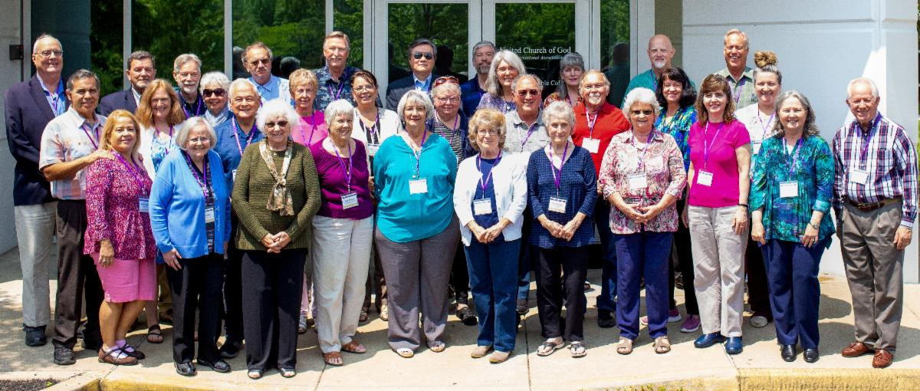
Attendees of the 2023 ABC Continuing Education classes.
The Continuing Education program consists of excerpts from the ABC curriculum, featuring all of the resident faculty. Along with the opportunity for deep and specific Bible study, participants enjoy considerable time in fellowship. Several have attended for 10 years or more, and they look forward to seeing old friends, as well as meeting new ones.
—Frank Dunkle, Coordinator, Ambassador Bible College

Sermon Disc Program Transition to Memory Sticks
The United Church of God has provided sermon recordings since the establishment of the Church in 1995. We began mailing VHS tapes and audio cassette tapes, then moved to DVDs and CDs in the early 2010s.
We are at another one of those transitional moments. The need for DVDs and CDs has dwindled in the past few years. We at the home office still plan to provide curated sermon recordings, but they will now only be available for download from our website. Here is the direct link: ucg.org/sermon-disc-program.
Sermon Disc Program (SDP) 171 will be the final disc to be mailed out. We know there will be some shut-ins and others who will need recorded sermons and/or help with this transition. Here are a few suggestions moving forward:
- If the member has Internet access, our curated sermons will still be available on the United Church of God Roku app and website. These sermons auto populate as they are added by the home office staff.

- For those who do not have home Internet service, many new televisions allow a memory stick to be inserted into a TV to play video and audio files. A local volunteer can download our sermon recordings from ucg.org/sermon-disc-program and copy them onto a memory stick or SD card for the member or shut-in to use. Memory cards these days can fit numerous sermons on them.
- If the shut-in does not have a television that can play video or audio through a memory stick or SD card, a player can be purchased that connects to most TVs. Here is one example: amzn.to/3OfzkLo. Note, this model allows both HDMI and the older TV “analog” connections.
- The cost to purchase any necessary equipment for a person to play sermons from a memory stick or to gain Internet access, will be a cost savings for the Church over producing and mailing CDs and DVDs very quickly. We encourage each congregation to help its shut-ins in this way.
- If a DVD is still needed, someone in the congregation would need to download the files and burn a DVD for the shut-in. This would be the most labor intensive and costly choice over time.
For inquiries or questions in this regard, please contact Scott Buchanan at the home office at scott_buchanan@ucg.org.
—Peter Eddington, Media and Communications Services

No Cincinnati East Live Webcast on Pentecost
Due to being at another location for services on the Day of Pentecost, the Cincinnati East congregation is not able to provide a reliable webcast. However, a number of our other congregations will have a webcast available. A listing of congregations that normally webcast each week can be found at ucg.org/webcast/all.
Another resource is our Sermon Disc Program page that has curated sermons, including SDP 168, SDP 159, SDP 149 and SDP 140 each of which contain one Pentecost-related sermon.
—Peter Eddington, Media and Communications Services

Youth Instruction Family Study Guide
We have begun a new Family Study Guide series, “The Ten Commandments.” In this series, we examine each of God’s Commandments to see their spiritual and physical practical applications in life.
The latest Family Study Guide covers the First Commandment, “You shall have no other gods before me,” and is designed to help families learn more about developing a deeper relationship with God. We compare the results of obeying the First Commandment to the results of violating the First Commandment. God loves us and wants to be first in our lives. When we put our trust in the only true God, we learn to look to Him for direction, protection, healing and our everyday needs. “‘You shall love the LORD your God with all your heart, with all your soul, and with all your mind.’ This is the first and great commandment” (Matthew 22:37-38).
You can read and download this study guide at: ucg.org/members/family-study-guides/ten-commandments-first-commandment

Calling All Graduates!
We plan to feature the high school and university graduates of 2023 in the July-August issue of United News! Please take a few minutes to answer the questions below and send a photograph by June 7. Please keep it to 250 words maximum. Also include your phone number or e-mail address in case we need to confirm spellings, etc. (they will not be printed). Send with a recent, appropriate photo of the graduate by June 7. Digital photos should be at least 800 pixels in their smallest dimension to print sharply. Send by e-mail to un@ucg.org, or send by mail to United News, P.O. Box 541027, Cincinnati, OH 45254-1027 (postmarked by June 7). We may edit for clarity and/or length to meet the 250-word maximum length.
Here’s what to include:
- Graduate’s name
- Parents’ names (if high school grad)
- Congregation
- School, work, internship, co-op or other accomplishments
- Interests, interesting facts about yourself, Church activities you’re involved in, hobbies, unusual skills, etc.
- Plans after graduation
Congratulations!

Job Opening: Receptionist
The United Church of God has announced an opening for a Receptionist.
The Receptionist is present and opens the home office lobby door on time each morning and secures the lock at the end of each workday. He or she answers multiple incoming business telephone lines, directs caller to destination or fulfills caller’s request while on line. The incumbent greets office visitors in lobby and directs to appropriate personnel and acts as first line of security for the home office.
The Receptionist provides clerical support for Media and Communications Services and also takes literature requests, address changes, subscription renewals, subscription cancellations and tithe envelope requests and processes them through subscriber database while online with caller. In addition, he or she sorts incoming postal mail, processes mail returns and opens them for reuse.
A college degree or equivalent and two years related experience and training in computer skills, editorial and office duties is required. Experience working with the general public in a professional manner is essential.
Potential employees must be baptized members (in good standing) of the United Church of God. Applicants must be biblically literate and possess a thorough working knowledge of the doctrines, beliefs and practices of the United Church of God.
To request a job application or for questions about the position, please contact human_resources@ucg.org.

Upcoming Events
June 4–7 | Camp Gilmont | Gilmer, TX
June 18–21 | Camp Colorado | Allenspark, CO
June 18–25 | Camp Cotubic | Bellefontaine, OH
July 2–9 | Camp Pinecrest | Fredericktown, MO
July 7–9 | Colorado Women’s Enrichment Weekend | Allenspark, CO
July 7–9 | West Michigan Camping Weekend | White Cloud, MI
July 9–12 | Camp Ironwood | Stewartville, MN
July 9–12 | Camp Ochoco | Prineville, OR
July 9–16 | Southwest Camp | Prescott, AZ
July 9–16 | Boundary Waters Adventure | Voyageurs NP, MN
July 21–28 | Camp Woodland | Temple, GA
July 23–30 | Northwest Camp | Rockaway Beach, OR
July 30–Aug. 2 | Camp Buckeye | Orrville, OH
July 30–Aug. 2 | Camp Seven Mountains | Spring Mills, PA
Aug 11–13 | Northwest Young Adult Weekend | Cle Elum, WA

Upcoming activities may be sent to weekly_update@ucg.org. Additional calendar information is available on the members’ website.

