
  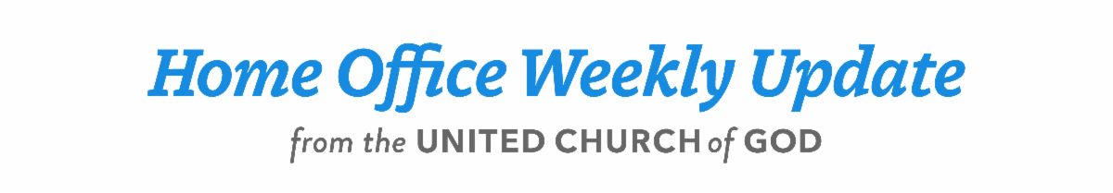
  May 18, 2023
  From the President . . .
  Greetings brethren around the world,
  In the midst of a flurry of activities in the Church—and our individual personal lives—it is good and appropriate to take time to reflect on and remind ourselves of the meaning of the Feast of Pentecost as it approaches. Today is “Day 40” as we continue the count toward this special Holy Day.
  On that day in A.D. 31, God’s Holy Spirit was poured out on the disciples who were gathered together before God “with one accord in one place” (Acts 2:1). In those words, we find an essential description of what God desires in His people. They are “with one accord in one place.”
  As people of “one accord,” God’s people must be united and led by His Spirit. They are committed to the truth as given by God. They are unified in mind and purpose, learning and living His way of life in complete submission to Him. Recognizing Christ as the first of “the firstfruits” (1 Corinthians 15:20) they follow in His footsteps, yielding to Him as He prepares them for eternity, working with Him and becoming His bride.
  It is a high calling and all of us have been called to this purpose. Pentecost reminds us that firstfruits to “God and the Lamb” follow Him wherever He goes. Because they are “in accord” with Him and each other, they are not defiled by false ideas, have no deceit in their mouths and are “without fault before the throne of God” (Revelation 14:4-5). We are part of His body—that “one place” He works with us all as we learn and endeavor “to keep the unity of the Spirit in the bond of peace” (Ephesians 4:3).
  As firstfruits in these physical bodies, we are reminded that our days in this physical life are numbered (Psalm 90:12). This should focus us on the preparation of our hearts and minds—our spiritual lives that God is working in us—constantly leading us as we go about the physical activities of life.
  Meetings and conferences
  The month of May, leading right up to Pentecost is really a busy time at the home office.
  The Sabbath of May 6 was the “GCE Sabbath” where the Church from around the world gathered for Sabbath services as elders assembled for the annual General Conference of Elders meeting held on May 7 and 8. More than 600 were present for Sabbath services in Cincinnati and were joined by thousands from around the world with more than 1,800 streaming video connections. Truly, God’s Church was “in one place” that day. GCE sessions on Sunday and Monday at the Holiday Inn Eastgate were attended by 240 elders and wives, representing nine different countries. Almost 100 more joined the two-day meetings remotely, also adding more international representatives.
  A highlight of the conference was a presentation and discussion of the 10-page Hebrew Calendar study paper and its 121-page appendix, which had been researched and prepared by the Doctrine Committee of the Council of Elders for the past six years. A summary of this paper, as well as the complete appendices document, is available now at www.ucg.org. Click on “Study Papers” under the Resources menu tab.
  Immediately following the GCE meeting, the Council of Elders met in Cincinnati May 9–11. At the same time, the Ambassador Bible College (ABC) school year concluded on May 11. The class of 2023 was a wonderful group of 26 students who completed the nine-month course and received their diplomas in a very well-orchestrated and well-attended graduation ceremony last Sunday, May 14. Our congratulations to all the students.
  Next week, May 22-26, 37 members of the Church from around the nation will be here in Cincinnati for the annual five-day ABC Continuing Education program. We’re looking forward to their arrival and the time we will be able to spend with them.
  Our international scope of service
  While all this has been going on at the home office, we know there is much going on where you live as well. We are constantly reminded that God is at work in all parts of the world. We see His hand in our international areas and we see His hand here in the United States. In “one accord” we’re all here to seek His will, learn His will, submit to it and do it. Together we are here to serve His people—His disciples—wherever they live.
  Let us remember that we all have a vital part in this great work to which God has called us. Continually pray to God on each other’s behalf. Stir up His Spirit, pray for His comfort, His guidance and direction on all His people. Even though we live in many different areas and have our individual trials, we are one, united by Him in belief, purpose, mission and truth, and led by His Spirit.
  Thank you, brethren, for your loyalty and commitment to God and His will. Let us all strive and endeavor for that unity that God desires in all of us as we look forward to Pentecost.
  Have a wonderful day of preparation and Sabbath. Our thoughts and prayers are with all of you.
  In Christ’s service,
  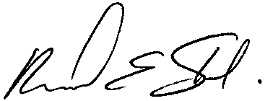
  Rick Shabi
  Power to Change: The Spirit of Love
  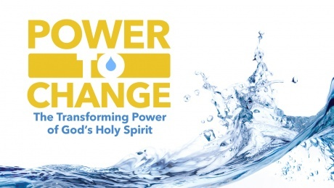
  Please join us for the third and final week in our study and preparation for the Day of Pentecost through our Beyond Today Bible study video series: “Power to Change: The Transforming Power of God’s Holy Spirit.”
  ucg.org/beyond-today/beyond-today-bible-study/power-to-change-the-transforming-power-of-gods-holy-spirit
  “Jesus Christ gave a new commandment to us. How can we allow God’s Spirit to work in us so that we can fulfill that command to love? In this study, we’ll examine 2 Timothy 1:7 and the apostle Paul’s reference to God’s Spirit as the Spirit of Love. As an essential to our whole Christian character, we’ll focus on this indispensable spiritual quality that must be vibrant in our life.” It is titled: “Power to Change: Part 3: The Spirit of Love” by Steve Myers.
  ucg.org/beyond-today/beyond-today-bible-study/power-to-change-part-3-the-spirit-of-love
  —Peter Eddington, Operation Manager, Media and Communications Services
  Spanish-to-English Translators Needed for Chilean Feast Site
  The Feast of Tabernacles site in Chile is in need of one or two more Spanish-to-English translators to help with daily church services. The Feast site is located in the seaside town of Pichilemu and hosts around 100 members mostly from Chile and surrounding countries, and this year several more visitors from English-speaking areas. If you or someone you know would like to spend the Feast on the beautiful coast of Chile and have an opportunity to do meaningful service, please contact Garrett Fenchel (garrett.fenchel@gmail.com) and Marcelo Saavedra (marcelo_saavedra@ucg.org).
  West Michigan Camping/Tubing Weekend—July 7–9
  You are invited to join the West Michigan UCG congregations for a weekend of fellowship, camping and fun-filled outdoor adventure! There is a special outdoor Sabbath service on July 8 at Sandy Beach County Park in White Cloud, Michigan, and an organized tubing trip on the Muskegon River for Sunday morning, July 9. If you would like further details or a copy of the flyer advertising the event, contact Christina Morris at 269-903-1902 or stinamsu@yahoo.com. A copy of the flyer may be downloaded here: West Michigan Weekend Flyer 2023.
  Upcoming Events
  May 26–28 | Brown County Pentecost Weekend | Nashville, IN
  May 28 | Pentecost
  May 29–June 2 | Camp Florida | Umatilla, FL
  June 4–7 | Camp Gilmont | Gilmer, TX
  June 18–21 | Camp Colorado | Allenspark, CO
  June 18–25 | Camp Cotubic | Bellefontaine, OH
  July 2–9 | Camp Pinecrest | Fredericktown, MO
  July 7–9 | Colorado Women’s Enrichment Weekend | Allenspark, CO
  July 7–9 | West Michigan Camping Weekend | White Cloud, MI
  July 9–12 | Camp Ironwood | Stewartville, MN
  July 9–12 | Camp Ochoco | Prineville, OR
  July 9–16 | Southwest Camp | Prescott, AZ
  July 9–16 | Boundary Waters Adventure | Voyageurs NP, MN
  July 21–28 | Camp Woodland | Temple, GA
  July 23–30 | Northwest Camp | Rockaway Beach, OR
  July 30–Aug. 2 | Camp Buckeye | Orrville, OH
  July 30–Aug. 2 | Camp Seven Mountains | Spring Mills, PA
  Aug 11–13 | Northwest Young Adult Weekend | Cle Elum, WA
  Upcoming activities may be sent to weekly_update@ucg.org. Additional calendar information is available on the members’ website.

