
  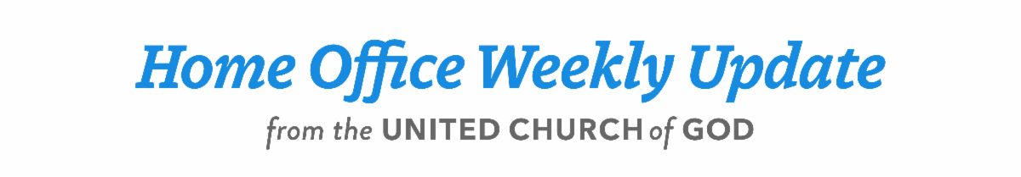
  May 11, 2023
  Power to Change: Inside Out
  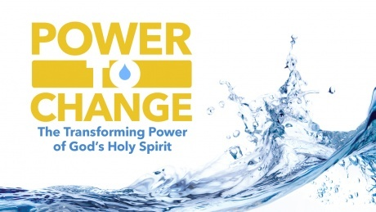
  Please join us again this week in enhancing our study and preparation for the Day of Pentecost through our Beyond Today Bible study video series: “Power to Change: The Transforming Power of God’s Holy Spirit.”
  ucg.org/beyond-today/beyond-today-bible-study/power-to-change-the-transforming-power-of-gods-holy-spirit
  Making any change in our lives is challenging and difficult. How can it be done? It starts in the heart when we allow God to create within us a clean heart. This Bible study will explain the process of “inside out,” living the transformed life. It is titled: “Power to Change: Part 2: Inside Out” by Darris McNeely.
  ucg.org/beyond-today/beyond-today-bible-study/power-to-change-part-2-inside-out
  —Peter Eddington, Operation Manager, Media and Communications Services
  Upcoming Events
  May 22–26 | ABC Continuing Education | Milford, OH
  May 26–28 | Brown County Pentecost Weekend | Nashville, IN
  May 28 | Pentecost
  May 29–June 2 | Camp Florida | Umatilla, FL
  June 4–7 | Camp Gilmont | Gilmer, TX
  June 18–21 | Camp Colorado | Allenspark, CO
  June 18–25 | Camp Cotubic | Bellefontaine, OH
  July 2–9 | Camp Pinecrest | Fredericktown, MO
  July 7–9 | Colorado Women’s Enrichment Weekend | Allenspark, CO
  July 9–12 | Camp Ironwood | Stewartville, MN
  July 9–12 | Camp Ochoco | Prineville, OR
  July 9–16 | Southwest Camp | Prescott, AZ
  July 9–16 | Boundary Waters Adventure | Voyageurs NP, MN
  July 21–28 | Camp Woodland | Temple, GA
  July 23–30 | Northwest Camp | Rockaway Beach, OR
  July 30–Aug. 2 | Camp Buckeye | Orrville, OH
  July 30–Aug. 2 | Camp Seven Mountains | Spring Mills, PA
  Aug 11–13 | Northwest Young Adult Weekend | Cle Elum, WA
  Upcoming activities may be sent to weekly_update@ucg.org. Additional calendar information is available on the members website.

