

March 7, 2024

From the Chairman . . .
Greetings brethren,
As many of you already know, the Council of Elders convened last week for the final quarterly meeting prior to the upcoming Passover and Holy Days. At the conclusion of those meetings, the Council approved the Strategic Plan, Operation Plan and Budget to go to the General Conference of Elders for ratification at the annual meeting in Cincinnati, Ohio, May 5–6, 2024. If you care to know more about those meetings, ask any elder for a copy of the reports from the Council reporter. Those reports are intended to be shared with all of you.
The planning, budgeting, scheduling, etc., is necessary so that things can be done decently and in order (1 Corinthians 14:40). This is true whether it is happening globally—as with the Council of Elders, national councils and home office administration—or locally in your own congregation. However, these activities are a means to an end, not the end in and of itself. We must never lose sight of why we do the things we do—why we attend Sabbath services every week, why we observe the annual Holy Days at their appointed times, why we tithe, why we observe food laws, why we examine ourselves, and so much more.
When the scribes and Pharisees wanted to know why Jesus’ disciples did not follow their own man-made traditions, Jesus turned it back on them, asking, “Why do you also transgress the commandment of God because of your tradition?” (Matthew 15:3). He took it a step further, quoted from Isaiah and said, “‘These people draw near to me with their mouth, and honor me with their lips, but their heart is far from me. And in vain they worship me, teaching as doctrines the commandments of men’” (Matthew 15:8-9).
Has our worship and devotion to God become mere lip-service, void of meaning and purpose? Have we forgotten why we do the things we do? Do we simply go on year-after-year, forgetting what the final outcome is intended to be as a result of what we are doing? Are we worshipping in vain?

Examination and reconciliation
In just over six weeks from now, we will repeat the cycle of the annual “feasts of the LORD” (Leviticus 23) beginning with Passover and the Days of Unleavened Bread. In the days ahead we will be reminded of the responsibility to examine ourselves, to put sin out of our lives and seek reconciliation with God and each other.
The Greek word most often translated “sin” in the New Testament is hamartia and it is an archery term for “missing the mark.” So while we examine ourselves, we should look for where we are missing the mark—where our lives do not mirror the perfect righteous character of our elder brother and the only perfect standard, Jesus Christ. Once we identify our sins, we repent and go forward. The more we do this, the closer we get to hitting the mark!
As we repeat this process of examination and change, it is intended to bring us all together into a close personal relationship with each other, the Father and Jesus Christ. The Greek word most often used in the New Testament to describe this relationship is koinonia. Strong’s describes it as a “partnership, that is, (literally) participation.” In the English language the word is translated fellowship. But it is not merely the socializing we do before and after services, but it is the relationship we have with the Father, Jesus Christ and each other 24 hours a day, seven days a week.
In 1 John 1:6-7 it is written: “If we say that we have fellowship with Him, and walk in darkness, we lie and do not practice the truth. But if we walk in the light as He is in the light, we have fellowship with one another, and the blood of Jesus Christ His Son cleanses us from all sin” (emphasis added throughout).
Brethren, as we focus on preparation for Passover and the upcoming Holy Days, let’s remember why we do the things we do. We have been called out of this world into a relationship with God, Jesus Christ and each other. Let’s look at where we are individually missing the mark, then repent and go forward. If there is a breach in our relationship with a brother in the faith, be reconciled so we can share in koinonia with the Father and Jesus Christ, which only exists if we are all walking in the light.
The apostle Paul wrote to the church in Ephesus saying: “Christ also loved the church and gave Himself for her, that He might sanctify and cleanse her with the washing of water by the word, that He might present her to Himself a glorious church, not having spot or wrinkle or any such thing, but that she should be holy and without blemish” (Ephesians 5:25-27).
May the upcoming Holy Days inspire us all to become a glorious Church, holy and without blemish.
In Christ’s service,

Len Martin

Food Assistance for Nigeria
From the Senior Pastor for English-speaking West Africa, Paul Moody:
In the face of an ongoing economic crisis, Nigerians are struggling to make ends meet and put food on the table for their families. The Nigerian currency, the Naira, recently hit an all-time record low against the U.S. Dollar, losing nearly seventy percent (70%) of its value since June 2023. Fuel prices have tripled over the last year, adding to the increased cost of goods across the board. Overall annual inflation is up close to 30%, the highest figure in almost 30 years. Food costs have risen well above that percentage, with the cost for certain basic household staples, such as rice, more than doubling from this time a year ago. Milk, eggs and beef are now considered a luxury as many families forgo such extras or cut out meal portions all together to get by.
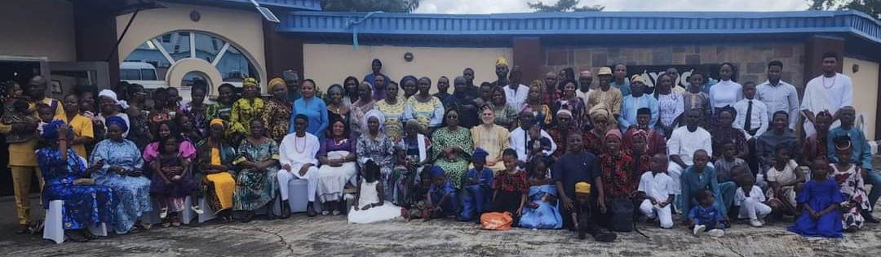
The members of the United Church of God have not been immune to such impacts. Many of our brethren in Nigeria were already living in difficult economic circumstances. In a country where the monthly minimum wage is $19 at the current exchange rate, it has become increasingly difficult to cope. In fact, a number of our Church families are now forced to choose between purchasing either food for their family or transportation on the Sabbath. In some cases, Church members are showing up to the Sabbath service hungry, having chosen to skip a meal in order to purchase transportation to assemble.
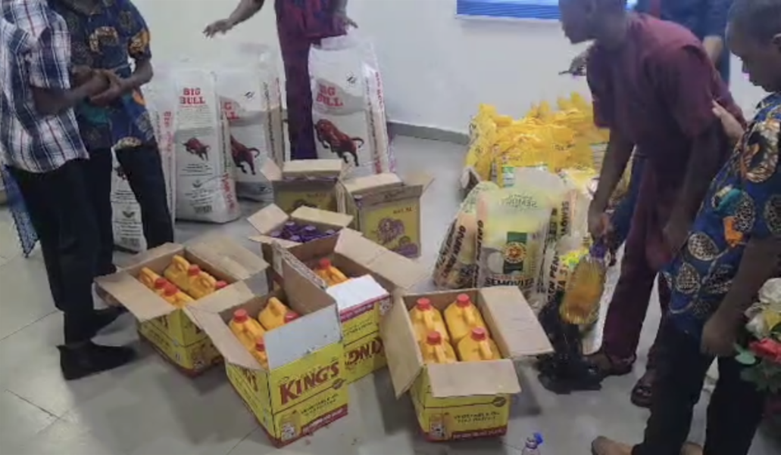
In response to this economic hardship, the Good Works program has stepped in to help provide food assistance to our brethren in Nigeria. Funds have been sent over to purchase food staples which will be distributed to approximately 157 members of the United Church of God in that region. Rice, beans, semo and vegetable oil are being purchased in bulk for equitable distribution to the brethren. While this assistance doesn’t solve the economic crisis these individuals and families are facing, it is intended to help ease some of the strain in the short-term by providing basic meal related commodities for consumption. Your generous contributions to this and other Good Works projects around the world are greatly appreciated!
Donations can be made to this project at: ucg.org/members/service-projects/relief-funds-for-nigeria.

Feast of Tabernacles Announcements
This year the United Church of God will be hosting the Feast of Tabernacles in Hong Kong for the first time in five years.
Hong Kong, also known as the Pearl of the Orient, is very welcoming to international travelers. This vibrant city also has stunning natural beauty, with lush green mountains and Victoria Harbour, one of the great natural harbors of the world. You are invited to join us in celebrating God’s Feast this year in Hong Kong!
For more information, please contact Terry Franke: terry_franke@ucg.org.

List of 2024 Feast Sites
Currently 54 Feast sites are listed at ucg.org/members/feast as well as key dates for planning.

Registration for the Feast
For most sites, registration will begin after Passover. However, some international sites need to begin earlier.
Italy—registration for will be announced soon.
France—Registration for the Feast in France, which will be held once again on the beautiful French Riviera, will open on Wednesday, March 20, at 12 p.m. Eastern Time. Further details can be found below.
Germany—registration is open.

Feast of Tabernacles Site in France
Your French brethren are pleased to welcome you back to Club Miléade La Gaillarde for the Feast of Tabernacles in 2024. The Feast will be held on the beautiful French Riviera near the well-known tourist destinations of Saint-Tropez and Saint-Raphaël. We have enjoyed the Feast in this region of France for many years, and this will be our third time celebrating the Feast at this seaside location.

Located an hour south of the Nice airport, Club Miléade La Gaillarde is situated just across the street from the beautiful Mediterranean Sea with 180 degree ocean views and an underpass walkway to the well-known beach of La Gaillarde. The outdoor heated pool and children’s play area overlook the water and the hotel’s newly constructed main building has a restaurant and bar, playroom for children, as well as a spa where visitors can schedule a massage, enjoy a sauna, or relax in the indoor jacuzzi overlooking the sea. The auditorium for church services is located next to the main building and the hotel accommodations, many with ocean views, are a short walk from the main complex. This site’s room and board package provides the opportunity to experience full-course buffet style French meals while enjoying fellowship with other brethren from around the world.
We plan to offer three afternoon excursions to nearby points of interest.
Registration opens March 20, 2024. Keep an eye out for announcements with further details on ucg.org/members/feast/sites/2024 and the 2024 UCG Feast of Tabernacles Locations Facebook page.

Milwaukee Prom Is Now Milwaukee Family Weekend—March 30
It is with deep regret that we announce the cancellation of the Milwaukee Teen Prom “Under the Sea” scheduled for March 30. Unfortunately, due to insufficient interest, we are unable to proceed with the event. Refunds will be issued to those who have already made payments. We appreciate your understanding.
Now, on to some uplifting news! The Milwaukee Family Weekend event is still on for the same weekend! While the teen prom won’t be happening, we will be having an evening filled with dancing for everyone to enjoy. Family dances promise fun for all ages, from the little ones to the elderly, ensuring a delightful and joyous time for everyone involved!
We’re continuing with many of the events that were originally scheduled. For instance, Devin Schulz (and his family) will be joining us for the weekend as a guest speaker. The morning seminar led by Dan Dowd remains on the agenda. Plans for the teen Bible study and Sabbath school are currently underway. And, of course, a fantastic potluck dinner for everyone to enjoy is still part of the plan. We are still planning to lace up our skates and have some fun on wheels at the roller-skating activity on Sunday, March 31.
There will be ample opportunities for fellowship, forging new friendships, nurturing existing ones, and relishing time spent together as members of God’s family.
—Dan Dowd

Upcoming Events
Mar. 15–17 | Midwest Teen Prom | Berlin, OH
Mar. 22–24 | Portland Women’s Enrichment Weekend | Canby, OR
Mar. 30-31 | Milwaukee Family Weekend | Milwaukee, WI
Apr. 11–14 | Mammoth Cave Camping Weekend | Mammoth Cave NP, KY
May 10–12 | Spokane Women’s Enrichment Weekend | Loon Lake, WA
May 24–27 | Smoky Mountain Young Adult Retreat | Townsend, TN

Upcoming activities may be sent to weekly_update@ucg.org. Additional calendar information is available on the members’ website.

