
  
  March 9, 2023
  From Ministerial and Member Services...
  Greetings brethren!
  Planning has been a focus for Ministerial and Member Services and the administration this week at the home office. Preparing the agenda for the upcoming General Conference of Elders to be held in Cincinnati in May has been an important topic of discussion. The conference is an exciting opportunity to have many elders come together in unity from around the world, not only to carry out the business of the Church, but also for spiritual strengthening.
  Even though spring has not officially arrived, advanced planning for the Feast of Tabernacles is taking center stage. Feast sites in the United States have been determined. They are:
  - Branson, Missouri
  - Cincinnati, Ohio
  - Estes Park, Colorado
  - Galveston, Texas
  - Gatlinburg, Tennessee
  - Jekyll Island, Georgia
  - Lake Geneva, Wisconsin
  - Ocean City, Maryland
  - Panama City Beach, Florida
  - Spokane Valley, Washington
  - St. George, Utah
  In the near future, you’ll be able to see all the locations on our Feast website at feast.ucg.org. Some international sites are already accepting registrations and we’ll keep everyone posted when it is time to begin to register for U.S. festival sites.
  When it comes to planning, we are all in a most important time of preparation as we approach the Passover, and recommit and recount the fact that “Indeed Christ, our Passover, was sacrificed for us” (1 Corinthians 5:7). This simple statement is full of profound meaning.
  In the Old Testament, the Israelites were to choose and then sacrifice the finest, strongest, very best Passover lamb that was without blemish or defect (Exodus 12). God told them to take the best and kill it, so symbolically the consequence of sin could be understood.
  When Christ was put to death for our sin, the Father God was offering His very best. Jesus was in the prime of His life—sinless, flawless, perfect (2 Corinthians 5:21). The Father gave his most excellent and only Son to die the death each one of us deserves so that we could have forgiveness and be brought back into a right relationship with Him (Matthew 26:28). What a marvelous plan!
  Planning is certainly a focus. So as we plan for this coming Passover, we contemplate, reflect, and re-pledge our loyalty to our Father and Savior, and have our faith strengthened by the love, sacrifice and profound gift of God.
  —Steve Myers, Operation Manager, Ministerial and Member Services
  Six Steps to Passover: Part 3
  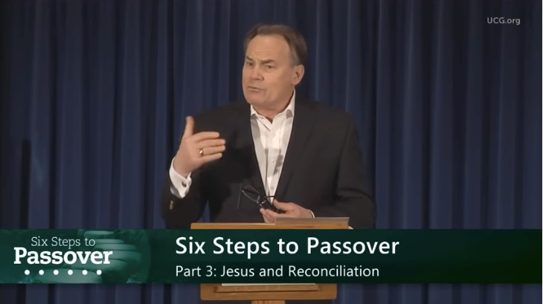
  We encourage everyone to continue this opportunity to deepen our understanding of God, and gain insight as we approach the Passover season together. This week’s study is titled: “Six Steps to Passover – Part 3: Jesus and Reconciliation” by Darris McNeely.
  ucg.org/beyond-today/beyond-today-bible-study/six-steps-to-passover-part-3-jesus-and-reconciliation
  —Peter Eddington, Operation Manager, Media and Communications Services
  Wamatochick Weekend Wrap-up 2023
  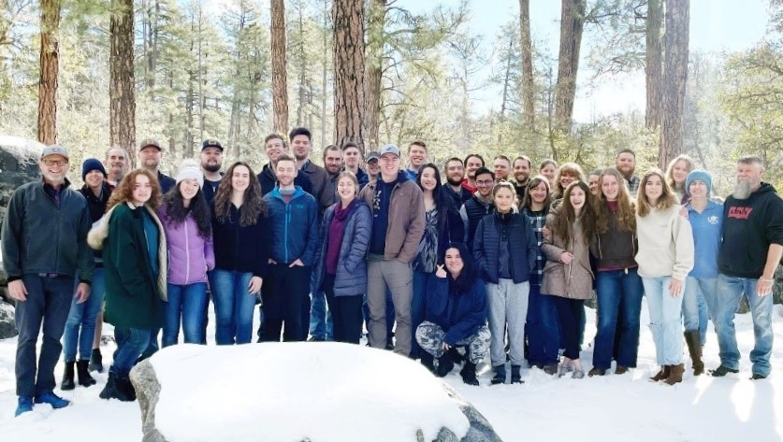
  We had a wonderful Young Adults Wamatochick Weekend February 17–20, with 42 of God’s people coming together to consider how we might apply His Word to our lives. The theme of the weekend was based on Hebrews 4:12—“The Word of God is Living and Powerful.” This theme served as the basis for the messages and discussions, which were led by the young adult participants and the local ministry.
  We started out Friday night with a discussion on how to live by every word of God. Sabbath services were split sermons discussing the spectrum of well-being and human emotions, and the critical nature of hope in our lives.
  Sabbath afternoon sessions included “Preparing the Heart,” how the first commandment can be life-changing, and “What if Marriage is Designed to Make You Holy More Than Happy.” Sunday’s session explored how God’s Living and Powerful Word applies to our everyday lives. Monday morning’s discussion was about the interworking of the membership and how all generations play a special role in the Body of Christ.
  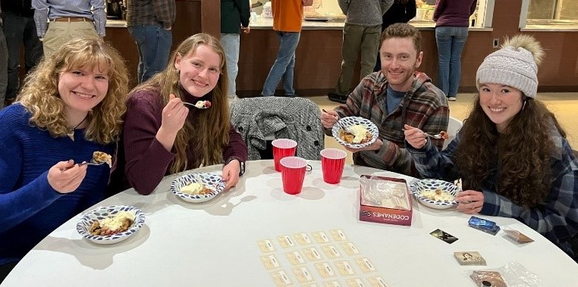
  It was a wonderful weekend filled with fun and fellowship, amazing food, and horseback riding for all interested. A fire outside in the crisp air surrounded by snow was a highlight of Sunday evening. We had a fire burning in the lodge during all the sessions, adding to the cozy atmosphere.
  We look forward to next year already. Thank you all for your prayers and support as we focused on the next generation of the Body of Christ. Please mark your calendars for the last weekend of February 2024.
  —Scott McKeon, Pastor, Northern Arizona and Phoenix Northwest
  
  U.S. Print Advertising—April 2023
  The 2022-23 fiscal year print advertising campaign of the United Church of God will draw to a close at the end of April 2023. Throughout this period, 248 million ads in Sunday newspaper coupon inserts will have made available a wide variety of Bible study aids and Beyond Today magazine subscriptions—reaching multiple millions of households in the United States.
  In the campaign’s April 2023 finale, two new ads will be tested, offering a subscription to Beyond Today magazine. The headline featured on both ads will state, “Hope: When All Seems Hopeless” with the subhead declaring, “Discover where you can find real, lasting hope when trials have no end and despair threatens to leave you bitter and defeated.” One ad showing a photo of a man will reach five million households and the other ad featuring a photo of a woman will target an additional five million households. (Please see the ads below.) By using two different photos, we expect to determine which ad will draw the best response if we choose to advertise to larger audiences during the next fiscal year.
  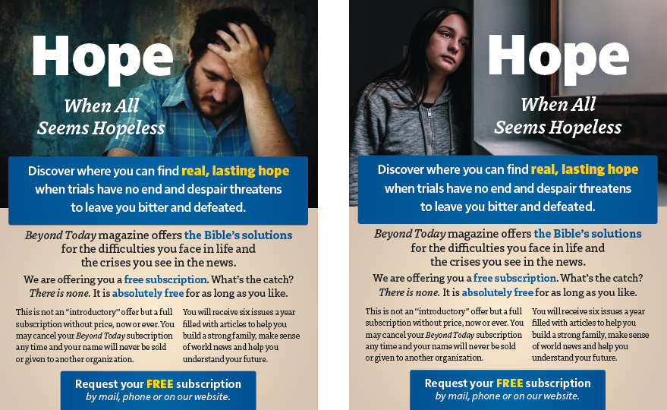
  Finally, your vital prayers for God’s blessings on these new test ads will be greatly appreciated. Plus, we offer our thanks for your ongoing prayers for all the Church’s efforts to reach people throughout the world with the awesome gospel of Jesus Christ and the coming Kingdom of God.
  —Peter Eddington, Operation Manager, Media and Communications Services
  Upcoming Events
  March 18 | SW Missouri Women’s Enrichment Event | Ozark, MO
  March 18–19 | Midwest Teen Prom | Berlin, OH
  March 19 | ABC Charity Auction | Milford, OH
  March 24–26 | Portland Women’s Enrichment Weekend | Canby, OR
  April 4 | Passover Evening
  April 6 | First Day of Unleavened Bread
  April 7–9 | Milwaukee Prom & Family Weekend | Milwaukee, WI
  April 8–9 | Southeast Regional Formal Weekend | Atlanta, GA
  April 12 | Last Day of Unleavened Bread
  April 13 | Festival Planning Brochure Posted Online
  April 21–23 | Women’s Enrichment Weekend | Indianapolis, IN
  April 30 | Festival Housing Reservations Begin
  May 4 | Second Passover Evening
  May 6–8 | GCE Annual Meeting | Cincinnati, OH
  May 22–26 | ABC Continuing Education | Milford, OH
  May 26–28 | Brown County Pentecost Weekend | Nashville, IN
  May 28 | Pentecost
  May 29–June 2 | Camp Florida | Umatilla, FL
  June 4–7 | Camp Gilmont | Gilmer, TX
  June 9–11 | New England Family Weekend | Boston, MA
  Upcoming activities may be sent to weekly_update@ucg.org. Additional calendar information is available on the members website.

