

March 30, 2023

From the Chairman and President . . .
Greetings brethren around the world,
We are headed into what will be a spiritually meaningful and rewarding week for all of us. Next week members will observe the Passover, as the 14th day of the first month of God’s calendar begins. In remembrance of our Savior who suffered and died for us, we will observe the Passover as He did, recommitting ourselves to Him.
The next evening, as the 15th day of the first month begins, God’s people will be together with each other for the Night to Be Much Observed, which is the beginning of the Days of Unleavened Bread. This observance had so much meaning and significance for God’s people who He brought out of Egypt. Likewise, it has an even deeper significance and meaning for those God has called out of the world today.
Then, one week from today, we will gather at various locations around the world to observe the First Day of Unleavened Bread. During these final days leading up to the first Holy Day of the year, we are most likely looking throughout our homes for leaven, so that we can have it out of our lives before the days begin.

What is leaven?
When cleaning for the Days of Unleavened Bread, we may have to take a refresher course on what actually constitutes leaven. We may have a reference guide we pull out once a year to review, or you can check the home page of ucg.org where you will see a link to “What is Leavening?”
Leaven includes a few ingredients we know to look for on labels such as yeast, baking powder and baking soda (sodium bicarbonate), but often there are other ingredients that we forget about or just don’t know about. We want to be diligent in our effort.
Then, for the next seven days of Unleavened Bread we will be very careful to avoid eating anything with leaven in it, because we remember this was no small matter to ancient Israel!
“For whoever eats leavened bread from the first day until the seventh day, that person shall be cut off from Israel” (Exodus 12:15, emphasis added throughout).
That one simple item, if consumed during the Days of Unleavened Bread, would result in a person being cut off! God wants us to go through this process of searching for and putting away the leaven from our homes, cars, school lockers, offices, etc., on an annual basis so we learn a much deeper lesson.
Leaven will be a symbol of sin for seven days. It will be on our minds all week. We will think about it when we get up in the morning and as we go about our day. When we go out to eat, we will be careful about what meals we order, or even which restaurant to visit.

Removing sin from our lives
What kind of effort do we make searching for, finding and removing all sin from our lives? We’re talking not just about the “big” sins, but also about the “little sins” we might justify as not being a “big deal.” Then, as pictured by our keeping of the Days of Unleavened Bread, are we diligent to avoid letting sin back into our lives, so we are not cut off? What can we do to avoid sin coming back into our lives?
Israel was told it was not enough to only put out leaven, they were also told, “Seven days you shall eat unleavened bread” (Exodus 12:15). This is a pattern we see throughout God’s Word—replacing that which is bad, evil or sinful, with that which is good and righteous. Jesus said, “Seek first the kingdom of God and His righteousness, and all these things shall be added to you” (Matthew 6:33). Do we seek after righteousness?
The apostle Paul wrote to the church in Rome, “Do not be overcome by evil, but overcome evil with good” (Romans 12:21). To the church in Ephesus he admonished to replace stealing with labor; unwholesome words with edifying words; and bitterness, wrath, anger, clamor, slander with being kind, tenderhearted and forgiving (Ephesians 4:29-32).

Unleavened bread of sincerity and truth
So, the Days of Unleavened Bread show us a pattern for living every day of our lives. The apostle Paul wrote to the church in Corinth: “Your glorying is not good. Do you not know that a little leaven leavens the whole lump? Therefore purge out the old leaven, that you may be a new lump, since you truly are unleavened. For indeed Christ, our Passover, was sacrificed for us. Therefore let us keep the feast, not with old leaven, nor with the leaven of malice and wickedness, but with the unleavened bread of sincerity and truth” (1 Corinthians 5:6-8).
Replace malice and wickedness (represented by leaven), with sincerity and truth (represented by unleavened bread). The Greek word for “malice” refers to the evil habit of mind or habitual evil thinking. The Greek word for “wickedness” refers to the actions in word or deed resulting from an evil mind.
As we wrap up our final week of purging out leaven from our homes, let’s consider how we might seek after His righteousness by purging out evil habits, evil thinking, evil attitudes or the evil deeds that result from them. We then must put something in its place or our old ways will return. So let’s focus our minds on the Word of God more than ever. Let’s put more time into becoming fully mature in godly knowledge, Christian conduct and agape love, “till we all come to the unity of the faith and of the knowledge of the Son of God, to a perfect man, to the measure of the stature of the fullness of Christ” (Ephesians 4:13).
We pray God’s blessings upon all of His people around the world during these upcoming Holy Days.
In Christ’s service,
  Len Martin  Chairman, Council of Elders | 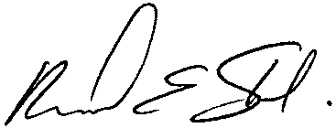  Rick Shabi  President

Next Weekly Update Scheduled for April 20
Due to the timing of the Days of Unleavened Bread, the next edition of the Home Office Weekly Update will likely be on Thursday, April 20. It is possible that an issue may be released on April 13 if there are timely announcements that need to be distributed.

FINAL WEEK—Six Steps to Passover: Part 6
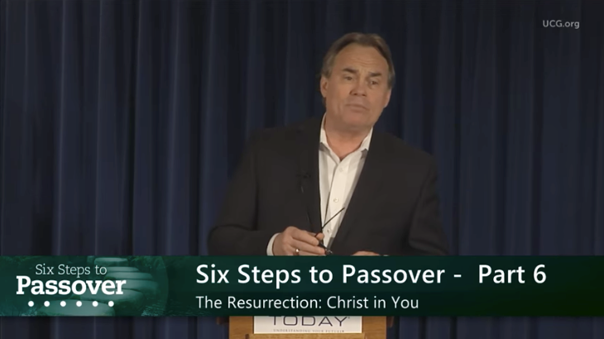
We encourage everyone to continue this opportunity to deepen our understanding of God, and gain insight as we approach the Passover season together. This week’s FINAL study is titled: “Six Steps to Passover – Part 6: The Resurrection—Christ in You” by Darris McNeely.
ucg.org/beyond-today/beyond-today-bible-study/six-steps-to-passover-part-6-the-resurrection-christ-in-you
—Peter Eddington, Operation Manager, Media and Communications Services

Greetings from Italy

The congregation gathered in Milan, Italy.
The whole Italian Church sends the warmest and loving greetings to you and the whole United Church of God overseas, with hope and expectation of that day when His people will be gathered together without distance.
—Angelo di Vita

Beyond Today Article on Transhumanism Gets Publicity
An article posted on our website on January 12 about transhumanism, written by Becky Sweat, is getting some very good publicity. Becky’s article is titled: “Transhumanism: What It Is, and Why It Is So Fundamentally Wrong” found at ucg.org/beyond-today/blogs/transhumanism-what-it-is-and-why-it-is-so-fundamentally-wrong.
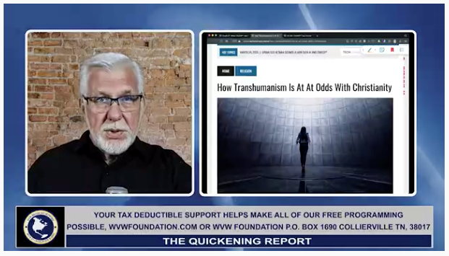
Podcaster Patrick Wood referencing one of our Beyond Today articles.
A popular podcaster, Patrick Wood, covered our article in depth this past Monday afternoon. His topic was, “Transhumanism and Christianity Can Never Be Reconciled.” Shortly into the podcast he mentioned “an article by Becky Sweat on the Beyond Today website." He went through the entire article on his podcast, quoting a lot from it.
You can listen to Mr. Wood’s podcast at worldviewweekend.com/tv/video/transhumanism-and-christianity-can-never-be-reconciled.
Patrick Wood has written at least one book on transhumanism, and is very well-informed on this topic. He even agreed with the last section of Becky’s article that we added late in the editing process. He said that he, too, didn’t think transhumanism could ever really come to fruition. When you do Internet searches on transhumanism, you don’t always get a lot of information along the line that transhumanism is unlikely to happen. Our search engine optimization (SEO) worked very well in this case!
Patrick Wood also reposted the article on his own website at technocracy.news/how-transhumanism-is-at-at-odds-with-christianity with a link back to UCG.org.
—Peter Eddington, Operation Manager, Media and Communications Services

Upcoming Events
April 4 | Passover Evening
April 5 | Night to be Much Observed
April 6 | First Day of Unleavened Bread
April 7–9 | Milwaukee Prom & Family Weekend | Milwaukee, WI
April 8–9 | Southeast Regional Formal Weekend | Atlanta, GA
April 12 | Last Day of Unleavened Bread
April 13 | Festival Planning Brochure Posted Online
April 21–23 | Women’s Enrichment Weekend | Indianapolis, IN
April 30 | Festival Housing Reservations Begin
May 4 | Second Passover Evening
May 6–8 | GCE Annual Meeting | Cincinnati, OH
May 22–26 | ABC Continuing Education | Milford, OH
May 26–28 | Brown County Pentecost Weekend | Nashville, IN
May 28 | Pentecost
May 29–June 2 | Camp Florida | Umatilla, FL
June 4–7 | Camp Gilmont | Gilmer, TX
June 18–21 | Camp Colorado | Allenspark, CO
June 18–25 | Camp Cotubic | Bellefontaine, OH
July 2–9 | Camp Pinecrest | Fredericktown, MO
July 7–9 | Colorado Women’s Enrichment Weekend | Allenspark, CO

Upcoming activities may be sent to weekly_update@ucg.org. Additional calendar information is available on the members website.

