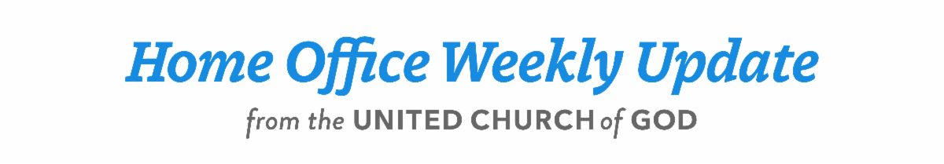

March 28, 2024



WATCH: Biblical Worldview Videos
The Church has launched a new video series titled A Biblical Worldview, presented by Rick Shabi, released each week. These 10-minute videos are the Church’s response to what is going on in the world, with the aim to reach the world (outside our membership) and preach a warning message, a message of repentance and a message of the gospel of the Kingdom of God to the nations.
The first eight episodes are titled:
- A Biblical Worldview: What Vivek Said Was Right
- A Biblical Worldview: Tucker Said He Didn’t Know Why—Understanding the Decline of English-Speaking Nations
- A Biblical Worldview: Where Is the West and the United States in the Coming New World Order?
- A Biblical Worldview: “He Gets Us”—Do You Get Him?
- A Biblical Worldview: Can There Be a Gaza Ceasefire?
- A Biblical Worldview: Why Hamas Attacked Israel
- A Biblical Worldview: Christ Gave Only One Sign That He Is the Messiah
- A Biblical Worldview: The Crucifixion Was Not on Friday
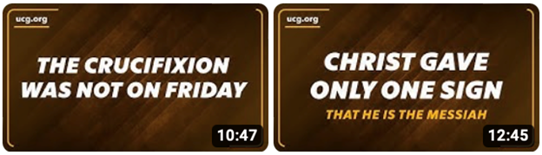

Important this week: debunking traditional Easter beliefs
As you will see from the listing above, the latest two videos have a strong message about the false Easter holiday weekend. Mr. Shabi explains the truth about Easter, which is an important message of the Church crying aloud—on this and other issues.
You can watch these videos on our website at ucg.org/beyond-today/beyond-today-daily and from our YouTube channel at youtube.com/user/BeyondTodayTV.
You can also view these videos on the Beyond Today app on Google Play for Android devices, Roku, Amazon Fire TV, Samsung smart TVs, LG smart TVs, and Apple iOS devices.
—Peter Eddington, Operation Manager, Media and Communications Services

2024 Festival Planning Brochure
The 2024 Festival Planning Brochure will be posted online at 12 p.m. EDT, Sunday, March 31. It should start arriving at members’ homes the second week of April. Please read the instructions before making housing reservations. There will be two phases of online registration this year—which won’t begin until after Passover. The first phase is for members who must attend their closest site and the second phase is for general membership. See details in the Festival Planning Brochure. If you have Feast-related questions, you can write to Festival@ucg.org.

Feast of Tabernacles, Montego Bay, Jamaica
This year, registration for the Montego Bay, Jamaica, Feast site will open Sunday, March 31, at 12 p.m. CDT. It will once again be at the all-inclusive Iberostar Beach Resort where services are also held. Please visit feast.ucg.org and select Montego Bay, Jamaica for more information and for the link to register.

Language and Literacy Center in Porto Novo, Benin
Your brothers and sisters in Porto Novo, Benin, are building a school focused on teaching French-language literacy to illiterate women and girls, and need help. French is the official language of Benin, but according to World Altas, Benin ranks in the top 10 most illiterate countries in the world alongside Somalia, South Sudan and Afghanistan. Currently 53 percent of Benin’s population cannot read and the rates for women and girls hovers at 60 percent. Studies show that literacy is a key determinant for poverty and life expectancy.
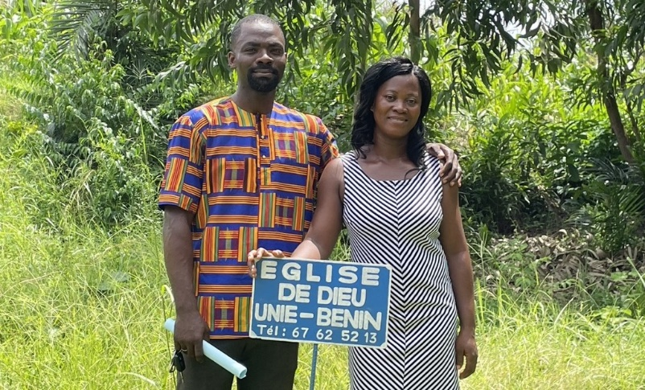
The Church in Benin has been blessed with two members who have advanced degrees, allowing them to teach. These members, along with the local elder and others in the Church, believe they can make a difference in the community and preach the gospel in a powerful way by running this language and literacy center. They have already purchased the land and received a donation to begin construction but are looking for additional help to finish the initial classrooms and office, to begin classes.
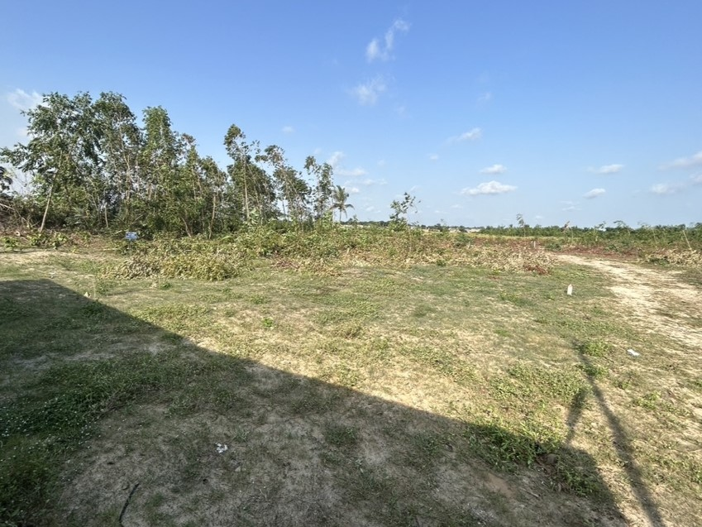
Land purchased for the school in Porto Novo.
Although French classes will be offered for free, English classes will also be offered on fee basis, which will not only help to empower those who study with greater opportunity for employment, but also financially support the school, helping to offset operating costs.
On Sabbaths and Holy Days, the facilities will be used by the Church. In addition, one office will be dedicated to the Church’s head office, consolidating our presence in the community.
United Church of God elder Pierre Ogoudélé shares this about the project: “We believe that by investing in education and providing this learning opportunity, we are actively contributing to the positive development of our community. Also, this facility, serving as our church headquarters, will allow us to begin to preach the gospel in a powerful way in our nation’s capital city as well our country’s largest city. We look forward to seeing this project take shape and sharing its benefits with all members of the Church.”
The Good Works project page is available here: ucg.org/members/service-projects/language-and-literacy-center-in-porto-novo-benin.

Dallas-Fort Worth Regional Weekend Report
Our Dallas-Fort Worth, Texas, congregations hosted a family regional weekend with the theme “Be Strong and Courageous,” March 8–10. Nearly 300 brethren from 18 different states, England and Canada gathered to deepen their connections, strengthen their faith and create memories together.
We kicked off the weekend with a scrumptious dessert social on Friday evening. On the Sabbath, fellowship hours for teens and young adults were offered as well as interactive preteen, teen and general Bible studies and a workshop for young adults related to the theme. Jeff Lockhart facilitated the general Bible study about drawing from biblical examples in order to encourage the next generation to not grow weary in doing well. Heidi Braun’s young adult workshop focused on recognizing the purpose of challenges in life and developing an action plan to overcome those difficulties, with God’s help. Matthew McDonald’s study urged teens to live courageously by choosing to do what is right, even in the most trying moments.
After lunch, David Jones’ sermon, “The Army of the Lord,” developed the concept of us as Christian soldiers and expounded on the important role that brethren of every age have as part of a greater body. Musical highlights included hymn accompaniment by a multigenerational instrumental ensemble and special music by teens and young adults from various states. Graduating seniors were honored in a slideshow presentation. Members also interacted more with all four speakers in a discussion panel after services.
“The Royal Ball”-themed prom was attended by 65 teens who enjoyed a catered dinner, a photo booth, and danced the night away. Meanwhile, young adults gathered for a special dinner, fellowship and games. The remaining brethren dined together and fellowshipped while preteens enjoyed activity stations and a movie. On Sunday, brethren gathered to fellowship and play volleyball, basketball and dodgeball.
We are thankful to God for the blessing of gathering together and hope to see you all next year!

Upcoming Events
Apr. 11–14 | Mammoth Cave Camping Weekend | Mammoth Cave NP, KY
Apr 21 | Passover Evening
Apr 22 | Night to be Much Observed
Apr 23 | First Day of Unleavened Bread
Apr 29 | Last Day of Unleavened Bread
May 2 | Festival Housing Reservations Begin
May 4–6 | GCE Annual Meeting | Cincinnati, OH
May 10–12 | Spokane Women’s Enrichment Weekend | Loon Lake, WA
May 21 | Second Passover Evening
May 24–27 | Smoky Mountain Young Adult Retreat | Townsend, TN
May 27–31 | Camp Florida | Umatilla, FL
Jun. 2–5 | Camp Gilmont | Gilmer, FL
Jun. 16 | Pentecost

Upcoming activities may be sent to weekly_update@ucg.org. Additional calendar information is available on the members’ website.

