
  
  March 2, 2023
  From the President...
  Greetings brethren,
  Here in Cincinnati it’s a slightly overcast day, but the temperatures have been quite pleasant for the past few weeks. Everything is “greening up,” and is coming back to life after the winter season. It’s an encouraging sight to see and provides a pleasant outlook for the day.
  One of my “rituals” each morning is to just look outside and appreciate the plants, foliage and wildlife in the area. As they emerge from winter dormancy and sluggishness, it’s refreshing to see energy and life “coming back” into nature.
  Wherever you live, whether you are coming into the spring season or autumn, we learn from each season of the year and how nature responds to it.
  God created such a magnificent earth for us to dwell on and to take care of. It is rich in variety of every imaginable thing. Think of the various species of animals that abound in your area, even in city dwellings. Squirrels inhabit the trees, rabbits nibble in the garden—and we observe cattle, birds of all types, long-haired and short-haired cats, and dogs of all shapes, sizes, colors and types of coat.
  Just look at the types, shapes and textures of trees, leaves and even grass—some to cover lawns, and some as ornamental, taller grasses. There are fruit trees, flowering trees, palm trees with their distinctive leaves and straight trunks, oaks, elms and so on. And so many types of flowers, all of different shapes, sizes and smells.
  God’s imagination and creativity is beyond our physical ability to fathom. We can just be grateful to be part of His creation and to have the senses to appreciate it and praise Him.
  The color of God’s creation
  As you look at the world around us, it is vibrant, beautiful and so inspiring when it is full of COLOR—the natural colors with which God adorned it. In the northern hemisphere we are coming into that season of color. South of the equator, you are nearing the end of that time when the autumn and winter seasons will emerge.
  It is no secret that at times in our lives we may feel discouraged, despondent or even depressed. Some suffer from these emotions more than others. During those times our world seems dark, dull, overcast. We find little to nothing that excites us, pleases us or makes us want to live. The color in our life is gone.
  Years ago we had the opportunity to visit the Czech Republic and Austria after observing the Feast in Germany. Austria is a beautiful country with mountains and landscapes that are literally “postcards” unto themselves. And the cities we visited—Salzburg, Vienna and others—had buildings and landscapes that were bright, adorned with color. They matched the environment and the whole area just made you feel glad to be alive.
  By contrast, in the Czech Republic and its capital, Prague, while the natural surroundings were beautiful, the old Communist buildings that marked its history were dull, colorless and unimaginative. I remember it made me think that the result of this evil government was an environment that would hold people back, dull their senses and make their lives dark and despairing. There was nothing in their surroundings that would bring them to life, energize them, or make them feel good.
  Dark, dingy surroundings and lack of color can sap our energy to do anything—even spiritual things.
  By contrast, we find COLOR all over the Bible and God’s environment. We have green grass, blue skies, brown tree trunks, every type of green (dark, regular, light) and other colored leaves; red, yellow, orange, blue, purple, white and other flowers; a golden sun, an amber moon and bright, sparkling stars at night.
  From time to time we stop and take notice of the sign God gave to man that He would never again flood the entire earth: a multi-colored rainbow—a sight to behold with its red, orange, yellow, green, blue, indigo and violet bands of color.
  When He instructed Moses on the details of building His temple, you find elements of creation—palm trees and pomegranates as part of the design. Curtains were blue. Ivory and other colors are mentioned as well as the types of wood to use, each in their variety of textures and colors. The priestly garments were colorful and decorated.
  Even God’s throne is marked with color. The Bible gives us glimpses of the amber, bronze, the color of fire and its vibrancy, lightning and its brightness—and the colors of the rainbow are associated with it (Ezekiel 1, for example).
  When the New Jerusalem descends from heaven, notice the construction of the walls as described in Revelation 21:16-21. All those precious stones, all glimmering, and all with their distinct color. God loves color, and He created us to love color and not darkness, dullness or dinginess.
  Put God’s color in your life
  Is your life colorless, dark, dingy with no excitement physically or spiritually?
  Follow God’s example. Get outside and see and appreciate God’s creation. Build light and color into your life. And learn to enjoy and appreciate the color and the variety of all of His creation, including your fellow brethren and the Bible—His very Word—that He has preserved and given us. That and prayer will ignite your zeal and put spiritual color and energy into your life.
  Don’t neglect God’s command to come into His presence, when you can, at His appointed times. Those times and your brethren build color into your life.
  Don’t neglect study of the Bible and prayer. If your study has become dull and colorless, consider joining or listening to some of the online Bible studies that go verse by verse through books of the Bible. Some have said they want to go “deeper” into study. Through the miracle of modern technology, those resources are available to you wherever you live in the world. You just need to seek them out and if properly received and prioritized, they will add color to your spiritual life, thought, meditation, prayer and appreciation of God and the calling He has given you. Revel and come to life in God’s presence and with His family, of which you are a very important part.
  Have a wonderful preparation day and Sabbath, brethren. You are all in our thoughts and prayers.
  In Christ’s service,
  
  Rick Shabi
  Six Steps to Passover: Part 2
  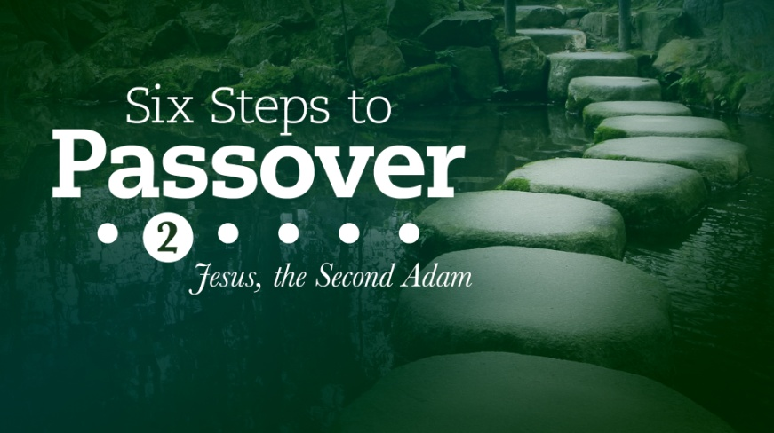
  We encourage everyone to continue this opportunity to deepen our understanding of God, and gain insight as we approach the Passover season together.
  This week’s study is titled “Six Steps to Passover—Part 2: Jesus, the Second Adam” by Gary Petty.
  ucg.org/beyond-today/beyond-today-bible-study/six-steps-to-passover-part-2-jesus-the-second-adam
  —Peter Eddington, Operation Manager, Media and Communications Services
  UPDATE: 19 Video Recordings Available of ABC Class, Acts of the Apostles
  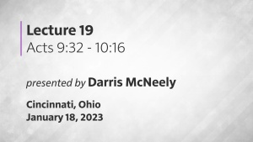
  A total of 19 video recordings of the Ambassador Bible College class, “Acts of the Apostles,” are now available to view at: https://www.ucg.org/ambassador-bible-college/acts-of-the-apostles-ambassador-bible-college. A new video will be released on Thursday of each week for the next 8 months.
  These recordings are available on our website, but also available on our UCG app on Roku and Amazon Fire TV. Navigate to the “sermon videos” line to view on these streaming devices.
  We pray this will be helpful tool in your ongoing study of God’s Word.
  —Rick Shabi and Peter Eddington
  Upcoming Events
  March 10–12 | Dallas/Fort Worth Regional Weekend | Plano, TX
  March 18 | SW Missouri Women’s Enrichment Event | Ozark, MO
  March 18–19 | Midwest Teen Prom | Berlin, OH
  March 19 | ABC Charity Auction | Milford, OH
  March 24–26 | Portland Women’s Enrichment Weekend | Canby, OR
  April 4 | Passover Evening
  April 6 | First Day of Unleavened Bread
  April 7–9 | Milwaukee Prom & Family Weekend | Milwaukee, WI
  April 8–9 | Southeast Regional Formal Weekend | Atlanta, GA
  April 12 | Last Day of Unleavened Bread
  April 13 | Festival Planning Brochure Posted Online
  April 21–23 | Women’s Enrichment Weekend | Indianapolis, IN
  April 30 | Festival Housing Reservations Begin
  May 4 | Second Passover Evening
  May 6–8 | GCE Annual Meeting | Cincinnati, OH
  May 22–26 | ABC Continuing Education | Milford, OH
  May 26–28 | Brown County Pentecost Weekend | Nashville, IN
  May 28 | Pentecost
  May 29–June 2 | Camp Florida | Umatilla, FL
  Upcoming activities may be sent to weekly_update@ucg.org. Additional calendar information is available on the members website.

