
  
  March 16, 2023
  From the President . . .
  Greetings brethren around the world,
  We live in a fast-changing world where you can never be sure what news you will wake up to each morning.
  Since March 8, three banks in the United States have failed, including the second and third largest bank failures in U.S. history. Depositors at Silicon Valley, Signature, and Silvergate banks have been advised that, despite FDIC insurance limits, all their deposits will be covered by the government.
  Internationally, we learned yesterday that a major European bank, Credit Suisse, is having significant financial difficulties, and its stock finished at the lowest price in its history, stoking fears of another collapse.
  While governments seek to calm investors, the “cracks” in the world economic system are beginning to be exposed and economic experts and financial company CEOs are expressing concern.
  On the diplomatic scene, for the first time in our lifetimes, it was announced that China has been actively involved in the Middle East, brokering a reconciliation between Saudi Arabia and Iran. This is quite a development, as the United States had been the active party in attempting to broker peace in the Middle East.
  What lies ahead in the Middle East with China actively involved? How will the relationship between Saudi Arabia and the United States, which has been tense in the last few years, be affected? Iran is a vocal and defiant enemy of the United States and Israel, and China is a chief rival of the United States, with a plan for world dominance.
  It was interesting to hear a news commentator comment about the regional impact this will have, and that it is as if we are beginning to see a union developing in the Middle East.
  Of course, we know what the Bible says about end time geopolitics: there will be a “King of the South” that will be a union of Middle Eastern states that the Bible specifically says includes Egypt, Libya, Ethiopia, Jordan (the modern-day Edom, Moab, and Ammon) and other countries (Daniel 11:40-43).
  And what about the relationship between Russia, China, North Korea and the nuclear powers of the East? Recently, there have been rumors of China indicating they will supply support to Russia in their conflict with Ukraine. That alliance seems to be deepening, even as North Korea has actively reinstated their nuclear aspirations. This burgeoning Eastern bloc, united against America, is reminiscent of “the news from the east” that troubles the King of the North, also noted as a factor in end-time geopolitics in Daniel 11:44.
  A changing political climate, talk of a World War 3, escalating economic problems and how the world banking system could be permanently changed all add up to a dismal future for the world and dramatic changes in the way all of us, all around the world, have lived our lives and been accustomed to.
  All those “cracks” in the current world order should remind us of an ominous warning God gave His people, the descendants of Israel:
  “Therefore thus says the Holy One of Israel: ‘Because you despise this word, and trust in oppression and perversity, and rely on them, therefore this iniquity shall be to you like a breach ready to fall, a bulge in a high wall, whose breaking comes suddenly, in an instant. And He shall break it like the breaking of the potter’s vessel, which is broken in pieces; He shall not spare. So there shall not be found among its fragments a shard to take fire from the hearth, or to take water from the cistern’” (Isaiah 30:12-14).
  Dire words.
  Brethren, we are now less than three weeks away from Passover and the Days of Unleavened Bread. Let’s honestly be examining ourselves from the Word of God, through the eyes of God and through His Spirit which dwells in us, and let’s be drawing closer to God with all our being.
  These can be harrowing times as we see the “handwriting on the wall” for this world, but there is comfort and assurance in God. Following those words in Isaiah 30, we see God’s admonition to us in Isaiah 30:15, a verse we read just last night in our online Isaiah Bible study:
  “For thus says the Lord GOD, the Holy One of Israel: ‘In returning and rest you shall be saved; in quietness and confidence [in God] shall be your strength.’”
  Brethren, let’s turn to God with all our hearts, minds and souls. Day by day, trust in Him more, turn to Him more, rely on Him more, live His word more carefully, earnestly and diligently.
  Our thoughts and prayers are with all of you. Have a wonderful rest of the week and inspiring Sabbath day.
  In Christ’s service,
  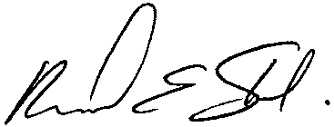
  Rick Shabi
  From Ministerial and Member Services . . .
  Recent Ordination
  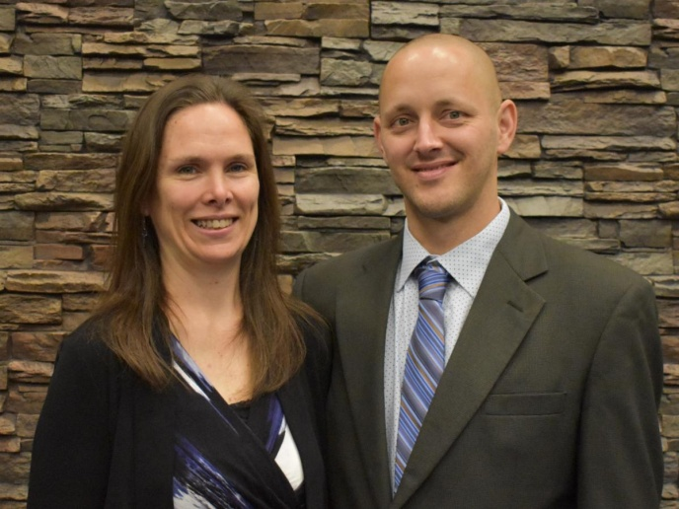
  Marcus and Lindsay Lucas
  On March 1, 2023, Marcus Lucas was ordained into the ministry. He serves as an assistant pastor in the Cincinnati, Ohio, congregations with his wife, Lindsay.
  Around the Home Office . . .
  There is always much to do in the home office, as all the departments—MMS, media, mail processing and administration—are actively involved with the many projects and issues that confront the Church daily and on an ongoing basis.
  This week there are two things we’d like to bring to your attention.
  Beyond Today Interview
  Many of you have seen the “Patterns of Evidence” films that have been produced over the years, which have delved into Bible accounts and “proved” the truth of those. Events such as the crossing of the Red Sea, the reality of the man Moses, and the plagues of Egypt have been discussed and proven.
  Timothy Mahoney is the producer of those films and he was in this week to do a Beyond Today interview with Darris McNeely. Mr. Mahoney’s latest film, which will be released in mid-May of this year, speaks to the possible location of Mount Sinai, where God gave the Ten Commandments.
  Through the use of Scripture, Mr. Mahoney and his team, over a period of 20 years, took every one of the biblical clues as to the location and what happened at Sinai, and has reached a conclusion about its location.
  What is notable in this and other archaeological studies, is that they consistently verify the validity and veracity of the Bible. In this end time, God is providing a witness that His Word is true and it stands. Mr. Mahoney’s response to a question from Mr. McNeely during the interview was very inspiring:
  In response to the question “What do you want to achieve through these films?” Mr. Mahoney’s response was simple, but so revealing: “To prove that God’s Word is true.”
  Watch for the BT interview to be released at ucg.org sometime in May.
  Development of a 30-second TV Ad
  On May 6, 2023, the world will be focused on the coronation ceremony of King Charles III, who will be officially installed as the king of the United Kingdom. The throne, crown and scepter will be given to him and he will be anointed as king with an oil compounded from Jerusalem.
  The world will be fascinated by this “once in a lifetime” occurrence and a worldwide audience is expected for this significant event.
  A series of five Beyond Today television programs have been developed and presented by Darris McNeely pertaining to the throne of England, its scriptural significance, the identity of modern-day Israel and the blessings God promised to Joseph in Genesis 49. Those programs will be aired and made available on Roku, at ucg.org, and on the Beyond Today YouTube channel, beginning the last week of April.
  Because the world will be so focused, we are developing a 30-second TV ad which highlights this series of programs and draws attention to ucg.org and the significance of that throne in England. These ads will air on major television networks around the nation, as well as on Google, Facebook, YouTube and other outlets for three or four weeks while the series is running.
  May we ask for your prayers for God’s guidance on the development of those ads and their placement, that they may provide a witness to the world and open the door for us to proclaim the return of Jesus Christ and the gospel of the Kingdom to the whole world, in a more direct and powerful way in the years ahead? Please join us in asking that God’s will be done and, as we do, that He will bless these efforts, if indeed it is His will.
  Six Steps to Passover: Part 4
  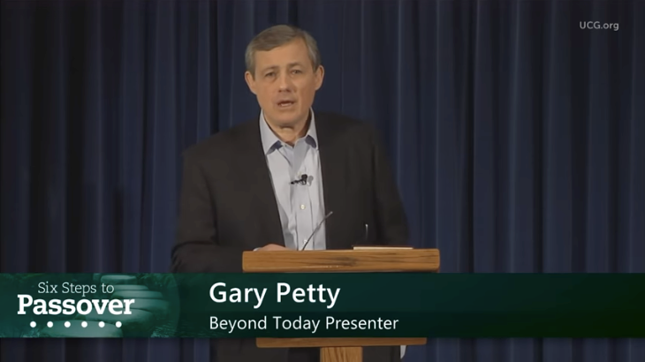
  We encourage everyone to continue this opportunity to deepen our understanding of God, and gain insight as we approach the Passover season together. This week’s study is titled: “Six Steps to Passover—Part 4: The Bread and the Wine” by Gary Petty.
  ucg.org/beyond-today/beyond-today-bible-study/six-steps-to-passover-part-4-the-bread-and-the-wine
  —Peter Eddington, Operation Manager, Media and Communications Services
  Cyclone Freddy Relief
  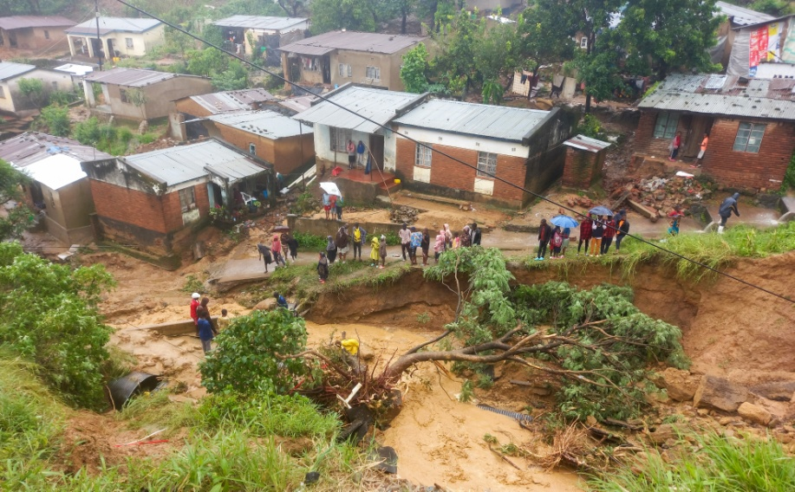
  In early February 2023, Cyclone Freddy developed off the north coast of Australia. Slowly making its way across the Indian Ocean, the storm initially made landfall in Madagascar on Feb. 21, 2023; it has been traversing back and forth across Malawi and Mozambique ever since, gaining strength as it traveled. In a country already plagued with power shortages, the infrastructure could not handle the added strain of downed powerlines and the entire Blantyre/Zomba region lost all power as of Saturday, March 11. As cellphone batteries drained and with no way to charge them, the ability to contact members has been paralyzed. As of March 15, an estimated 88,000 people in Malawi have been displaced from their homes as their houses have been washed away in floods and landslides; this number includes at least 10 families in United Church of God. Along with their homes, for many, their gardens and farms have been washed away, leaving families with nowhere to live and unable to feed themselves. This is truly a dire situation for the Malawian people.
  We are most grateful to God that it appears all of our members are safe in spite of the devastating losses they have incurred.
  A few have asked how they might be able to help support our brethren in Malawi who have been affected by Cyclone Freddy. The Good Works Program has started a fund to help raise money to aid brethren as we begin to assess what the needs might be: ucg.org/members/service-projects/cyclone-freddy-relief-2023.
  ABC Charity Auction
  The Ambassador Bible College students have been hard at work preparing for a very important annual event, and they are pleased to announce that the time has arrived! On March 19, 2023, beginning at 1 p.m. Eastern time, Ambassador Bible College is hosting its annual Charity Auction at the home office in Cincinnati. There will be lots of entertainment, refreshments, a baked goods auction and a silent auction.
  Everyone is invited for food, fun and fellowship. The Charity Auction will be webcast at: abc.ucg.org/webcast/abc-charity-fun-show.
  Ambassador Bible College and Good Works thank you in advance for your contributions.
  —Frank Dunkle, coordinator, Ambassador Bible College
  Caribbean Feast Registration
  Registration opened earlier this week for the Feast of Tabernacles in Trinidad & Tobago, on the island of Tobago: ucg.org/members/feast/sites/2023/stonehaven-bay-tobago.
  Registration for the site in St. Lucia is currently full, but names can be added to a wait list: ucg.org/members/feast/sites/2023/vieux-fort-st-lucia.
  —Chuck Smith, senior pastor, Caribbean
  
  Good News About the Angolan Situation
  The Angolan brethren of God’s Church have been in a very difficult situation in which they were instructed by the government-controlled religious authority not to meet any further because they were not an approved church by the Angolan government. Your prayers were requested in this issue.
  We are pleased to announce that God opened a door to solve this situation. A number of other smaller churches were in the same situation and these churches, which have contacts with the government, agreed to create an umbrella organization which was approved by the religious authority. This umbrella organization allows each church to be autonomous and to practice their beliefs freely. God’s Church in Angola is now authorized to meet and practice God’s Sabbaths and Holy Days. Thank you so much for your prayers on this matter.
  —Jorge de Campos, senior pastor, Portuguese-speaking areas
  Upcoming Events
  March 19 | ABC Charity Auction Webcast | Milford, OH
  March 24–26 | Portland Women’s Enrichment Weekend | Canby, OR
  March 25 | New York City Social | Queens, NY
  April 4 | Passover Evening
  April 6 | First Day of Unleavened Bread
  April 7–9 | Milwaukee Prom & Family Weekend | Milwaukee, WI
  April 8–9 | Southeast Regional Formal Weekend | Atlanta, GA
  April 12 | Last Day of Unleavened Bread
  April 13 | Festival Planning Brochure Posted Online
  April 21–23 | Women’s Enrichment Weekend | Indianapolis, IN
  April 30 | Festival Housing Reservations Begin
  May 4 | Second Passover Evening
  May 6–8 | GCE Annual Meeting | Cincinnati, OH
  May 22–26 | ABC Continuing Education | Milford, OH
  May 26–28 | Brown County Pentecost Weekend | Nashville, IN
  May 28 | Pentecost
  May 29–June 2 | Camp Florida | Umatilla, FL
  June 4–7 | Camp Gilmont | Gilmer, TX
  June 18–21 | Camp Colorado | Allenspark, CO
  June 18–25 | Camp Cotubic | Bellefontaine, OH
  Upcoming activities may be sent to weekly_update@ucg.org. Additional calendar information is available on the members website.

