
  
  June 8, 2023
  From the President . . .
  Greetings brethren,
  As I write this early on Thursday morning, I see a bright red sun rising in the east—a spectacular sight as the day begins and a reminder of the constancy and certainty of our God. He is our refuge, our strength, our shield, the One in whom we place our trust and to whom we always turn.
  While it is a sunny day here in Cincinnati, we know there are wildfires raging in the eastern part of Canada. The smoke emanating from those fires has resulted in air quality advisories in the northeast United States. Please keep your brethren in your prayers.
  International initiatives
  It has been, and will continue to be, a busy and productive week in the work of God. Today, Darris McNeely (International Education and Services Coordinator), and Ed Dowd (newly appointed International Senior Pastor for Zambia), are traveling to Zambia for two weeks to conduct training sessions with the leadership there, and to meet with the brethren. We don’t know exactly how many members we have in Zambia, but there are several hundred as God continues to call people there. I might also mention that Mr. McNeely will be in Johannesburg, South Africa, this Sabbath and Sunday before continuing on to Zambia.
  There have been other exciting developments on the international front. We have seen God’s mighty hand at work in Bangladesh. You remember in previous updates that the first baptisms in this country occurred earlier this year, when Manik Biswas and his wife travelled to India and were baptized by International Senior Pastor, David Schreiber. They returned to Bangladesh, spoke of the truth, and soon there was a Bible study group of 16 people meeting in their home! Some had given up their livelihoods in order to keep the Sabbath as they learned of God’s way. Shortly after that the local authorities approached Manik and said they needed to be registered in order to have religious meetings.
  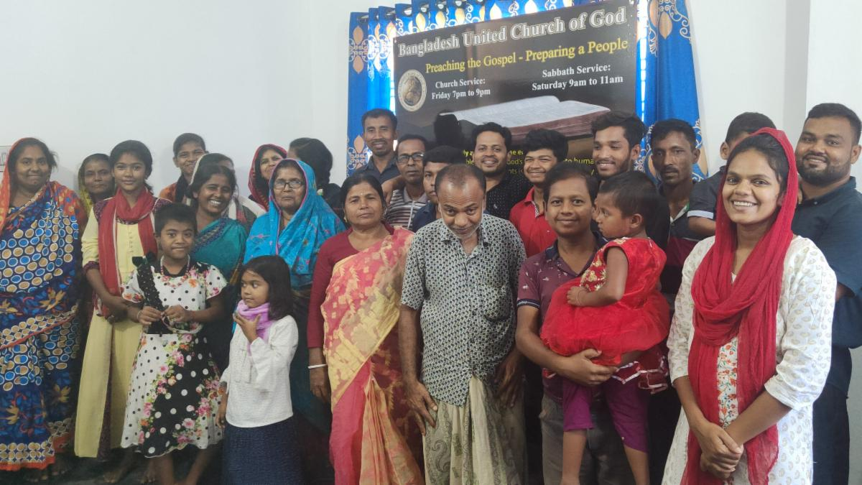
  Meeting of the United Church of God in Bangladesh on Pentecost.
  We are happy to say the registration in Bangladesh is complete! Working with local authorities there, Manik navigated the challenges, including the purchase of a small piece of land for the Church, which is a requirement in that country. With the prompt completion of the registration and purchase of that land, there is no doubt in anyone’s mind that God directed this whole process and opened doors that no man could have.
  As a result, we have a local church that can now meet every Sabbath for services and “legal” Bible studies. Our thanks for Manik and David Schreiber and their efforts in this, but most of all to God who opens doors and directs our path. We look forward to how God will build His Church in that area and request your prayers for our brethren and work in Bangladesh.
  This Sabbath and Sunday, the annual Canadian ministerial conference will be held in Toronto, Ontario, Canada. My wife, Deborah, and I, along with Aaron and Michelle Dean, will be heading to Toronto for Sabbath services and the following conference. We are very much looking forward to meeting the ministry and members in Canada.
  Home office initiatives
  Here at the home office, this past Tuesday we had a very good all-day meeting with the media staff responsible for our Beyond Today products. We are blessed with a dedicated, smart, committed and talented staff who have a lot of promising ideas on how we can more effectively get the message of hope and the Kingdom of God out to the world. Along with the directives in our Operation Plan, that includes developing a strategy utilizing various communication resources and messaging to strongly proclaim the gospel message, several other areas were discussed that we plan to work toward introducing in the months ahead.
  Never out of our minds is the fact that this is God’s Work and that Jesus Christ is the Head of His Church. We continually look for His guidance and daily direction in every aspect of the Work. Christ is “the way, the truth, and the life,” and He is continually growing and developing us individually and collectively into who He wants us to be. He knows the answers and He knows exactly what needs to be done in His Work to accomplish the commission He gave us. We just need to sincerely seek Him and follow Him.
  It's also reassuring to remember that He knows exactly what you and I need in our personal lives to complete the work He is doing in us to prepare us for His Kingdom. At times that growth may come through trials or tests, and sometimes even correction, but it is always from God as we strive to become like Christ. Let’s continually yield to Him and seek His will. He promises to never fail any of us.
  So, brethren, please pray for each other and please ask God to continually guide and direct all of us in His Work. Our prayers are with all of you, around the world.
  Have a productive day of preparation and a rewarding and inspiring Sabbath.
  In Christ’s service,
  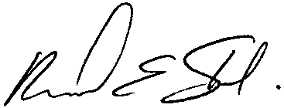
  Rick Shabi
  From Ministerial and Member Services . . .
  Upcoming Ministerial Transfer
  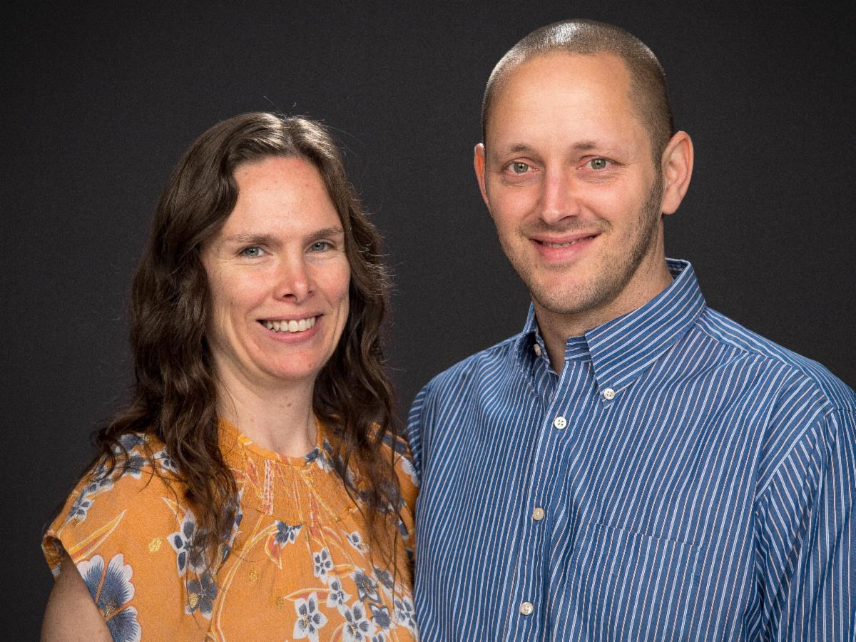
  Marcus and Lindsay Lucas
  Marcus Lucas, his wife Lindsay, and their children, Téa and Elisha, will be transferring from the Cincinnati area to Rome, Georgia. Mr. Lucas will work with pastor Rick Beam and serve as associate pastor to the Rome (Georgia), Gadsden (Alabama) and Chattanooga (Tennessee) congregations. We wish them well in this new assignment!
  Northwest Young Adult Weekend
  Please join the Seattle young adults in Cle Elum, Washington, Aug. 11–13, for a weekend of fellowship, discussions and seminars on the theme “A Heart of Remembrance.” We anticipate a weekend of building community with each other and building a heart more pleasing to God. Please sign up at tiny.cc/SeattleYA23 by Friday, July 15. Cost info can be found at the signup link. For questions, please email Rachel Keirouz at Rachel.keirouz@gmail.com.
  UNMASKED: Second Beyond Today TV Series Airing May 28–Jun 24
  The second of our new, five-part Beyond Today video series is now airing—this one by Steve Myers.
  Mr. Myers’ series is titled, “Unmasked.” It reveals the insidious and far-reaching influence of Satan the devil. Watch to learn how to guard against his attacks on society, your family and your very identity as a future child of God. You can watch the entire second series at ucg.org/beyond-today/beyond-today-television-program/unmasked-satans-work-in-our-world-beyond-today-series.
  In addition, a comprehensive 30-second advertising campaign is underway to promote this five-part series on broadcast television. We are advertising on The WORD Network and the following 18 broadcast TV stations in these cities:
  - MyNetwork Ft. Smith-Fayetteville, Arkansas
  - CW Network Huntsville-Decatur, Alabama
  - ABC Springfield-Decatur-Champaign, Illinois
  - ABC St. Louis, Missouri
  - CW Network Minneapolis-St. Paul, Minnesota
  - CW Network Grand Rapids-Kalamazoo, Michigan
  - CW Network Milwaukee, Wisconsin
  - MyNetwork Birmingham, Alabama
  - MyNetwork Harrisburg, Pennsylvania
  - MyNetwork Chattanooga, Tennessee
  - MyNetwork Corpus Christi, Texas
  - MyNetwork Omaha, Nebraska
  - MyNetwork Wichita-Hutchinson, Kansas
  - MyNetwork Wilkes Barre, Pennsylvania
  - MyNetwork Greensboro-Winston-Salem, North Carolina
  - MyNetwork Cincinnati, Ohio
  - MyNetwork Dayton, Ohio
  - MyNetwork Indianapolis, Indiana
  We are also advertising the series on YouTube, Google and Roku.
  The third series is titled “The Unknown Jesus” and begins July 2 and will be presented by Gary Petty.
  Please pray for the success of these series and the corresponding advertising campaigns that are designed to draw people to the Beyond Today television program, our ucg.org website and the global work of the United Church of God, an International Association.
  —Peter Eddington, Operation Manager, Media and Communications Services
  Job Opening: Receptionist
  The United Church of God has announced an opening for a Receptionist.
  The Receptionist is present and opens the home office lobby door on time each morning and secures the lock at the end of each workday. He or she answers multiple incoming business telephone lines, directs caller to destination or fulfills caller’s request while on line. The incumbent greets office visitors in lobby and directs to appropriate personnel and acts as first line of security for the home office.
  The Receptionist provides clerical support for Media and Communications Services and also takes literature requests, address changes, subscription renewals, subscription cancellations and tithe envelope requests and processes them through subscriber database while online with caller. In addition, he or she sorts incoming postal mail, processes mail returns and opens them for reuse.
  A college degree or equivalent and two years related experience and training in computer skills, editorial and office duties is required. Experience working with the general public in a professional manner is essential.
  Potential employees must be baptized members (in good standing) of the United Church of God. Applicants must be biblically literate and possess a thorough working knowledge of the doctrines, beliefs and practices of the United Church of God.
  To request a job application or for questions about the position, please contact human_resources@ucg.org.
  Upcoming Events
  June 18–21 | Camp Colorado | Allenspark, CO
  June 18–25 | Camp Cotubic | Bellefontaine, OH
  July 2–9 | Camp Pinecrest | Fredericktown, MO
  July 7–9 | Colorado Women’s Enrichment Weekend | Allenspark, CO
  July 7–9 | West Michigan Camping Weekend | White Cloud, MI
  July 9–12 | Camp Ironwood | Stewartville, MN
  July 9–12 | Camp Ochoco | Prineville, OR
  July 9–16 | Southwest Camp | Prescott, AZ
  July 9–16 | Boundary Waters Adventure | Voyageurs NP, MN
  July 21–28 | Camp Woodland | Temple, GA
  July 23–30 | Northwest Camp | Rockaway Beach, OR
  July 30–Aug. 2 | Camp Buckeye | Orrville, OH
  July 30–Aug. 2 | Camp Seven Mountains | Spring Mills, PA
  Aug 11–13 | Northwest Young Adult Weekend | Cle Elum, WA
  Sept. 10 | Gear Grinder Classic Bike Ride | Two Harbors, MN
  Upcoming activities may be sent to weekly_update@ucg.org. Additional calendar information is available on the members’ website.

