
  
  June 6, 2024
  Northwest Region Pastoral Conference
  A pastoral conference for the Northwest region was held from Sunday, June 2 through Tuesday, June 4, and continued the overall theme of “speaking the same thing” taken from 1 Corinthians 1:10. “Now I plead with you, brethren, by the name of our Lord Jesus Christ, that you all speak the same thing, and that there be no divisions among you, but that you be perfectly joined together in the same mind and in the same judgment.”
  This was the last U.S. pastoral conference of this round, finishing up meetings in all six regions in just eight months. The conference was attended by 32 elders and wives, meeting at the Canby Grove Retreat Center near Portland, Oregon.
  The sessions of the conference revolved around critical responsibilities within the Church: being first a dedicated disciple, recognizing the accountability of elders, and how to be a “pastor for the vision.” These topics were explored in depth through presentations, lectures and engaging discussions.
  President Rick Shabi set the stage, beginning with a powerful message on the essence of being a disciple. He highlighted the ministry’s first responsibility to be a disciple of Christ, called to preach, teach and live by God’s Truth, upholding the “faith once delivered” (Jude 3).
  The next presentation focused on the importance of accountability and integrity among pastors. Steve Myers emphasized the instructions given in 1 Peter 5 and elders’ responsibility to shepherd, oversee and lead God’s people by example. He underscored the cost and commitment required to fulfill the God-given duties of the ministry and the need to be ready to lead and guide the brethren even through fiery trials (1 Peter 4:12).
  The visionary role of pastors was emphasized in Darris McNeely’s lecture, centering on the importance of our goal to fulfill the vision statement of the United Church of God taken from Ephesians 4 and Hebrews 2:10. He encouraged all to strive to come to the “unity of the Spirit” and the “unity of the faith” as we fulfill the admonition to equip and edify the people of God (Ephesians 4:3; 4:13). He highlighted the necessity of vision for the direction and vitality of the Church.
  Regional Pastor Steve Nutzman gave a presentation that stressed the scriptural importance of a pastor’s role in serving God and His elect. His topic: “A Good Shepherd Should” related many biblical passages, highlighting the practical application of God’s instruction to the ministry.
  The conference also featured numerous opportunities for open discussion. Pastors and wives discussed common challenges, protecting the flock of God, true doctrine, ethics, Church policy, and various aspects of pastoral responsibilities. These sessions emphasized pastoral duties and the importance of care, guidance, love, practical application and maintaining unity.
  The connections that were built and the camaraderie between the pastors and wives was a highpoint of the conference. One attendee mentioned that “the conference gave me direction, a spiritual boost and encouraged me greatly.” Others cited a renewed sense of unity and purpose. Certainly, the ministry has been given a call to action—to implement God’s teachings, principles and vision for His Church as we serve God and His flock.
  —Steve Myers, Operation Manager, Ministerial and Member Services
  Report from Camp Florida
  Camp Florida just completed its fourth year and kicked off the UYC Camp season. Camp Florida was held once again at the beautiful Florida Elks youth camp just outside of Orlando, Florida. It ran from May 27–31; we had 63 preteen campers along with 55 adults, 31 teen staff and nine mini campers. This was the largest camp we have had so far. It was a truly inspiring week as we were once again able to get into the Zone and enjoy a week away from the outside world.
  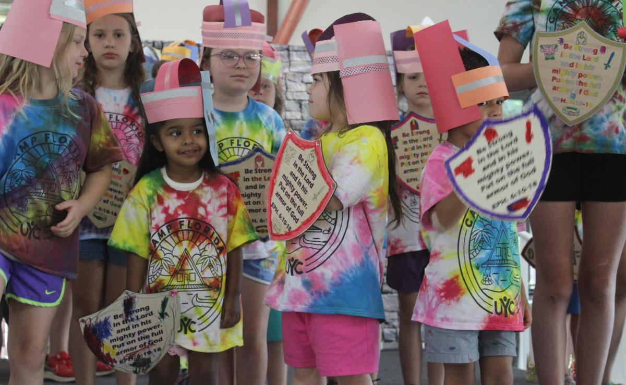
  Our camp saw God’s blessings every day with good weather and His protection. The week was full of fun, while providing our campers an environment to learn about God’s way of life, which leaves a lasting impact on the campers. This year’s theme, “Stand Strong,” gave an opportunity for our campers to learn that God has given us all the protection we need for spiritual battle as we taught them to “put on the whole armor of God” so that they “may be able to stand against the wiles of the devil” (Ephesians 6:11).
  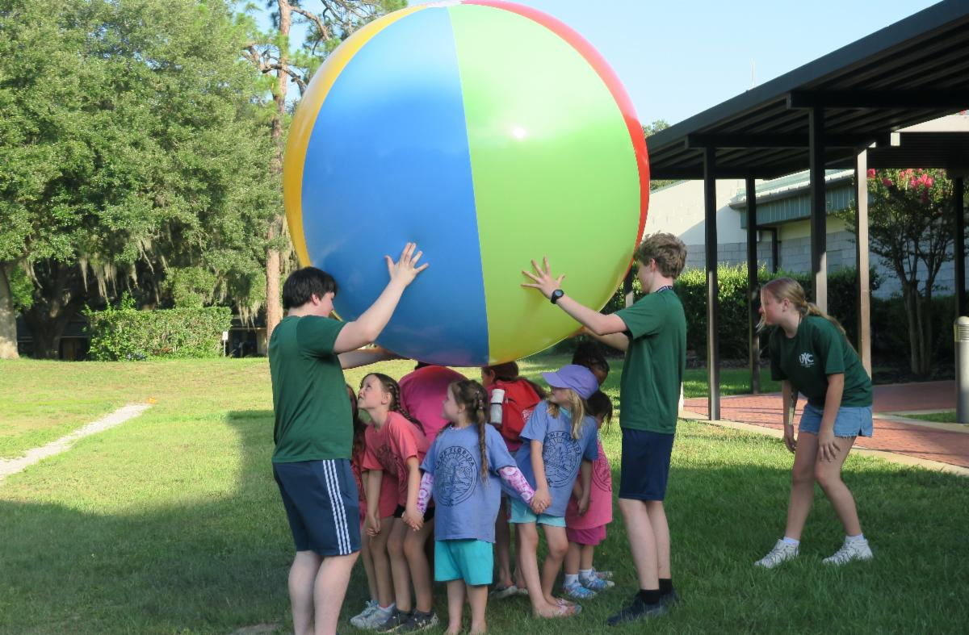
  Each day started out with Christian Living, ended with an evening Compass Check and nightly dorm parent time. All campers participated in lots of fun activities like swimming, canoeing, sports, dance, archery, water games, woodcraft, and arts and crafts. New this year was a bounce house and a team-building activity where all the dorms were challenged to use simple objects like dominos, marbles and ping pong balls to complete the simple task.
  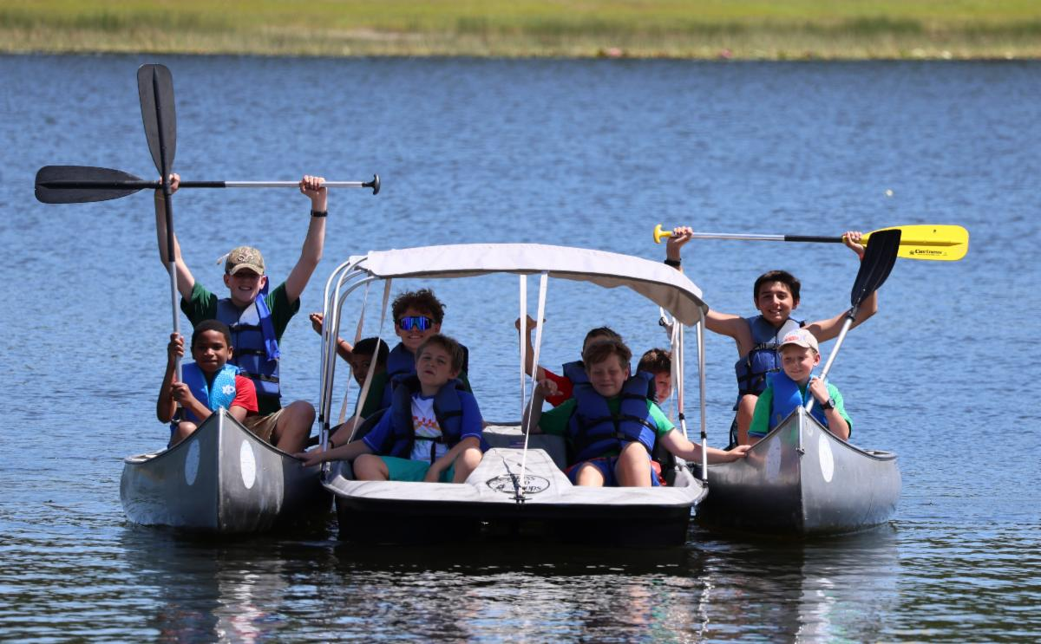
  The campers’ favorite activities were tie dye shirts, gaga ball, big swing and our campfire program which consisted of yummy s’mores, corn on the cob and a fun singalong with “Fred the Moose.” Our camp ended with a camp-wide wooden car derby race where each camper raced the cars they built in woodcraft. A highlight was a special service project to clean about 600 plastic portable lockers for the facility’s upcoming summer camp program.
  Camp has led to close friendships for our campers and staff that will last well after camp is over. It was another great year, and we are looking forward to camp in 2025!
  —Bert and Tricia Merring
  Upcoming Events
  Jun. 16 | Pentecost
  Jun. 21–23 | Troyer’s Hollow Campout | Charm, OH
  Jun. 23–26 | Camp Colorado | Allenspark, CO
  Jun. 23–30 | Camp Cotubic | Bellefontaine, OH
  Jun. 28–Jul. 1 | West Michigan Camping/Tubing Weekend | White Cloud, MI
  Jun. 30–Jul. 7 | Camp Pinecrest | Fredericktown, MO
  Jul. 7–14 | Southwest Camp | Prescott, AZ
  Jul. 14–17 | Camp Ironwood | Stewartville, MN
  Jul. 14–17 | Camp Ochoco | Prineville, OR
  Jul. 19–26 | Camp Woodland | Temple, GA
  Jul. 21–28 | Northwest Camp | Rockaway Beach, OR
  Jul. 28–31 | Camp Buckeye | Delaware, OH
  Jul. 28–31 | Camp Seven Mountains | Spring Mills, PA
  Jul. 31–Aug. 6 | Challenger Sierra | Emigrant Wilderness, CA
  Upcoming activities may be sent to weekly_update@ucg.org. Additional calendar information is available on the members’ website.

