
  
  June 29, 2023
  From the President . . .
  Greetings brethren around the world,
  Here in the northern hemisphere, summer is in full swing. This is the growing time of year when fruit forms and ripens, flowers are in full bloom and the earth is vibrant and alive. It’s a wonderful time, especially when we compare the seasons of the year to our spiritual development.
  Between Pentecost and the fall Holy Days we have the summer—the growing season. God has given His called-out ones this time to spiritually mature and ripen, growing constantly in the grace and knowledge of Christ—growing into who He wants us to become.
  As part of the hope we have in the promise of Christ’s return and the establishment of His righteous government on this earth, we too need to be in growth mode during this time—so we are ready and prepared for the roles God has called us to fulfill now and in the future, into eternity.
  He is able, just and apt to bring us to that perfection as we focus on our calling, allowing His Spirit to change our hearts, minds and souls.
  Tacoma men’s retreat
  Last weekend I had the pleasure and privilege of being at a men’s retreat hosted by the Tacoma and Olympia, Washington, congregations. The event was attended by 37 men from 11 different congregations in the northwestern United States. Included in the group were the elderly, young adults, pastors, elders, deacons and members who voluntarily gave up their weekend to learn about “Becoming Men of God.”
  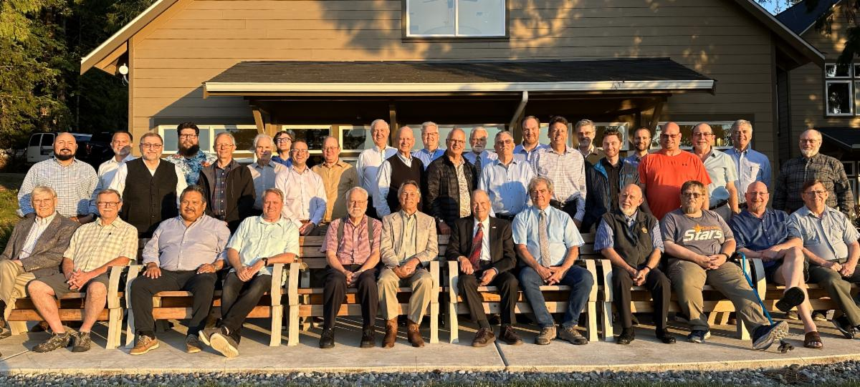
  Participants at the Tacoma men’s retreat.
  It was a very worthwhile conference and my thanks go to Roc Corbett, pastor of the Tacoma and Olympia churches, and his team who so very well coordinated the entire event. A variety of speakers prepared presentations on the various aspects of being a man of God. It was an event that challenged us all to look at ourselves from the perspective of God’s Word—a real “iron sharpening iron” experience—while giving us all us all the opportunity to get to know each other better.
  In a world that is challenging the identity of the genders God created—male and female—it is necessary for us to review God’s direction in the roles He created men and women to fulfill and learn in this lifetime—all in preparation for the eternal lives and roles He wants to give us.
  May we all be growing closer to God and looking into His Word for the direction He gives.
  Have a meaningful and productive day of preparation tomorrow and inspiring Sabbath, everyone.
  In Christ’s service,
  
  Rick Shabi
  Report From Camp Colorado
  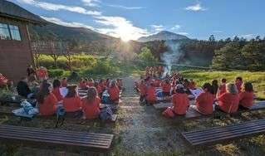
  Camp Colorado 2023 was a complete success! We had nearly 50 campers and over 50 staff members who gathered together in Allenspark, Colorado. Campers ages 5–12 spent their time learning about the incredible invitation they have been offered to the race for their crown. Each day began and ended with learning about their special calling and how to prepare for their race, in morning compass checks and evening Christian living sessions.
  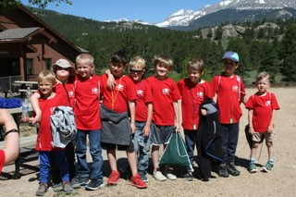
  Throughout the day, campers enjoyed activities such as ax throwing, field games, gaga ball, arts and crafts, hiking and dance class and, in the evening, they gathered around the campfire to sing, learn about God and roast marshmallows. Campers and teen staff took part in a youth choir and performed to those gathered on the last day of camp. We even had our first “mini dorm” run by the “mini mamas” or the “M & M’s” as we came to call them. Our youngest members, ages 2–4, were able to rejoice and take part in each day’s activities.
  Our camp was abundantly blessed by God. We are already looking forward to and planning for Camp Colorado 2024. We hope to see you and your campers there with us.
  —David and Joy Jones
  Columbus Young Adult Weekend
  Join us in Columbus from Aug. 25–27 for a weekend with the theme “Becoming Men and Women of God.”
  To register, visit forms.gle/dCR4c1Jdeb1rYEtXA. If you have questions about registration, contact Max Heine at (801) 448-9729 or e.max.heine@gmail.com. The cost for this weekend is $20. Please pay with Venmo before you arrive; send Venmo payments to Julie Berg: @Julie-Berg18.
  Details about hotel accommodations will be provided as soon as they are available. For other questions, reach out to Sophie Hand (614-254-2879 or sophiasnake@gmail.com) or Micah Gunn (614-633-8179 or abcdefgunn@gmail.com).
  Winter Family Weekend - New Location!
  Although we’ve just entered summer, plans for Winter Family Weekend have begun! WFW this year will be held at a new facility—Champion Mill Conference Center in Hamilton, Ohio. Everything is conveniently all at one location.
  We’ll stay at the new Warehouse Hotel at Champion Mill and use the brand-new huge sports facility featuring 14 beautiful hardwood courts and 14 sport courts.
  You won’t want to miss this unique opportunity to gather together for Sabbath services, seminars, sports, dances and activities for all ages.
  Plan now to attend Winter Family Weekend. It will begin Friday evening, Dec. 22, and end Tuesday, Dec. 26, 2023.
  Watch for further updates on wfw.ucg.org and a special video preview!
  Job Opening: Video Editor
  The United Church of God has announced an opening for a video editor. The position will be responsible for editing internal video projects including:
  - Educational videos.
  - Special project videos.
  - Ambassador Bible College videos
  - Ministerial training videos.
  - Sermon videos.
  - Camera operation for Beyond Today television.
  - Plus, any other projects assigned by supervisor.
  Working closely with a team in a creative environment is essential. Knowledge of video editing software (Adobe Premier Pro, Apple Final Cut or Avid Media Composer) is required, and competency using photo editing software (Photoshop) and animation software (Adobe After Effects) is a plus, along with storytelling skills and an eye for detail.
  An associate’s degree and one to two years’ direct related experience is preferred, with training in communication. An equivalent combination of education and experience may be considered. Strong language, logic and communication skills, and algebra/geometry level math skills are required. Those applying for consideration and invited for an interview must supply a portfolio of their work.
  Potential employees must be baptized members (in good standing) of the United Church of God. Applicants must be biblically literate and possess a thorough working knowledge of the doctrines, beliefs and practices of the United Church of God.
  To request a job application or for questions about the position, please contact human_resources@ucg.org.
  Job Opportunities
  The United Church of God is still seeking a Video Editor and Receptionist. Details about all of the current job postings for the Church may be reviewed at ucg.org/members/news/current-job-openings.
  Upcoming Events
  July 2–9 | Camp Pinecrest | Fredericktown, MO
  July 7–9 | Colorado Women’s Enrichment Weekend | Allenspark, CO
  July 7–9 | West Michigan Camping Weekend | White Cloud, MI
  July 9–12 | Camp Ironwood | Stewartville, MN
  July 9–12 | Camp Ochoco | Prineville, OR
  July 9–16 | Southwest Camp | Prescott, AZ
  July 9–16 | Boundary Waters Adventure | Voyageurs NP, MN
  July 21–28 | Camp Woodland | Temple, GA
  July 23–30 | Northwest Camp | Rockaway Beach, OR
  July 30–Aug. 2 | Camp Buckeye | Orrville, OH
  July 30–Aug. 2 | Camp Seven Mountains | Spring Mills, PA
  Aug. 11–13 | Northwest Young Adult Weekend | Cle Elum, WA
  Aug. 25–27 | Columbus Young Adult Weekend | Columbus, OH
  Sept. 10 | Gear Grinder Classic Bike Ride | Two Harbors, MN
  Sept. 16 | Feast of Trumpets
  Sept. 25 | Day of Atonement
  Upcoming activities may be sent to weekly_update@ucg.org. Additional calendar information is available on the members’ website.

