
  
  June 27, 2024
  Our Amazing and Awesome God
  Greetings brethren around the world,
  Thursday morning (Australia time) we arrived in Brisbane, Queensland, where we will be at Sabbath services this week. Then the Australian pastors’ conference begins next week. Darris McNeely, Steve Myers and our wives are here with us as we begin this round of international conferences that will take the three of us from here to various other areas of the southern hemisphere over the next several weeks.
  All of us have thought many times in our lives that we live in an absolutely fascinating and beautiful world. Each continent and region has its unique beauty, vegetation and even animal life. God didn’t need to go to all this detail, but it is a lasting legacy of His love for mankind that He created this world with such a variety of everything, so we could enjoy and learn from it. Take the time to enjoy His creation and learn about what He created.
  It is an ongoing spiritual exercise and eye-opener when we learn lessons about ourselves and God when we study nature and see traits God would have us develop. We get to know Him better when we contemplate what He created. And we are told that God created all these things through Jesus Christ, our Savior. Even more reason to be thankful and eternally grateful to Him.
  As we were flying from America to Australia, I was looking at the flight map that showed the progress of our flight. We flew over Mexico, then a huge expanse of the Pacific Ocean. For who knows how many miles, there was nothing but water underneath us. No islands plotted on the flight map, just a large expanse of ocean.
  Here we were, flying over this vast area in just a matter of hours, because God gave humans the spirit of man and a marvelous brain, mind and determination to learn, research, explore, develop and take control over the physical realm. God gave man the dominion over this earth, and He gave mankind the tools, brain and body to do it.
  Centuries ago, when explorers left Europe to explore the vast reaches of the world, they had no idea what they would encounter. They faced months on the open sea, with uncertainty and perils as storms and the unknown confronted them. Many never reached their destinations, but those who succeeded did not find beautiful cities and the advantages of modern life—they had to build from scratch.
  Today people “run to and fro” and knowledge is increased (Daniel 12:4). What amazing talents, skills and potential God built into mankind—men and women—when He created us and put us on this beautiful planet earth!
  And mankind has accomplished magnificent things, like huge airplanes flying from city to city and over thousands of miles of ocean to get people from one place to another quickly. Developments like the Internet allow us to communicate with each other individually or in groups, all over the world, through computers. The cost is negligible, and it allows us to work together as family, becoming as one.
  While man can accomplish amazing things, all the credit goes to God. He is the reason we are here. He is the reason we can see the beauty of the earth and can learn, grow and continue to develop and improve ourselves all the days of our lives.
  He is the reason we have had the opportunity to meet many of you all over the world this year. He is the reason we are “family,” and He is the reason for the “incredible human potential” for all of mankind. The vast, vast majority of humanity does not understand the potential God has in mind for mankind—but you and I do. Never forget it.
  It is a busy world we live in, and if we are not careful, we let all the cares and “things” of this life use up our time. Be sure to take the time to contemplate God’s creation, love and attention to all of us. Meditate on His goodness and love and plan for you and all mankind. Contemplate the love He and Christ have, and the power of His Holy Spirit that He gives to those who love Him. We demonstrate that love through ongoing repentance, coming out of the world and clinging to and living daily His way of life.
  Our God is truly an amazing and awesome God.
  To our brethren in Brisbane, all of us visiting here look forward to seeing you this Sabbath. To our brethren all over the world, God’s precious worldwide family, our thoughts and prayers are with you. Have a wonderful and rewarding Sabbath.
  In Christian love,
  
  Rick Shabi
  Tacoma and Olympia Men’s Weekend 2024
  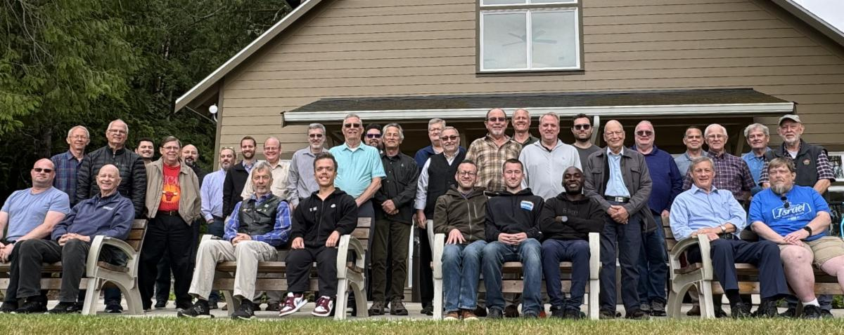
  From eight congregations, 33 men came together last weekend for the eighth Tacoma and Olympia Men’s Weekend in Seabeck, Washington. The theme for this year was “Put on the Whole Armor of God.” An interactive one-hour seminar for each of the elements of the armor of God listed in Ephesians 6 was led by attending pastors and elders.
  Roc Corbett, the hosting pastor, led the session on “The Belt of Truth.” Gary Petty was the guest speaker and led the discussion about “The Breastplate of Righteousness” as well as giving the Sabbath sermon. Paul Moody stepped up our understanding of “Our Spiritual Footwear.” Tim Heine described and explained “The Shield of Faith—the Armor’s Armor.” Ben Light taught about “The Helmet of Salvation,” bringing out some of the subtleties of the words that were inspired about this piece of God’s armor. Bob Dick led the concluding session about “Learning to Be a Skilled Spiritual Swordsman.” Each man was given a notebook containing the notes prepared by the various presenters to keep as a resource for future study and potential sermon material.
  The Sabbath service from the Tacoma Men’s Weekend was webcast to the rest of the local members and to congregations where the attending pastors serve. A Sabbath evening salmon bake on the Puget Sound shoreline added to the enjoyment of the weekend. Every man attending agreed that the weekend was spiritually edifying and strengthening.
  —Roc Corbett, pastor, Tacoma and Olympia, Washington
  Upcoming Events
  Jul. 7–14 | Southwest Camp | Prescott, AZ
  Jul. 14–17 | Camp Ironwood | Stewartville, MN
  Jul. 14–17 | Camp Ochoco | Prineville, OR
  Jul. 19–26 | Camp Woodland | Temple, GA
  Jul. 21–28 | Northwest Camp | Rockaway Beach, OR
  Jul. 28–31 | Camp Buckeye | Delaware, OH
  Jul. 28–31 | Camp Seven Mountains | Spring Mills, PA
  Jul. 31–Aug. 6 | Challenger Sierra | Emigrant Wilderness, CA
  Aug. 9–11 | Seattle Young Adult Weekend | Cle Elum, WA
  Sep. 6–8 | Women’s Enrichment Weekend | West Portsmouth, OH
  Sep. 8 | Gear Grinder Classic Bike Ride | Stillwater, MN
  Upcoming activities may be sent to weekly_update@ucg.org. Additional calendar information is available on the members’ website.

