
  
  June 22, 2023
  From the President . . .
  Dear brethren around the world,
  Here in America, summer has arrived and the United Youth Camps season is in full swing! There is one teen camp in session this week, and two preteen youth camps, one in Florida and one in Colorado, have already been completed within the last two weeks.
  Our youth camps are a special service of the United Church of God, and we appreciate and thank all those who serve at these camps. Camps give parents the opportunity to make sure their children have this special occasion to be together with people of like mind, where they learn to have fun, make new friends and have new experiences. Most importantly, God’s Word is emphasized and taught daily, with His way of life put into practice, being lived every minute.
  What a contrast with the way of this world, and its unseemly, despicable and damaging messages that try to subvert our children and young people. Camps are so necessary—more than ever before—and are a ray of light and hope in a world that is becoming “darker and darker” day by day.
  Isaiah 60:2 prophesies of this time, before the return of Jesus Christ: “For behold, the darkness shall cover the earth, and deep darkness the people.” We are living in a time when this spiritual darkness is growing, demonstrated by the descending morality of our society “attacking” not only our young people, but also all people.
  Young children are being told they don’t have to be “male or female” as God created them. They can choose to be whatever they want. They are being taught by schools, television, the Internet or their friends, that unbiblical sexual relationships are healthy and good with any person, male or female, who they choose. Children are being taught that they know better than their parents, and if their parents disagree with their choices, the parents are wrong, and the government will support the children.
  This is a sick society promoting poisonous thoughts, words and practices promulgated through immoral media and antibiblical forces with such a loud voice that it drowns out the voices of those with any wisdom or basis in sound moral principles. Prophecy is being fulfilled before our eyes as this world grows darker and darker, and evil continues to increase (2 Timothy 3:13).
  But there is hope! True hope is found ONLY in God. Even though there is no hope in this world, we can look to our Great Creator God and have a confident hope, but only in Him. Notice the encouraging conclusion of Isaiah 60:2: “… But the LORD will arise over you, and His glory will be seen upon you.” God has certainly called us out of darkness into “His marvelous light” (1 Peter 2:9).
  People of God, it is imperative that our children and teens be taught the Word of God daily. We all know the admonition that God, through Moses, gave us in Deuteronomy 6:6-9:
  “And these words which I command you today shall be in your heart. You shall teach them diligently to your children, and shall talk of them when you sit in your house, when you walk by the way, when you lie down, and when you rise up. You shall bind them as a sign on your hand, and they shall be as frontlets between your eyes. You shall write them on the doorposts of your house and on your gates.”
  If we claim to be God’s people, we must not only understand these instructions, but put them into action. Teach your children His words and His way of life. Diligently, daily, intentionally write them in the minds and hearts of your children and continue to model God’s way by having them written on our own hearts and minds.
  What this society’s ideologies and culture are espousing is NOT the way to happiness, fulfillment or a meaningful life. It is the way of death, inspired by Satan, who hates mankind and the purpose and desire of God, which is to bring joy, purpose and peace into the lives of all mankind.
  Guard your children! Let’s all pray for our children. Pray that God through His Spirit will guide all of us to incorporate His Word MORE into our daily lives and that we will teach it and arm our children with the “weapons” we need to ward off Satan and this society’s attempts to destroy lives. Teach your family the importance of having a close, special, loving relationship with God. He will never let us down (Hebrews 13:5).
  As God’s Church, we recognize the need for us to provide biblically-based materials and resources to help parents, families and all of us to build more spiritual direction and education into our daily lives. Mr. Myers and Ministerial and Member Services are at work on this, but we could use more resources and help, so if you have suggestions or would like to help in the development of this, please let us know.
  And please, most importantly, pray to God daily. Pray that He will guard our children’s hearts and minds, keeping them from the evil that can seem so attractive. Pray also for fathers and mothers, that God will turn their hearts to the children and ensure they know the truth of God.
  Thank you all for your prayers and support for the Work God is doing.
  In Christ’s service,
  
  Rick Shabi
  Report From Camp Cotubic
  Greetings from Camp Cotubic! 157 campers and 78 staff are soaking up their time in the Zone while learning how to “Race to Their Crown.” Campers have been loving their time together the past several days and are enjoying a variety of engaging activities.
  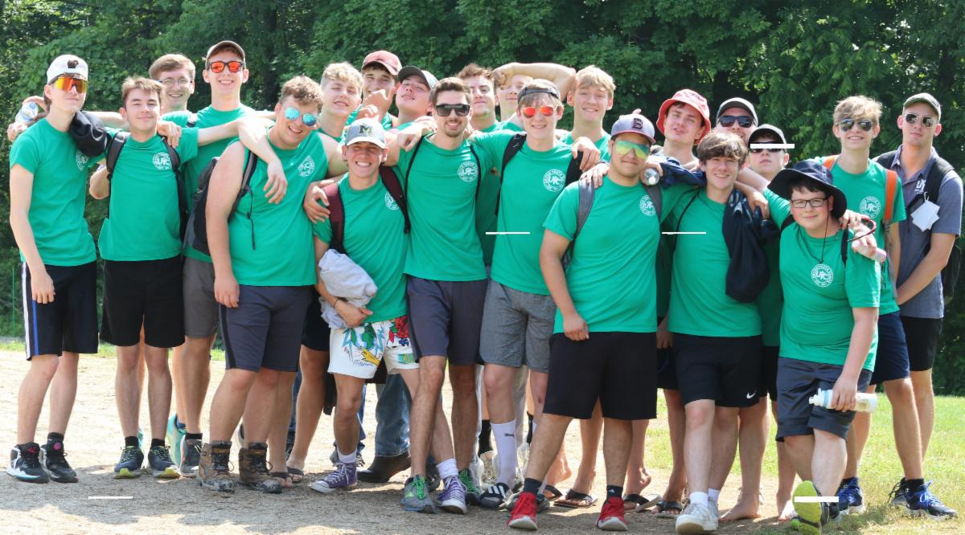
  Here at Cotubic, you can see a dorm running for the Amazing Race, encouraging each other as they go. As the race participants pass other activities, other dorms take a moment to cheer on their fellow campers. The sound of power tools can be heard over at arts and crafts as campers make their projects. Bible class is highlighting how elements of the Zone come straight from God’s Word and are hard at work.
  One dorm works on their basketball skills, while their sister dorm is climbing the high ropes. The new compound bows are being put to good use as the teens set personal records in archery, and a roar of cheers goes up when someone scores a goal at speedaway. Dance class is an all-around favorite for our dorms and they talk excitedly after learning a new line dance.
  The new service activity is giving a brother and sister dorm a chance to fellowship while providing a wonderful gift for shut-ins. Campers over at volleyball high-five after a fantastic volley, their supportive words highlighted by the sound of the zipline at the rock wall. Our days have been filled with amazing opportunities to grow and challenge ourselves, but we all are unified by Christian living classes in the morning. They have been an encouragement we have all needed, staff and campers alike.
  Please continue to pray for the success of not only Camp Cotubic as we wrap up the week, but also for all camps this summer.
  —Joshua Creech
  Report From Camp Florida
  This was the third year of Camp Florida, and we truly experienced the Zone. This year’s camp was awesome! It ran May 29-June 2, and we had 47 preteen campers along with 35 adult and 15 teen staff.
  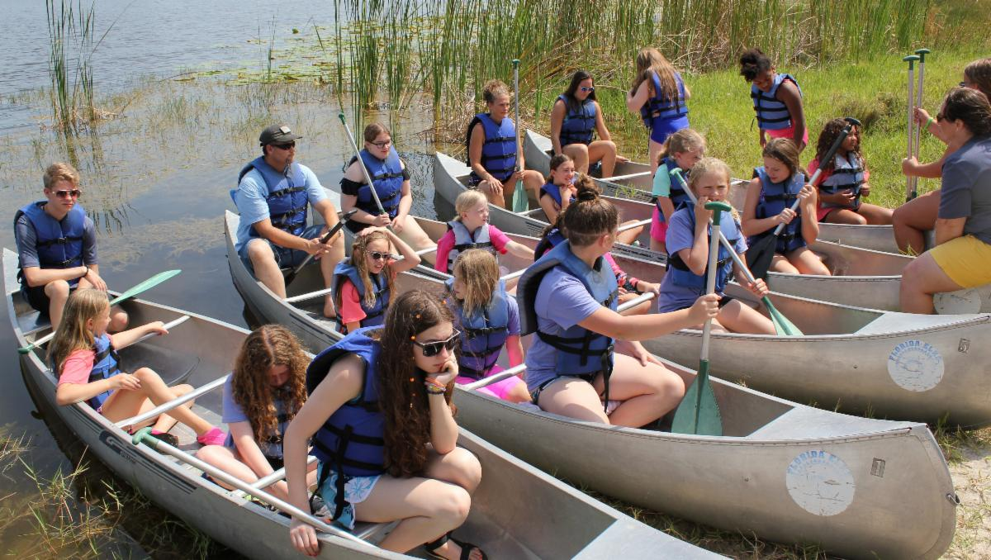
  Our camp saw God’s blessings every day, as the weather was cool and sunny for the entire week of camp. “Race to Your Crown” was a great theme; our days began with Christian living, featured an evening compass check and finished with nightly dorm parent time. All campers participated in lots of fun activities like swimming, canoeing, sports, arts and crafts, archery and water games. The campers’ favorite activities were tie dye shirts, gaga ball, zip line and our campfire program which consisted of yummy s’mores, corn on the cob and fun sing-alongs.
  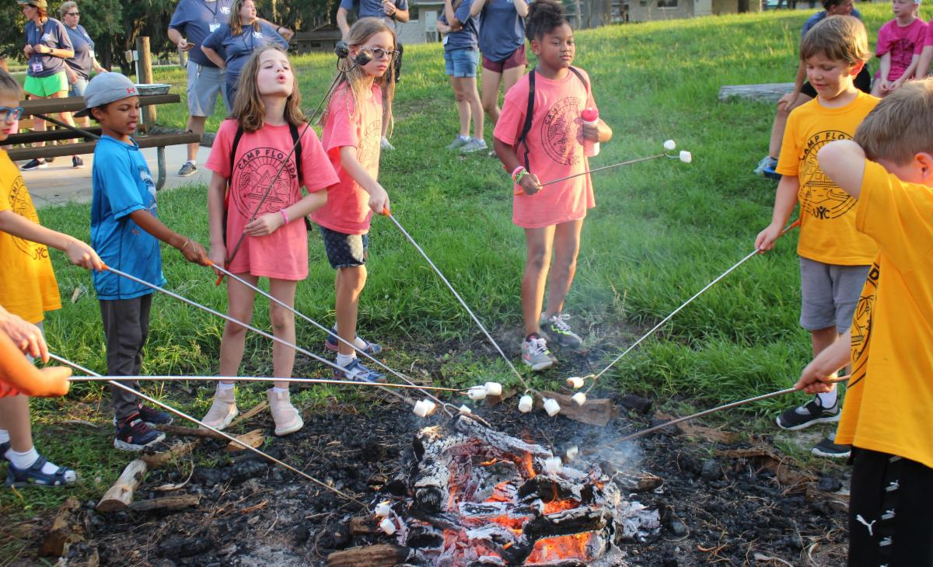
  A highlight was a special service project to clean about 600 plastic portable lockers for the facility’s upcoming summer camp program. Dorms had fun as they got wet and competed to see how many they could clean in an hour! Camp has led to close friendships for our campers and staff that will last well after camp is over.
  The staff at the beautiful Florida Elks youth camp just outside of Orlando, Florida, was very responsive to our needs, loved seeing our campers having fun and really catered to our needs. It was another great year and we are looking forward to camp in 2024!
  —Bert and Tricia Merring
  Trip to Portugal and Angola
  Jorge de Campos just completed a two-week trip to Portugal and Angola. He provides the following report:
  I arrived in Lisbon, Portugal, on June 6, where I was able to meet with a member from the British Isles whom I baptized last year in Brazil, and who is now living in Portugal. I was able to have dinner with a family I had not seen for many years, and to meet with a prospective member and a widow who has been a church member for many years.
  On June 9, I arrived in Angola, where 40 or 50 members met me and we held a brief service of thanks for the trip. On the Sabbath of June 10, we had 913 members at morning services and about 400 members attended a Bible study and Q & A session that I conducted for about three hours in the afternoon. Over lunch, I was interviewed by the local radio station.
  On Sunday, I met in the morning with the national council and national administration on various questions about how the United Church of God is organized. In the afternoon, we conducted ministerial training that covered baptism counseling and our fundamental beliefs.
  On Monday, we had a ladies’ study with 47 women present, plus a number of elders and leaders. Questions were asked about dress, jewelry and modesty, as well as alcoholic beverages. In the afternoon, we had a study for couples about the commitment of marriage that was attended by nearly 100 people.
  On Tuesday, we met with an enthusiastic group of about 60 young adults. They had a lot of questions and I gave an overview of the seven seals and the seven trumpets of the book of Revelation. With all their questions, the study lasted about three hours. Over lunch, I did an interview/podcast with church young adults for their social media network. In the afternoon I did a Bible study for all members on true repentance and the unpardonable sin. This topic had come up during the Q & A and became the central theme of the study.
  On Wednesday, I visited the Águas Vivas school and the children who attend there. In the afternoon, I gave a study on the ministry of reconciliation. With all the questions and answers, this session for all the members who could attend (nearly 100) lasted another three hours. We concluded the day with a private session with their Council of Elders and leaders and talked about the possibility of some of their leaders attending the Feast of Tabernacles in Brazil.
  On Thursday, I drove five hours to Malanje, where I conducted a Bible study on Friday with the elders, deacons and other leaders in the congregation and then a separate session, open to all members, attended by about 50 people.
  On the Sabbath of June 17, we had over 200 members in attendance for the morning service and, in the afternoon, we followed up with another three-hour Q & A. I started my return trip back home the next day.
  Overall, it was a very profitable trip and very much appreciated by the Angolan brethren. They send their well wishes and are very grateful to the Council of Elders and leadership of the United Church of God.
  —Jorge de Campos, senior pastor, Portuguese-language areas
  St. George 2023 Feast Site Update
  We have received a contract from Utah Tech University for the 2023 Feast site. We are in the process of ironing out wording, but we don’t anticipate any problems that would prevent a final mutual agreement. The Church is not recommending that anyone should finalize housing or travel commitments that are not refundable, as that would be a personal decision. However, we fully expect this to be completed and finalized in the next few days or sooner. An update will come out to everyone next week or will be directly emailed to anyone registered.
  Youth Instruction Family Study Guide
  The latest Family Study Guide covers the Second Commandment, “You shall not make for yourself any graven images.” In this Study Guide we review the meaning and importance of the Second Commandment. God is our only true God and our protector. We cannot worship or put anything above God. How we worship God is important to Him. We review biblical examples of the Second Commandment being obeyed or disobeyed.
  You can read and download this study guide at: ucg.org/members/family-study-guides/ten-commandments-second-commandment
  Reminder: Sermon Disc Program Transition
  Sermon Disc Program (SDP) 171 was the final disc mailed out. The home office still plans to provide curated sermon recordings, but they will now only be available for download from our website. Here is the direct link: ucg.org/sermon-disc-program.
  We know there will be some shut-ins and others who will need recorded sermons and/or help with this transition. Here are a few suggestions moving forward:
  - If the member has Internet access, our curated sermons will still be available on the United Church of God Roku app and website. These sermons auto populate as they are added by the home office staff.
  
  - For those who do not have home Internet service, many new televisions allow a memory stick to be inserted into a TV to play video and audio files. A local volunteer can download our sermon recordings from ucg.org/sermon-disc-program and copy them onto a memory stick or SD card for the member or shut-in to use. Memory cards these days can fit numerous sermons on them.
  - If the shut-in does not have a television that can play video or audio through a memory stick or SD card, a player can be purchased that connects to most TVs.
  - The cost to purchase any necessary equipment for a person to play sermons from a memory stick or to gain Internet access, will be a cost savings for the Church over producing and mailing CDs and DVDs very quickly. We encourage each congregation to help its shut-ins in this way.
  - If a DVD is still needed, someone in the congregation would need to download the files and burn a DVD for the shut-in. This would be the most labor intensive and costly choice over time.
  For inquiries or questions in this regard, please contact Scott Buchanan at the home office at scott_buchanan@ucg.org.
  —Peter Eddington, Media and Communications Services
  Job Opportunities
  The United Church of God is still seeking a Video Editor and a Receptionist. Details about all of the current job postings for the Church may be reviewed at ucg.org/members/news/current-job-openings.
  Upcoming Events
  July 2–9 | Camp Pinecrest | Fredericktown, MO
  July 7–9 | Colorado Women’s Enrichment Weekend | Allenspark, CO
  July 7–9 | West Michigan Camping Weekend | White Cloud, MI
  July 9–12 | Camp Ironwood | Stewartville, MN
  July 9–12 | Camp Ochoco | Prineville, OR
  July 9–16 | Southwest Camp | Prescott, AZ
  July 9–16 | Boundary Waters Adventure | Voyageurs NP, MN
  July 21–28 | Camp Woodland | Temple, GA
  July 23–30 | Northwest Camp | Rockaway Beach, OR
  July 30–Aug. 2 | Camp Buckeye | Orrville, OH
  July 30–Aug. 2 | Camp Seven Mountains | Spring Mills, PA
  Aug 11–13 | Northwest Young Adult Weekend | Cle Elum, WA
  Sept. 10 | Gear Grinder Classic Bike Ride | Two Harbors, MN
  Sept. 16 | Feast of Trumpets
  Upcoming activities may be sent to weekly_update@ucg.org. Additional calendar information is available on the members’ website.

