
  
  June 15, 2023
  Report From Camp Gilmont
  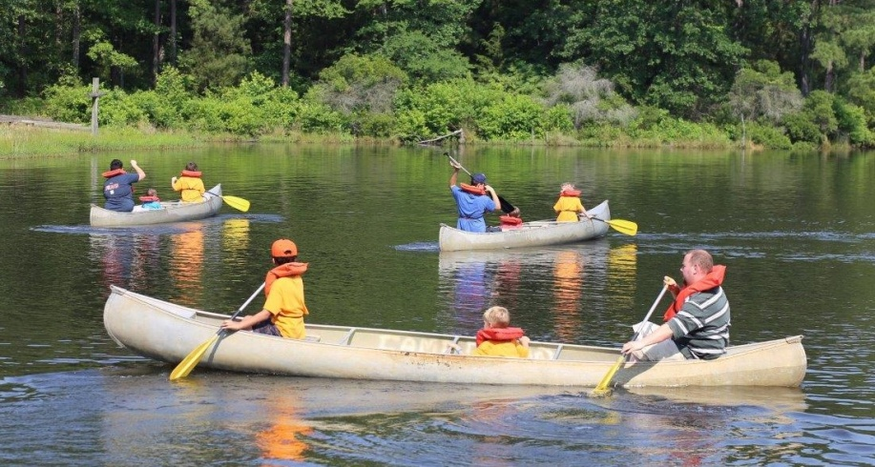
  The first year of Camp Gilmont, located in the Piney Woods of East Texas, was a success! From June 4–7, 35 preteen campers along with 32 adult and teen staff enjoyed a camp experience that was abundant with God’s blessings. Everyone who was registered arrived safe, no one got sick or hurt (except for a few bumps and a minor horsefly sting) and everyone seemed to have a blast! The weather stayed cool, mostly cloudy with highs in the mid to upper 80s, and rain for a few hours Monday morning allowed us to reshuffle activities in a way that ended up being more beneficial to everyone.
  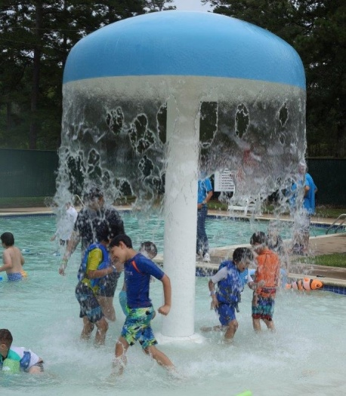
  Fun activities included the swimming pool which ranged from 1 foot to 5 feet deep and featured a splash pad. Canoeing, sports, water games, arts and crafts, hiking, the campfire and free time under the pavilion were enjoyed by all. The pavilion featured a gaga ball area, basketball hoops, chess and checkers games on the concrete with oversized pieces, a nine square game and carpetball table.
  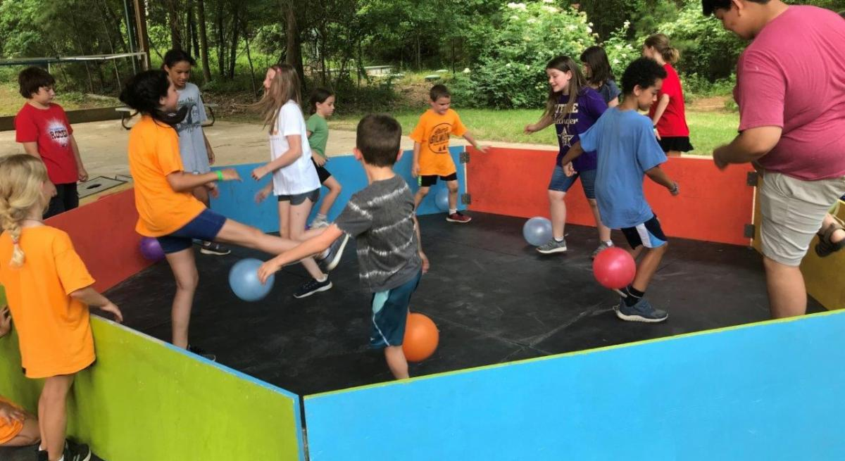
  The UYC theme of “Race To Your Crown” was well received and hopefully will stay in the minds and hearts of all of us.
  The Gilmont staff was very responsive to our needs, and their kitchen crew enabled our staff to focus on the other activities. They were very organized regarding both our biblical and personal dietary requirements. The salad bar was enjoyed by adults and kids alike.
  Our UYC staff was complimentary of the Camp Gilmont facility, with a number stating they are planning to spread the word. We’re looking forward to a bigger and even better camp next year from June 2–5, 2024!
  —Jim and Laurel Moody
  From Ministerial and Member Services . . .
  Recent Ordinations
  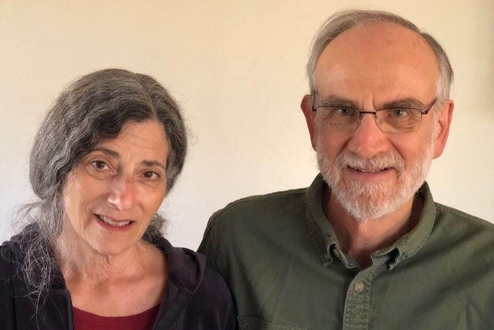
  David and Paula Hoover
  On May 28, 2023, David Hoover was ordained into the ministry. He and his wife, Paula, serve the congregation in Sacramento, California.
  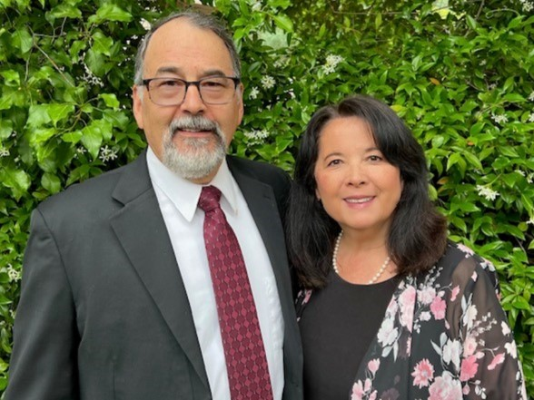
  Drew and Lydia Trone
  On May 28, 2023, Drew Trone was ordained into the ministry. He and his wife, Lydia, serve the congregation in Sacramento, California.
  Job Opening: Video Editor
  The United Church of God has announced an opening for a video editor. The position will be responsible for editing internal video projects including:
  - Educational videos.
  - Special project videos.
  - Ambassador Bible College videos
  - Ministerial training videos.
  - Sermon videos.
  - Camera operation for Beyond Today television.
  - Plus, any other projects assigned by supervisor.
  Working closely with a team in a creative environment is essential. Knowledge of video editing software (Adobe Premier Pro, Apple Final Cut or Avid Media Composer) is required, and competency using photo editing software (Photoshop) and animation software (Adobe After Effects) is a plus, along with storytelling skills and an eye for detail.
  An associate’s degree and one to two years’ direct related experience is preferred, with training in communication. An equivalent combination of education and experience may be considered. Strong language, logic and communication skills, and algebra/geometry level math skills are required. Those applying for consideration and invited for an interview must supply a portfolio of their work.
  Potential employees must be baptized members (in good standing) of the United Church of God. Applicants must be biblically literate and possess a thorough working knowledge of the doctrines, beliefs and practices of the United Church of God.
  To request a job application or for questions about the position, please contact human_resources@ucg.org.
  Job Opportunities
  The United Church of God is still seeking a Receptionist. Details about all of the current job postings for the Church may be reviewed at ucg.org/members/news/current-job-openings.
  Upcoming Events
  July 2–9 | Camp Pinecrest | Fredericktown, MO
  July 7–9 | Colorado Women’s Enrichment Weekend | Allenspark, CO
  July 7–9 | West Michigan Camping Weekend | White Cloud, MI
  July 9–12 | Camp Ironwood | Stewartville, MN
  July 9–12 | Camp Ochoco | Prineville, OR
  July 9–16 | Southwest Camp | Prescott, AZ
  July 9–16 | Boundary Waters Adventure | Voyageurs NP, MN
  July 21–28 | Camp Woodland | Temple, GA
  July 23–30 | Northwest Camp | Rockaway Beach, OR
  July 30–Aug. 2 | Camp Buckeye | Orrville, OH
  July 30–Aug. 2 | Camp Seven Mountains | Spring Mills, PA
  Aug 11–13 | Northwest Young Adult Weekend | Cle Elum, WA
  Sept. 10 | Gear Grinder Classic Bike Ride | Two Harbors, MN
  Sept. 16 | Feast of Trumpets
  Upcoming activities may be sent to weekly_update@ucg.org. Additional calendar information is available on the members’ website.

