

July 6, 2023

From the Treasurer . . .
With the end of June marking the final month in fiscal year 2022–2023, we are encouraged to report that (unaudited figures throughout) general contributions and Holy Day offerings have increased more than 5 percent year over year. This also represents more than a 10 percent increase over budget for the same period measured.
Though the fiscal year had inflationary challenges in many expense categories, as of the date of this writing expenses, in the aggregate, remain in line with annual budgeted amounts.
I am again reminded of Philippians 4 where the apostle Paul writes about the generosity of faithful followers in Philippi, and how pleasing it is to God (who is ultimately the source of it). Verse 19 reads, “And my God shall supply all your need according to His riches in glory by Christ Jesus. Now to our God and Father be glory forever and ever.”
God continues to bless His Church. Those blessings also provide the Church with the means and opportunity to give and provide support as well. In fiscal year 2023, in recognition of its responsibility to help those with financial needs, the Church provided just under $1.2 million in “assistance to the needy.” By comparison, about $350,000 was donated to the assistance fund during the year.
Also, in recognition of our commitment to members outside the United States, the Church, in the form of international subsidies, provided just under $1.7 million in assistance for fiscal year 2023 to international areas (this assistance being exclusive of the cost of printing, postage and shipping of English and foreign language magazines and booklets).
God continues to provide the Church with what it needs to accomplish the commission of preaching the gospel and caring for the members of the Church around the world. We know and trust He will see us through whatever comes our way—and in the wake of an ever-changing world. We are grateful to Him, and to the members, coworkers and donors who faithfully support the Work. May we all continually seek God’s will and be faithful in submitting to it.
Until next time, if you have any questions about the finances of the Church, please feel free to contact me.
—Barry Korthuis, Treasurer

From Ministerial and Member Services . . .
As we have just ended one fiscal year (June 30) and begin a new fiscal year, Ministerial and Member Services (MMS) has a number of important projects in the works:
Festival planning has been high on the priority list. God’s command to assemble as we observe His holy time is a wonderful opportunity for us to collectively worship Him and come together as His people. In order to effectually do this, it takes a considerable amount of planning on everyone’s part. Our festival coordinators are already organizing and scheduling speakers, song leaders, musicians and many volunteers to help serve at the Feast of Tabernacles. If we all do our part, it will help make it an especially spiritually rewarding occasion.
We’re also planning for our 20th Leadership Workshop over the Labor Day weekend, Sept. 1–4, 2023, here in Cincinnati. This is held as an educational opportunity for those recommended by their pastors to receive further spiritual training as God may be calling them to greater service. Over the years these meetings have produced much good fruit and we look forward to another profitable workshop.
As we strive to fulfill the directives of our Operation Plan, it calls for an emphasis on ongoing education for the ministry. Meetings are being planned for church pastors and wives in each of the six regions across the United States over the next year—beginning right after the Feast of Tabernacles. This will help us be even more unified as we speak the same thing, serving God and His people (1 Corinthians 1:10).
MMS is also in the beginning stages of providing additional parenting resources and guidelines to assist parents in teaching their children. We know God has given all parents the responsibility to teach God’s truth diligently to their children (Deuteronomy 6:6-9). The goal is to help parents, families and all of us to build more spiritual direction and education into our daily lives. At the moment we are in the process of collecting volunteers who would like to assist in developing resources that can be used by parents to assist them in daily biblical instruction. It seems we can always use more resources and help, so if you have suggestions or would like to help in the development of this, please let me know.
Please continue to pray for God’s inspiration, direction and guidance as we work together to fulfill our God-given mission.
—Steve Myers, Operation Manager, Ministerial and Member Services

Report From Camp Pinecrest
Camp Pinecrest 2023 is off to a tremendous start! Located in the rolling hills of southeast Missouri, the UYC program has enjoyed this beautiful camp for 27 years.
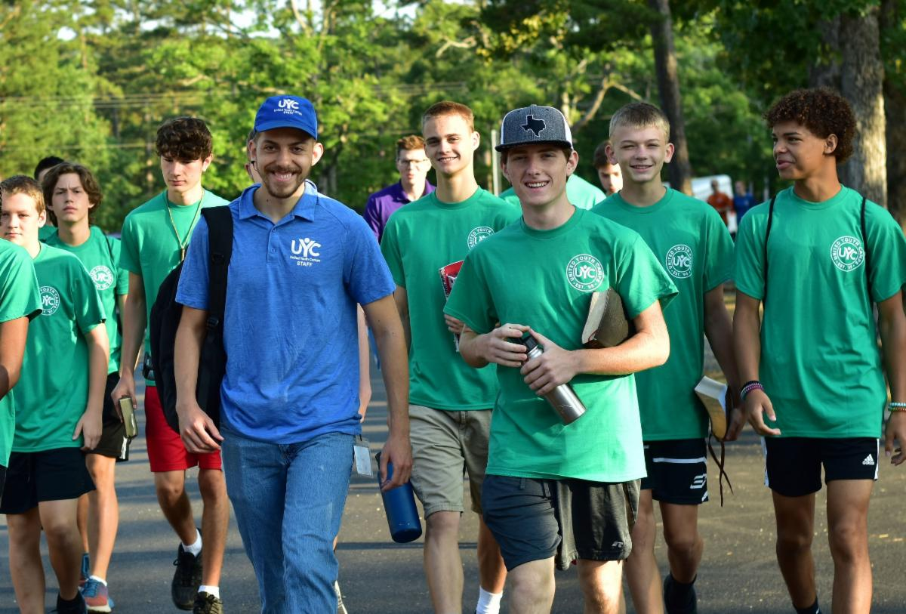
Seventy-seven campers (33 ladies and 44 gentlemen) and 60 staff are enjoying God’s wonderful blessings and provision, which have been evident for everyone to see. The teens are setting excellent examples of how God’s way works and are letting their lights shine. This year’s camp theme, “Race to Your Crown,” has strengthened the campers’ and staff’s relationship with God and renewed their focus on running the ultimate race of their lives toward God’s Kingdom. We are strengthening our vision of the incredible future that awaits each of us whom God is personally inviting.

The weather has been comfortable for our outdoor activities, with an occasional passing summer storm. One of these thunderstorms caused a three-hour power outage Tuesday evening. But with the use of a power inverter and LED lighting, we were able to continue the evening’s scheduled fellowship and gym activities. We sang “Teach Me Thy Way” together powerfully in the dining hall as sunset approached, and the words of this hymn, which had been selected before camp, were perfectly suited to the experience. It was further evidence of God’s very near presence with us. Just before bedtime, as Mr. Phelps shared the final instructions for the evening, the power suddenly came back on, resulting in a giant shout and applause from everyone! The timing was perfect since we were all gathered together at that point. The return of air conditioning was a welcome relief after a warm evening of fun activities at the gym. We clearly saw God’s hand of love and mercy for His precious young people and everyone here to serve.
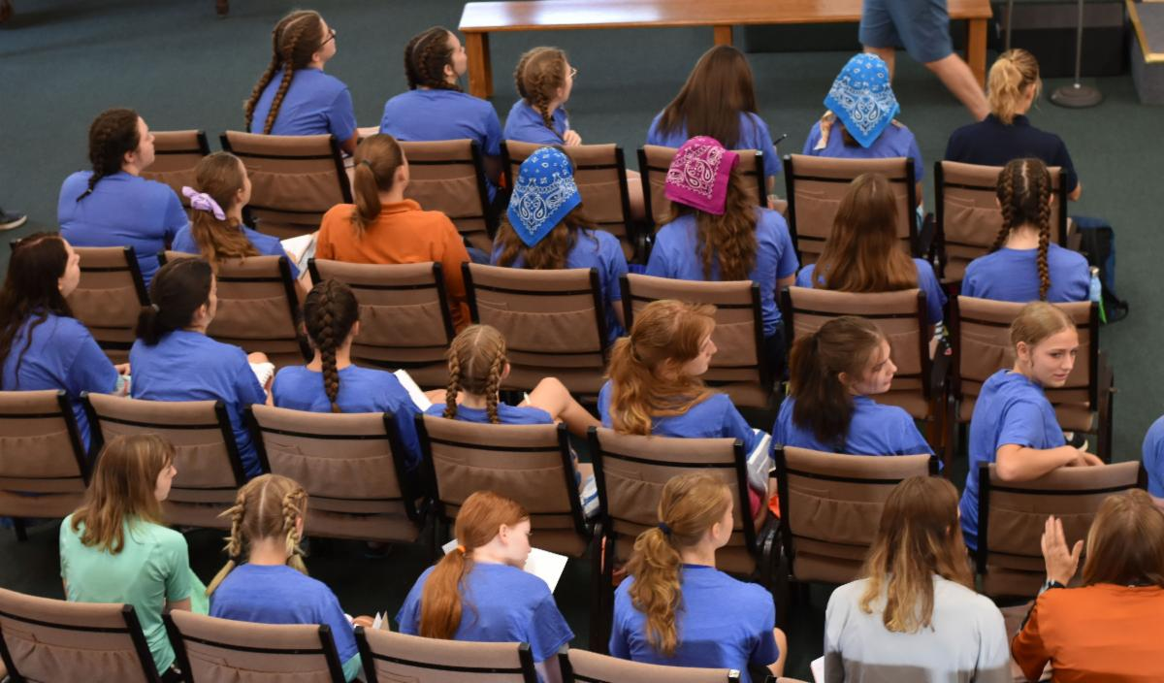
Many prayers were sent up regarding the weather and success of the river float trips this week, and we are thrilled to report that so far, two of the three have gone beautifully. The final float trip is Thursday, and we are praying for another successful day. Every camper and their counselors will have then had the opportunity to participate in this memorable off-site adventure trip this summer.

Thank you so much for your past and continued prayers for Camp Pinecrest and for God to continue leading and guiding all aspects of His camp for the remainder of the week.
—Mike Phelps, director, Camp Pinecrest

St. George Finalized as a Definite Site
St. George, Utah, is a definite Feast of Tabernacles site for 2023. Sorry for the delayed announcement, but it was due to reasons beyond our control. If you haven’t registered yet, please do so. Thank you for your patience.

Job Opportunities
The United Church of God is still seeking a Video Editor and Receptionist. Details about all of the current job postings for the Church may be reviewed at ucg.org/members/news/current-job-openings.

Upcoming Events
July 21–28 | Camp Woodland | Temple, GA
July 23–30 | Northwest Camp | Rockaway Beach, OR
July 30–Aug. 2 | Camp Buckeye | Orrville, OH
July 30–Aug. 2 | Camp Seven Mountains | Spring Mills, PA
Aug. 11–13 | Northwest Young Adult Weekend | Cle Elum, WA
Aug. 13 | Kids Rodeo | Portland, OR
Aug. 25–27 | Columbus Young Adult Weekend | Columbus, OH
Sept. 10 | Gear Grinder Classic Bike Ride | Two Harbors, MN
Sept. 16 | Feast of Trumpets
Sept. 25 | Day of Atonement
Sept. 30–Oct. 6 | Feast of Tabernacles
Oct. 7 | Eighth Day

Upcoming activities may be sent to weekly_update@ucg.org. Additional calendar information is available on the members’ website.

