

July 13, 2023

From the President . . .
Greetings brethren around the world,
Last night on my home office Zoom Bible study, we covered Isaiah chapter 43. As we progress through the book of Isaiah, we see that it really is a book for our time. In this section of Isaiah, we are learning about the mercy and love of God in detail, since this prophecy is set at the time of Christ’s return, the establishment of His Kingdom and the return of physical Israel to the land God promised them.
These are encouraging and exciting sections of Scripture because we see God mercifully lead and guide His people. He skillfully teaches that He alone is God and that He is the Protector and Provider of His people. As His people are brought back from captivity to the Promised Land, God reminds them of the miracles He has performed for them and the wonders of the future that He will perform.
“When you pass through the waters, I will be with you” (verse 2a). Indeed, God literally brought Israel through the water as He delivered them from Egypt through the Red Sea.
“And through the rivers, they shall not overflow you” (verse 2b). Indeed, as they entered the Promised Land, God actually stopped the waters of the River Jericho and they crossed over on dry land.
“When you walk through the fire, you shall not be burned, nor shall the flame scorch you” (Isaiah 43:2). Indeed, when Shadrach, Meshach and Abednego refused to bow to the idols of Nebuchadnezzar and were thrown into the fiery furnace, God shielded them from the flames and they emerged untouched by the flames. They didn’t even smell of smoke (Daniel 3:27).
God emphatically states that He is God and there is no other, and besides Him there is no savior (Isaiah 43:10-11). He reminds us of His willingness to demonstrate His mercy, love and patience for His people.
What a tremendous, loving, merciful, all-powerful Father we serve—along with His Son Jesus Christ, who is always with us, gently leading us, guiding us and preparing us for His everlasting Kingdom. I hope that every day we thank Him and are dedicating our lives to becoming more like Him and doing His will.

God’s message of hope
As we head into a new fiscal year in the Church (which began July 1) God is leading us further down the path to His Kingdom and the return of His Son to this earth. There is much to do as we follow God along this path, as we work toward fulfilling the commission He has given His body—His Church—to do.
We ask for your continued prayers as Christ leads the Church to preach the “good news” of the coming Kingdom of God to the world, with focus not only in the United States but in every nation where God is calling people. That message of the Kingdom is the message of hope the world needs, and it’s accompanied by a message of repentance and turning to God—the same message Jesus Christ and the apostles taught and preached.
The work of God also includes teaching all nations and His called-out ones to “observe all things He commanded.” Caring for and shepherding His people includes all of us teaching and living by the same truth that Christ and the apostles taught. His “own special people” speak the same thing in every area around the world and we are people who are called to know, live and “do the truth” (John 3:21) in all our congregations and communities.

The upcoming feasts
As we begin this new fiscal year and follow what God would have us do, we look forward to the fall Holy Days now just a few months ahead of us.
The words of Isaiah speak to the time of Christ’s return and what God expects of us now. As we live in an increasingly troubled and deteriorating world, we look forward to the Feast of Trumpets, the Day of Atonement, the Feast of Tabernacles and the Eighth Day. These days picture a time of trouble unlike any ever before as Satan attempts to destroy mankind. And ultimately, they show the power and triumph of our God, who is always there, who will conquer evil and bring to the world lasting peace and harmony.
Contemplate God’s plan and the meaning of these Holy Days, as you make plans to leave your home and observe the Feast of Tabernacles in the “place where God chooses.” Remember, as you plan your travel and accommodations, that the Feast begins at sunset on the 15th day of the seventh month (at sunset on Sept. 29) and continues through sunset on the Eighth Day (Oct. 7).
Plan to be at the Feast, in your accommodations, ready to celebrate the beginning of the Feast in God’s presence on opening night or whenever the first service at the Feast site you are attending is scheduled. Honor and respect God by being there and showing Him your commitment, love and submission to Him through your heartfelt observance of His holy times.
As we are on the road to His Kingdom, always remember His goodness, mercy, patience and love for us—and be thankful. We are His family, wherever we live in this world. We are to be at one with Him and each other, being led and transformed by His Spirit in us.

Travel to England and Italy
Over the next two weeks I will have the privilege and honor to work with our offices in London, England, then Milan, Italy, for several days. We look forward to meeting everyone at Sabbath services in Bricket Wood (England) and Bergamo (Italy) and in the other meetings and discussions with members and the ministry as we discuss and plan the work in those areas.
Please always keep the work of God around the world in your prayers as we all strive to do His will.
Our thoughts and prayers are with all of you. Have a great rest of the week and Sabbath day.
In Christ’s service,

Rick Shabi

Report from Southwest Camp
In our third year here in Prescott, Arizona, Southwest camp is off to a wonderful start. We have 114 campers and staff gathered together in the mountains of the Prescott National Forest.
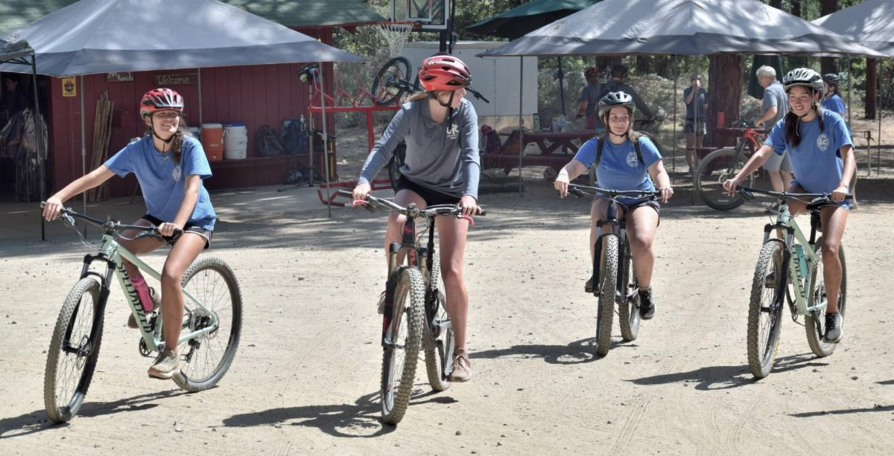
Our mountain biking class is once again a big hit, as the campers push through a challenging yet rewarding experience that often is new to them and pushes them out of their comfort zone.
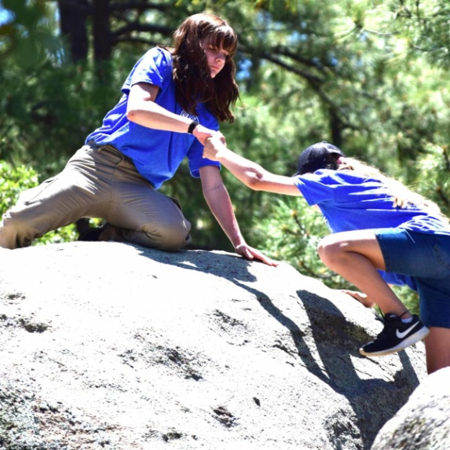
We also added horseback riding for the first time this year. The campers have enjoyed the chance to trail ride and learn to ride bare-back.
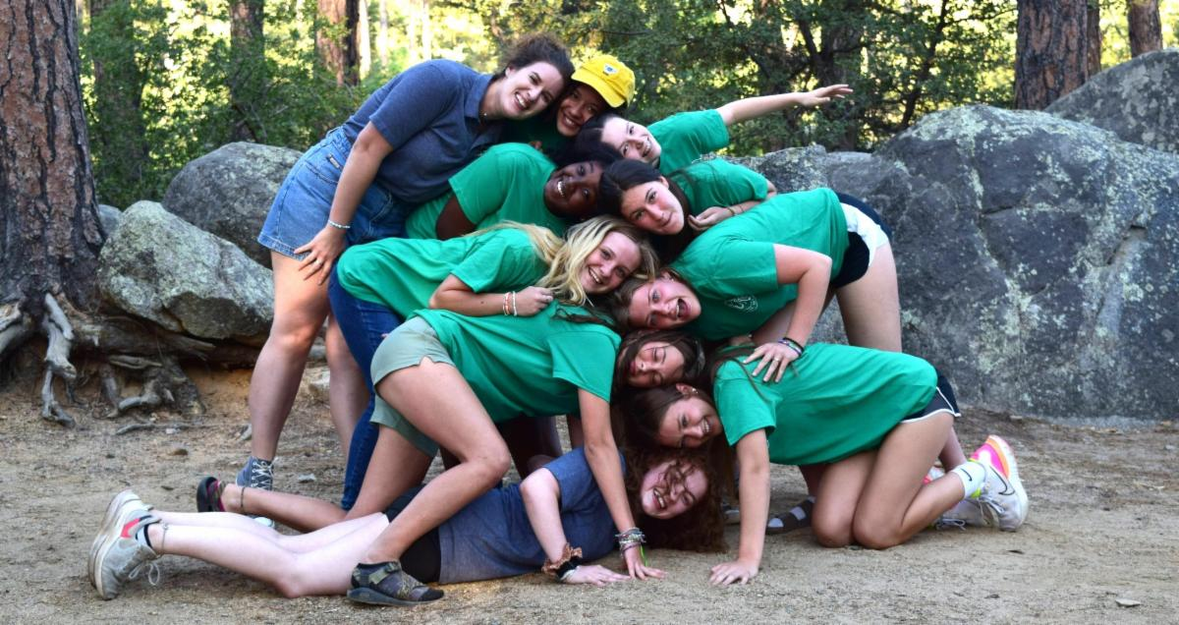
We have a wonderful group of campers and staff that are fully engaged in the activities and Christian living classes. The theme this year of “Race to Your Crown” has been discussed and applied in many ways to help the campers connect to their calling and the race set in front of them. So many of our activities have powerful connections to the theme to help bring the lessons home.
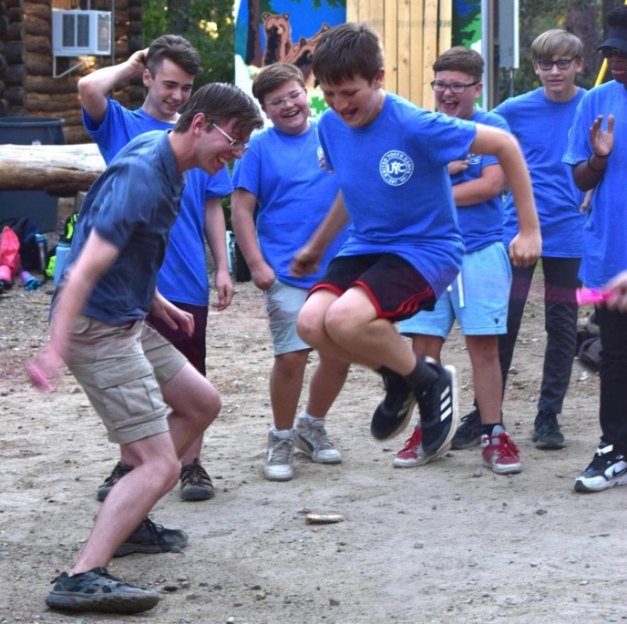
I am thankful for all the support of our wonderful staff, as well as the home office and all the members who contribute to our camp program in so many ways. It truly is a life-changing experience.
—Aaron Creech, director, Southwest Camp

2023 Front Range Women’s Enrichment Weekend
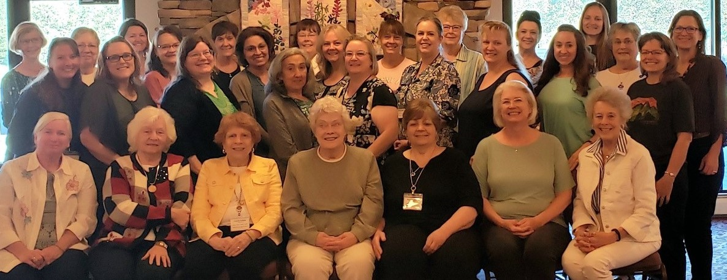
Thirty ladies from Colorado, South Dakota, Arizona, Tennessee and Texas gathered together July 7–9 in Allenspark, Colorado, to attend the 2023 Front Range Women’s Enrichment Weekend. The theme of this year’s weekend was “Women of Faith: Standing Together.” The focus passage for the weekend was Titus 2:3-5. Each presentation focused on unpacking a different facet of this passage and exploring the importance of women mentoring other women, so that we might be better equipped to walk out our faith and finish the race to the crown that we all are on.
—Joy Jones

Job Opportunities
The United Church of God is still seeking a Video Editor and Receptionist. Details about all of the current job postings for the Church may be reviewed at ucg.org/members/news/current-job-openings.

Upcoming Events
July 21–28 | Camp Woodland | Temple, GA
July 23–30 | Northwest Camp | Rockaway Beach, OR
July 30–Aug. 2 | Camp Buckeye | Orrville, OH
July 30–Aug. 2 | Camp Seven Mountains | Spring Mills, PA
Aug. 11–13 | Northwest Young Adult Weekend | Cle Elum, WA
Aug. 13 | Kids Rodeo | Portland, OR
Aug. 25–27 | Columbus Young Adult Weekend | Columbus, OH
Sept. 10 | Gear Grinder Classic Bike Ride | Two Harbors, MN
Sept. 16 | Feast of Trumpets
Sept. 25 | Day of Atonement
Sept. 30–Oct. 6 | Feast of Tabernacles
Oct. 7 | Eighth Day

Upcoming activities may be sent to weekly_update@ucg.org. Additional calendar information is available on the members’ website.

