
  
  July 20, 2023
  Report from Preteen Camp Ochoco
  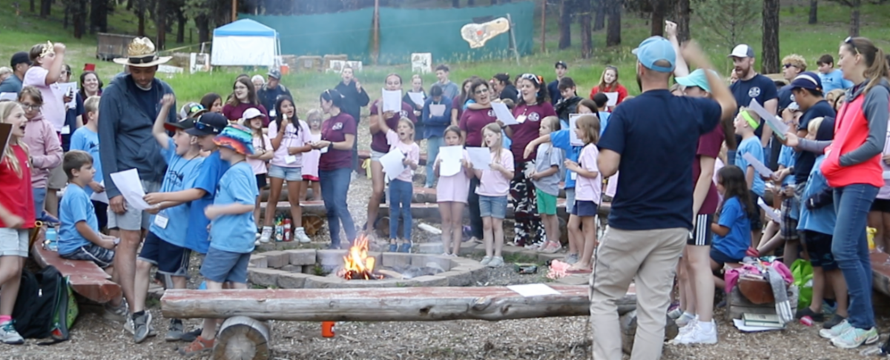
  Our second year for Camp Ochoco was an amazing experience! 146 campers and staff enjoyed the lessons each day provided as we all focused on the theme, “Race to Your Crown.” Pickleball, gaga ball, swimming, a variety of sports, and some special arts and crafts all offered opportunities to make the theme personal.
  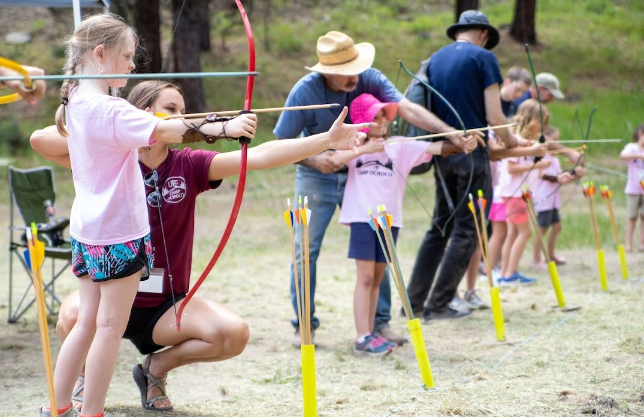
  If you ever wondered if your support of the camp programs is making a difference, I can tell you it is! While chatting with some of the staff after camp had ended, I heard story after story of how the campers made a difference in their lives.
  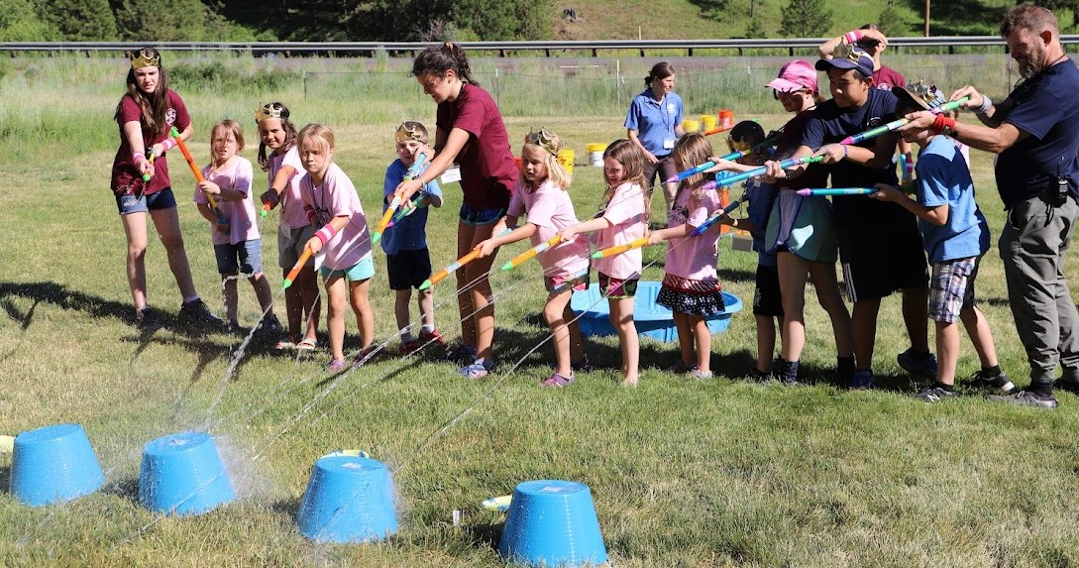
  Some of the remarkable comments made by the youngest of campers show that they have an understanding of what God is doing in their lives, and how they can be better little people and be encouraging to others. They support one another to overcome daily challenges and become a family within their dorms—exactly what God is all about. Let’s all thank God for United Youth Camps.
  —Jeff Richards, director, Camp Ochoco
  Report from Preteen Camp Ironwood
  There were 190 of us gathered on Sunday, July 9, through Wednesday, July 12, at the beautiful country setting at Ironwood Springs Christian Ranch, in Southern Minnesota.
  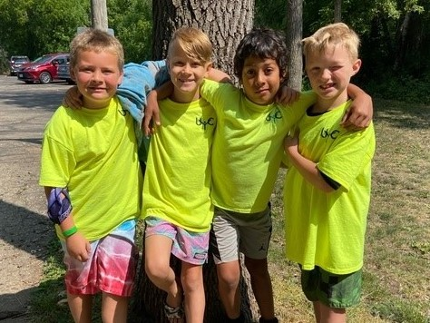
  There were 101 preteens (which included 12 mini dorm campers ages 2–5 and five little ones under the age of 2), 20 teens and 69 adults enjoyed four days of living, playing and working together “God’s way.” God blessed the camp with His protection for campers and staff as well as absolutely beautiful weather most of camp. (Rain missed the camp Monday night, but we had a few showers Wednesday morning before the skies cleared once again).
  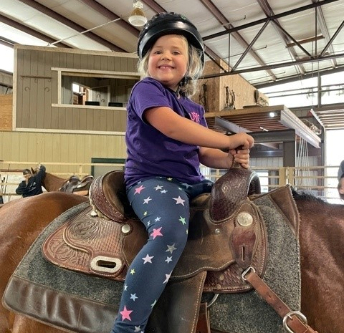
  This was the biggest camp we have had in the 23 years we’ve had Camp Ironwood. It was attended by preteens and teen staff from Texas, Ohio, Iowa, Illinois, Missouri, North and South Dakota, Michigan, Wisconsin, Minnesota and Canada!
  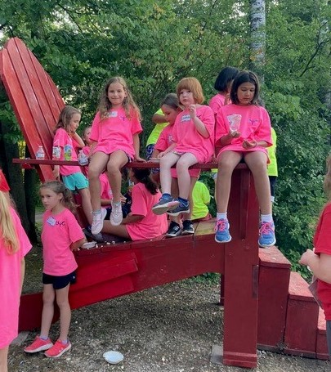
  One of our camp goals was to enrich the children’s lives by giving them opportunities to build relationships with other children who share common beliefs, as well as experience a variety of challenging activities and deepen their relationship with God. Each morning the entire camp was in Christian living or Bible study. Classes emphasized our camp theme “God’s Family” and campers got to know more about their loving Father and that He wants them in His family. The theme was also emphasized throughout the day in activities and in their evening wrap-up dorm time. Campers enjoyed the new Jelly video and soon started trying to memorize all the words to Mark Graham’s new Jelly song: “God is Growing a Family.”
  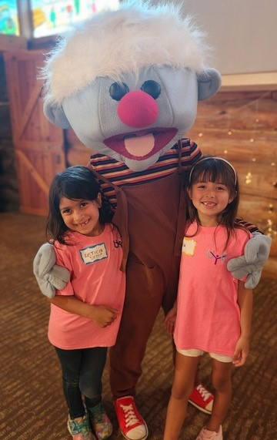
  Jamie Schreiber, who filmed many of the camp activities at Camp Ironwood, made a short video which can be viewed at: youtube.com/watch?v=cV5UA1jbGCI
  We are very thankful and blessed to have Church members’ support, financial contributions and prayers for Camp Ironwood and the other UYC camps yet to be held. We praise God and thank Him for another successful year at Camp Ironwood!
  —David Schreiber, director, Camp Ironwood
  Report from Boundary Waters Adventure
  July 9–16, 2023, a group of 15 young adults and staff experienced the third biennial Boundary Waters Adventure in Northern Minnesota. This Challenger Program provides young adults an opportunity to practice teamwork, initiative and spiritual growth in a beautiful, wild setting.
  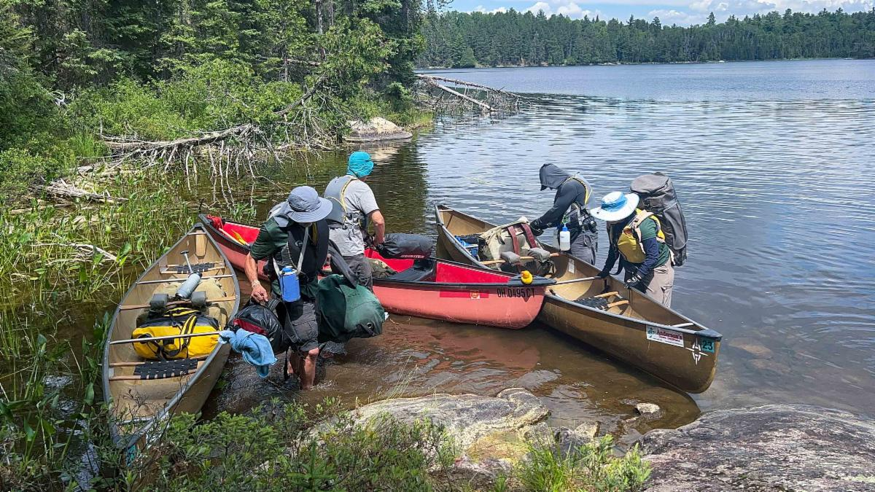
  Participants ranged in age from 18 to sixty-something and came from all over the United States. Along with canoeing approximately 58 miles and camping in the wilderness, each young adult presented a sermonette or “trail talk,” and took part in group discussions. The weather was quite favorable this year and, fortunately, smoke from Canadian wildfires was not an issue.
  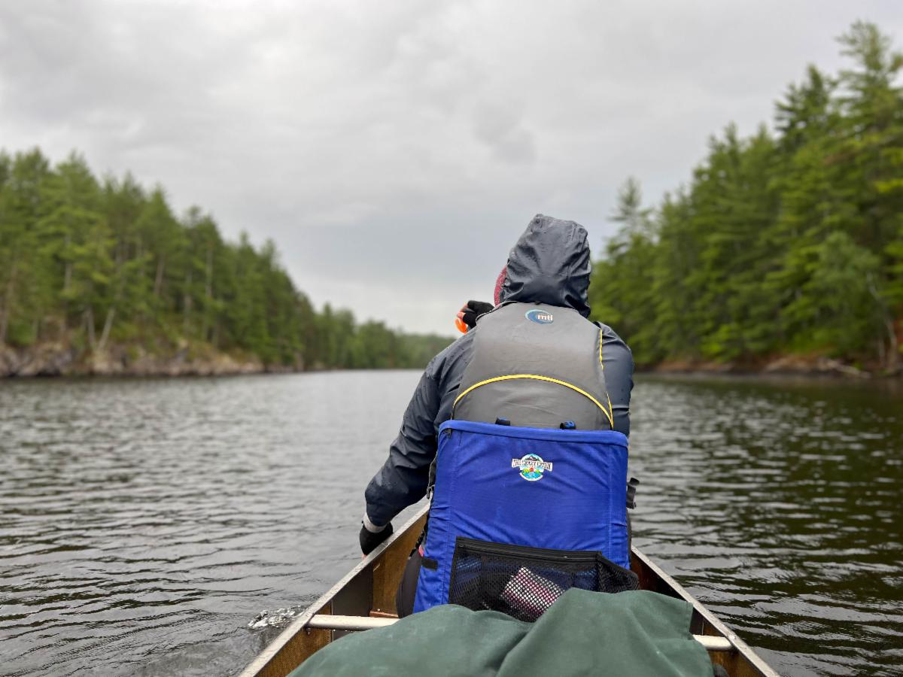
  Because of limited permits into the Canoe Area Wilderness and scheduling constraints, this was the most difficult Boundary Waters Adventure yet—leading to tremendous satisfaction for those completing it. Plans for the future will avoid this extent of challenge, while still making it an amazing adventure. Our goal is to make this special program accessible to almost all young adults in God’s Church.
  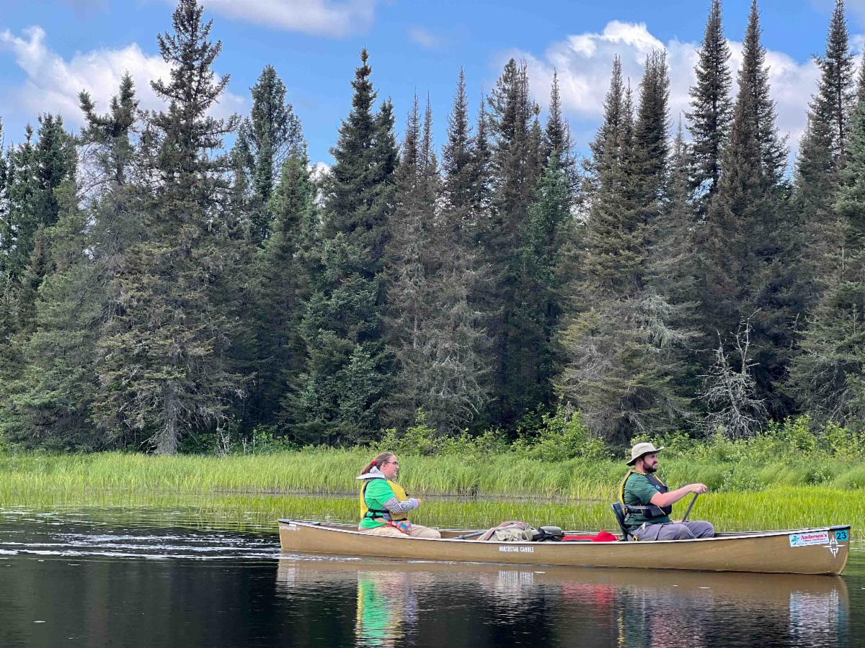
  Next year Challenger Sierra will be available and we strongly encourage young adults to participate. Boundary Waters Adventure will return in 2025, and we hope to have many of you join us then!
  —Frank Dunkle, director, Boundary Waters Adventure
  Youth Instruction Family Study Guide
  In this Family Study Guide we review what it means to take God’s name in vain and why it is wrong. There are many ways in which God’s name is taken in vain. This study guide will explore these important concepts, so that you can help your children learn to show true respect for our Heavenly Father.
  “Do not misuse the name of the LORD your God. The LORD will not let you go unpunished if you misuse His name” (Exodus 20:7).
  You can read and download this study guide at: ucg.org/members/family-study-guides/ten-commandments-third-commandment
  Job Opportunities
  The United Church of God is still seeking a Video Editor and Receptionist. Details about all of the current job postings for the Church may be reviewed at ucg.org/members/news/current-job-openings.
  Upcoming Events
  July 30–Aug. 2 | Camp Buckeye | Orrville, OH
  July 30–Aug. 2 | Camp Seven Mountains | Spring Mills, PA
  Aug. 11–13 | Northwest Young Adult Weekend | Cle Elum, WA
  Aug. 13 | Kids Rodeo | Portland, OR
  Aug. 25–27 | Columbus Young Adult Weekend | Columbus, OH
  Sept. 10 | Gear Grinder Classic Bike Ride | Two Harbors, MN
  Sept. 16 | Feast of Trumpets
  Sept. 25 | Day of Atonement
  Sept. 30–Oct. 6 | Feast of Tabernacles
  Oct. 7 | Eighth Day
  Upcoming activities may be sent to weekly_update@ucg.org. Additional calendar information is available on the members’ website.

