
  
  February 9, 2023
  A New Look for the Home Page of UCG.ORG
  For the past year the Information Technology (IT) and Media departments at the home office, in concert with a web development company, have been at work on a complete update and redesign of the Church’s website, UCG.org.
  It has been several years since the website has had an upgrade, and in that time there have been tens of thousands of videos and pages of material added to it. Meanwhile, technology has advanced so far in the last few years that there are new features that can be built into a system that allows interaction with users and allows us to funnel material and suggestions for study to newcomers to the website in ways that weren’t available seven or eight years ago.
  All this takes time, and it will be several more months until the completely new website will be ready to debut. But, we can’t wait any longer for that project to be complete, because the Internet is the most dynamic way to get the gospel message out to the world, to respond quickly to major news events and to engage those whom God may be calling to the truth.
  So, we have “refreshed” the home page and several sections of our current website to better serve the members and the world. My thanks to the Media and IT departments for their efforts in making this “refresh” possible.
  God willing, the “new” UCG.org home page will debut tomorrow (Friday). On it you will see a new look that will speak of God’s true Church and what that means. You will see “windows” into other sections of the website, and you may discover hidden gems that have been “buried” in the old site and design that can spur your Bible study.
  In the coming weeks we have additional plans for the website that we will unveil as they come about.
  We have asked all along the way for God to lead, guide and direct what we are doing. Please ask God to continue to lead this process as we develop the completely new site, that it can be used as a tool to effectively preach the gospel of the coming Kingdom to the world, and to help us in our care for congregations around the world. And ask Him to bless our efforts.
  Thank all of you for your prayers and support.
  —Rick Shabi
  From the President...
  Greetings brethren around the world,
  Through the miracle of modern technology and television, we all witnessed the devastating earthquake that struck the nation of Turkey and Syria a few days ago. The latest death tolls are over 19,300 as they continue to search through the rubble for survivors and bodies.
  The pictures of mothers and fathers in grief over the loss of their children, the despair and shock evident in the faces of those still alive, and the vivid images of buildings just crumbling before our eyes, plus the scenes of mass destruction everywhere, tear at our hearts.
  While we have no members in this area of the world, it is right and good that we pray and mourn for those suffering. They don’t know the truth of God, but one day they will. Pray for the day when Christ returns to earth and God removes the “veil” that covers the world (Isaiah 25:7).
  “In that day,” God says, Christ will be King of Kings and Lord of Lords, and the knowledge of God will “cover the earth as the waters cover the sea” (Habakkuk 2:14) and there will be no more suffering, no more pain, no more tears (Revelation 21:4).
  As we empathize and sorrow with those who are suffering, we are also heartened by the “human spirit” that is displayed at times like this—times of extreme distress. We see people working together, helping each other, consoling each other. When someone is found alive, everyone rejoices; when another body is found, they share in the heartache and grief.
  Nations from all over the world have pledged to send aid and to work together to provide needed supplies, funds and support to help the people in this stricken area through this unexpected tragedy.
  If only that spirit of humanity that binds mankind together in times of tragedy could be evident all the time, how wonderful the world would be. No more war, no more strife, no more hate, but just everyone working together in harmony, bearing with each other and supporting each other.
  That’s the way of God—bearing with each other, living in accord, watching out for each other—that’s the hope you and I have, and that the world needs to know. We see the heavy toll on humans and infrastructure when a major earthquake strikes, and we know the time is coming when there will be more earthquakes even more devastating than this one.
  In the Olivet Prophecy, Christ said that in the time before His return to earth there would be “famines, pestilences, and earthquakes in various places” (Matthew 24:7). Those will pale in comparison to the earthquake mentioned in Revelation 16:18-19: “And there was a great earthquake, such a mighty and great earthquake as had not occurred since men were on the earth. Now the great city was divided into three parts, and the cities of the nations fell.”
  We’ve just seen a city “fall” in the images and videos that were transmitted around the world this week. We’ve seen the power of this earthquake and we realize again how we are completely dependent on God to see us through whatever comes our way.
  Mourn for those who are suffering, but also pray earnestly for His Kingdom to come when all men will come to know God, love Him and live by His way. Pray for the time when sorrow and tears will be past.
  And as we have all been spectators to this display of power, let’s purpose to keep the right fear of God before our eyes. That fear will keep you from sin (Exodus 20:20) and keep you in perfect peace through the difficult times of life.
  Our thoughts and prayers are with all of you, that God will bring us all into the unity of the Spirit and the brotherly love that binds us together at one with Him.
  Have a wonderful rest of the week and Sabbath.
  In Christ’s service,
  
  Rick Shabi
  From Ministerial and Member Services...
  Death of Carol Morgan
  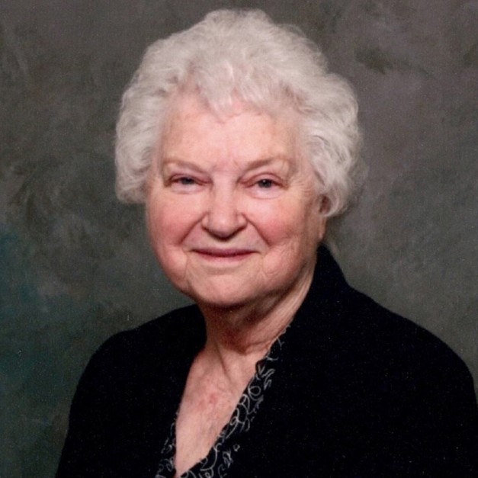
  Carol Morgan
  Carol Morgan, the wife of elder William Morgan of the Show Low (Arizona) congregation, died on Jan. 21 at age 83. She was born on Sept. 14, 1939, in Warren, Ohio. She married William on June 11, 1961. She was baptized in the Church of God in September 1963.
  She had two children, Sandra in 1962 and Brian in 1966, who are members of the Church of God. She was always known as a loving servant of God's people in assisting her husband as an elder. She loved preparing Mexican food and other dinners for Sabbath guests. She never wavered in her love of God's Truth and looked forward to His Kingdom.
  Surviving is her husband William (Bill), 88, daughter Sandra, son Brian, daughter-in-law Suzanne, grandson Jared, and granddaughters Tabitha and Abbigail.
  Compass Check subscription
  Just a reminder that all UCG teens can receive a free subscription to Compass Check. Compass Check is written especially for teens in the Church, and strives to cover topics that are relevant to our teens. Recent articles include, “How Far is Too Far?” which discusses principles of dating, “Leaving Unfit Words Unspoken” covering the problem of foul language and “Who Was Jesus?” which took an in-depth look at who Jesus was as a person. Many of articles are written by our teens and we always welcome article submissions.
  Compass Check is for teens 12–18 years old. If your teen is not already receiving their quarterly copy, please let your pastor know or write us at compasscheck@ucg.org.
  Good Works Seeking Volunteers
  Good Works is seeking two volunteer participants to serve at the youth camp in Benin, preferably one male and one female.
  Participants will need to demonstrate conversational French or a B1 level or higher French language proficiency (according to DELF standards) in order to participate effectively in the program. Volunteers will have the opportunity to develop their French skills, and contribute their own personal skillsets to the courses we will offer to the campers. Volunteers will work closely with Tim Pebworth and Werner Solórzano, as well as camp director Pierre and Rose Ogoudele to prepare and lead courses.
  Camp experience is required, either as camper or staff (though staff experience is preferred).
  Dates: Aug. 8 or 9–Aug. 27, 2023
  Cost: 50% airfare (based on economy ticket prices and reasonable itineraries reviewed by GW staff) and all necessary immunizations required by Benin and France (scholarships available).
  Deadline to apply: Mar. 12, 2023
  For more information email Lena VanAusdle at Lena_VanAusdle@ucg.org or to apply visit: ucg.org/Youth-Camp-in-Benin-2023
  
  Preaching the Gospel as a Witness to All Nations—Part 3
  In Part 1 and 2 of this report we described a variety of Internet-based media methods used today to reach people throughout the world with the good news of Jesus Christ and the Kingdom of God.
  But, it’s vital to note that any endeavor the Church pursues won’t go anywhere without God’s blessings. Consider what King Solomon wrote: “Unless the Eternal builds the house, those who labor to raise it will have worked for nothing” (Psalm 127:1, The Voice). Also, God told Zerubbabel, “You will not succeed by your own strength or by your own power, but by my Spirit” (Zechariah 4:6, New Century Version). Accordingly, all thanks and honor must always go to our Father in heaven for the financial and human resources He provides to accomplish His work.
  So, while God’s Church as a united spiritual body under Jesus Christ (Ephesians 2:19) executes its duty to preach the gospel, each one of us as individual members needs to wholeheartedly champion and rally behind this tremendous effort. And while doing so, let us pray that God will open greater media doors so that many more people in this dark age will hear and grasp the identical biblical truths that you and I are so delighted to know and understand.
  Furthermore, let’s pray for the many individuals whom God is calling right now that they will respond readily to His invitation (Matthew 22:14). Plus, as opportunities arise, let’s be eager to express to anyone who asks us the reason for the hope that lies within us (1 Peter 3:15). Finally, let us be fully determined to personally imitate Jesus Christ by our righteous behavior—as shining examples of the wonderful and inspiring gospel message reaching the nations today (Matthew 5:14-16, 24:14).
  —Peter Eddington, Operation Manager, Media and Communications Services
  Virtual Pinewood Derby 2023 Registration Open!
  The New England congregations are planning an online social event. Continuing the tradition from last year, there will be a Virtual Pinewood Derby on Sunday, March 5, from 1–4 p.m. EST.
  We have held the Pinewood Derby race each winter in New England for the last several years. It is a much-loved activity among our kids and parents. Kids love racing their homemade decorated Pinewood Derby cars down the over 30-foot-long track. We are inviting everyone to participate, no matter where you are located!
  For details and instructions on how to participate, please see the article on the UCG Members website: ucg.org/members/news/virtual-pinewood-derby-2023-registration-open.
  Online Prayer Requests
  This is just a reminder that in Sept. 2021, the home office launched a web page where church members may access recent church-wide prayer requests at any time. The address is register.ucg.org/intranet/PrayerRequests and the password for the page may be obtained from your pastor.
  Upcoming Events
  Feb. 17–19 | East Texas Regional Family Weekend | Big Sandy, TX
  Feb. 17–20 | Wamatochick Young Adult Weekend | Prescott, AZ
  Feb. 17–20 | Young Adult Winter/Ski Retreat | Pipestem, WV
  Feb. 18 | “Pride and Prejudice” Formal Dance | Westford, MA
  March 3–5 | Puget Sound Women’s Enrichment Weekend | Conner, WA
  March 5 | Virtual Pinewood Derby | (online)
  March 10–12 | Dallas/Fort Worth Regional Weekend | Plano, TX
  March 18 | SW Missouri Women’s Enrichment Event | Ozark, MO
  March 18–19 | Midwest Teen Prom | Berlin, OH
  March 19 | ABC Charity Auction | Milford, OH
  March 24–26 | Portland Women’s Enrichment Weekend | Canby, OR
  April 4 | Passover Evening
  April 6 | First Day of Unleavened Bread
  April 7–9 | Milwaukee Prom & Family Weekend | Milwaukee, WI
  April 8–9 | SE Formal Teen & Family Weekend | Atlanta, GA
  April 12 | Last Day of Unleavened Bread
  April 21–23 | Women’s Enrichment Weekend | Indianapolis, IN
  May 4 | Second Passover Evening
  May 6–8 | GCE Annual Meeting | Cincinnati, OH
  Upcoming activities may be sent to weekly_update@ucg.org. Additional calendar information is available on the members website.

