

February 2, 2023

From the President...
Good afternoon brethren around the world,
It’s said that we live in a “smaller world” today than in the past. We speak of global economies, global ideas and global problems. We have global businesses, global entertainment, global celebrities, global communication opportunities and global business people—who have power through the companies that we use and they control.
And indeed, the work God is doing spans the globe. He is working around the world in ways that even today we may not be aware of. In recent years we’ve rejoiced and been amazed when we came to realize there are people in areas of the world who are keeping God’s law and have been called as we are, yet we didn’t know anything of them. Such was the case with our brethren in Angola and our brethren in Mizoram, India—and other places we’ve heard of. God works in wondrous ways with people all over the world. Who knows where else He may be working today in nations around the world?
With specific focus this week on a couple of the several projects we have been working on in the home office, the international scope of God’s work has really struck home.

Operation Plan and Budget
By the end of this week, we will submit the Operation and Budget plans for the next fiscal year for review by Council of Elders at their next meeting. From there they (and the Council’s Strategic Plan), will go to the General Conference of Elders (which represents all our elders who serve around the world), for their review and approval.
Recognizing our responsibility to the membership around the globe, there are many initiatives and dollars included in next year’s plans which are designed to increase our interaction and service to our international spiritual family.
The Internet binds us together and makes us more visible to everyone around the world. For example, just last night I was delivering an online Bible study that included several people in the United States, but also people from five other nations who join us regularly. The ability to connect with and develop bonds of brotherhood with people around the world is amazing and so uplifting and inspiring. It is a key, we know, to our ability to preach the gospel and effectively reach those whom God is calling.

New UCG.org home page coming
For more than a year now, our Information Technology (IT) and media departments have been working in concert with a contracted web development company to upgrade and refresh the ucg.org website. That project is moving along, and we plan for the release of a completely new website at ucg.org later this year. But in recent weeks we have focused on incorporating significant and needed changes and improvements to our home page, search engine and other key areas.
Within the next week we will introduce this new home page at ucg.org. You will see a more dynamic page that allows us to more readily address key world events—and direct attention to the wealth of articles, videos and other information available on our website. Even many of our members may have forgotten or are not using what is available to them.
One of the features we have planned is a Bible study video series with seven “episodes” leading up to Passover. Watch for the first video to be announced in a few weeks here in the Home Office Weekly Update. Additionally, a Bible reading program and other interactive features are being developed—along with arranging and highlighting our Bible Questions and Answers section, making it more readily accessed.

YouTube sermon page
The Church’s YouTube channels are being updated with new sermons, Ambassador Bible College classes and other videos regularly; and along with the weekly Sabbath webcast from the home office in Cincinnati, we are more focused on how we can use the technology of this age and the skills and talents of our staff to more effectively preach the gospel around the world—as well as provide education, inspiration and care for all our brethren who live all over this world.
Christ said that He is “the way, the truth, and the life.” Please continue to ask God to guide all of us and direct our paths so that we follow Him and do things His way, preaching and providing His truth to all our members and to the world. And may we all continue to get to know God better and to walk in His ways as He leads us to His Kingdom and eternal life.
May God be with you all. Have a wonderful rest of the week and Sabbath day.
In Christ’s service,

Rick Shabi

From Ministerial and Member Services...

Death of Bill Robinson
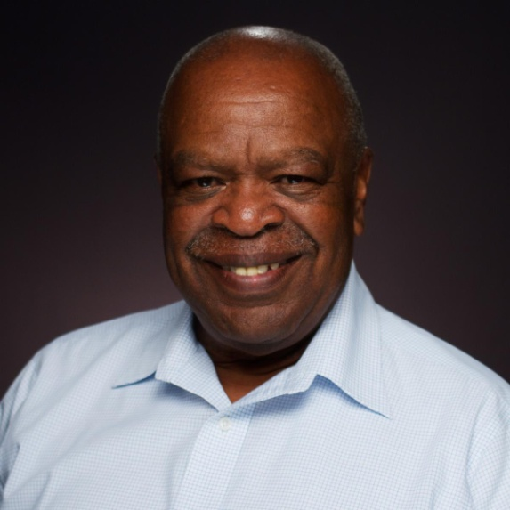
Bill Robinson
Bill Robinson, an elder in the Columbia, Maryland, congregation, died after a brief illness on Jan. 8, 2023, at age 75. Bill was born on the Eastern Shore of Maryland. In high school, he excelled academically and developed a passion for music of all types from jazz to classical. Bill attended Morgan State College in Baltimore, where he majored in mathematics. Bill married the love of his life, Nancy Carolyn Moore, and soon welcomed Tira, William the 3rd, Allysha and a niece Patrice into their home.
Bill’s faith was a central aspect to his life. In late 1974, Bill and Carolyn began attending the Worldwide Church of God in Baltimore, Maryland. He was baptized in 1976 and committed himself to learning God’s ways and service. Bill participated in Spokesman’s Club, choirs and a variety of youth programming of the Church. His passion included spending time and developing deep relationships with brethren from many areas of the country.
In 1995, Bill and Carolyn began attending the United Church of God in Columbia. He was ordained a deacon in June 2000 and an elder in April 2014. Together with Carolyn, Bill was active in the care and support of the brethren. Ever ready to serve, he opened his home to guests for services, summer relaxers, church picnics and was present at many other social gatherings. He blessed babies, assisted with baptisms, and taught about a walk of life focused on Jesus Christ and our Heavenly Father.
In retirement, Bill discovered a love of gardening. He spent many hours developing garden spaces around his house, where he grew beans, peppers, greens, cabbage and tomatoes that routinely grew over 12 feet in height. He became an expert at using his intellect and creativity to solve problems and improve our growing areas, including converting an old chicken coop into a greenhouse, used with great success last year.

Death of Phyllis Knochel
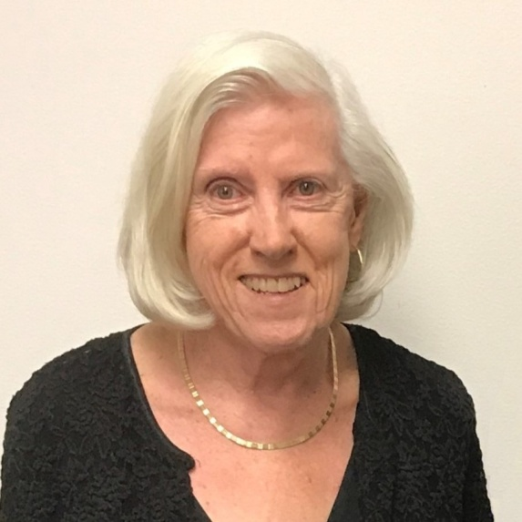
Phyllis Knochel
Phyllis Knochel, the wife of elder Gerald Knochel of the Central Illinois congregation, died on Jan. 18, at age 87.
Phyllis valued hard work, and she appreciated those who did the same. In her early years, she was employed as a cap nurse. Later, she ran a small housecleaning service while supporting her husband’s window washing business. She was a considerable gardener. As a member of the United Church of God, Phyllis’s faith in God was always her top priority. She died with full confidence in God’s plan.
A full obituary is available online.

Recent Ordination
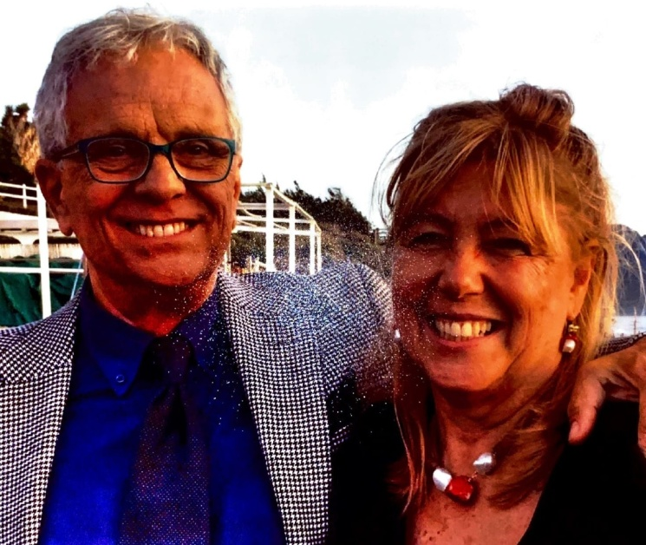
Enzo and Margherita Alfieri
On Oct. 17, 2022, Enzo Alfieri was ordained into the ministry. He and his wife, Margherita, serve in the Bergamo, Italy, congregation.



The Work of God in Angola
Jorge de Campos, senior pastor of the work of God in the Portuguese-speaking areas, wrote: “Angola is a Portuguese speaking country in southwest Africa which is about 1.8 times bigger than Texas, with about 35 million people. UCG Angola has 70 congregations, 1,800 baptized members and an average Sabbath attendance of 4,500 brethren. We are printing 1,500 Boa Nova magazines (the 28-page Portuguese version of Beyond Today) in Angola.
“The Boa Novas are distributed by hand to the various congregations, which saves mailing costs. Those who have access to the Internet are able to listen to weekly Portuguese sermons online. The sermons are also transcribed and then printed locally and personally distributed to remote areas.
“The greatest concern in Angola is that their national law of ‘religious freedom’ requires a church to continue assembling only if they have in Angola 60,000 signatories as members of the organization. Their Angolan National Council is looking at legal ways to address this seemingly impossible situation. In the meantime, the brethren continue to gather in peace. Their faith that they will be able to resolve the issue with God’s help is very encouraging. Please pray for open doors and favor so that these brethren may continue to assemble and fellowship in peace.”
—Peter Eddington, Operation Manager, Media and Communications Services

Milwaukee Teen Prom—Apr. 7–9
The Milwaukee, Wisconsin, congregation will be hosting a Teen Prom and Family Weekend this coming spring. The dates are April 7–9, 2023, which is during the Days of Unleavened Bread.
Activities planned will include a Friday evening Q & A, Sabbath morning seminar/teen Bible study/Sabbath School, Sabbath services, a formal dinner and dance for the teens, a recognition of those teens graduating from high school, a Sabbath evening social and activities for the families and pre-teens.
The cost for teens participating in the prom events will be $48/person. More details are available at the website for this event: https://milwaukeeteenprom.wordpress.com/
We look forward to sharing this special weekend with you!

Upcoming Events
Feb. 4–5 | Atlanta Ski Trip | Gatlinburg, TN
Feb. 17–19 | East Texas Regional Family Weekend | Big Sandy, TX
Feb. 17–20 | Wamatochick Young Adult Weekend | Prescott, AZ
Feb. 17–20 | Young Adult Winter/Ski Retreat | Pipestem, WV
Feb. 18 | “Pride and Prejudice” Formal Dance | Westford, MA
March 3–5 | Puget Sound Women’s Enrichment Weekend | Conner, WA
March 10–12 | Dallas/Fort Worth Regional Weekend | Plano, TX
March 18 | SW Missouri Women’s Enrichment Event | Ozark, MO
March 18–19 | Midwest Teen Prom | Berlin, OH
March 19 | ABC Charity Auction | Milford, OH
March 24–26 | Portland Women’s Enrichment Weekend | Canby, OR
April 4 | Passover Evening
April 6 | First Day of Unleavened Bread
April 7–9 | Milwaukee Prom & Family Weekend | Milwaukee, WI
April 8–9 | SE Formal Teen & Family Weekend | Atlanta, GA
April 12 | Last Day of Unleavened Bread
April 21–23 | Women’s Enrichment Weekend | Indianapolis, IN
May 4 | Second Passover Evening
May 6–8 | GCE Annual Meeting | Cincinnati, OH

Upcoming activities may be sent to weekly_update@ucg.org. Additional calendar information is available on the members website.

