

April 20, 2023

From the President . . .
Greetings brethren around the world,
I hope that the Passover and Feast of Unleavened Bread were deeply meaningful and spiritually beneficial for you. We need the annual reminder God gives us each year of the salvation that comes only through Jesus Christ.
There are experiences in life that cause us to look at the world in a different way and to understand our absolute need for Christ and God’s Spirit. In 2 Corinthians 4:4, Paul tells us that Satan is the “god of this age.” The world is quickly becoming more and more like him. As God’s people, we are called to become more and more like God. We must make choices to leave the world and its ways and attitudes behind and choose to follow God, and to live the way of life to which He has called us.
We see the evidence of a quickly changing system and set of values in Western culture that is headed in the direction of totalitarianism—attempting to dominate our lives in every aspect. God has graciously and kindly given us time now to be turning ever more closely to Him and away from the world, and to wake up to what is going on around us so that we are not caught “sleeping” when the “time” comes.
Life in the West is much different than life in other parts of the world, I continue to learn. The pressures we feel in the United States are literally “nothing” compared to what our brethren around the world face every day.

Biblical Tour of Seven Churches of Revelation
Yesterday my wife and I returned from an eight-day educational “journey” through Turkey, visiting the sites of the seven churches of Revelation (Revelation 2 and 3). There were 54 of your brethren on this trip, which was capably and very well coordinated by Darris McNeely, in conjunction with a Turkish tour group. Biblical messages and passages related to those seven churches found throughout the New Testament were read and discussed, as well as the history and lifestyle of those cities.
The experience was beneficial and eye-opening in many ways, as these types of trips are. We learned a lot about those cities and the meaning and archaeological significance of some of the descriptions Christ used in His letters—illustrations that recipients back then would have understood. Several pastors were on this trip, and I’m sure you will see the effect of firsthand experience in their upcoming messages. Our Media department, in concert with Mr. McNeely, will also be producing a documentary on the trip which will include most of the discussions and presentations, as well as video footage of each place visited.
While the “tour” itself was beneficial in many ways, just being with God’s people for what amounted to 10 days in a row was wonderful, too. It was like a mini-Feast of Tabernacles. As you walk through the cities—most notably Ephesus, Laodicea and Pergamos where a lot of excavation has been done—you begin to see how beautiful and magnificent to human eyes those places must have been. When you see the ruins of temples that were erected to false gods, you begin to see how people devoid of God’s Spirit and understanding might have been in awe of such amazing structures.
The ancient world was steeped in paganism—steeped in such a way that you and I in America, England, Canada, Australia, New Zealand and English-speaking nations do not understand. Our Christian brothers—true Christians like Paul, Timothy, Apollos, Aquila and Priscilla—lived in a world surrounded and dominated by false gods and religion. While we were in Turkey (now called Türkiye), we heard the Muslim calls to prayer broadcast throughout the area from the local mosque—a reminder of the dominant religion in that area, and that we are not part of that system. God’s people in ancient times were reminded daily of the paganism and wrong, sinful culture in which they lived and walked.
And they came out of it.

Brethren in Hardship
Today I am learning, and continue to learn, about the pressures and challenges that our brethren—true Christians who have been called and are striving to live by every word of God, led by His Spirit—are facing that we have not faced in America.
This is God’s Work and His Work is a worldwide work. Jesus Christ died for all mankind and His will—as He so clearly stated to His disciples on His last Passover night on earth—was that we “become one” and that we all, wherever we live, “live by every word of God.” The same message, the same gospel, the same way of life is to be taught, preached and practiced by every member of God’s Church around the world. We are all responsible to see that this happens in our individual lives, our families and in the collective body of Christ. That is His will, and we must do it.
Immediately following this letter is a short article on our brethren in Bangladesh, where (you will remember) the first couple from that nation was baptized a few months back. Life is very different in Bangladesh than in America, the Philippines or even nearby India. Our brethren there face pressures in ways we have not heard before.
Our brethren in Europe—especially in places like Italy, Germany and France dominated by false religion—also face pressures, situations and choices that we are learning more about. God wants His people to know each other, understand each other and to be praying for one another.
“Bear one another’s burdens, and so fulfill the law of Christ” (Galatians 6:2).
As we walk forward from the Days of Unleavened Bread into a world that will become more fraught with strange doctrines and philosophies, let us renew and strengthen our faith and trust in God, growing closer to Him and to each other, always encouraging each other to stay on the path to the Kingdom, and fervently praying for each other. “The effective fervent prayer of the righteous man avails much” (James 5:16). May His Kingdom come.
Have a wonderful day of preparation and Sabbath. Our thoughts and prayers are with all of you.
In Christ’s service,
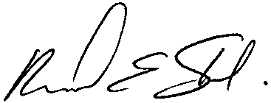
Rick Shabi

From the International Work . . .

Update on Work in Bangladesh
You will remember from a few months back that David Schreiber, senior pastor over India and Sri Lanka, wrote to us about a couple from Bangladesh who made their way to India to be baptized. They are Manik and Rita Biswas Balaam, and if you want to read the history of their calling again, you can find it here.
Within the past week, Mr. Schreiber has given us an update on Manik and Rita. It is in one way very encouraging, and in another way very instructive and educational about the power of religious authorities in some areas of the world.
Since their baptism, Manik and Rita have been talking with people in their village about their calling and the truth of the Bible. As a result, there is now a group of 18 people who are meeting every Friday evening at Manik’s home for a Bible study.
How encouraging and exciting it is to see God at work, as He is beginning to open the eyes of people in this nation! Please pray for God’s continuing guidance and direction for Manik and Rita, as well as the people He appears to be calling.
As this group has developed, it has also caught the attention of religious leaders and the “District Commissioner” in the village, who has given some directives regarding religious gatherings. Bangladesh is a Hindu nation and while they are tolerant of Christians, there is not religious “freedom” in Bangladesh as there is in America. Rita and Manik have been told how the Church must operate if it is to continue.
We are working with the situation in Bangladesh to ensure the Church can grow and operate in the manner things are done in that nation, while following God first. Meanwhile, the brethren are feeling pressures and trials. We will provide more details on this at a later date, but please keep the people God is calling in your prayers, that He may give them the strength and courage to continue and not yield to the pressure being put on them. Also ask Him to guide us in what needs to be done in this area of the world so that His Work may continue.

Update on Philippines Trip from David Dobson
We arrived in Manila late Wednesday evening, March 29. On Friday, we flew to Butuan City for the Sabbath. We enjoyed being with 42 members at services in Butuan City. We had not been there in probably 6 or 7 years, so it was past time to visit.
A member family from Davao (on the southern part of Mindanao) had driven up to Butuan for the Sabbath. On Sunday, they drove us on the six-hour trip down to Davao where we spent the next week.
On Tuesday evening, 38 members observed the Passover service in Davao. Members from the Santo Tomas congregation joined us. One of our young men who gives sermonettes assisted me in conducting the service and he did a fine job. I encourage the Filipino elders to always have one of the other men assist them, so they log valuable experience in various service roles within the Church.
The Night to Be Much Observed in Davao was kept by about 30 of us. For the first Day of Unleavened Bread, the Sto. Tomas members returned to Davao for a combined service with an attendance of 75.
For the Sabbath of April 8, we traveled to Sto. Tomas for Sabbath services with 43 brethren. (This congregation is near the prisons where Jed Sy and Jong Pilapil are incarcerated). The Sabbath was buzzing with excitement since they were meeting in a newly constructed hall for the first time! Some U.S. church members had made donations through their place of work to LifeNets, and their company matched their charitable donations. LifeNets graciously forwarded the funds to the Manila office, and enough money was provided for a community center to be constructed. A formal dedication of the building took place before services.
The building now serves as the Sto. Tomas Sabbath hall and is also available for charitable needs in the community. The area is prone to storm damage and flooding from typhoons, so the building can be used as shelter and for distributing relief goods. It can also serve as a school classroom if necessary.
On Sunday, we visited Jed and Jong in their prisons, and then we traveled to Cebu City to observe the Last Day of Unleavened Bread. The attendance was 27 for morning and afternoon services, which is about double the number from before the pandemic. We were thrilled to meet several who started attending services in the last two years.
We flew to Bacolod, which is on the island of Negros, where we joined 13 people for services on the Sabbath of April 15. They are a close-knit, happy group of members.
On this trip, we were also able to meet with the Luzon elders and wives for a lunch meeting. We discussed the need to start a speech club for the elders. This is like the program Ministerial and Member Services conducted for the U.S. pastors over the last three years. Also, we plan to start a separate speech club for those who give sermonettes during Sabbath services.
In adding up attendance figures for all Sabbath and Feast services for this trip, we personally saw well over 200 of the Filipino brethren. In addition, we spent at least a little time with seven of the ten elders in the Philippines.

From Ministerial and Member Services . . .

Recent Ordination
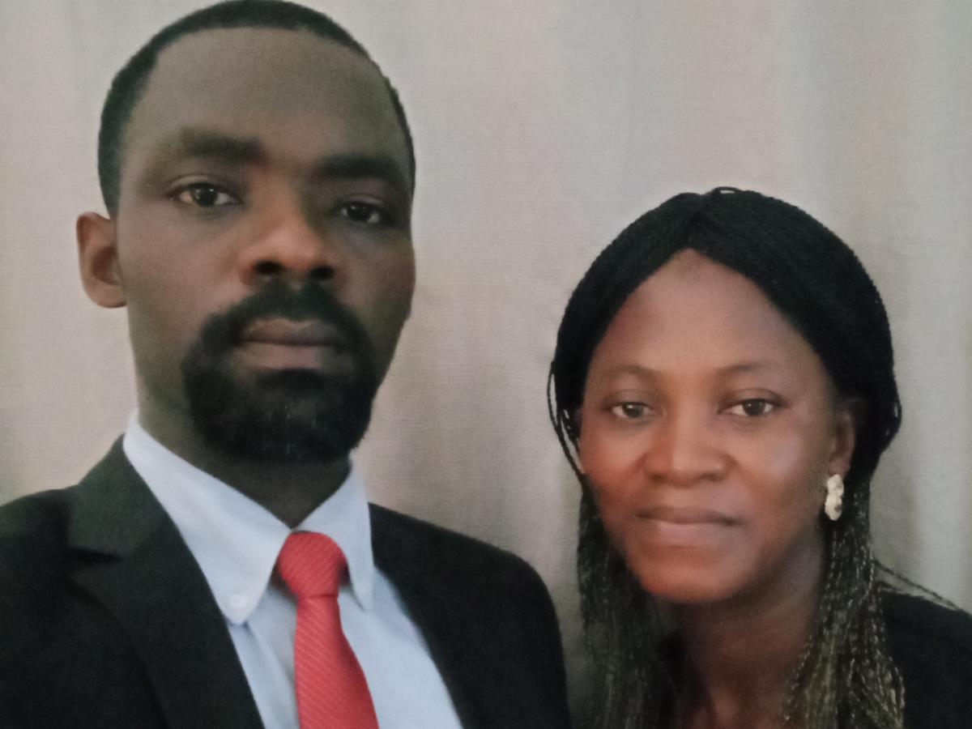
Pierre and Rose Ogoudele
On March 18, 2023, Pierre Ogoudele was ordained into the ministry. He and his wife, Rose, serve the congregation in Cotonou, Benin.

Upcoming Ministerial Transfer
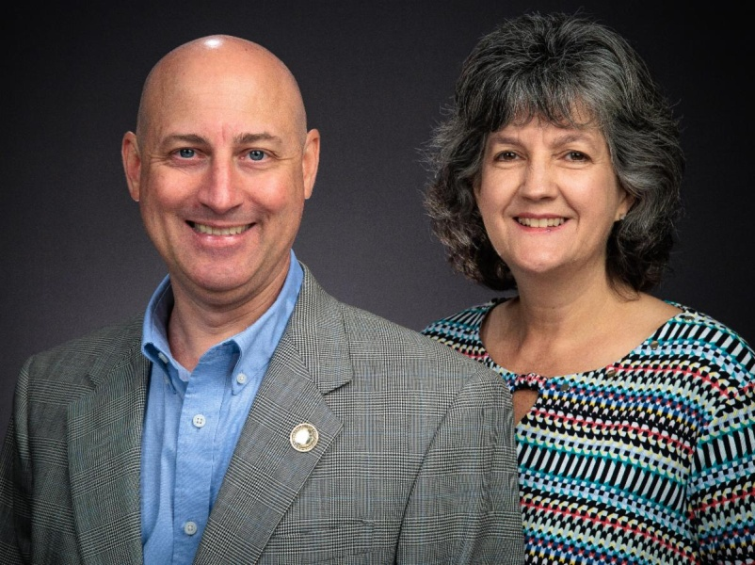
Jeff and Alisa Lockhart
Later this summer, Mr. Jeff Lockhart and his wife, Alisa, will be transferred from the Ft. Lauderdale, Florida, area to Ft. Worth, Texas. Mr. Lockhart will work with pastor Jorge de Campos and serve as associate pastor to the Ft. Worth, Texas, and Lawton, Oklahoma, congregations. He will continue to assist Chuck Smith with pastoring the congregations in Jamaica.

New Beyond Today TV Series Premieres April 23
The Beyond Today production team has been working on three, new, five-part video series—the first of which airs April 23 and 30, and May 7, 14, and 21.

The first series, presented by Darris McNeely, is on the subject of “Joseph’s Birthright.” Why did millions of people around the world watch the funeral of Queen Elizabeth II? Why in a modern world are people fascinated by the person who wears the crown in Great Britain? Could it be there’s something more than celebrity and glamour that’s connected with this ancient structure called the British Monarchy?
This five-part Beyond Today video series will show you how that monarchy relates to the Gospel of Jesus Christ and the Kingdom of God. You’ll see how God guides history, and how this story explains much in today’s world. You can watch the entire first series at ucg.org/tv.
In addition, a comprehensive advertising campaign will launch next week and run for 14 weeks to advertise each five-part series as it begins. The first five weeks will be advertising the “Joseph’s Birthright” series on The WORD Network and 18 broadcast TV stations in these cities:
- MyNetwork Ft. Smith-Fayetteville, Alabama
- CW Network Huntsville-Decatur, Alabama
- ABC Springfield-Decatur-Champaign, Illinois
- ABC St. Louis, Missouri
- CW Network Minneapolis-St. Paul, Minnesota
- CW Network Grand Rapids-Kalamazoo, Michigan
- CW Network Milwaukee, Wisconsin
- MyNetwork Birmingham, Alabama
- MyNetwork Harrisburg, Pennsylvania
- MyNetwork Corpus Christi, Texas
- MyNetwork Omaha, Nebraska
- MyNetwork Wichita-Hutchinson, Kansas
- MyNetwork Wilkes-Barre, Pennsylvania
- MyNetwork Greensboro-Winston-Salem, North Carolina
- MyNetwork Cincinnati, Ohio
- MyNetwork Dayton, Ohio
- MyNetwork Indianapolis, Indiana
- MyNetwork Chattanooga, Tennessee
We will also be advertising each series on YouTube, Google and Roku.
The second series is titled “Unmasked,” and will be presented by Steve Myers. The third series is titled “The Unknown Jesus” and will be presented by Gary Petty.
Please pray for the success of each series and the corresponding advertising campaigns that are designed to draw people to the Beyond Today television program, our ucg.org website and the global work of the United Church of God, an International Association.
—Peter Eddington, Operation Manager, Media and Communications Services

Sabbath Services May 6
Pastors should be aware that on May 6 (the weekend of the General Conference of Elders meeting) services will be webcast live from Cincinnati. Split sermons will be from President Rick Shabi and GCE Chairman Len Martin. Connection to the service can be found at ucg.org at the Webcast tab. The time will 2 p.m. EDT. For those congregations that meet later in the day, the full Church service will be available within 30 minutes after the service in Cincinnati. That link can be found at the Sermons tab.

Feast of Tabernacles Announcements

Feast Registration Announcement
By now everyone should have received their Festival Planning Brochure in the mail.
This Sunday, April 23, Feast registration opens at 12 p.m. EDT. Also, those who have special needs and qualify for early housing may make their housing reservations this coming Sunday, too. General housing reservations begin on Sunday, April 30.
To begin the online registration process go to: feast.ucg.org. Select the site you are interested in, then look for the blue band that reads “Click here to register.”
If you have problems, check with your pastor, festival advisor, or you can email USFestival@ucg.org or call (970) 484-5878.

Branson Feast Site
For those who qualify for early housing and were considering staying at the Baymont Inn—it has changed ownership and is temporarily not ready for new business. The new name is The Boardwalk Inn, and their new phone number is (417) 417-0411. They are honoring the rates listed in the Feast Planning Brochure and online at the Branson webpage. They will begin taking reservations on May 8.

Jamaica and Dominica Feast Sites
Registration for the sites in Jamaica and Dominica has already begun and both sites still have room for new registrations.

Festival 2023 Updates for Pastors
All pastors will receive today 2023 updates for tracking local congregational Feast information. This information can be forwarded to your congregational festival advisor. The sections are (1) Designating a Festival Advisor, (2) Festival Advisors Registering Others, (3) Congregation Feast Reports, (4) Members Registering for Multiple Feast Locations, and (5) Request for a specific information or to change a registration.

Upcoming Events
April 23 | Festival Registration Begins
April 30 | Festival Housing Reservations Begin
May 4 | Second Passover Evening
May 6–8 | GCE Annual Meeting | Cincinnati, OH
May 22–26 | ABC Continuing Education | Milford, OH
May 26–28 | Brown County Pentecost Weekend | Nashville, IN
May 28 | Pentecost
May 29–June 2 | Camp Florida | Umatilla, FL
June 4–7 | Camp Gilmont | Gilmer, TX
June 18–21 | Camp Colorado | Allenspark, CO
June 18–25 | Camp Cotubic | Bellefontaine, OH
July 2–9 | Camp Pinecrest | Fredericktown, MO
July 7–9 | Colorado Women’s Enrichment Weekend | Allenspark, CO
July 9–12 | Camp Ironwood | Stewartville, MN
July 9–12 | Camp Ochoco | Prineville, OR
July 9–16 | Southwest Camp | Prescott, AZ
July 9–16 | Boundary Waters Adventure | Voyageurs NP, MN
July 21–28 | Camp Woodland | Temple, GA
July 23–30 | Northwest Camp | Rockaway Beach, OR
Upcoming activities may be sent to weekly_update@ucg.org. Additional calendar information is available on the members website.

