
  
  April 18, 2024
  From the President . . .
  Greetings brethren around the world,
  Reflecting on Jesus’ sacrifice
  In just a few days, baptized members of the Church will commemorate the most important event in human history—the death of our Savior, Jesus Christ. As we approach this time, it is vital that we take the time to contemplate Jesus Christ and what He did for all of us. He is the reason you and I are here and know the wonderful truth and plan of God. He is the reason there is hope and a future for all mankind. He is the name—the only name—by which salvation comes. And we are called to become like Him in all aspects of our lives.
  I hope everyone will take time out of our busy lives to put aside the smartphones, to get away from the computer, television or other entertainment device, and those things that distract us. Go somewhere, shut the door and make the time to contemplate what Christ did for you, me and all of mankind.
  His willingness to suffer and die an agonizing physical death, His willingness to endure the mockery, the looks of glee when His enemies saw Him suffer, the hatred they felt for Him who did nothing but good in His life, the cruelty of human nature and the works of the flesh (Galatians 5:19) including the envy, pride and selfish ambitions of the religious leadership of that day, were all on full display as He lived the last days of His life.
  Think about what He endured and why He did it. He did it because He loved mankind—you and me—so much. Jesus and the Father were absolutely committed to the plan for mankind that they established. It was the only way for their ultimate plans for eternity to move forward. Despite the pain, despite the hatred from His own people, Christ moved forward, not deterred from accomplishing His mission.
  Reflecting on Jesus’ suffering for us
  Contemplate that, meditate on His trials, read through the Bible accounts of His suffering. Let it enter into your minds and hearts. Let it and God’s Spirit lead you to the love for God and your commitment to follow God and the example of Christ. Be committed to His calling and His will.
  While you contemplate His love, also contemplate the immense capacity that true agape love produces in us. Christ forgave all those who tortured and were happy to see Him suffer. As they mocked, jeered, cast false accusations His way and roused the Jewish crowds against Him, He said as He was dying and suffering, “Father, forgive them for they know not what they do.”
  God’s Holy Spirit was notably absent among the Jews of His day and those who welcomed His crucifixion and death. It was notably in Jesus Christ, who did not allow the cruelty and anger of human nature to deter Him from what He was on earth to do.
  Be very thankful to God for His Holy Spirit and for opening our eyes. Be very thankful to God for His Holy Spirit that leads us into truth, understanding, forgiveness and makes us aware of the faults, sins, attitudes and pride that we need to overcome.
  “Open our eyes that we may see” one old song says. Our prayer and focus as we head toward Passover should be in honest examination of ourselves, as Paul says in 1 Corinthians 11:27-32. David echoes those words when He sincerely asks God to “try me and know my anxieties.” What drives us and motivates us? Is it humility and acceptance of God’s plan and guidance in our lives—or do we seek our will rather than His, as the Pharisees of old did?
  David continues, “Search me and see if there is any wicked way in me” (Psalm 139:23-24).
  Let’s take the time and make the time to beseech God for honest self-examination and to reveal the sins, faults, weaknesses and wrongful attitudes that are in us, and grant the heartfelt sincere repentance that He desires so that we come before Him as His people with willing and humble hearts at Passover, commemorating our Savior’s death, sacrifice and love for us in the worthy manner God desires.
  Days of Unleavened Bread
  During the next few days, we will also be completing our preparation for the Days of Unleavened Bread, which begin with the Night to Be Much Observed this coming Monday evening, April 22. All leavening must be out of our homes before that time.
  Just like the proper observance of Passover, there is work that must be done before these holy times begin. You are taking the time to clean your homes, search for leavening and throw it out. As you do, remember and review the admonitions and symmetry of the God-inspired writings of Paul in Colossians 3:1-9 which lists some of those items we “put out,” or “put off” our lives.
  Get rid of that physical leavening, but also focus on identifying and putting out the spiritual sins and faults of our lives. Put it out, get rid of it, and let’s purpose in our hearts as God’s people to overcome and develop and strive for the true unity, physically and spiritually, that Christ prayed for in His final hours.
  Christ did it for us. He showed us the way and His death made possible for us to receive the Holy Spirit, which is the only way we can overcome and please Him.
  Eating unleavened bread
  As we put out the sin, also be prepared to have unleavened bread ready to eat all seven days of the Days of Unleavened Bread. Remember the admonition God gave His people, Israel, in Exodus 13:9: “[Eating unleavened bread] shall be as a sign to you on your hand and as a memorial between your eyes, that the LORD’s law may be in your mouth; for with a strong hand the LORD has brought you out of Egypt.”
  Paul reiterated those words in 1 Corinthians 5 as they put out sin from the midst of their church and were admonished to “keep the feast with the unleavened bread of sincerity and truth” (1 Corinthians 5:1-8).
  Brethren, have a very meaningful and inspiring upcoming Sabbath, Passover and Days of Unleavened Bread. Many ministers from the home office will be traveling to various areas in the United States this Sabbath and Passover. Please pray for God’s protection and guidance on all of us.
  My wife and I are looking forward to being with the Hartford, Connecticut, congregation this Sabbath and the New York City congregations for the Passover, Night to Be Much Observed and the first Holy Day. Truly, one of greatest blessings in the role of service I have is to meet our brethren in the various areas we have had the opportunity to visit.
  God has called a wonderful group of people. You are all in our thoughts and prayers daily.
  In Christian love,
  
  Rick Shabi
  Northeast Region Pastoral Conference
  The pastoral conference for the Northeast region was held April 9–11 and attended by 47 pastors and wives. This was the fifth of our six scheduled regional meetings. We met at the Potomac Park Conference Center in Falling Waters, West Virginia, which is near Baltimore and Washington D.C.
  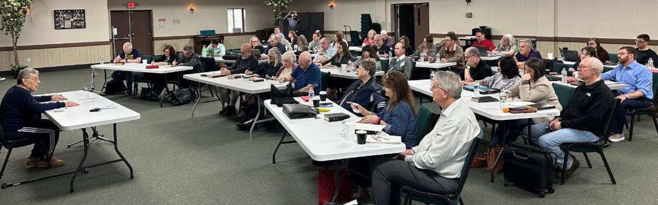
  1 Corinthians 1:10 set the theme of “speak the same thing” with presentations and many hours of interactive discussions. Topics ranged from policies, ethics, doctrine and pastoral responsibilities.
  One of the attendees commented that they “appreciated the fellowship and camaraderie with one another.” It certainly was an opportunity to “get on the same page” and strive to “come to the unity of the faith and unity of the Spirit” (Ephesians 4).
  —Steve Myers, Operation Manager, Ministerial and Member Services
  From Ministerial and Member Services . . .
  Death of Richard Duncan
  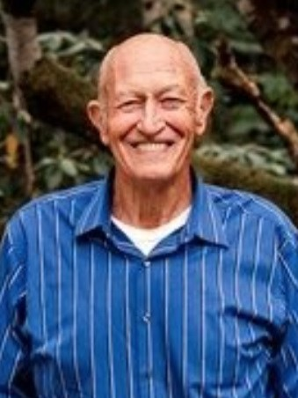
  Richard Duncan
  Long-time elder and retired pastor Richard Duncan passed away suddenly and unexpectedly on April 10, 2024, at the age of 90 at his home in Ridgefield, Washington. Richard was affectionately known as the I-5 minister because throughout his employment history in the Church he served congregations along the I-5 corridor in Olympia, Vancouver, Everett and Sedro Woolley, Washington, then Salem and Albany, Oregon, which was his final pastoral assignment in the United Church of God. He retired to Ridgefield, Washington, in 2002 and served in support of the Portland, Oregon, congregation until his death.
  Richard was beloved by many whose lives he touched through his spiritual messages, weddings, baptisms, counseling, and the many children he blessed over his long years of service. He ran his race well, served the brethren faithfully, and will be greatly missed. While we mourn the loss of this wonderful servant, we take comfort that we will see him again, glorified at the return of Christ.
  Cards may be sent to his wife, Betty, to whom Richard was married for 70 years, at the following address:
  Betty Duncan
  29220 NW 71st Ave
  Ridgefield, WA 98642
  United Youth Camps Volunteers Needed
  Camper and staff registration has been open for just over one month and already we are beginning to see a need for specific help at several of our camps. Please review the list below and reach out to the specific camp director if you would like more information, or apply online at: uyc.ucg.org/online-registration
  Cotubic:
  - Counselors and Assistant Counselors (male & female)
  - Nursing/First Aid
  Pinecrest:
  - Counselors and Assistant Counselors (male & female)
  - Dance Class Instructors
  - Lifeguarding
  - Nursing/First Aid
  Southwest:
  - Counselors and Assistant Counselors (male & female)
  - Kitchen Staff
  Pre-teen Camp Gilmont:
  - Male Counselors
  United Youth Camps Scholarships
  Each year generous donations are made for the purpose of assisting parents and campers with the expense of camp tuition. There are several factors to be considered in order to be approved for a scholarship, but if you would like to be considered for a scholarship, please speak to your local pastor first to determine if there is any assistance available at the local level. If not, then please contact the director of the camp you have applied to attend.
  May 4—GCE Sabbath Service Live From Cincinnati
  As a reminder, during the General Conference of Elders weekend, Sabbath services on May 4 will be webcast live at 2 p.m. EDT. Go to ucg.org and look for the Webcast tab.
  Michigan Camping/Tubing Weekend—June 28–July 1
  You are invited to join the West Michigan UCG congregations for a weekend of fellowship, camping and fun-filled outdoor adventure! There is a special outdoor Sabbath service on June 29 at Sandy Beach County Park in White Cloud, Michigan, and organized tubing trips on the Muskegon River for Sunday morning, June 30 and Monday morning, July 1. If you would like further details or a copy of the flyer advertising the event, contact Christina Morris at 269-903-1902 or stinamsu@yahoo.com. A copy of the flyer may be downloaded here: West Michigan Weekend Flyer 2024.
  Upcoming Events
  Apr 21 | Passover Evening
  Apr 22 | Night to be Much Observed
  Apr 23 | First Day of Unleavened Bread
  Apr 29 | Last Day of Unleavened Bread
  May 2 | Festival Housing Reservations Begin
  May 4–6 | GCE Annual Meeting | Cincinnati, OH
  May 10–12 | Spokane Women’s Enrichment Weekend | Loon Lake, WA
  May 21 | Second Passover Evening
  May 24–27 | Smoky Mountain Young Adult Retreat | Townsend, TN
  May 27–31 | Camp Florida | Umatilla, FL
  Jun. 2–5 | Camp Gilmont | Gilmer, TX
  Jun. 16 | Pentecost
  Jun. 23–26 | Camp Colorado | Allenspark, CO
  Jun. 23–30 | Camp Cotubic | Bellefontaine, OH
  Jun. 28–Jul. 1 | West Michigan Camping/Tubing Weekend | White Cloud, MI
  Jun. 30–Jul. 7 | Camp Pinecrest | Fredericktown, MO
  Jul. 7–14 | Southwest Camp | Prescott, AZ
  Jul. 14–17 | Camp Ironwood | Stewartville, MN
  Jul. 14–17 | Camp Ochoco | Prineville, OR
  Jul. 19–26 | Camp Woodland | Temple, GA
  Jul. 21–28 | Northwest Camp | Rockaway Beach, OR
  Upcoming activities may be sent to weekly_update@ucg.org. Additional calendar information is available on the members’ website.

