
  
  April 13, 2023
  From Ministerial and Member Services . . .
  Recent Ordinations
  On the First Day of Unleavened Bread, April 6, four elders were ordained.
  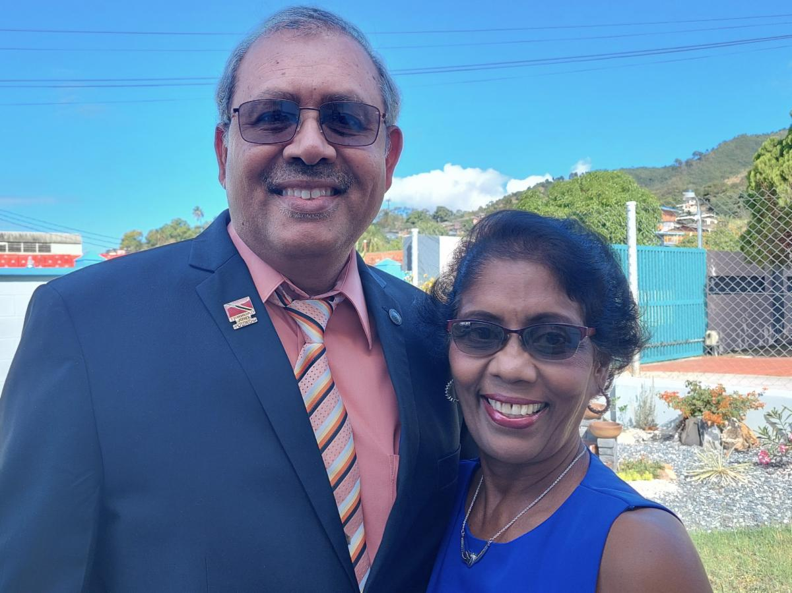
  Dale and Indeera Bissessar
  Dale Bissessar was ordained into the ministry; he serves the congregation in Trinidad and Tobago with his wife, Indeera.
  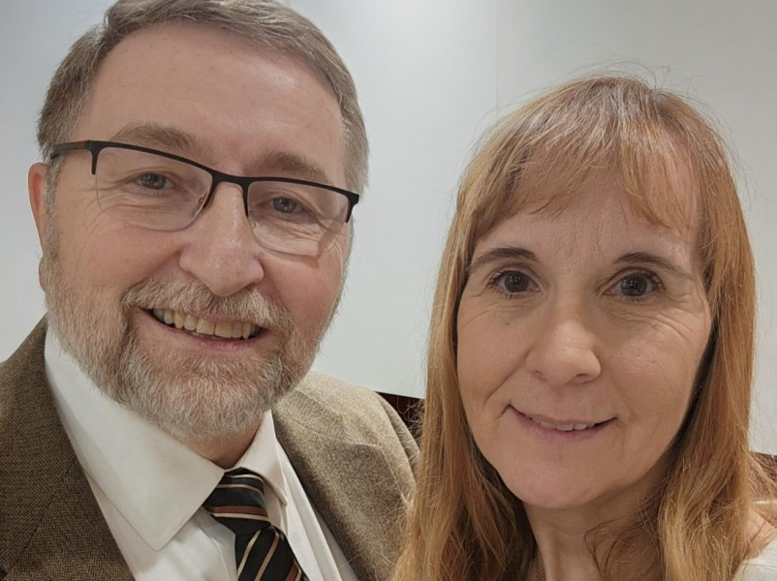
  Carl and Kathy Kinsella
  Carl Kinsella was ordained into the ministry; he serves the congregation in Salem, Oregon, with his wife, Kathy.
  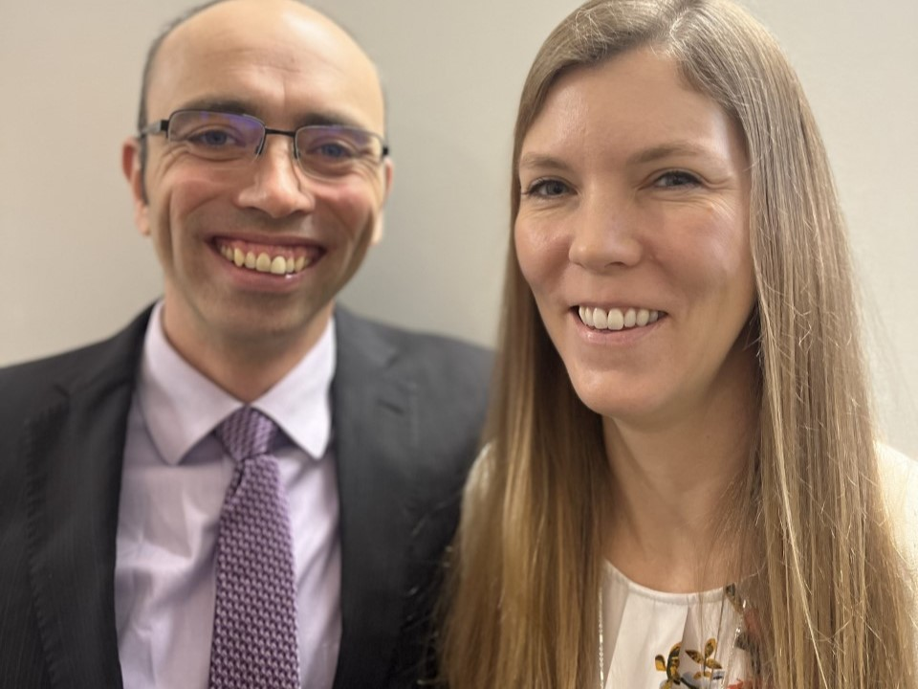
  Carl and Sabrina Koester
  Carl Koester was ordained into the ministry; he serves the congregation in Salem, Oregon, with his wife, Sabrina.
  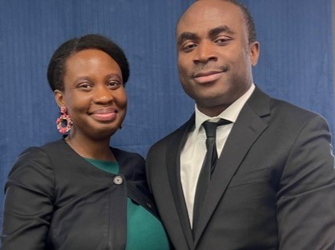
  Madu and Ivie Nkwocha
  Maduawuchi Nkwocha was ordained into the ministry; he serves the congregation in New York City, New York, with his wife, Ivie.
  Recent Appointment
  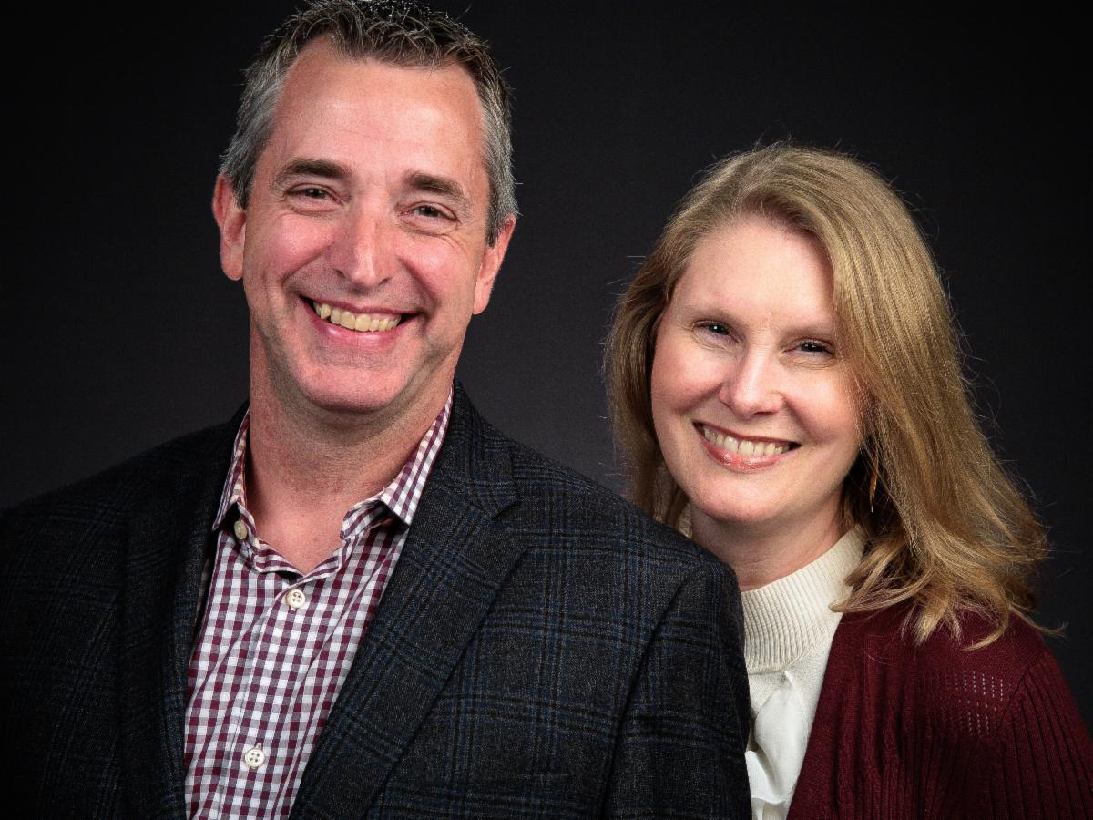
  Ed and RaeAnn Dowd
  Ed Dowd has been named the International Senior Pastor for the United Church of God congregations in Zambia, which is in south-central Africa. Mr. Dowd is working with the previous senior pastor for Zambia, Aaron Dean, in the transition for his new role. He will continue to serve as pastor to the Tulsa and Oklahoma City, Oklahoma, congregations.
  United Youth Camps Video
  To all U.S. Pastors: Please play the UYC video for the sermonette period on one of the upcoming Sabbaths (April 15, 22 or 29). It can be downloaded at: 2023 Camp Film (be sure to use this link, and not the URL where you are redirected after opening the link in your browser).
  Please note: Do not stream this by playing from a browser. The file should be downloaded and played locally. The link above must be used to access the file, so please forward the link above to your A/V crew or person responsible for playing the video.
  To introduce the video: “During the sermonette time today, the home office has asked us to play the United Youth Camps video. This video is about 18 minutes long and will provide a brief glimpse at our United Youth Camps program and the theme for the upcoming year.”
  United Youth Camps Announcement
  (Regardless of which week you play the UYC video, we would like you to make the following announcement this week.)
  The United Youth Camps program will once again host five teen summer camps, seven pre-teen summer camps, one teen winter camp as well as the young adult boundary waters adventure. The details for each camp can be found at uyc.ucg.org. It is important to note that several camps have an application deadline of May 1—just two weeks away, so please apply right away! If funds are a concern, scholarships are available, so please speak to your pastor if you need one.
  Boundary Waters Adventure 2023
  Please share with any young adults you know who may be interested in this:
  The Boundary Waters Adventure—a challenger program for young adults in UCG—is scheduled to occur July 9-16, 2023, in northern Minnesota. Full information can be found at uyc.ucg.org. The program is intended to build confidence, friendships and leadership skills in a natural environment. It is also a tremendous amount of fun!! The tuition is only $150, and participants need to provide most of their food and some personal equipment.
  The original deadline for applying was April 17. If you are interested, or if you know a young adult who might like to participate, please contact me at once at: frank_dunkle@ucg.org. At the moment, we haven’t reached the minimum number of participants to conduct the program. With sufficient interest we will have another memorable and spiritually uplifting experience that you won’t want to miss.
  Feast of Tabernacles Announcements
  Festival Planning Brochure Posted Online
  Some members have already received their 2023 Feast Planning Brochure in the mail. If not, it should arrive over the next week or so. In the meantime, the Festival Planning Brochure has been posted online at the UCG webpage at ucg.org/members/feast.
  St. George Feast Site Alert
  We still don’t have a contract with Utah Tech University in St. George, Utah. This will be the third consecutive year at the university, so we expect the process to complete soon. However, it is recommended that members not make housing reservations until the contract is finalized—or at least not to make non-refundable housing arrangements.
  Feast Site Registration Information
  April 14 | Distribution of online registration instructions for festival advisors and pastors
  April 15 & 22 | Verbal announcement at Church with instructions for online Festival registration
  April 23 (Sun) | Online Festival registration begins
  April 23 (Sun) | Early housing reservations begin for those who qualify
  April 30 (Sun) | General housing reservations begin for U.S. and Canada
  Upcoming Events
  April 21–23 | Women’s Enrichment Weekend | Indianapolis, IN
  April 23 | Festival Registration Begins
  April 30 | Festival Housing Reservations Begin
  May 4 | Second Passover Evening
  May 6–8 | GCE Annual Meeting | Cincinnati, OH
  May 22–26 | ABC Continuing Education | Milford, OH
  May 26–28 | Brown County Pentecost Weekend | Nashville, IN
  May 28 | Pentecost
  May 29–June 2 | Camp Florida | Umatilla, FL
  June 4–7 | Camp Gilmont | Gilmer, TX
  June 18–21 | Camp Colorado | Allenspark, CO
  June 18–25 | Camp Cotubic | Bellefontaine, OH
  July 2–9 | Camp Pinecrest | Fredericktown, MO
  July 7–9 | Colorado Women’s Enrichment Weekend | Allenspark, CO
  July 9–12 | Camp Ironwood | Stewartville, MN
  July 9–12 | Camp Ochoco | Prineville, OR
  July 9–16 | Southwest Camp | Prescott, AZ
  July 9–16 | Boundary Waters Adventure | Voyageurs NP, MN
  Upcoming activities may be sent to weekly_update@ucg.org. Additional calendar information is available on the members website.

