
  
  January 5, 2023
  From the Home Office...
  Dear members and ministers,
  Welcome to the first issue of the revised home office newsletter we have named “Home Office Weekly Update.”
  We are all a vital part of the work of God. He has called each of us, and He has placed each of us in His Body—His Church—and we are here to seek His will and do His will, as we fulfill the commission Christ gave us. As you often hear me say, “what every joint supplies” (Ephesians 4:16).
  As you know, I spent the last several years of my life serving as a pastor in Florida. I loved the job of serving God’s people and getting to know them, and I came to sincerely love the brethren as much as blood family. It has and always will be a privilege to be able to serve God’s people. He loves us, and we come to love each other as we follow Him and live the way He shows us how to live.
  In my short time at the home office I have come to have an excitement, zeal and appreciation for God’s work and why it is so important for us to do it His way. The work of God in this world is a dynamic and exciting thing. Mankind is floundering and suffering as they do things “their way.” The awful end of “their way” is yet ahead of us.
  Yet Christ came to earth and is eager to bring the “good news” of the gospel of the Kingdom of God. He will bring peace, stability, harmony and joy to a world that so desperately needs it. And we have the God-given opportunity to spread that gospel of hope and joy to all the world, that will be realized when the world learns to live “God’s way.”
  I wonder if perhaps over the years we as members of the Church haven’t felt as much a part of the work of God as we should have. It is exciting to be part of what is going on. It is inspiring to hear the comments and ideas of others as we talk about offering God’s message to the world, and as we together seek Him in all we do (Amos 5:4).
  Through this weekly update, we want to provide information on the work around the world, and on the efforts and methods we are exploring and using to preach the gospel of the Kingdom through every door Christ opens to us. We want you to be part of this Work and share in our prayers and our zeal for what God is doing.
  In this first issue you will find reports on youth camps that were recently held in Wisconsin and South Africa, and you will read of the trials encountered by one family in a remote area of the world as they seek to follow God and work toward baptism. Their story, and others like them, will inspire you to pray for God’s people, and connect to the very many whom God is calling and who live in much more challenging conditions than those of us in the United States.
  In this publication there will be announcements and reports about various events that are of interest on a national and even global basis. We live in a world where technology has allowed us to engage with each other and to get to know each other—and bond without even leaving our homes. Some international and domestic brethren who can’t join Sabbath services in person join via webcast with the home office. Some attend Bible studies by Zoom and have become “family” with the groups they “attend” as they have the opportunity to see and interact with others regularly.
  It is our hope and vision that this communication will be one of those vehicles by which we can all become “one” with each other, loving, caring and praying for each other no matter where in the world we are.
  We are one family, one body committed to living by “The Way” and “The Truth” by which God has brought us together.
  As we in God’s Church enter into man’s calendar year 2023—and as we look forward to the spring Holy Days, which remind us of our commitment to God to follow Him earnestly, diligently and carefully with our entire minds, bodies and hearts—let’s make a commitment to honor Him by striving to meet His will that we become “one” with each other, as He and the Father are one.
  May you all have a wonderful day of preparation and an uplifting and inspiring Sabbath day as we all gather before our great God and Father.
  In Christ’s service,
  
  Rick Shabi
  Winter Camp Report
  Winter Camp wrapped up this past Sunday after a wonderful week. I am very thankful for all the prayers for God’s blessing, safety and protection on camp, as it was clearly seen. We had a wonderful group of 116 campers, 56 staff and eight mini campers. This was the largest Winter Camp we have ever held.
  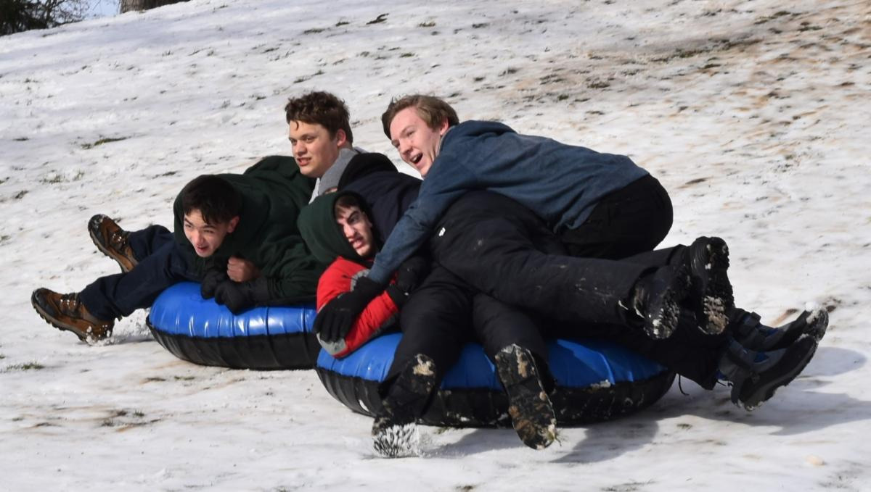
  To begin camp, we had a beautiful covering of snow with very cold temperatures. We were blessed with beautiful weather all week that allowed for all of our activities to run as planned.
  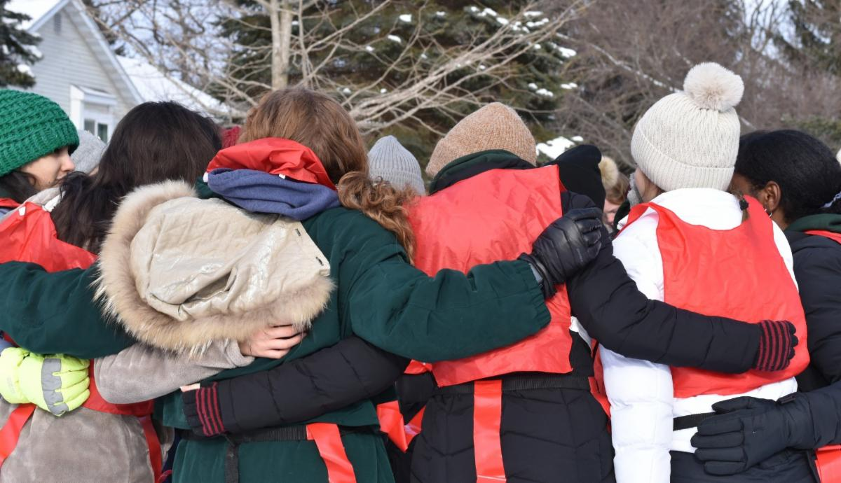
  I am always amazed and thankful for the maturity of our campers and the dedication, service and passion of our staff. Winter Camp is a unique experience, even compared to the summer camps, due to the cold weather. We have a slower pace with lots of time for fellowship. It allowed us to really create a family atmosphere as we discussed our theme of “Becoming Sons and Daughters of God.”
  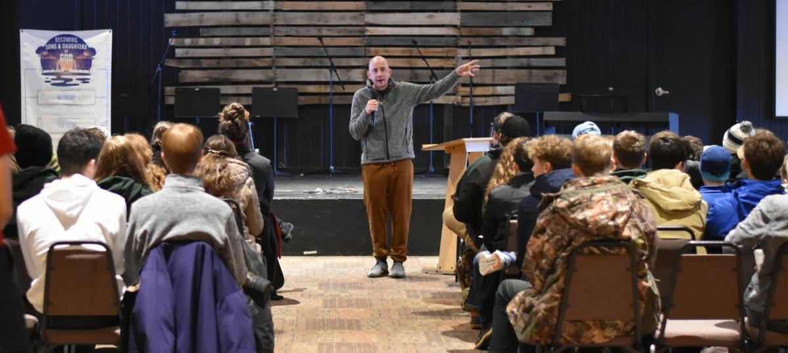
  We look forward to the next camp season where we can continue building friendships and growing in our relationship with God.
  —Aaron Creech, director, Winter Camp
  South Africa Camp Report
  From Dec. 21–29, 27 campers and 12 staff converged together at Moolmanshoek Leadership Development Center in Free State, South Africa, for the United Youth Camp South Africa program for 2022.
  The theme, “Becoming Sons and Daughters of God” was well received, and inspired many good discussions about the plan of God, our common calling, and how we can continue to live in “the Zone” as we move forward from the camp program back into the world around us.
  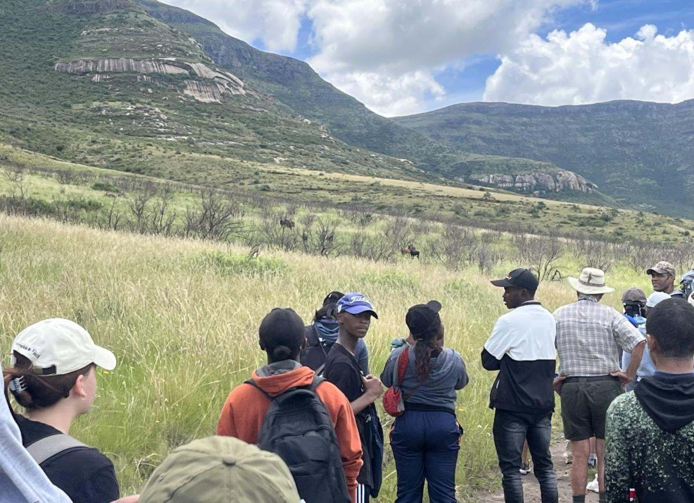
  The campers enjoyed numerous activities such as hiking, abseiling (rappelling), soccer, volleyball, swimming, arts and crafts, and newsletter. They participated in groups in a cooking competition known as a potjiekos, and enjoyed a delicious braai together one evening among the rolling thunderstorms in the valley. They also had opportunities to hike back among the wild game on the Moolmanshoek preserve seeing many South African animals such as springbok, eland, sable, waterbok, zebra and countless birds.
  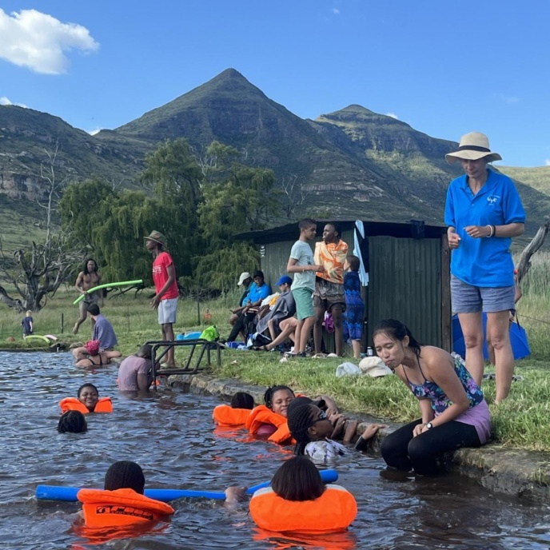
  This year, the United Youth Corps provided two counselors, one from the United States, Josh Cook, and one from the Philippines, Wrestley Cinco—who served the boy and girl dorms, respectively, and helped to train the next generation of counselors, while Ben Light, a camp director from the United States, came as a consultant to assist the South African camp director Vivien Botha and his administrative staff as they work to build up their camp program.
  There were numerous opportunities for shared fun and building of positive relationships between the participants and the staff. While we may have begun the week as strangers, we ended the week as family.
  We are thankful to God for the great success that the 2022 United Youth Camp program in South Africa experienced this year. If you’re interested in attending the South African camp, or interested in serving in the United Youth Corps either in South Africa or another location, keep an eye on our publications and communications for the various opportunities to serve.
  —Ben Light
  Dallas/Fort Worth Regional Weekend: March 10–12
  The Dallas and Fort Worth, Texas, congregations will host a Regional Weekend, March 10–12, with the theme, “Planted by the River.” Taken from Psalm 1:1-3, the focus of the weekend will be on how to live a life that is firmly grounded in God’s Word and continuously cultivated with the nutrients God supplies. This is an approach that will help us to withstand the pressures that surround us and to produce godly fruit that positively influences others.
  Most activities will take place at our meeting hall in Plano or within 10 minutes thereof. Attendees ages 5 and up can volunteer at a non-profit organization on Friday afternoon. Friday evening, we will have a dessert social. On Saturday morning, there will be separate Teen and Young Adult Hospitalities, followed by Sabbath school and Bible studies for the general membership, young adults (ages 18-35), and teens. Our congregations will then provide lunch before the Sabbath service. After services, there will be a slideshow honoring graduating high school seniors.
  After sunset, a formal dinner and dance will be offered for teens (ages 12-19) at a nearby 4-star hotel. Meanwhile, a separate gathering at a different location will be offered for young adults. Remaining brethren will be able to enjoy a pizza dinner, fellowship and games as well as entertainment for preteens (ages 4-12).
  From 9–3 on Sunday, brethren can play sports or board games and fellowship at a local school. The DFW congregations will provide lunch.
  Anyone attending ANY portion of the weekend will need to register so that we can plan for the volunteer activity, Sabbath seating and food, and make any necessary prepayments. The cost for the teen prom and dinner will be $48 per person and must be paid by Feb. 21 (the cost is only $43 if payment is made by Feb. 7). Saturday’s pizza dinner (for those not attending the prom or young adult activity) will be $6 per person or $25 per family. Guests will need to make plans for their own breakfasts.
  
  Register at https://bit.ly/dfw-regional
  Details can also be found on our “2023 UCG DFW Regional Family Weekend, Teen Prom & Young Adult Fellowship” Facebook page, https://www.facebook.com/groups/1260963671412684
  We hope to see you there!
  Save the Date: ABC Charity Auction
  Ambassador Bible College’s annual Charity Auction program will take place on Sunday, March 19, from 1–4 p.m. We hope to webcast the program live and hope that you will save the date to join us for fun, music and a good cause. This year, donations will raise money to help our brethren in Kadoma, Zimbabwe, have a safe place to fellowship and to keep the Feast of Tabernacles. We hope to see you there!
  ABC Continuing Education
  Registration is open for the Ambassador Bible College Continuing Education program, which will be held May 22–26 at the home office in Milford, Ohio. During the program, faculty members will teach excerpts of classes from the ABC curriculum. Lunch and a continental breakfast will be provided each day. Tuition is $85 per person, or $100 for married couples. Space is limited, so early registration is encouraged. To register, please contact Katherine Rowland at (513) 576-9796 or katherine_rowland@ucg.org.
  Winter Family Weekend Recordings Available
  The Bible study, Sabbath morning seminars and sermon from this year’s Winter Family Weekend have been posted online for those who would like to hear them:
  - Bible Study: Living God’s Purpose in Your Life - Brian Hoselton
  - Seminar: Baptism - the First Step! - Marcus Lucas
  - Seminar: Rethinking Marriage - Scott Delamater
  - Seminar: Your Purpose in the Church - Jacob Mammen
  - Seminar: Give God the Glory - Andy Lee
  - Sermon: Three Books - Rick Shabi
  
  Sri Lanka, India, Bangladesh and Pakistan
  As senior pastor in the countries of Sri Lanka, India, Bangladesh and Pakistan, David Schreiber has been blessed to meet many dedicated men and women who strive to follow God despite the challenges in these countries. These challenges include very poor wages, current runway inflation and, for many, the difficulty of finding work which allows them to keep the Sabbath. If one is unwilling to work on the days the employer demands, there are dozens—if not hundreds—of others waiting in line for the same job.
  Mr. Schreiber sent the following report and update:
  Bangladesh
  Religious persecution is also a trial for many, as it was for one of our families in Bangladesh. The husband was required to shut down a mushroom-growing business because the Muslims in his village intentionally and cruelly cut the electric wires and then the water supply. Finally, they voted to have him move from his home and gave him hours to get out of their village as they did not want him as a “Christian” living there. He did move to his wife’s family home and tried to start a new business to provide for his family. He was set back with two major cyclones and flooding, resulting in damage to his rice fields and no electricity.
  Recently they sent me an email expressing their trust in God to wait on Him to open the door for them to be baptized and accept His will and timing to do so. I am happy to report and rejoice that Manik and Rita from Bangladesh have been granted entrance into India and are in Visakhapatnam! I met with them on Wednesday evening, and then will continue our baptism counseling today (Thursday). Their baptisms are the main purpose of this trip. This is an answered to prayer by many! Thanks to those of you who have been praying for them.
  Please pray for God’s guidance, protection and blessing on this family as they will be, to my knowledge, the only baptized members in Bangladesh. Thank you all for your love, concern and prayers for so many others like them, whose daily life and Christian journey is a challenge.
  India
  My first stop in India was the city of Hyderabad. We have two UCG members (Dr. Samuel and his wife Asha Susanth) who are living in this city and there are also several Beyond Today readers here.
  Dr. Samuel and Asha hosted a Bible seminar on Tuesday, which about 50 people attended. Some in attendance I had not met before, as they were acquaintances and friends of Dr. Samuel. Around 10 or so were Sabbath-keepers who I’ve had contact with over the years. It was a long but productive day in which the gospel of the Kingdom was shared with some who had never heard this message before.
  One noteworthy guest was a lady who told me her grandfather was once in the Worldwide Church of God. She said her mother was taught God’s truth and her mother passed this truth and way of life on to her. As she and I visited briefly, she told me she keeps the Sabbath, Holy Days and understands the resurrections and the Kingdom of God. It was an inspiring encounter as one realizes there are many Christians and disciples of Christ which we do not know of, but Christ knows His sheep and they hear His voice. It was truly inspiring.
  On Friday, another Bible seminar has been scheduled at the home of Ezekiel Polinati, a UCG member. I’m not sure how many Beyond Today readers are coming, but I’m praying for God’s guidance as we once again share the gospel and the hope of Christ’s return and the Kingdom of God.
  Thank you for your prayers for the work of God in this very populous area of the world.
  —Peter Eddington, Operation Manager, Media and Communications Services
  Food Service Manager Job Opening
  The United Church of God is announcing a job opening for a Food Service Manager.
  The Food Service Manager handles the daily affairs of the cafeteria for Ambassador Bible College, including the kitchen and general dining area. He or she coordinates all dining activities at the home office of the United Church of God during normal business hours and for special events. He or she orders all food and supplies, ensures the kitchen operates to department standards and health regulations, and supervises other kitchen workers.
  A ServSafe certification and two years of experience with cooking and commercial kitchen operations is preferred. The candidate must be able to stand for long periods, frequently lift and/or move up to 35 pounds, be well-organized and able to pay attention to detail and accuracy. Potential employees must be baptized members of the United Church of God. This is a full-time position scheduled throughout the 9-month ABC academic year.
  The deadline for submission of an application is Feb. 6, 2023. To request a job application or for questions about the position, please contact human_resources@ucg.org.

