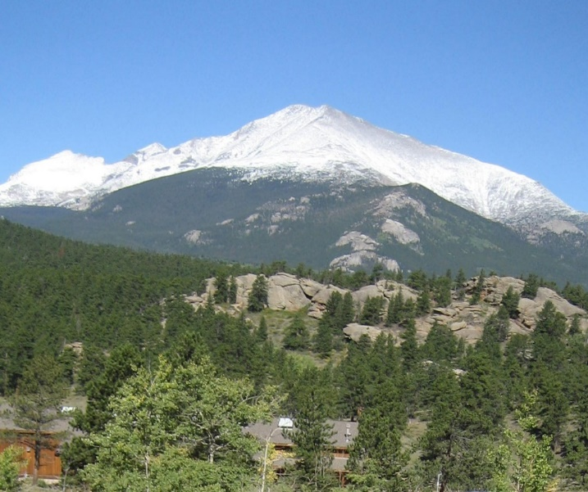

2023 Colorado Women's Enrichment Weekend
Ladies, we hope you can join us for an inspiring weekend in the
beautiful Colorado Rockies!!!!
The Colorado Front Range churches are hosting a Women's Enrichment Weekend beginning Friday evening, July 7 through noon Sunday, July 9.
The location will be in a lodge retreat near beautiful Allenspark just 15 miles south of Estes Park, CO. The view of Mt. Meeker behind the lodge is spectacular.
The theme this year is “Women of Faith: Standing Together”.

Cost of lodging, 6 meals and handouts - beginning with Friday night dinner - will be $175.00 per person.
There will be inspiring presentations, a campfire on Friday night to open our weekend, fellowship with our sisters, and service opportunities.
Please make plans now to join us!
Information and Registration Forms are posted on.
ww.denver.ucg.org
https://women.ucg.org/enrichment-weekends/colorado-2023
.
Or you can call Beth Bradford at 303-805-0089 or
send her an e-mail at beth.bradford@comcast.net.

