Weekly radio program from 10-11 AM, Sundays – WKDW-FM, Northport, FL Weekly Bible Study, Wednesdays, 7:30-9 PM, now covering Jeremiah 12, 13 Cybercast, most weekends from Ocala, FL, Saturdays at 1:30 PM

Pastor’s Letter August 13, 2021

Why It’s 1936 all over again
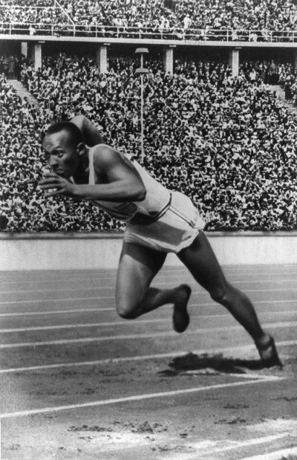

Jesse Owens, Winner of 4 gold medals in Berlin, 1936

I well remember the crisp autumn afternoon when I jogged through streets of Berlin, Germany to a park that housed the famous Sports Stadium - built for the 1936 Olympic games. Although the stadium had a seating capacity of 110,000 people, it was locked up and empty when I got there. Nevertheless, I asked the head security guard if I could go inside the stadium. He was surprised that I would dare ask in my marginal German; especially with an American accent. After showing initial shock and wagging his head with an emphatic “no” he began muttering words in German that I had never heard before. And then he shocked me. Suddenly he shrugged his shoulders and waved me in and the next thing I knew was that I was running on the same Olympic track that the international athletes used for the 1936 Olympic games. Running around the first curve I was able to see the press box and chief seats that were reserved for Adolph Hitler and his entourage who were hoping to see their “superior” Aryan race triumph uber alles! I could imagine the roar of the crowd of 100,000 plus people for the surprising black athlete Jesse Owens of the American team. With blazing speed, Owens won four gold medals here.
Although he did not show his angry frustration publicly, Hitler was furious with the outcome of the contests. He wanted his Aryan brotherhood to dominate the Olympics as the superior nationality above all other races – especially Jews and Blacks.

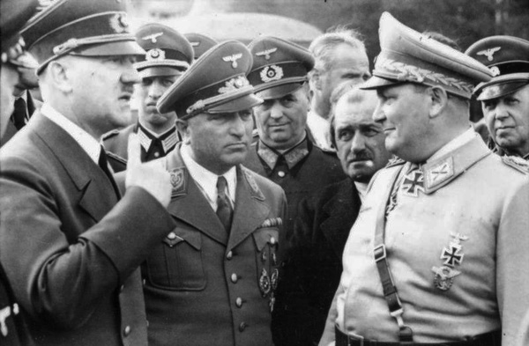
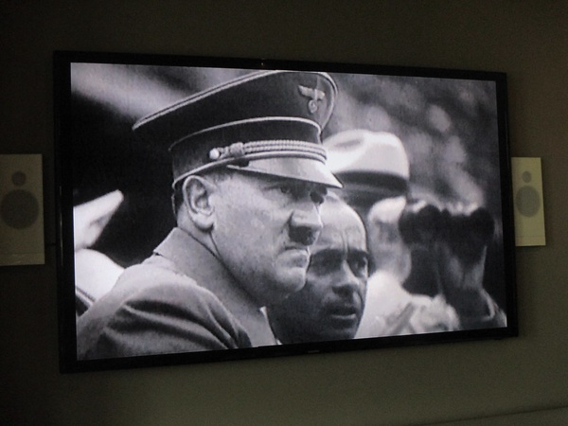
Hitler disapprovingly observing the Olympics Time to Regroup

National pride is a potentially dangerous poison. SO many wars and skirmishes have erupted due to unbridled pride, brought on by pompous assertions that certain nationalities or certain races are to be favored for regional or world dominance – often done at the expense of other peoples.
Origins of great confrontations can usually be traced back to pride and arrogance. As society gets increasingly self-absorbed (II Timothy 3), we can identify seeds of future clashes and wars through the behavior of political and military personnel as well as even some athletes. This sometimes results in making political statements through the Olympics which initially were designed to be non-political. Cases in point are listed below:

1964 in Japan: South Africa is banned from participation over Apartheid
1968 in Mexico: In a political statement, two American gold medalists are expelled for raising their fists in a Black Power salute on the winners’ podium
1972 in Munich: Palestinian terrorists kill 11 Israeli Olympians in protest of Israeli participation in the summer games.
1976 in Montreal: Taiwan comes to the games under the banner “Republic of China” only to be told to change its name because it was not mainland China. Instead the Taiwanese athletes protested and left without participating.
1980 Moscow: The U.S. and 63 other countries boycott the Moscow Olympics over the Soviet Union’s invasion of Afghanistan.
1984 Los Angeles: - perhaps for being stood up in 1980, the Soviet Union and 13 other nations decide to boycott the games in Los Angeles.
1988 North Korea, Cuba and Ethiopia pull out of participation with the U.S. and its allies.
…And in subsequent years, the nations of the world have generated boycotts and rumors of boycotts including in the more recent Olympics.
Viewership of the Olympics was at an all-time low because more formerly- interested fans are turned off by increasing political assertions from some of the Olympic participants.
Politics was originally not supposed to be a factor in Olympic competition. But today the Olympics are inevitably becoming more political as an extension of national pride and aspirations of dominance. They are a microcosm of current world affairs.
Last week the summer Olympics were completed in Tokyo, Japan. One Ukrainian gymnast openly requested political asylum but was returned to her original country by the International Olympic Committee. Other Americans and one Costa Rican stood on the medal stand and shook their fists in the air to express solidarity with Black Lives Matter. In Paris different hoodlums attacked and tackled the runner who was carrying the Olympic torch toward Japan.
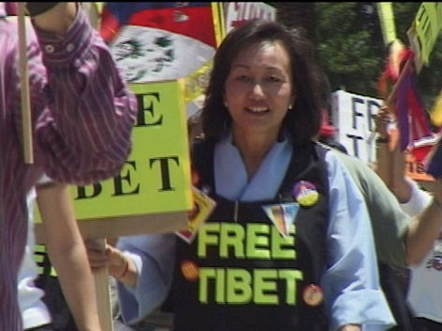
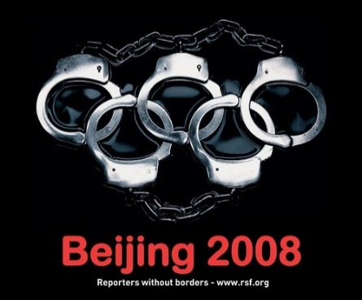
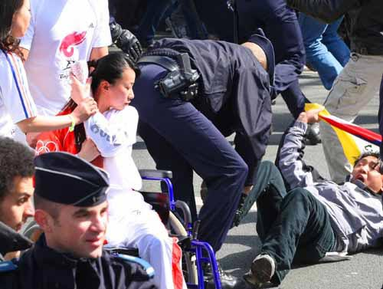
Protesters tackle Olympic Torch Runner in Paris Protest Against CCP China Message against China at Olympics
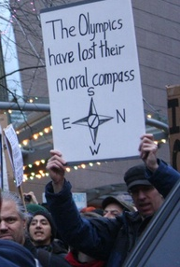

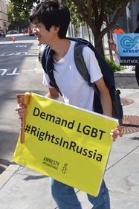
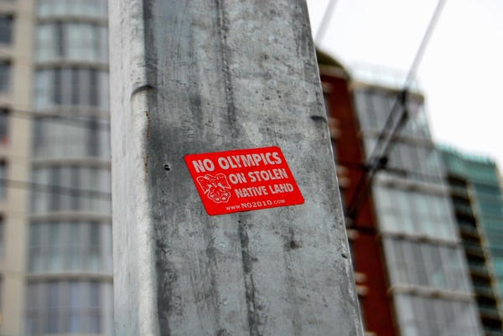

Israeli Reaction to “Black September” in 1972 when Palestinians killed 11 Israeli athletes:
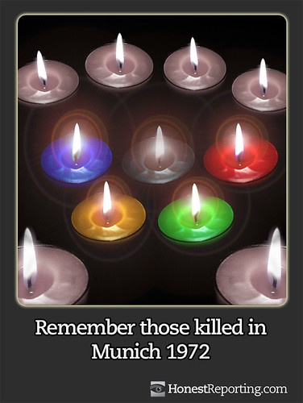
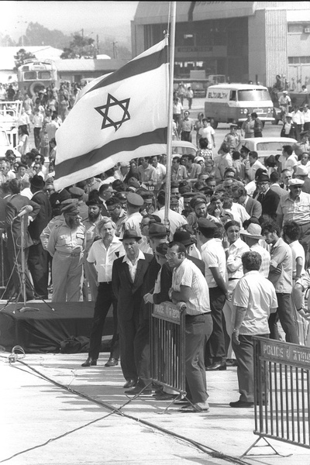

A barometer on world conditions
Of course, we understand that arrogance and pride can be traced back to Lucifer (Isaiah 13 & Ezekiel 28). Extensive pride is typically a curse on humanity and can only be eradicated by repentance. In the Millennium after Christ returns, not only will swords be beaten into plowshares, but man’s inordinate pride will also be pulverized. By then man will learn that a haughty spirit does in deed go before a fall.

I call your attention to this portion of Victor Kubik’s letter (the complete letter was sent separately) in which he outlines a plan to contact dedicated donors and co-workers with on-line seminars. I would like to do the same thing in our region. We have an on-going responsibility to reach people with a message of hope.
“…In our major subscriber development letter in May, I gave our readers a list of nine subjects of interest and asked them to choose three topics that they would like for us to write more about. More than 7,000 readers responded and the top three were: getting closer to God, understanding the Bible better and prophecy. In the coming months we’ll work on writing more on these subjects. In addition, we will be hosting a series of online seminars in Florida, where these subjects will be addressed. The presenter will be Rick Shabi who is pastor of the Orlando and Jacksonville congregations. We have over 380 donors living in this area, indicating a high level of interest in our message. An invitation will first be extended to this group. The first seminar will be held on Oct. 10.
The advantage of offering these seminars online is that interested people can listen from home and not have to go out to meet people they do not know. This has been a barrier to meeting people who definitely want to know more, but are reluctant to meet initially in person. Our desire is to get to know these people first in this manner, and then make them feel welcome to visit our congregations in person

SERVICES THIS WEEK
This Sabbath I will speak in Ft. Myers and Mike McCarty will speak in Tallahassee at the “Farm”. Ocala is cancelled as a precautionary measure until next weekend. Most everyone is on the mend; however we have extended prayed requests for Sharri and Roy Swindle, (Covid) Sherrie Eakin,(IBS) Gus and Kelly Egedus (Covid) and Pat Greenfield (Covid) .
Let us wisely utilize the freedom that God continues to allow us to have.

bv

"Jesse Owens" by www.brevestoriadelcinema.org is marked with CC PDM 1.0 "Olympiastadion video extract: Adolf Hitler at the 1936 Berlin Olympics" by Diego Sideburns is licensed under CC BY-NC-ND 2.0 "File:Bundesarchiv Bild 101III-Reprich-012-08, Wolfschanze, Hitler, Ley, Porsche und Göring.jpg" by Reprich is licensed under CC BY-SA 3.0 "Paris_Torcch_Bearer_attacked2" by ttstam is licensed under CC BY-NC-SA 2.0 "Sydney Harbour Olympic protesters arrested" by publik16 islicense under CC BY-NC-SA 2.0 "Beijing 2008 - Reporters without Borders Olympics protest poster" by fortinbras is licensed under CC BY-NC-SA 2.0 "Amnesty International Olympic Torch run in San Francisco to protest Russia LGBT law" by Steve Rhodes is licensed under CC BY-NC-ND 2.0 "Memorial Service for the Munich Massacre" by Government Press Office (GPO) is licensed under CC BY-NC-SA 2.0 "Memorial Service for the Munich Massacre" by Government Press Office (GPO) is licensed under CC BY-NC-SA 2.0 "Candles to remember those killed in Munich 1972" by HonestReporting.com is licensed under CC BY-SA 2.0

