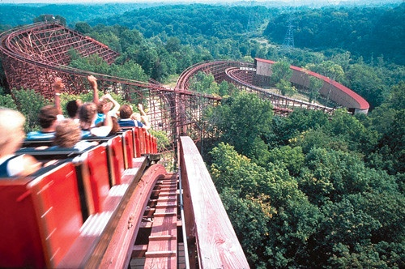
Pastor’s Letter (August 7, 2021)

Are You Ready For
this ?

Ready or Not… Welcome to “The Beast” at King’s Island, Ohio
For that matter, Are you ready for what else is coming (shown below)?

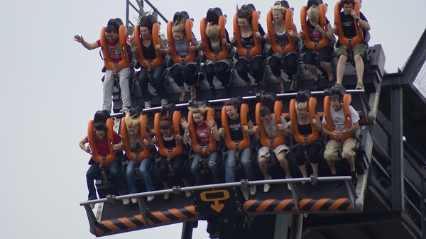
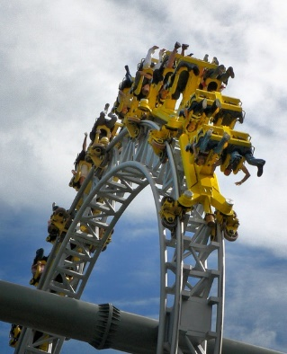
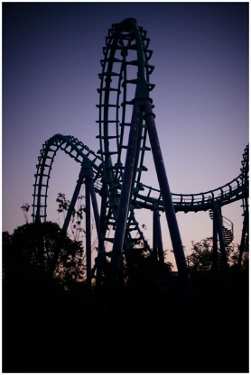
For the world of loops Or “The Tornado? Or “The Oblivion”

Covenant with death?
I will never forget the seniors/widows/widowers church sponsored outing we had in Tampa at Busch Gardens some 37 years ago. It was a lovely activity up until mid-afternoon. The group got to pet dolphins, watch an ice skating show, meander through the Busch Gardens Zoo, watch gutsy young adults go on wild rollercoaster rides throughout the theme park, and eat at one of the African pavilions.
Now that the group had something to eat, those of us who planned the event before the next pavilion show were thinking at about this time, “Man, what could be better? Why everything is going so well”…We deacons and elders gathered after an activity snack before the next scheduled indoor show and we were all predicting how this group would probably like to come back next year.
Yes we were all feeling rather good about the success of the activity until suddenly someone exclaimed, “Oh, no ... the seniors didn’t stop when we did. They think we are across the field trying to get them to ride a rollercoaster! And they are strolling straight toward The Scorpion; the newest rollercoaster in Florida, with challenging hair-pin turns at speeds in excess of 70 m.p.h. It was the scariest ride that Busch Gardens offered. Just the ride without the deafening bells and whistles would have been more than sufficient to accommodate anyone’s aberrant need for excitement—but this rollercoaster was extra fast and furious. It was full of tight turns and drop-offs at high speeds and it also turned its riders upside down. Two words would describe the Scorpion: “Downright scary”.
Because most visitors thought that the Scorpion was too dangerous and too fast, they shied away from it which made the waiting line non-existent. So, from afar I saw most of our group blissfully and very quickly get on the roller coaster. Our group of elderly people got seated having NO idea where this train would be going. As I sprinted toward them, I yelled across the wide open spaces for them to stop the rollercoaster but the Scorpion was hissing and belching so loudly that no one could hear me. As I got closer, I passed multiple signs that sternly warned that anyone with a heart condition should not get on this ride. Well … EVERYONE in our group, I think, had a heart condition including our 85-year-old matriarch, Lillian Cerks—who imbedded herself in the front row of the first car.
Time for the angels to take over
At that point, I saw them chug out of the station and I began praying intensely as time seemingly came to a standstill. During that time the group (only ones to get on it in the last hour) started flying through the loops, right side up and upside down. I was sweating bullets. And I wondered: Were my brethren ok? Were they still alive? And should I dial 911? If they survived, did they need to go home? After the longest two minutes of my life, the train returned to the station. Everyone in our party had ash white faces but everyone was still alive! Then Mrs. Cerks said in a jovial manner, “Oh! That was fun! We weren’t scared.” Oh yes they were! I saw the way they looked when the pulled in to the station.

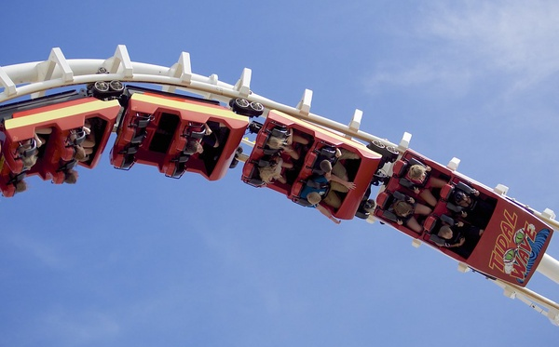

…and people actually pay money to put themselves through this

Operation Fast & Furious - Just ahead
Brethren, we find ourselves in a similar type of spiritual rollercoaster. Didn’t Christ say that the times in which we find ourselves today are just the beginning of rollercoaster rides? Well, perhaps not exactly in these words but the experiences we will have can be analogous to some of the hairpin corners and awkward positions that we might find ourselves in from time to time when life becomes ever more challenging on multiple fronts.
We can assuredly say that many are the afflictions of the righteous and that end-time events will often result from tension caused by clashing philosophies, deceits and misunderstandings that we see abounding already. We should be grounded in the bedrock understanding of God and His work on this earth. When we strive to extend God’s message of hope and warning, we do not want to carelessly fall out of the rollercoaster seat thinking that we can be careless, lukewarm or indifferent to what we see all around us. We cannot afford to go it alone; we need God to guide and stabilize us.
The Bible is full of ordinary people doing extraordinary works, guided by the hand of God. He wants to inspire us to be among His productive servants. And when we encounter difficulties we should know that the prized values of this world are upside down. Our time for spiritual preparation for the future is limited now and the stakes are very high. Can we ride our spiritual rollercoaster successfully to its conclusion? We see conditions all around us moving in directions that not too long ago were unrecognizable: Covid 19, Delta variant, looming stagflation, attacks on religion, various leaders who lie, full-term abortion, energy shortages, and pockets of a famine of the Word of God in too many places on this earth. One could easily raise the question, “What is the challenge of the month?” This month it appears to be the Delta variant. Perhaps next month it will be energy shortages and fires on the west coast, perhaps one month next year it will be a big earthquake
We have to be ready for anything. In the future, it will even be more significant for us to be able to “ride the roller coaster”. The challenges we face and spiritually grow from will refine us and also define us. Let us strive to hold fast to that which is right and ride a “spiritual Scorpion” without falling out.

SERVICES THIS WEEK

This coming Sabbath we will have services in Ft. Myers at 1:30 at the La Quinta Inn – just 2 hotels east of the Wyndham (on same street as the Baymont Wyndham). Bob Orosz will give the sermon.
Due to circumstances, Ocala will not meet this Sabbath. We hope it can resume meetings, beginning next week.
And I will give the sermon this Sabbath in Tallahassee at 1:30 at the Marriott Hotel.
PRAYER REQUESTS
There are many people to remember in prayer. Two local requests that I certainly want to pass along are Pat Greenfield, and Sharri Swindle. Pat has a serious case of Covid and is at Ocala Regional hospital. No visitors are allowed at this time. Sharri accidentally fell at night and broke her ankle. She may be housebound for 3-6 months as she goes through rehab and hobbles around with a walker. It could be that God will accelerate her recovery, which would be a major blessing. Both of these people and many others (and all of us to one extent or another), are riding the rollercoaster.
Also: Prayer Request Update - Gary Petty and Murfreesboro Congregation
From Fred Kellers, elder, Murfreesboro, TN:
Gary Petty reports: “I was finally sent home from the hospital today. A number of the nurses and doctors told me that I was a ‘blessed man’ because my COVID could have been much worse than it was. It has been a difficult illness and I am still very weak.” Gary’s wife, Kim, also had COVID-19 but was not as seriously ill. She is also doing better.
Regarding the other members of the Murfreesboro congregation, the status changes daily but most are at varying degrees of recovery from ages 22–84. We have 25 affected that we know of. It’s been difficult to find out exactly who is sick. Those who were hit harder are farther behind in recovery. One member in her early 50s was hit hard; her mother also had a tough time. Leo and Barb Sancho are in their 80s and having a tough time. One member, Don Smith, did not survive; he was about 83—but a pretty robust 83. Another member age 83 recovered well and was canning tomatoes a week later; he was vaccinated, but whether that helped or not, time will tell. We think that in total about 55 percent of the members in the congregation have been affected.
Thank you for your prayers for the Pettys and our precious little congregation.

Due to the virus, our president Victor Kubik wrote the following and I have included it here in its entirety:

Personal From the President...

A Critical Time for Love, Understanding and Action
The facts are plain. A fresh surge of coronavirus infections—driven by the Delta variant—has created a new set of challenges for much of the world. Its impact has been felt keenly within the Church of God community. Many of you know that Beyond Today TV host Gary Petty and his wife, Kim, both came down recently with the virus, as did a number of members in the Tennessee congregations they serve. Mr. Petty’s case grew severe, and he had to be hospitalized.
Thankfully, he is scheduled to be released soon, but will require time to fully recover at home. As he told me by phone, his personal experience with COVID-19 confirms that it is “a bad disease.” None of us want to experience it. Other groups within the Church of God community report several cases—mild and severe alike—among members and ministers. This virus respects no human.
There are some issues that we need to consider over the coming weeks. I believe that God helped us all get through a successful camp season for our church youth. With the exception of one camp where there were many who came down with the virus, we mostly were spared. In addition to God’s amazing protection, no small measure of thanks goes to the intensive planning and execution of safety measures.
What I am about write about is a delicate and solemn subject, but one that we must face head on, especially as we near the Fall Festival season. I write here of the issue of COVID-19 precautions and safety measures, and yes, that includes the available vaccines.
As well documented in our doctrinal study paper (streaming.ucg.org/files/papers/UCG-papers-Divine-Healing.pdf), the United Church of God believes in and teaches divine healing. The paper rightly states that “We will never understand in this life every step in the process which leads to the healing of our illnesses. We must rely on the clear scriptural statements for our doctrine . . . We believe that divine healing is a promise from God and we claim that promise through faith.”
We also understand and positively teach that seeking medical treatment—including the administration of vaccines—represents a personal choice. We positively teach that it is not a sin to seek such services.
During this year and a half of pandemic, we have all faced various trials and tests. We have watched and personally experienced the intense polarization of America and the politicization of virtually the entire spectrum of COVID-19 issues. When it comes to our members, our relationships, and our choices, what are we to do?
Our direction is crystal clear! We read it every Passover evening, and it should be front and center in our everyday lives. Here’s what our Savior and coming King Jesus Christ proclaims to each one of us: “A new commandment I give to you, that you love one another; as I have loved you, that you also love one another. By this all will know that you are My disciples, if you have love for one another” (John 13:34-35, emphasis added throughout).
In the Church, the issue is not about vaccines or whether or not someone wears a mask or takes other precautions. The issue is about attitude. With respect to our spiritual assembly, make no mistake, we are our brother’s keeper. We are to show love and respect. We are to love our neighbor as ourselves (Mark 12:31).
The apostle Paul makes it clear. From across the ages, he directs us to be “of the same mind, having the same love, being in full accord and of one mind. Do nothing from selfish ambition or conceit, but in humility count others more significant than yourselves. Let each of you look not only to his own interests, but also to the interests of others. Have this mind among yourselves, which is yours in Christ Jesus” (Philippians 2:2-5, English Standard Version).
If you believe that you should take (or already have) one of the COVID-19 vaccines, that is not a breach of faith. That is a personal choice. If you are opposed to vaccines, the Church recognizes that also is a personal choice. The Church also understands that there may be consequences for either action, but still supports individual choice.
We acknowledge that much has been written, published, broadcast, or posted about vaccines. Vaccines do not offer or create some kind of invisible science fiction “force field.” Pathogens—disease-causing organisms—exist everywhere around us. God gave our bodies complex immune systems to protect us. When we fall ill from infection from one of these pathogens, our body produces specific antibodies and other new defenses to both recover from and help prevent future illnesses. A vaccine triggers a response in our immune systems to develop new antibodies and other defenses to prevent or minimize future infection, particularly in potentially lethal illnesses like COVID-19.
Based on personal research and choice, some in the church elect to be vaccinated. Others elect not to do so. Whatever the reason or the choice, the understanding and application of loving one another and being our brother’s keeper hold fast. Creating division, unnecessary trauma, or unsafe conditions are not the answer.
Apart from those who are licensed physicians or other medical professionals within the United Church of God, we recognize that we are not medical experts. As a spiritual assembly, we do not offer medical advice or diagnostic suggestions.
But here is an important point: Since we arrange and oversee the meeting together of many thousands of members in public areas on a continuing basis, we do hold a very strong interest in positive public health and public safety. Even outside of COVID-19 issues, we must regularly plan for and attend to many issues in the realm of public health. Many biblical passages direct us to be good stewards, which includes creating safe places for worship and fellowship.
We are but weeks away from the Festival season. In America, two of our Feast sites are in Florida, currently the state with the highest number of new COVID-19 infections and related hospitalizations. Some cities—like New York City—have already adopted a vaccine mandate and are now requiring proof of vaccination to enter restaurants, gyms, and other gathering places. Unless the surge abates, we may face changes in how we conduct the Feast. For example, we may need to suspend in-person meetings in favor of off-site webcasting if COVID-19 case(s) are widespread at or near a site, but almost a certainty if that infection is confirmed among attendees (hence the extreme need for everyone to take precautions).
We are carefully monitoring the developing situations around all of our Feast sites and all of our church congregations.
My message and my request are this: please pray fervently for God’s protection, God’s wisdom, and God’s direction. As Paul directs us, “Share each other’s burdens, and in this way obey the law of Christ” (Galatians 6:2, New Living Translation). Be tolerant and supportive of each other, including the posting of messages on social media. Please pray for our older members and those with various conditions, as they may be more vulnerable to COVID-19 infection.
In summary, now is a critical time. Now is the time to really show love for one another. Now is the time for understanding, of appreciating the spiritual and physical challenges that we face. Now is the time for action, of taking precautions and promoting safety for all, even if it is inconvenient. Let us come together, let us speak together, let us worship together “with all humility and gentleness, with patience, bearing with one another in love, eager to maintain the unity of the Spirit in the bond of peace” (Ephesians 4:2-3 ESV).
In Christ’s service,
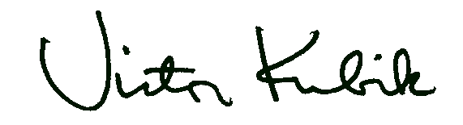
Victor Kubik

"Wooden Roller Coaster - The Beast at Kings Island Theme Park" by Warren County CVB is licensed under CC BY-NC-ND 2.0 "SIX FLAGS NEW ORLEANS" by erikjorgensen303 is licensed under CC BY 2.0 "Tornado" by decade_null is licensed under CC BY 2.0 "Oblivion" by irBri is licensed under CC BY-"Upside Down Roller Coaster" by Au Kirk is licensed under CC BY 2.0NC-ND 2.0 "Oblivion" by irBri is licensed under CC BY-NC-ND 2.0 "Upside Down Roller Coaster" by Au Kirk is licensed under CC BY 2.0

