Weekly radio broadcast, WKDW-FM, 97.5 FM, Northport, Florida , Sundays, 10 – 11 AM. Weekly Bible Study, Wednesdays 7:30 PM. now concluding the book of Mark Weekly cybercast from Ocala (except tomorrow) Saturdays, 1:30 P.M.

Pastor’s Letter, July 30, 2021
The family Feud that Just Wouldn’t Stop
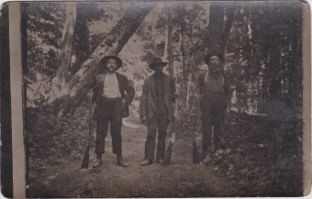
Can Anything Good Come
Out of Tug Fork ?

The Hatfields & the McCoys
A fair question. Tug Fork is territory along the Big Sandy River where the stream separates Kentucky from West Virginia. By the time of the American Civil War, two prominent families dominated the Big Sandy watershed – the Hatfields and the McCoys. These two extended families were getting along reasonably well until a very bad crime flared up in 1865.
The Tug Fork territory plunged into a dark age after several members of the Logan Wildcats militia force, which included several Hatfields headed by their patriarch, Devil Anse, shot and killed Asa McCoy. They claimed Asa was not a loyal Union soldier during the war.
Did Not Settle Well
Rest assured, the McCoys were bitter over the loss of their brother and patiently bided their time to get revenge. Thirteen years later, in 1878, a major incident occurred when Randolph McCoy accused Floyd Hatfield, a cousin of Devil Anse, of stealing his hog (a valuable commodity in what was a poor region). Here is a summary of what happened next as quoted from the History Channel:
“Floyd Hatfields’s trial took place in McCoy territory but was presided over by a cousin of Devil Anse. It hinged on the testimony of star witness Bill Staton, a McCoy relative married to a Hatfield. Staton testified in Floyd Hatfield’s favor, and the McCoys were infuriated when Floyd was cleared of the charges against him. Two years later, Staton was violently killed in a fracas with Sam and Paris McCoy, nephews of Randolph. Sam stood trial for the murder but was acquitted for self-defense reasons. In 1882 three of Randolph’s sons ended up in a violent dispute with two brothers of Devil Anse. Here one of the McCoy brothers shot and killed Ellison Hatfield. So the Hatfields regrouped and killed three McCoy brothers. Two years later, Staton was violently killed in a fracas with Sam and Paris McCoy”
Vengeance is Ours, We repay
Soon the court issued 20 indictments against the Hatfields for taking matters into their own hands. The Hatfields thought they were innocent and managed to escape capture. Later, other wrangles erupted and tensions smoldered between the two clans. But it must be iterated that even on a carnal plane, revenge cannot be the answer. Only God knows how to render perfect vengeance at the right time, under the right circumstances, in the right way. When man initiates vengeance, so often tensions and angry response proliferates. There is seldom any closure to the feud.
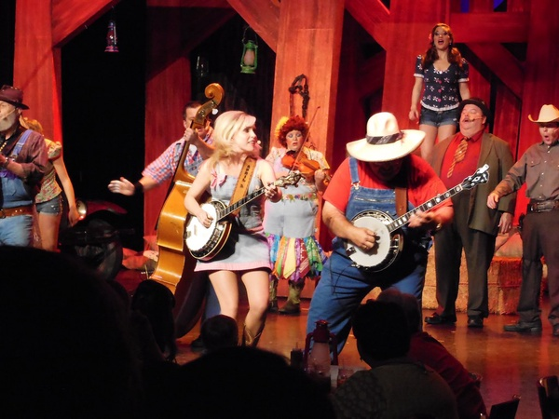
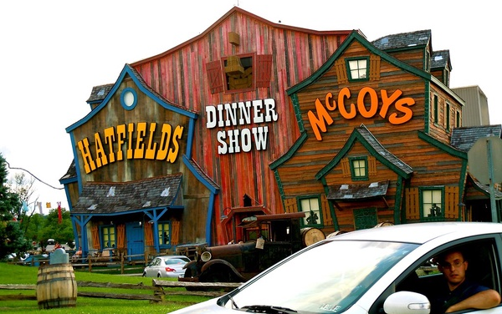
However, somehow through all of this, the rest of the members of both clans decided to lay down the hatchet! To be more accurate, the next generation decided to bury the hatchet. Being more objective, they rightly determined that perpetuating this feud would be utterly insane. Perhaps they concluded that “unless this family feud be shortened, no flesh would be saved alive.” Today both families get together for regular reunions, picnics and music festivals. As spirit beings under Christ, one day we will work for this same result amid all of the feuds that threaten to proliferate at the outset of the Millennium. Love and peace ultimately will prevail.

Amazing What Unity Can Accomplish Hatfield/McCoys Dinner Show
tyj
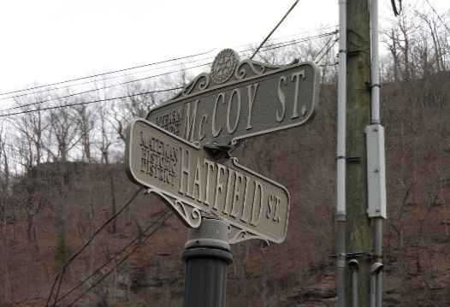
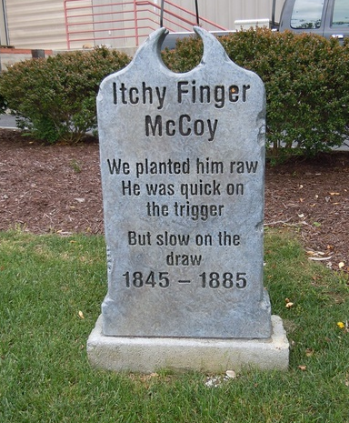
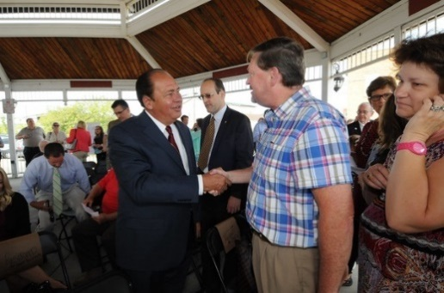

Celebrating Unity The War Is Over

Another Needless Death

It is truly amazing that these arch enemies became such good friends. How this example needs to be repeated worldwide!
Confused Puppy with a rifle in his hands
I am reminded of a Vietnamese teenager who fought with the Americans by day to avenge the death of his uncle by the North Viet Cong. But at night he fought with the Viet Cong against the Americans because the Americans killed his brother in a fire fight.
We killed them because they killed us because we killed them for killing some of us. Don’t ask me who started it. We assume God called us to finish it What? You disagree? Maybe we should step outside and settle this like men …uh, I mean like morons

And then there is the largest family feud of all time…the feud between the Israelis and their Arab neighbors. It will take the return of Christ to change things…and eventually maybe a little bit of encouragement from the Hatfields and the McCoys.

God will assuredly repay all misdeeds against us (Romans 12:19) but He will always do so in an appropriate time and manner that is best for all concerned. However it is almost impossible for man to match God’s timing and full understanding of the circumstances involved.
Tomorrow
Unfortunately we have had to cancel Ocala and Tallahassee services tomorrow due to a local flare up with Covid 19 that has affected enough of our members in each congregation to deem it unwise to meet together.
Ft. Myers will meet tomorrow at 1:30 at the LaQuinta near I-75 and Daniels Parkway. I will be there to give the sermon
As you know, we live in uncertain times. Let us make the best of it. bv

"HATFIELD McCOYS JED CLAMPETT LOOKING FELLAS AND ONE NEGRO ALL WITH RIFLES maybe HILLBILLYS COON HUNTING RPPC NAMES ON CARD Antique Real Photo Location UNK" by UpNorth Memories - Don Harrison is licensed under CC BY-NC-ND 2.0 "Hatfield & McCoy Dinner Feud" by Old Shoe Woman is licensed under CC BY-NC-SA 2.0 "Hatfield & McCoy Dinner Show" by Old Shoe Woman is licensed under CC BY-NC-SA 2.0 "Hatfield Meets McCoy" by howderfamily.com is licensed under CC BY-NC-SA 2.0 "DSC_1075" by Governor Earl Ray Tomblin is licensed under CC BY-ND 2.0 "Hatfield & McCoy Dinner Feud" by Old Shoe Woman is licensed under CC BY-NC-SA 2.0"Hatfield & McCoy Dinner Feud" by Old Shoe Woman is licensed under CC BY-NC-SA 2.0

