Weekly broadcast, Sundays, 10-11 AM, WKDW 97.5 FM, Northport, FL Weekly Bible Study via Zoom, Christ’s crucifixion and resurrection Weekly webcast from Ocala, Saturdays, 1: 30 PM

Pastor’s Letter, July 23, 2021

Really
Bad
Prophecies

1876: TELEPHONES WILL NEVER CATCH ON – President of Western Union to Alexander Bell who would sell him all of his patents for $100,000.
1946: TVs ARE NOT GOING TO BE A BIG THING 20th Century Fox informs investors and adds, “People will soon get tired of staring at a plywood box every night.”
1903: THE HORSE IS HERE TO STAY BUT THE AUTO IS ONLY A NOVELTY, A FAD, …so DON’T INVEST a bank President to Henry Ford.
1962: THE BEATLES HAVE NO FUTURE IN SHOW BUSINESS A Decca Records executive to the band’s manager, Brian Epstein, following an audition in 1962. He continued: “We don’t like your boys’ sound. Groups are out. Four-piece groups with guitars, particularly, are finished.”
1899: "EVERYTHING THAT CAN BE INVENTED HAS BEEN INVENTED." -- Attributed to Charles H. Duell, Commissioner, U.S. Office of Patents.
1943: "I THINK THERE IS A MARKET FOR ABOUT 5 COMPUTORS IN THE WORLD." -- Thomas Watson, chairman of IBM, 1943.
1899: RADIO HAS NO FUTURE. HEAVIER-THAN-AIR FLYING MACHINES ARE IMPOSSIBLE. X-RAYS WILL PROVE TO BE A HOAX -- William Thomson, Lord Kelvin, British scientist, 1899.

And These Aren’t the Only Ones !


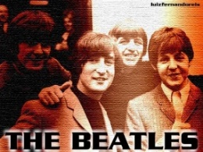



Interest will die out On their way out Horses are Better No one will want one of these

Other Bad Prophecies
Neville Chamberlain: we will have “Peace in our time.”
William Miller: It isn’t 1843 after all; Christ will return in 1844
- - - - -
Worse Prophecies

My Lord Delays His Coming – Matthew 24:48
You shall not surely die – Genesis 3:4
Peace and Safety (shall be upon us) – I Thessalonians 5:3

Forecasters who have been glaringly wrong have lacked sufficient information as well as discernment to rightly interpret what they were forecasting. As an example, the apostle Paul tells us in I Thessalonians 5 that some brethren would be deceived into thinking that they were securely on safe ground. However, this would not be so because some of the brethren would lack enough understanding of what was really going on or commit to what they should do to prepare for Christ’s return.

As we know, Christ had a great deal to say about spiritual discernment that would enable us to accurately understand the times in which we are living and what all is at stake. Christ pointed to the weather (Matthew 16:2-3) to remind us that just as we can rightly forecast the weather, we can know that we are in the End Times. Christ also admonishes us to be aware of the degenerating spiritual condition of mankind and know that we are beginning to relive “the days of Noah” which signal cataclysmic destruction through chastisement.

As was true in the past, there are modern day soothsayers today that reassure a deceivable public that everything in society “will be all right” as they claim that only good things will happen to the countries of this troubled world. They are quick to claim that man’s affairs are basically “o.k.” and the public clamors for its leaders to “Speak unto us smooth sayings; prophesy deceits” ( Isaiah 30:10). Of course there is no realistic basis for such thinking. Such delusion will only lead to enormous bewilderment later with a feeling of hopelessness as everything that people highly value (if not outright worship) will disappear.

Fortunately we are blessed to know that the world does not end in self-annihilation. Christ will save humanity from itself. Peace will eventually “be in our time”. The future will not be based on flimsy, inherently contradictory actions of human beings that beg for peace as they prepare for and wage war. The ultimate future of this world will transition into a tangible utopia. Of course we have heard this for all of our time in the church. It is important for us to challenge ourselves to reprove, cherish, and pray for it and anchor our hearts in the coming Kingdom of God.

It takes knowledge plus *discernment* to make accurate predictions:

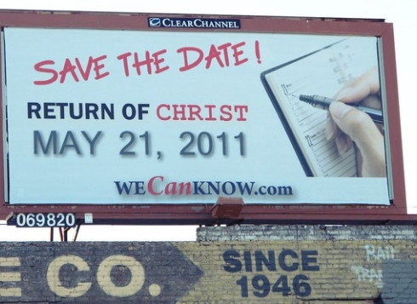

Forget the billboard above…
For the record, here are some of the very good prophecies:

The plowman shall overtake the reaper - Amos 9 Men will beat their swords into plowshares ) - Isaiah 2 Every man will be under his own fig tree - Micah 4 The desert shall blossom like a rose - Isaiah 40 People will have God’s Spirit - Jeremiah 31 & Ezekiel 36 The Saints will be resurrected - I Corinthians 15 & I Thessalonians 4 They will rule with Christ 1000 years - Revelation 20:4,6 The earth will be full of the knowledge of the Lord - (Isaiah 11:9
Wild animals (and wild people) will become tame - Isaiah 11

FT Myers
Randy McQuien will speak at a new location tomorrow in Ft. Myers at 1:30 p.m. Due to persistent roof leaks at our regular location, we will meet at the La Quinta Inn on Daniel’s Parkway near I-75. We are anticipating several guests.

OCALA
We had a great pot luck meal and extensive, interactive group discussion about the sermonette and sermon last Sabbath. We will do more of that in the future. Tomorrow Paul Bidetti will give the sermon. Services begin at 1:30 p.m.

TALLAHASSEE
Tomorrow we will meet at “the Farm” and I will be speaking. Services start at 1:30 p.m.

"Beatles cor 43" by Luiz Fernando Reis MMF is licensed under CC BY 2.0 "old tv set" by keen_seth is licensed under CC BY-NC-SA 2.0 "Hassler Shock Absobers for Model T Fords" by dok1 is licensed under CC BY 2.0 "Vintage Rotary telephone" by MarkGregory007 is licensed under CC BY-NC-SA 2.0 "Return of Christ." by jmawork is licensed under CC BY-NC-SA 2.0
