Weekly Radio program, WKDW - 97.5 FM, Sundays, 10-11 AM, Northport, FL. Weekly Bible Study via Zoom, Wednesdays, 7: 30 PM, continuing in Olivet Prophecy Weekly cybercast, UCG-Ocala 1:30 PM Saturdays

Pastor’s Letter, July 9, 2021

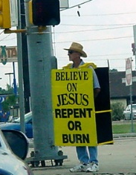
What will they eventually think about us??
Messengers of Gloom & Doom Repent! Or be fuel . for the Lake of Fire !?
OR Messengers of Real Hope ?

Repent or Burn ?
It will always be important to cry aloud and spare not as we urge our brethren in the world to harmonize their lives with God before it is too late. But is warning all that we can do? And is warning all that other people think we do?
Yes, warning is very important, and ideally we can emphasize the need for all of us to turn further toward God and to even be baptized if that is the next step for any of us. However, some future critics may claim that we just live to preach gloom and doom. Some critics might insinuate that we would enjoy bad mouthing the world to feel better about ourselves. Will that accurately define us?
A complete end-time witness requires more than condemnation and it should be done without self-righteousness. Our end-time message demands that we truly care about the future of mankind and give people hope and optimism for what God has planned when Christ returns. To obtain that level of high concern we have to ask God for His love and His Spirit to appropriately inspire us to fulfill our calling to support the preaching of the true Gospel.
People will need to sense that we want them to have the best futures possible. It is most interesting that even if many listeners initially reject the gospel message, that God’s messengers that preach the gospel “will be to them like a lovely song” (Ezekiel 33:32) that they will want to hear even if they choose not to obey – Later they will they conclude that this church had solid reason to be highly optimistic in a troubled world – Perhaps this, more than anything else, explains how an ”innumerable multitude” emerges and turns to God during the Great Tribulation (Revelation 7:9) Yes, if we can access God’s Spirit to express deep optimism and hope for Jesus Christ to return to solve today’s problems, then tens of millions of additional people will gain hope in a seemingly God-forsaken world.
When we read through the end-time prophesies of the Bible, we should take note of God’s repeated approach in warning the world. So many times through His prophets, God will lambaste His people only to interject ultimate optimism at regular intervals. He has deep mercy and love for all peoples on this earth and especially for all of modern-day Israel. God is the ultimate optimist and He will infuse that optimism to others through us. Notice below how determined God has been to extend mercy and hope to people who have rejected the great God.

Hope in God’s Love
Hosea 11:8-9 “But how can I give you up O Israel? How can I let you go? . . . I will not completely destroy Israel for I AM God and not man!”
Romans 5:8 “For God commands His love for us, while we were yet sinners He died for us”
Psalm 34:18 “The Lord is close to the brokenhearted; He rescues those whose spirits are crushed”
Jeremiah 36:2 “Perhaps the people of Judah will repent when they hear all of the terrible things I have planned for them. Then I will be able to forgive their sins.”
Ezekiel 18:31 “Put all your rebellion behind you and find yourselves a new heart and new spirit for why should you die O house of Israel?”
Luke 15: 32 (Regarding the Prodigal Son) “Let us be glad for this your brother was dead and is alive again; was lost and is found!”
…So even in their darkest hours and stiff-necked stubbornness, God’s lost ones will repent as prodigal sons and prodigal daughters to eventually begin to live lives of joy and spiritual happiness. Again, because of difficult years just ahead of us, mankind will desperately need tangible hope that only the Good News of the Gospel can now provide. The book of Revelation indicates that eventually millions and more likely billions of “prodigal sons (and daughters)” will turn to Him. They will finally recognize that God’s way works best because God’s way is the right way to live.
Flawed Strategy

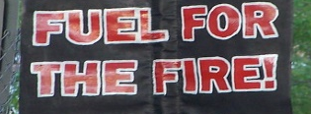
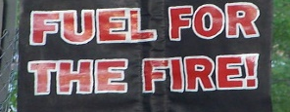
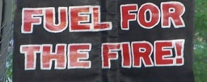
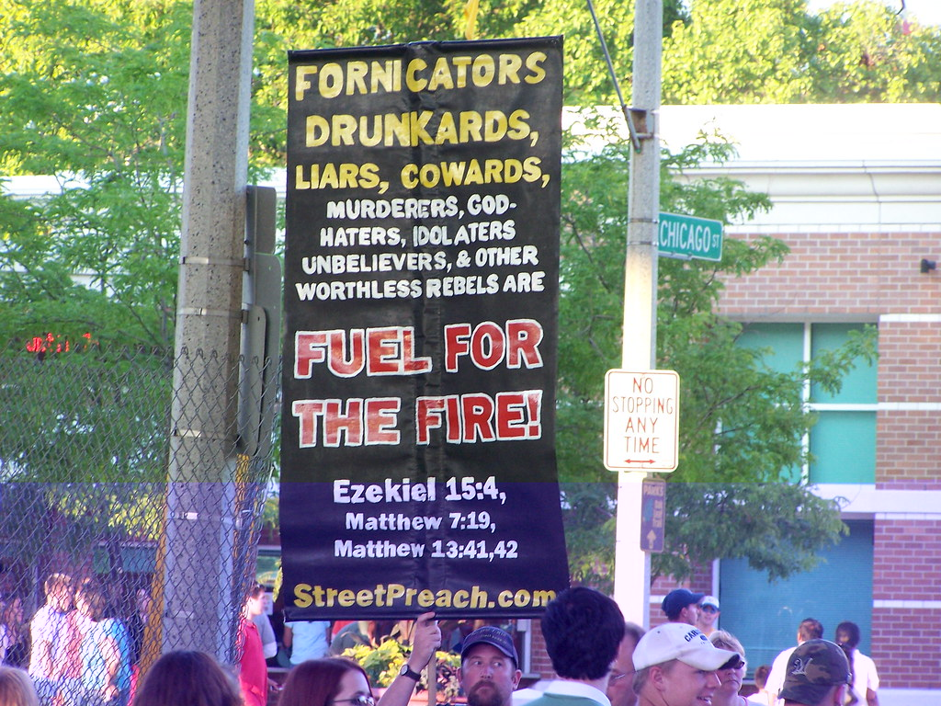
“Fuel for the fire” is an incomplete and perhaps uncaring message. This would be an example of how not to attempt to connect with people.
Without showing love and hope, this placard could serve as just another turnoff. People are best motivated by optimism instead of fear. They have to know that there is something out there still worth pursuing. The placard shown here is probably about as effective as the demented strategy of a boss issuing the warning…… “Firings in this office will continue until morale improves!!.................so REPENT! Or BE Fuel for the FIRE !
Groan.
Also, as mentioned earlier, let us remember that we could inadvertently turn everybody off if we projected a haughty air of self-righteousness. Isaiah recognized that proclivity when he condemned this wrong attitude projected by some as they carried a “holier than thou” attitude. (Isaiah 65:5)
But it is impossible to think of God’s tangible future for everyone and not get excited. Actually, we should be the most optimistic people on earth because we know how God will turn embarrassing, poor behavior of humans into lives with purpose. This vision kept Gerald Waterhouse going for years in spite of having to constantly live out of a suitcase with no real place to call home. Preaching the Kingdom of God was his all-consuming passion.

So… What Will Mankind say about us once Christ returns?
Our Report Card
Many times businesses or their consultants will send their contacts various questionnaires “to see how the company is doing”. Some questionnaires are quite detailed and often point up areas where different employees can do better. The challenge for us is that so much is at stake…if people are turned off with our approach, they may reject the gospel message and lose all remaining vestiges of hope.
We would like for those who finally choose to respond to our message to view us as genuinely caring, humble people, without prejudice or pre-determined condemnation. We should want to win their hearts, if possible, and at least be on record as becoming optimistic about God’s plan, going forward. It will be wonderful to get rave reviews that boil down to “Well done, good and faithful servant! You helped us enormously!” or “Your lives and your encouragement for us show how much you care…it is why we could hang on in the Tribulation and why we know that Christ will now transform us through God’s plan of salvation. We can achieve that with God’s love that you showed us when we needed it most.”

This is a stark contrast to my earlier days in God’s church when the church could be quite judgmental. In Spokesman Club Table Topics, I was amazed to learn that more than a few well-intentioned brethren wanted to see “God strike down them hippies” or blast the street people or “bash the pagans” or condemn certain politicians. If they did need to be punished or become “fuel for the fire,” why not let God deal with them ? (Romans 12:19) “Vengeance is mine, I will repay” says the Lord (not us).
To conclude, there is a way to show God’s people their sins (Isaiah 58:1) and “call a spade a spade” as we address mankind. However, we will always want to add hope and optimism to our message.


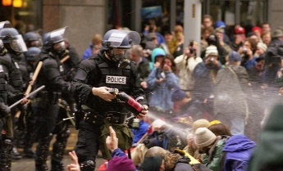

A future without chaos A future without disunity A Future without hate

Christ loves these sinners. He has already paid the penalty for their sins. And as soon as they seriously examine themselves and change to commit to God, He can steer them to repentance, ultimate baptism and the bestowal of God’s Holy Spirit. Yes, that is a lot to happen and it probably will never occur overnight. Much anguish may precede peoples’ repentance toward God. But it will be most helpful if the masses hear that God and God’s children care about them.

FORT MYERS
This Sabbath the Fort Myers congregation will meet away from its normal location one last time due to roof repair at the Bayfront Wyndham Hotel. This Saturday at 1:30 PM we will be meeting at the Best Western on 13021 N. Cleveland St., Ft. Myers 33903. We will have no snacks at this facility, since it is new to us. I will speak there. We were happy to have an enthusiastic new visitor seek us out last weekend and anticipate his return.
TALLAHASSEE
We were also happy to pick up another new person, a woman who is thrilled to be part of the Tallahassee congregation. Mike McCarty will speak this coming Sabbath.
OCALA
And two members from California, Al & Pat, have moved into the Ocala area and are glad to be with us (and vise-versa) This Sabbath Court Greenfield will give the sermon.

"The Prophet Moses with Torah" by Ian W Scott is licensed under CC BY-SA 2.0 "San Francisco Chronicle reporter Vivian Ho getting arrested at No Justice No BART protest at Powell Station Sept 8, 2011" by Steve Rhodes is licensed under CC BY-NC-ND 2.0 "WTO protests 10" by djbones is licensed under CC BY-SA 2.0 "Bangladeshi Spectrum workers protest deaths" by dblackadder is licensed under CC BY-SA 2.0 "Believe on Jesus: Repent or Burn!" by jasoneppink is licensed under C BY 2.0 "Repent!!!!" by rbieber is licensed under CC BY-NC-ND 2.0

