Weekly radio broadcast, WKDW – 97.5 FM, Sundays, 10-11 A.M. on Panorama of Bible Prophecy Weekly Bible Study, 7: 30 Wednesdays via zoom, continuing in Olivet Prophecy Weekly Cybercast from Ocala, FL., 1: 30 PM Saturdays

Pastor’s Letter, July 2, 2021
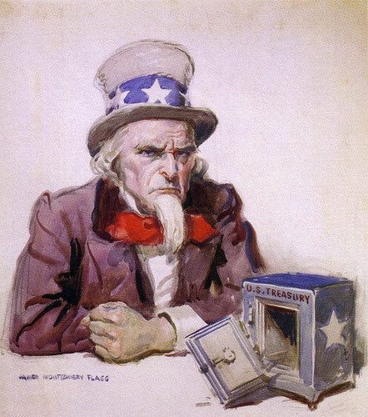
Uncle Sam is Broke; Are We?

Most people won’t think about it. Others will deny it. Some will believe this is fixable but Uncle Sam is indeed broke. As a representation of the government of the United States, Uncle Sam always spends more than he takes in and desperately needs more money to keep the wolves from beating down the door.
Is it Really True ?
Yes. According to Alan Greenspan, in February of this year, official U.S. government debt surpassed a record 28 trillion dollars. That breaks down to $85,000 for every man, woman and child in this country and the pace of expanding debt is running over $100 million per hour. And it is believed by some that the actual overall debt in this country exceeds 100 TRILLION dollars !!! Greenspan noted that it took 200 years for the US to rack up its first trillion in debt. However, the U.S. has increased its debt 1 trillion dollars in the past 4 months! Moreover, the current administration wants to launch 1.9 trillion in new debt for stimulus for the economy. This is such a magnanimous gesture for the people…but realistically, can we afford it?

Some naively believe that endless deficit spending will succeed in stabilizing the economy but other historians correctly note that all other civilizations that operate on that strategy ultimately crash. You can’t get something for nothing and you can’s extract blood out of a stone. When a government decides to print more money that it cannot back up, it merely dilutes the nation’s currency and eventually no one wants that currency. This is what happened in ancient Greece and Rome. It is what happened after World War I with Germany’s Weimar Republic when a wheelbarrow full of German currency would maybe buy a loaf of bread. You can see runaway inflation exemplified here by a postage stamp that originally cost 200 Marks that later cost 2 million marks! What an inflated mark up.

So many politicians of all political parties have learned that they . can win elections by making promises that they can ill-afford . to keep. The only way to continue keep that going is to borrow . more money and/or print more of it, blindly hoping that all others world others will forever accept it.

You and I are not going to alter this spiraling trend but looking ahead to the future, what can we do to mitigate the impact of this negative phenomenon in the lives of ourselves and our families? The answer is simple: harmonize with God’s laws of which many are included in Leviticus 26 and Deuteronomy 28. One of the key directives God gave was to be financially self-disciplined to the extent “we should lend and not borrow” . That is opposite of what we see with not only the US government but many other governments, worldwide.
Thomas Jefferson among other historians have purportedly made the statement that when the general populace learns that it can vote itself increasing government handouts, the nation is doomed to ultimately crash. We are beginning to see runaway inflation accelerate. The cost of lumber, pipe, houses and other products are rising in cost … in some cases..dramatically. .
What Can We Do if We Eventually Face Dire Straits?
1) As mentioned before, we should get out of debt everywhere that we can.
2) If we have a job we need to upgrade our skills in order to remain in demand in the work place. Many are not interested in doing this and will be stunned when inflation or possibly eventual deflation drastically reduces the work force. For businesses to survive, they will have to cut costs by reducing payrolls and employees. Ideally we can get trained to become indispensable to those that we work for.
3) We need to sharpen our communication skills to the widest extent possible. Those who can be as wise as serpents and get along with co-workers will be infinitely more attractive to their bosses and help create a more productive work environment. They will be retained when other employees are let go.
4) We can buy in bulk and strategically shop when prices are more favorable. We can be patient for sales to occur, knowing that it is a way to avoid spending too much for any given product or service.
5) We should consider doing everything that we can for ourselves. That would include gardening, auto maintenance, if possible, sewing, or perhaps saving up to purchase solar or other alternate energy products that may make life less expensive in the long run.
6) Always combine errands when driving
7) Become self-conscient to cultivate one’s health as best as one reasonably can since good health is definitely less expensive to deal with than marginal health. Sometimes we are limited in what we can do; but sometimes we are able to make significant improvement with our health. Staying in harmony with God’s health laws will pay off in many ways.
8) Make it almost an obsession to spend less than you earn and have an emergency fund.
9) Always research any product before you purchase it, just in case you come to decide that you really don’t need it or really don’t as much of it as you originally anticipated. Maybe you can obtained a pre-owned product for a fraction of a newer model. Doing one’s homework thoroughly can make a big difference.
10) NEVER buy on impulse !!
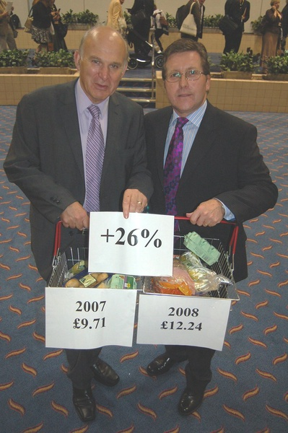
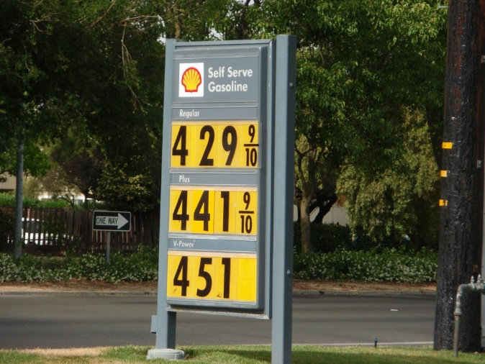

What we have been up against in the Past
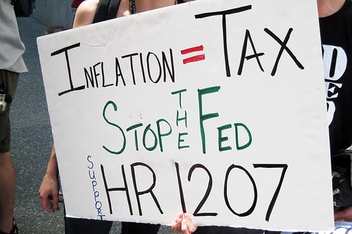

As Ronald Reagan said, “Inflation is the cruelest tax of all”

There are many additional points beyond the ten principles listed on page 2. This letter is not to put us in panic mode or suggest that we are in dire straits right now. However, this letter reminds us that we should strive to be careful with expenditures and have contingency planning in place so that when life becomes more challenging, we will be ready to do what we must to handle possible future adversities.
This is not the time to panic but it is the time to be wiser than we have even been before and proactively plan ahead to do all that we reasonably can for ourselves.

OCALA Last week we were delighted to receive Al and Pat Winters who have relocated to the Ocala area from San Diego, CA. This week Stan Braumuller will give the sermon.

FT. MYERS Thanks goes to Jeff Lockhart who helped us again last Sabbath. Moses Summers will be there this Sabbath.
Last Sunday, the radio station that we program on, WKDW-FM, accidentally played Sunday’s programs out of sequence. Consequently our broadcast did not appear until the afternoon. Because no one knew that would happen, several listeners e-mailed the station. It impressed the station manager who felt that such a reaction indicated that the show has followers and is growing.

TALLAHASSEE Last week we had a new person come to services and she left with an arm full of booklets. I will be there this week.

The zoom Bible study was enjoyable this past Wednesday. In addition to local brethren coming on line, we had three connections to Grenada, several to California, one to Germany and one to Philadelphia. We have had several Messianic Jews join us in the past several weeks. We expect that trend to continue and grow.
I’ll close here. I know it has been said already but please pray for the Work of God including our ability to reach new people. Victor Kubik shares the current thinking of our media people in his column as the church works to be evermore effective in giving hope and optimism to those in whom we come in contact with.
https://search.creativecommons.org/photos/d790370d-7c2c-43fd-8099-9d3679a7fcc2"Uncle Sam is Broke" by Infrogmation is licensed under CC BY 2.0"Vince Cable Mark Hunter MP Cost of Living" by Liberal Democrats is licensed under CC BY-ND 2.0"Inflation = Tax" by r0b0r0b is licensed under CC BY-NC-SA 2.0 "20110627 Now that is "High Cost of Living" by Zombie Normal is licensed under CC BY-NC 2.0inflation!" by Degilbo on flickr is licensed under CC BY-NC-ND 2.0

