Weekly Bible Study via Zoom, 7:30-9:00, currently in Olivet Prophecy – Mark 13 Weekly Radio Program, WKDW – FM Northport, FL., Sundays,10-11 AM Weekly Webcast from Ocala, Saturdays, 1:30 PM

Pastor’s Letter June, 25, 2021
Underdogs Take Note!

H O P E - L E S S ?
- They NEVER played football before
- They were WAY too small !!!
- They (sometimes) HATED each other
- They had NO equipment
- They had NO experience and …
- Some said they were a bunch of “losers” WHY? ..because they were
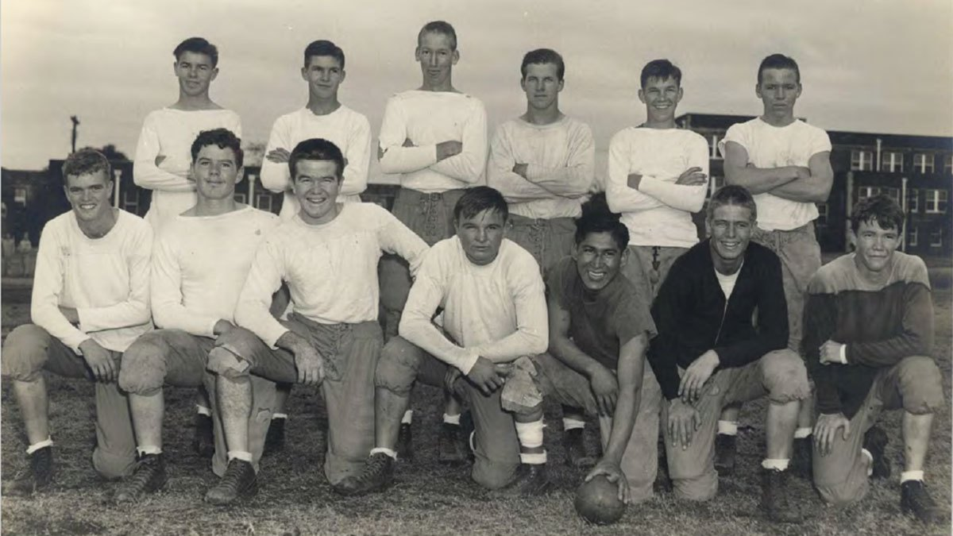

O R P H A N S

Shall We Call It Audacity?
A most improbable story occurred in the 1930s at the height of the Great Depression in Ft. Worth, Texas. An orphanage of fatherless boys (and girls) that existed there with a small high school enrollment at a fraction of a regularly sized high school, had the audacity to launch a high school football team. However, this was not your typical football team. It was far, far less likely to succeed. The team consisted of only 12 players which meant that some players would have to be on the field for the entire game as they played against other high school teams that rotated and rested up to 40 people in regular games.
No, No, No, No, & No!
As already stated, the orphanage barely recruited enough boys to field a team…just 12. The enlistees had never played football before. They had no equipment, no confidence, no camaraderie, no size, no tradition, no fans, no transportation, no field, no cheerleaders, no dads in the stands, no endorsements, and no experience of any kind. Their first piece of equipment for kicking field goals was an empty soup can.
Everywhere they went to play games, they were unfairly ridiculed and stigmatized for being orphans – as if to imply that they were inferior teenagers that could not be expected to do what other boys could do who had fathers to cheer them on. Adding insult to emotional injury, opposing football players, on average, outweighed the orphans by 30 pounds per player. But as the orphans gained success, the entire nation got behind them including President Franklin Roosevelt! The team was led by their innovative coach, H. N. “Rusty” Russell. As they began winning football games, the public bestowed upon them the name “Mighty Mites.”

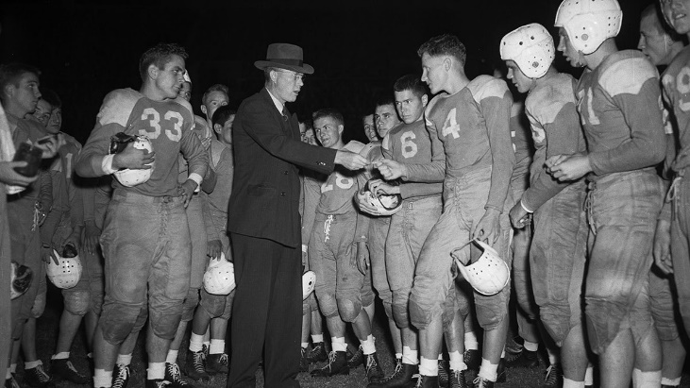

While it took time to build a winning attitude among the orphan teammates, coach Russell consistently and emphatically hammered home proactive statements to his players such as “You can do it,” “You matter!” “You do belong,” and “you are winners.”
Along the way, the players soon learned that their coach was an unconventional strategy genius as he employed “trick plays” and team speed into their offense. Moreover, Russell embellished their position of quarterback, the spread offense, and the half back option. All of these versatile strategies plus sheer speed with end sweeps is what he used to compensate for what his team lacked in terms of size. Opposing teams generally carried 10-12 plays in their football playbook. Coach Russell had 700 in his.
Also along the way, Russell’s players were stunned to learn that their coach also was an orphan who understood the painfully unforgettable experiences that many of them had in not having a dad. Their respect for coach Russell soared. It is fascinating to note that most of the teammates went on to have special careers that capitalized on the priceless lessons that Coach Russell instilled in them.
Source material for this story comes from Channel 5, Ft. Worth, Texas as well as the movie 12 Mighty Orphans (currently in release in theaters), and Randy Galloway—a very objective columnist for the Fort-Worth Star Telegram. Once again, success stories like this one remind us how vital it is for us to be visionary, self-disciplined optimists who can reach high achievement with God’s help. In our calling to represent and proclaim the Kingdom of God, we can never waste our opportunity.
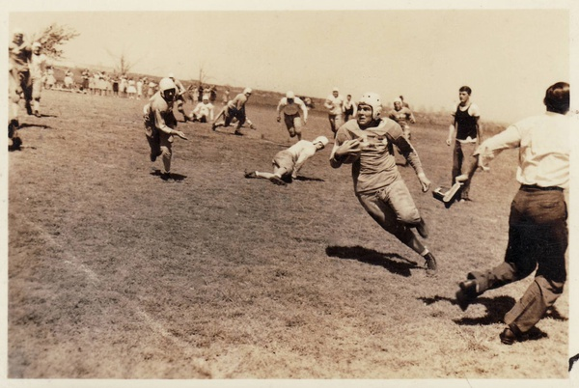

Congregational News
FT. MYERS
Our thanks go to Jeff Lockhart who spoke here last Sabbath and is able to again this time around. We had a nice summer crowd for services. In the revitalized intro for the radio broadcast, we have it rearranged to say that the United Church of God – Ft. Myers is sponsoring the broadcast. I plan to go into a series on prophecy after touching on several social issues.

OCALA
The Ocala website is making good progress. There was one glitch last weekend but we think we know why that occurred. Just as I was last week, I will be back in Ocala this week. I am plodding through bureaucratic red tape to again be able to visit one of our inmates in a facility north of Ocala and would appreciate your prayers for that to work out. Now that Covid is declining I am getting clearance to again see some of these inmates.
Barbara Braumuller continues to make a promising health recovery. The same is true also for Sharri Swindle.

TALLAHASSEE
Last week we had threats of tornadoes and intense rain and thus decided to cancel church services. This week Court Greenfield will be speaking with services held at “The Farm”. Leo Thomas is still waiting on full test results for his condition and welcomes everyone’s prayers on his behalf.

"Mighty Mites.04" by Boz Bros is licensed under CC BY-NC-SA 2.0

