Weekly Bible Study via zoom, this week on Mark 10-11, 7:30 P.M. Wednesdays Weekly Radio program, WKDW-97.5 FM, Sundays, 10-11 A.M. Weekly webcast from Ocala, Saturdays, 1:30 P.M https://www.ucg.org/congregations/ocala-fl

Pastor’s Letter, June 18, 2021

Up to 25 million children live without their biological fathers in the U.S. If this were a disease, we would call it an EPIDEMIC!
As we approach Father’s Day
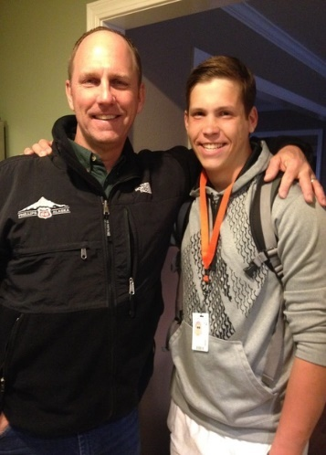
Ae Are
Are there any Fathers Left?

YES

63% of youth suicides are from fatherless homes - 5 times the average
90% of homeless and runaway children are from fatherless homes – 32 times average
85% of children who show behavior problems are from these homes – 20 times average
71% of all high school dropouts are from these homes – 9 times the average
80% of rapists with anger problems are from these homes – 14 times average
85% of all youth in prison come from fatherless homes – 20 times the average
90% of repeat arsonists come from fatherless homes
God never intended for society to get to this point. But as grim as these and other statistics appear, God knows how to solve this dilemma. We must remember that the Lord’s arm is not so short that it cannot save (Isaiah 59:1).
The good news is that there are many fathers left. Men that care about their families and/or are trying to re-connect with their family members.
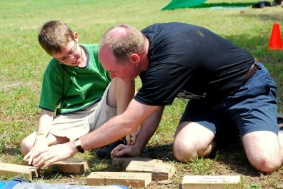
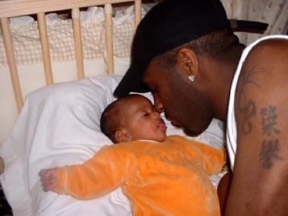



Individuals are learning that they can turn circumstances around in their own lives by harmonizing with God’s way. God reminds us to honor our parents (Ephesians 6 and Exodus 20) and provide a home in which a family would want to celebrate Father’s Day.
It is obvious from the statistics already listed that many children do not do nearly as well in life as they would if they had the strong backing and loving nurture of a proactive father. We can enrich family life if we can make Father’s Day more than just another day in the calendar. Those of us who can, must make a serious effort to uphold James 1:27 by including widows and the fatherless in our lives.
Of course, when fathers have abandoned their domestic responsibilities, surviving family members generally have a more difficult time in handling life circumstances. We cannot be insensitive to this challenge. We can be in awe of mothers who have striven, without their husbands, to fill the void that absentee fathers create but eventually God will exercise His wish to have fathers be genuine servant leaders in their homes.
Most people who are living without a father will be extremely grateful for whatever kindness we can extend toward them. It may be that a few of the fatherless are glad for some genuine attention yet may not seem thankful. We have to realize that this could be a result of never learning how to say ‘thank-you’ Why? Because they have lived for perhaps years in which no one else ever showed them any kindness at all. If we walked in the shoes of others who lacked sufficiency or lacked self-esteem or perhaps have gone through some type of abuse, we probably would not fare as well as we do. By the grace of God go any of us.

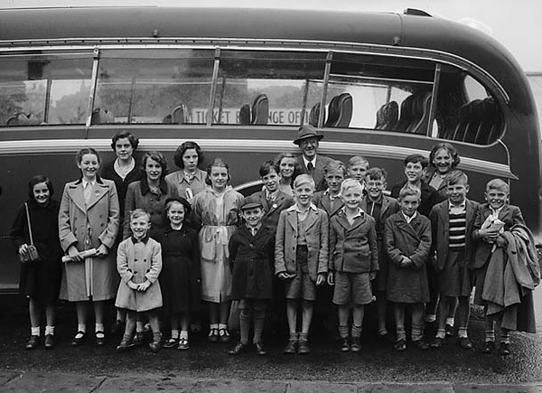

Fortunately, in past history, there have been at least some loving people to reach out to the fatherless to provide a quality of life that too often has been out of their grasp as shown in this field trip for fatherless children.

Father’s Day is an opportunity to jumpstart or further enhance harmony in a family and, again, it also presents the opportunity for us to do something nice for others outside our immediate families. One day the statistics that we see today will be reduced and eventually eliminated as fathers reconcile with their families. Perhaps with our help in the Millennium, the terrible statistical trends that we have seen at the beginning of this letter will be totally eliminated.

A forerunner to that time is reflected in the fairly new crusade of the “Promise Keepers” that have rallied in stadiums across the country to rededicate their lives to their families as they pray to God to have the character to follow through with right commitment. Below, you can see some of these people at a rally from three years ago.

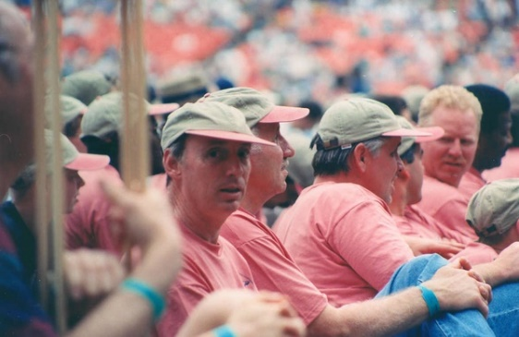
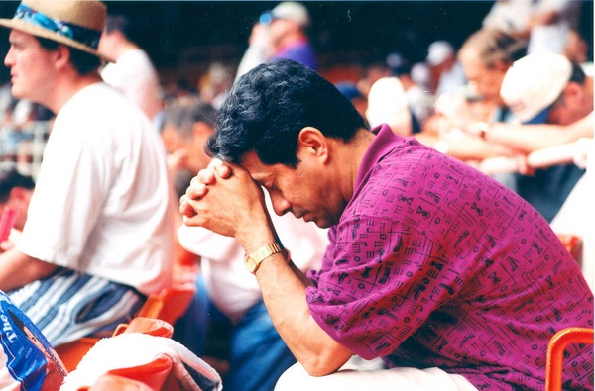

Promise Keepers Rally to rededicate their lives to lead their families

The issue of fatherless children and the opportunity to honor dads this weekend is a meaningful forerunner to the great reconciliation of children and their fathers as guaranteed in Malachi 4:6 “…His preaching will turn the hearts of the fathers to their children and hearts of the children to their fathers. Otherwise I will come and strike this land with a curse.”


LOCAL INFORMATION

- This weekend, Mike McCarty will be in Tallahassee, Mike Hammil will speak in Ft. Myers and I will be in Ocala. There will be a pot luck meal following services in Ocala.

- For those who cannot attend services on the Sabbath, you are encouraged to go to UCG-Ocala to watch services from Ocala at 1:30 P.M. Just click on to the Web Cast option. The password is “tree of life”.

- Below is the link for the Wednesday night Bible Studies.
- https://us02web.zoom.us/j/9417180031?pwd=L1dpanRxMDJIZ09qUk1rSHkxcnpZQT09

Bottom of Form
"Father, Son and Sun" by Doc Tharp is licensed under CC BY-NC-ND 2.0 "Father & son" by kaysha is licensed under CC BY-NC-ND 2.0 "Father/Son A and B" by heymarchetti is licensed under CC BY-SA 2.0"Father & Son II" by Hammonton Photography is licensed under CC BY-NC 2.0 "Father- Son" by OakleyOriginals is licensed under CC BY 2.0 "06.PKRally.RFK.WDC.14June1997" by Elvert "File:Trip for fatherless children (5078753730).jpg" by Geoff Charles is marked with CC0 1.0Barnes is licensed under CC BY-SA 2.0 "File:Trip for fatherless children (5078753730).jpg" by Geoff Charles is marked with CC0 1.0 "Brazil - A Day In the Life of Thaiza Vitória da Silva" by UN Women Gallery is licensed under CC BY-NC-ND 2.0

