Weekly Bible Study, Wednesdays, 7:30 PM via Zoom, currently covering Mark chapters 10-11 Weekly radio program, WKDW – FM, Sundays 10-11 AM, Northport, Florida Weekly cybercast from Ocala, FL., Saturdays, 1:30 PM
Pastor’s Letter June 12, 2021
Message to Addicts
When the majority think it can’t be done &
Your family may think that it can’t be done &
Your co-workers think it can’t be done &
Your closest friends think it can’t be done…

You Can Go From Here …

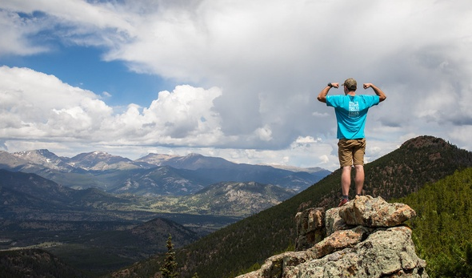

To Here..
But How ?

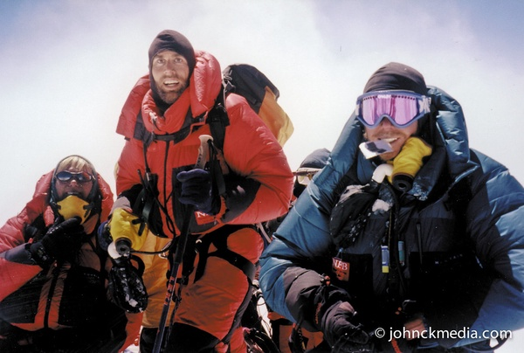

Victory!! 3 Standing on top of Mt. Everest

30,000 tried
300 died
94% quit
6% succeeded

Do you envision yourself overcoming your Mt. Everest?
Climbing up to and standing on top of the world’s tallest, rugged Himalayan mountain was Sir Edmund Hillary in 1953. Here he encountered and overcame the incredible obstacles that have daunted experienced athletes over the past number of decades that have striven to follow in his footsteps. It is sobering to consider that the 300 who died agonizing deaths were very experienced mountain climbers in peak condition. These many years later many of their frozen bodies remain strewn across the towering peak. Some of these people slipped and fell into deep crevasses and ravines, never to be seen again. Many were killed in avalanches. Some died of dehydration. The rest succumbed to asphyxiation brought on by a shortage of oxygen that induced brain fog and disorientation.
But let’s consider how some climbers succeeded. Those who succeeded believed in a winning game plan which included:
- Working as a team with others and not going it alone
- Taking care of one’s physical health
- Being sensitive to carelessness that led into backsliding
- Walking with the wise (the most experienced Sherpa guides)
- Having reasonable intermediate goals
- Encouraging each other
- Despising carelessness
- Yearning for fundamental preparedness
- Envisioning one’s self succeeding (Proverbs 23:7 “as he thinks,
so is he”)

It is interesting to note that these same principles that influence successful mountain climbing are also vital traits to maintain in overcoming any number of problems/addictions.

One of the one characteristic that jumps out is “Despising carelessness”. Similarly, Proverbs 8:13 says that the fear of the Lord is to hate evil”. When we are slow to or completely reluctant to overcome a character flaw, it is because we do not hate the sin enough. This is, of course, a reflection of our human nature which Jeremiah 17: 9 and Romans 8:7 address. It reminds us that too often we can become our own worst enemy.

Capitalizing on a popular proverb, when was the best time to begin hating our character flaws that hinder spiritual growth? …Years ago when we first became aware of them. When is the next best time to declare war on them? … it is now. We can dangerously assume that we will have plenty of time later to do what we should perhaps be doing now. We should walk with the wise. We should study the mind of God through His Bible. We should not try to “go it alone” if we can benefit from walking with the wise and working as a team. We generally do better when we connect with other teammates that can help us.

These are things that we all know. However, in the case of the mountain climbers, those who paid dearly in suffering and death generally tripped, stumbled or fell due to inattention and carelessness – albeit for perhaps a few precious seconds. It takes enormous self-discipline to climb an Everest-sized mountain.

Whatever our “Mt. Everest” is that we must overcome, God says he will help us if we will do our part. (I Cor 10:13 and Hebrews 13:5). Indeed this is a big subject and one that many ministerial counselors can add to. This letter is not the end of the matter but instead a reminder to us all to know that with God’s help, we can overcome anything … and the rewards for doing so are overwhelming.



Even in other languages, the stakes, as well as the rewards, are just as high
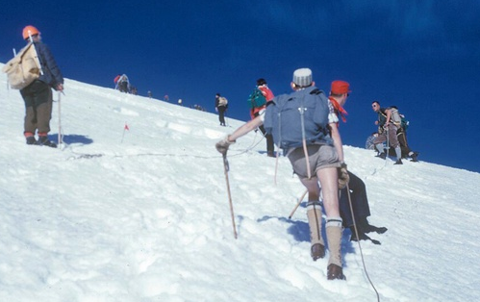
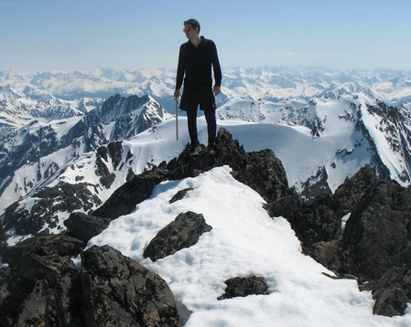

This man is standing on top of Alaska Teamwork is vital in these dangerous endeavors


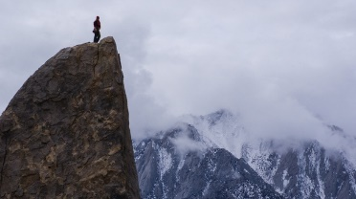
The Wages of Sin is With God all things
Death Things Are
Possible
Romans 6: 23 Luke 1: 37

No Reason to Retrogress We Can Conquer our own Mt. Everest

TALLAHASSEE
Leo Thomas let me know how much he has appreciated our prayers on his behalf. Preliminary tests show that he has prostate cancer but he is waiting on other tests to learn which stage it is in. Regardless, he has good energy and seems to be doing well. Pat and Court Greenfield will be with the brethren there this Sabbath.
OCALA
We will have accomplished a very important milestone for the congregations this weekend by launching our own webcast. This means that those who cannot make services will be able to listen and watch our local webcast. Much thanks goes to Jeff Lockhart and John Flink to make this finally happen.
Last weekend we had a number of visitors at services. They added much enthusiasm (and special music) to the congregation and basically everyone invited them back anytime. Tomorrow Stan Braumuller will give the sermon.
Ft. MYERS
It was a joy to the brethren last week to have both Jan and Bob Surratt come to church. The spirit is always willing but sometimes it is just not possible physically. I will speak there tomorrow.

Please remember to read this week’s letter from Vic Kubik, extolling the incredible value of strength through unity (being sent separately).
"What's Your Everest?" by No Barriers USA is licensed under CC BY-NC-ND 2.0 "File:Green Boots.jpg" by Maxwelljo40 is licensed under CC BY-SA 3.0

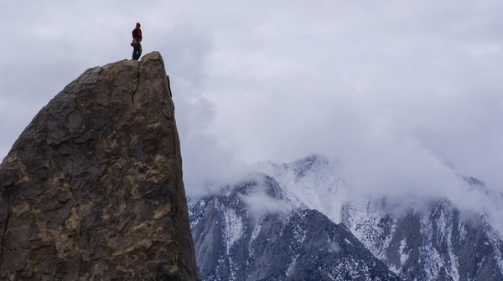
"alcohol slave" by Imagens Evangélicas is licensed under CC BY 2.0 "Alcohol Poisoning PSA Video Shoot" by stopalcoholdeaths is licensed under CC BY 2.0 "day-22-alcohol-poster" by …"Mountain Climbers circa 1965 Photo by my father Warren Brown" by Mind on Fire Photography is licensed under CC BY 2.0 "Crow Peak summit. Chugach Mountains, Alaska" by Paxson Woelber is licensed under CC BY 2.0 "Erik Weihenmayer Stands on Everest Summit" by Didrik J is licensed under CC BY-NC-SA 2.0

