Weekly radio broadcast on WKDW-97.5 FM, Sundays 10-11 AM from Northport, FL Weekly Bible Study via Zoom, 7:30 PM currently studying Mark 8-10 Coming soon: cybercast from Ocala
Pastor’s Letter, June 4, 2021

Sometimes forgotten…

God’s Love for His Sheep
Are YOU Loved?
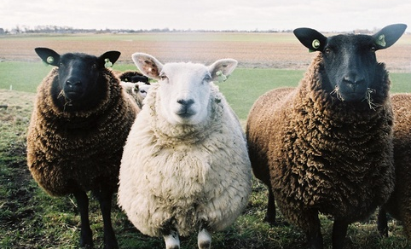
Absolutely yes!!

Will God adopt us? – We need to be loved
It is not accidental that God likens us to sheep. Sheep are lovable. They are adorable. They can be kind, intelligent, loyal, perceptive and huggable as is demonstrated in pictures that follow. When you woke up this morning as a spiritual sheep in good standing, did you say to yourself or possibly announce to others…”I feel lovable and adorable today!” Right?…..well...probably not. But God does love you…not with a syrupy, maudlin mindset but genuinely and deeply. If that sounds strange to someone, perhaps that person in his or her life has never heard that statement before.
If we stand back and consider what God says about us, we should know that we are much loved – very reassuring to know in this age of ruthless competition and condemnation of others. God knows every one of us by name and knows infinitely more about us. Through the Chief Shepherd, Jesus Christ, God has steered us this far and desperately wants to guide us the rest of the way – if we will cooperate with him.
Most sheep prefer not to be alone but there are often some confused sheep that love to stray into uncharted water, so to speak. Without a shepherd, too many unknowingly risk life and limb to find unsafe “greener” grass elsewhere. This can result in nibbling on false doctrines in danger zones that only a devil could love. Sheep have to be carefully led on safe paths so as to not get cut by poisonous shrubs or ivy. Sheep don’t realize that there are over 300 different diseases that could kill them. Moreover sheep are prone to panic if they think that they are lost or get desperate for food. And while they can be lovingly guided into green pastures, shepherds know that sheep must have a variety of grasses otherwise they will gorge themselves on thick green grass until they die. BUT if they follow the shepherd who will rotate them onto the different grasslands that they need, they will be at their best, health wise and look very adorable to God.
Some thoughts from the sheep
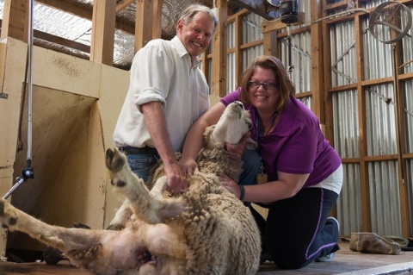
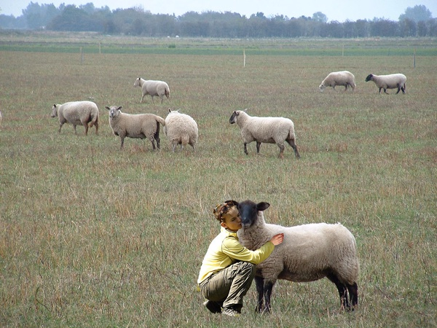
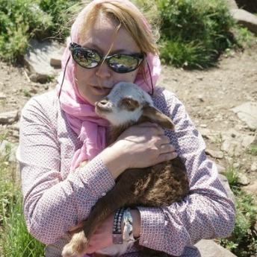

It’s time someone noticed me I think she is going to keep me Could God spoil me rotten like this?
What does it mean for God to love you? If you have seldom or never heard anyone say that to you before, consider reading the classic 23rd Psalm of David who worked with and had extensive knowledge of sheep. David not only adored sheep but risked his life to fight off lions and bears to defend his sheep.
David knew how to reassure them, and lead them besides the still waters. Cattle and other livestock, including sheep, get rattled when they encounter running water. This is why covered bridges were built over streams in New England. In the Spring, even with heavy runoff from melted snow, the livestock that had to be transferred across the river rapids displayed no fear because the side panels of the bridges obstructed their view so they could not see the rushing water.
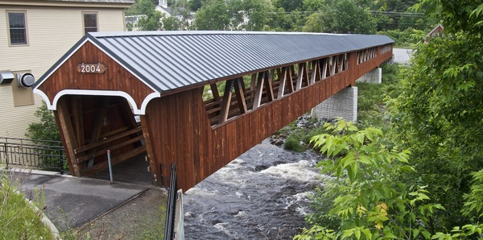

This covered bridge enabled cattle and sheep to cross without fear.

David writes about the good shepherd enabling the sheep to lie down in green pastures. Sheep never lie down unless they feel safe, secure, well fed and protected. Sheep that have lain down feel complacent. They trust the shepherd to provide them a secure life and they stay with their shepherd. However the picture below shows a sheep that was very bad because she wandered off the trail and lured some other inexperienced sheep to follow her. The shepherd either had to carry her or put her in the paddy wagon where she would go into special confinement.
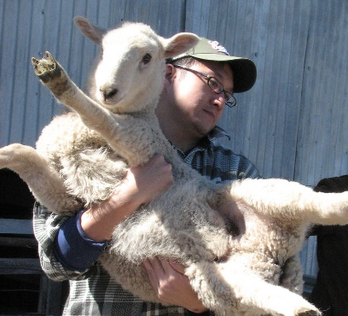
Bad Sheep! – you weren’t supposed to be such high maintenance! Let’s get back with the group…BUT - You know why I am hauling you back don’t you...It’s because I love you.

As I hope you have been praying for the overseas activity of the church, you all probably know by now that Jorge de Campos was in a life-threatening auto accident this past week in Brazil. Since it thoroughly totaled his rental car, he estimates that the collision by an on-coming car narrowly missed killing him. He was miraculously protected. Although, he had a number of bruises and was very sore, Jorge suffered no broken bones and walked away from the wreck. Two days later he is pictured in the pictures below, resuming his itinerary and performing a baptism. Read more: http://v2.travelark.org/travel-blog-entry/jorgedecampos/11/1621129144
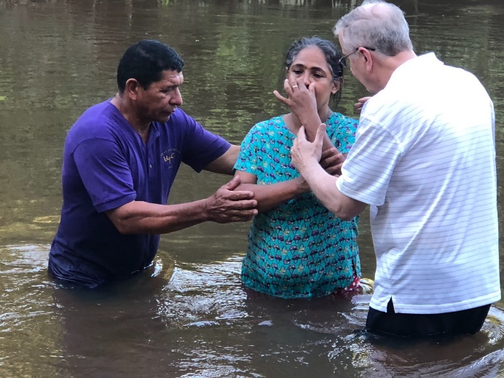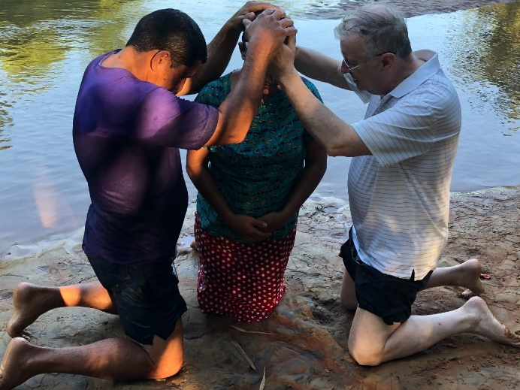

Local Church Events
Ft. Myers
Much thanks to Bob Orosz for coming with his wife to Ft. Myers last Sabbath. This Sabbath Frank Dunkle, head of the ABC college, will be here with his family as they travel this week in south Florida. I asked him to share his knowledge on aspects of the Law of Moses which is part of an on-line class that he did with the ministry last year.
Tallahassee It has been a big help to have Pat and Court Greenfield come to Tallahassee as they did this past week. I plan to be there this coming Sabbath. Church services this weekend will be at the Marriott Hotel, just off of I-10 on Raymond Diehl Rd.
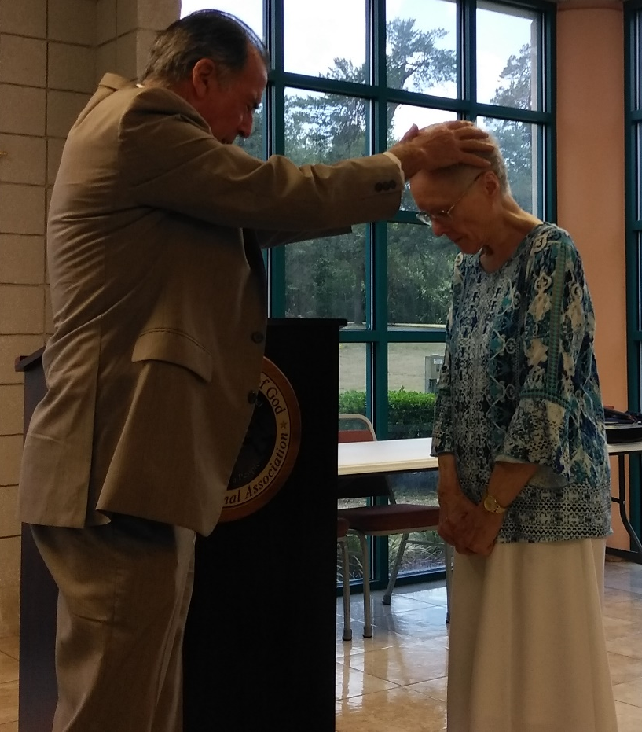
Ocala Euphoria was high last week in Ocala with the overdue ordination of Marcia Winne to the office of Deaconess (shown below). She has been serving in the role of a deaconess for many years and all of the congregation was very happy to see this designation made. Also, it has been wonderful to see Sharri Swindle do so well health wise after several years of difficulty. This week Randy McQuien will be speaking.

Also from Ocala !
Message from Stan Braumuller:
Since this world is inundated with bad news, I decided to break that chain with some uplifting news as you were so personally involved in both prayers and anointing of Barbara. The recovery is by God's grace very consistent and steadily. This morning we got the good news from the surgeon that the ensuing report from the pathologist was totally negative, which means no chemo treatments. We will see him, however, on Tuesday for a follow-up appointment. As we, God's children say, God is good all the time and all glory and honor to the Almighty.
Kind regards, S.B.
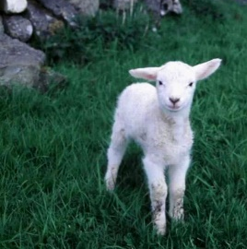

Hey! Don’t Leave me out!

by ClaraDon is licensed under CC BY-NC-SA 2.0 "i love sheeps!" by kygp is licensed under CC BY-NC-"lamb lifting" by BotheredByBees is licensed under CC BY 2.0ND 2.0 "Irish Lamb" by moonjazz is licensed under CC BY-SA 2.0 "A Family Scene Close DSC_3998" by barrygoble is licensed under CC BY-NC-ND 2.0 "Brenna and Sheep" by Mike 'Curby' Lee is licensed under CC BY-NC-SA 2.0 "Big Hug For Nature, Iran" by dinparvar is licensed under CC BY-NC-SA 2.0 "Old Sturbridge Village Covered Bridge" by foroyar22 is licensed under CC BY-NC-SA 2.0 "Littleton Riverwalk Covered Bridge" by jcbwalsh is licensed under CC BY-NC 2.0

