Weekly Bible Study via Zoom, 7:30 Wednesdays to cover Mark chapters 8-10 Weekly Radio broadcast, Sundays, 10-11 AM on WKDW-97.5 FM Coming soon, weekly cybercast from Ocala, FL

Pastor’s Letter May 28, 2021

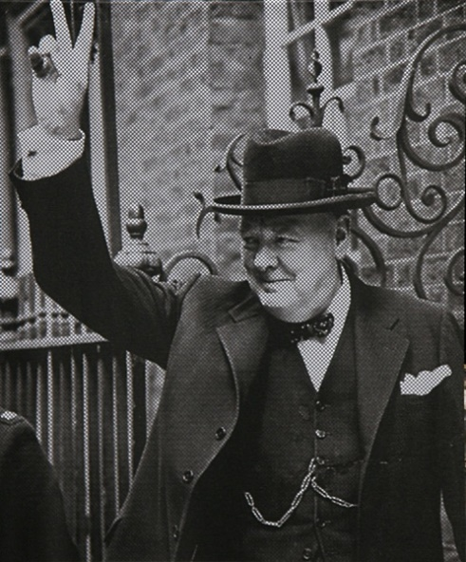
This Was Their Finest Hour

What is Ours ?

It is only natural that many people, and especially older ones people in their twilight years, look back on their lives and wonder if their best productive years are all behind them…or if they can maintain meaningful life.
Some have defied general trends such as Colonel Sanders who expanded Kentucky Fried Chicken nationwide while in his 70s. Grandma Moses became a nationally recognized artist after deciding to take up painting at the age of 78. Winston Churchill became Prime Minister of Britain at the age of 66 and again at 77.
Virtually everyone wants to matter to others and many want to leave a legacy or an endowment of some kind. One such person, Winston Churchill, felt that life “had passed him by” and he deeply felt he had much more that he could contribute to his country. For Churchill, circumstances changed dramatically in May of 1940 when, at the age of 66, Churchill was appointed by King George to form a new government and to become Prime Minister. Churchill was hardly a perfect man but he was able to contribute a certain amount of genius leadership that made a difference for millions of Americans and Europeans.
As he became Prime Minster in 1940, Nazi Germany invaded Denmark, Belgium, Luxembourg, and defeated France. Britain was on its heels and its last really-trained fighting force was stranded and defenseless against the Germans on a strip of land called Dunkirk. Britain and the western world desperately needed a leader who could rally the people and maintain sufficient backbone to endure to an ultimate victory. Churchill helped in many ways such as emboldening the free world with speeches such as this one given when he assumed his appointment.
“…the Battle of France is over. I expect that the Battle of Britain is about to begin. Upon this battle depends the survival of Christian civilization. Upon it depends our own British life, and the long continuity of our institutions and our Empire. The whole fury and might of the enemy must very soon be turned on us. Hitler knows that he will have to break us in this Island or lose the war. If we can stand up to him, all Europe may be free and the life of the world may move forward into broad, sunlit uplands. But if we fail, then the whole world, including the United States, including all that we have known and cared for, will sink into the abyss of a new Dark Age made more sinister, and perhaps more protracted, by the lights of perverted science. Let us therefore brace ourselves to our duties, and so bear ourselves that, if the British Empire and its Commonwealth last for a thousand years, men will still say, “This was their ‘finest hour’ “
Surely this was Churchill’s ‘finest hour’ as he rallied his countrymen. Britain’s royal air force then was further inspired to fight for its country’s survival and its citizens endured “the blitz” and went on to help win the war.
And Now Us
All these years later, a bigger crisis is brewing called the Great Tribulation. It will be far more extensive than World War II. Traumatic events from the Great Tribulation promise to create enough chaos to destroy this planet. God says that “except those days be shortened, no flesh will be saved alive” (Matthew 24:22). For as long as it can, God’s church will be in a position by which it can impart hope, optimism and strong confidence for all. However, the church’s message will not always be well received in society. Will we have the courage to do what God would want us to do, no matter what? IF we successfully fulfill this commission, surely it will be said of us, ‘This was their finest hour’.
Aw, the Price is too high! Let somebody else do all of this
For us to have our finest hour we will need to proclaim the gospel message everywhere we can. We will need to have a viable magazine distribution program. Perhaps we should have broadcasts as well as telecasts. We need a network of prayer warriors to invite God to help us succeed. Age cannot be an excuse for us as we “make a difference”. Judgment is still on us, the House of God (I Peter 4:17)
We may not be able to physically do what we did years ago but we can pray, communicate with others, organize more and “think smarter”. The Bible talks extensively about giving recognition and deference “to the hoary head” because such people have extensive experience and wisdom that they can share.
Years ago we had an elderly widow in Ohio who could barely walk help distribute Plain Truth magazines. She moved 2,000 of them every month. Another church widow, in almost impossible health, was permanently bedridden but from her bed she propped herself up with pillows and prayed multiple hours every day for as many people as she could. The day she died, paramedics had been asked to check on her. One said to her pastor, “Don’t ask me why I feel compelled to tell you but this widow died sometime last night, propped up by all of these pillows. Why all of the pillows? I don’t know . . .but anyway, that is what happened.” The pastor told the congregation what had happened and said that he had planned soon to ordain her as a deaconess because of all the help she rendered as a pillar of the congregation.
I remember a man by the name of Herbert Armstrong in his 90s who credited God for enabling him to accomplish more in a final year of his life than he had accomplished in all the previous years of his life. In the Bible there are mentioned such legends as Anna, Samuel, Abraham, Isaac, Job, Daniel and the apostle John who served God mightily in their older age. David wanted his life to continue. Hezekiah asked for another 15 years. Rahab wanted more time for her family and, humanly speaking, Christ did not want to die if there were any other way to deal with His future. They all wanted to continue serving God and also to make a significant difference in doing so.
In this church we also have younger brethren with the potential to become the next Timothy, the next John Mark or the next leader to follow in the footsteps of Daniel’s young friends, Hananiah, Mishael and Azariah.
The reality is that everyone of every age needs to be inspired to work together.
If we all yield to God and have Him live within us as Paul describes in Galatians 2:20, then it will be said of all of us, “This was their finest hour.”

In Search of the finest hour : Adages of Churchill
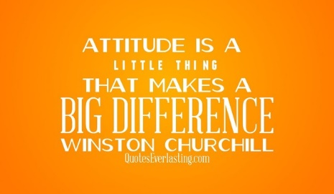

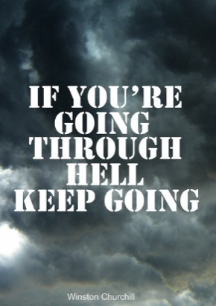

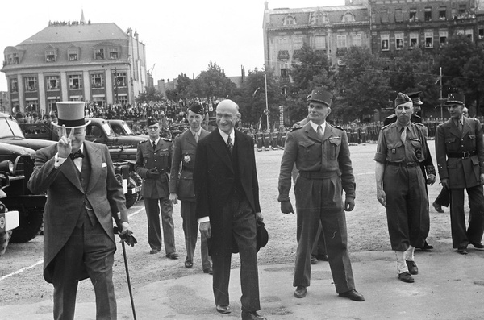

THIS SABBATH
Bob Orosz will speak in Ft. Myers
Court Greenfield will speak in Tallahassee
And I will speak in Ocala

"Winston Churchill à Metz, aux côtés de Robert Schuman (14 juillet 1946)" by Bibliothèques-Médiathèques de Metz is licensed under CC BY-NC-SA 2.0

