Weekly Bible Study, Wednesdays at 7: 30 PM, currently in early chapters of Mark Weekly Radio Program, From Northport, FL., Sundays 97.5 WKDW-FM Weekly Cybercast from Ocala, FL., coming soon
Pastor’s Letter, May 21, 2021

Protected by the Iron Dome

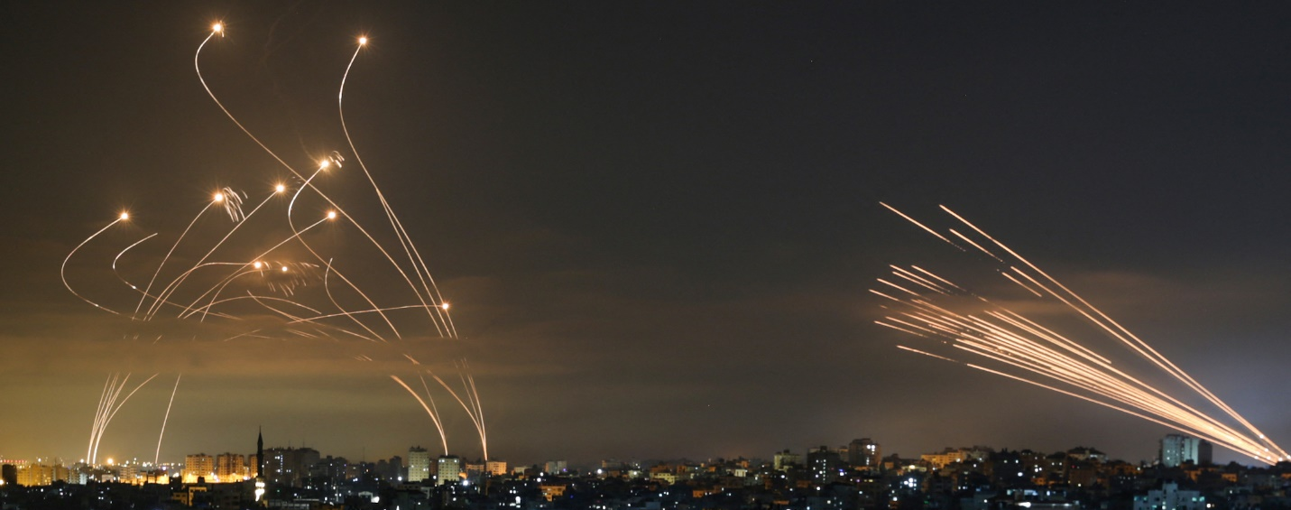

The Iron Dome interceptors (left) meet a volley of missiles from Gaza (right) on May 14, 2021. (Anas Baba/AFP via Getty Images)

The Iron Dome interceptors (left) meet a volley of missiles from Gaza (right) on May 14, 2021. (Anas Baba/AFP via Getty Images)

Suddenly you are under missile attack. In Israel, you read sensitive radar showing lethal incoming rockets racing rapidly toward you. As usual, the Israeli Defense Command has mere seconds to ascertain the direction and speed of the incoming missiles. The goal is always the same: to destroy Gaza’s incoming missiles with faster rockets of their own.
This protection is called the “Iron Dome”. When Hamas fires its rockets at point blank range from the Gaza Strip, the Israeli Defense Command must retaliate accurately or else the country could be lost. There is really no advanced warning.
If you were in charge of defending the country with only seconds to marshal a sufficient response to save it, when and how would you respond? The nation of Israel faces this horrible dilemma every day. Perhaps Israel would be an unrecognizable wasteland if not for the Iron Dome which it constructed 10 years ago with the help of US technology.
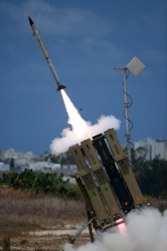

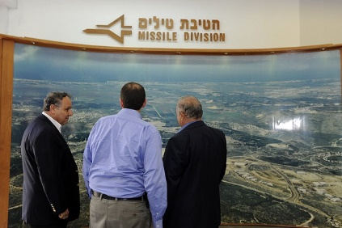
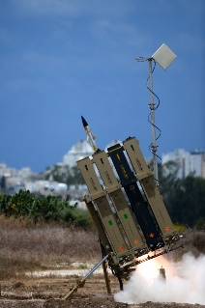

Israeli Central Command

The game plan below never changes:
A rocket is fired from Gaza
- Israeli radar locates rocket in flight
- A second later Israel launches a faster missile
- Israeli missile intercepts the incoming rocket at high altitude and destroys it
But as good as the defense system is, 10% of the incoming missiles get through and destroy Israeli neighborhoods, schools and roads as shown below.
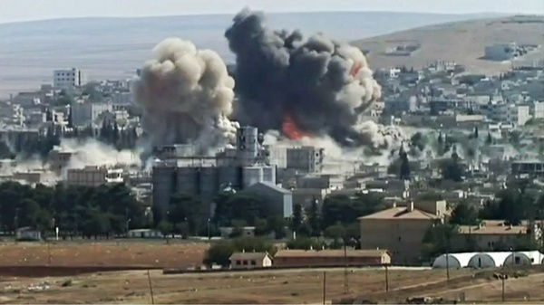

A Protective Dome around Us
It so happens that we can have an Iron Dome around us. It is described in Ephesians chapter 6. It is our protection against the fiery darts of Satan the Devil. We are admonished to be on guard against these darts as the Apostle Paul mentions in Ephesians 2:1-2.
Like Balaam, Satan wants to induce God’s family to sin and by doing so, separate Christians from God. Satan hates our practice of Christianity because we and all of mankind ultimately represent a threat to his domain which is now the earth.
Satan is the author of dissonance, strife, anger and hatred. He tries to make sin attractive and fire wrong thoughts in our direction with the hope that his sinful ways will gain a foothold in our minds (with our consent) and germinate further sinful thought patterns to separate us from our God.
Perhaps we associate Satan with throwing an occasional dart at us but fail to recognize that he could fire multitudes of wrong ideas at us at one time just as Hamas has thrown multiple missiles at Israel (see picture below on left)
That is what happened in the book of Job. From experience, Satan knew that he could upend many humans by infecting them through fiery darts of negativity, bitterness and hatred. This was his approach to gullible angels that became infected with his negative thinking. Satan knew that Job had an extraordinarily strong relationship with God so he chose to launch not one, but multiple, poisonous rockets at Job’s brain just as Hamas attempted that one night to flood the Israeli sky with rockets as shown below.

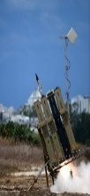
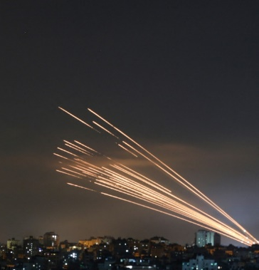

Could you handle this many incoming “darts” ? The best defense is a strong offense
In Job 1:14-15, one incoming “rocket” announced to Job that his livestock was stolen and his hired help was slain. Just a fraction of that bad news would discourage and maybe destroy one’s trust in God … but then, a second incoming missile announced that fire from heaven had destroyed additional livestock and killed Job’s servants.
Suddenly a third rocket landed with devastating news: The Chaldeans had stolen all of his camels and killed their caretakers. As if that were not enough, a fourth missile arrived to report that a vicious windstorm suddenly arose and killed all of his sons and daughters. All of these things suddenly happened without warning.
Job maintained his spiritual equilibrium by having on the armor of God (Ephesians 6:13). Probably anyone else who wore less armor would have become bitter against God. However Job basically held his peace in spite of deep anguish and allowed the darts of the devil to glance off of God’s armor that he wore.
But after these four darts of tragedies, Job’s wife herself fired a heavy dart at him at unfairly close range by goading him to size up his misfortune and “Curse God and Die”!!! As the accuser of the brethren (Revelation 12:10) Satan has manipulated many a person to succumb to his anger and bitterness as he has orchestrated.
At a point of his life where Job could have screamed and lost self-control, he deflected that Satanic dart as well. Job told her that she spoke as one of the foolish women. With that comment, his wife’s dart glanced off of Job’s armor and fell harmlessly on the floor.
So with no warning, Job was hit here by at least 5 darts yet none of them gained a foothold in his brain. None turned into a raging forest fire. Closeness to God and living His way of life will deflect these incoming missiles for us when we put on the armor of righteousness. (Ephesians 6:11-18)
Otherwise, if we neglect the armor, we can allow Satan to “successfully” work his influence on us and we can become just so much rubble as some buildings have become that were destroyed by Hamas rockets.
As you will notice in the President’s letter sent out yesterday, Vic Kubik utilizes the same concept of the Iron Dome.


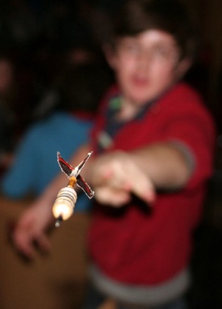
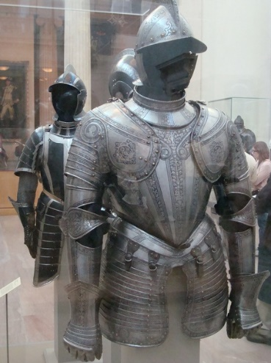

Protection from this to prevent spiritual death

I want to pass along a prayer request from Robert Luther and his wife for their daughter who apparently had a blood clot in one of her carotid arteries and another blockage with a small blood vessel in the brain. This occurred Wednesday evening and I announced it to our brethren that were at our Zoom Bible Study.

For services this week
Mike McCarty will speak in Tallahassee (at the “Farm”)
Court Greenfield and Jeff Lockhart will speak in Ocala
I will speak in Ft. Myers
All services begin at 1:30
_

"Iron Dome in action" by IsraelMFA is licensed under CC BY-NC 2.0"_PDA5444" by U.S. Embassy Jerusalem is licensed under CC BY-SA 2.0 "Visit to Rafael_No.008FL" by U.S. Embassy Jerusalem is licensed under CC BY-SA 2.0 "Medieval Armor" by IslesPunkFan is licensed under CC BY-NC 2.0
"Iron Dome in action" by IsraelMFA is licensed under CC BY-NC 2.0 "Twin-Explosion in southeastern Kobane on 8th October 2014" is licensed under by quapan CC BY 2.0 "On The Scrap Heap ." by Neil. Moralee is licensed under CC BY-NC-ND 2.0

