Weekly Bible Study, Wednesdays, 7: 30 PM, currently in early chapters of Mark Weekly radio broadcast, Sundays on WKDW – FM 97.5, 10-11 AM Weekly cybercasts of services in Vero Beach, Orlando, St. Pete & Tampa

Pastor’s Letter, May 14, 2021
Are You A Big Kid or a Medium Sized kid ?
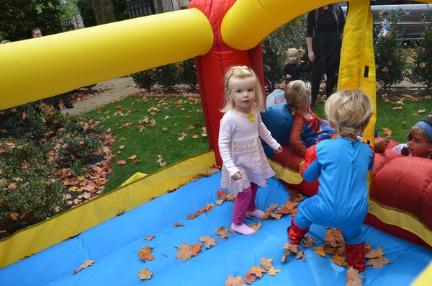

The Power of a Child

What? Since when does a child have great power?
One of my favorite questions to ask when I have engaged in conversation with a small child is: “Tell me, are you a little kid or a medium sized kid?”
The vast number of responses is, “I’m little” or “I’m a little kid” or “I’m just a kid”. Sometimes they will say, “I’m medium size” yet one very small boy answered me one time with intensity to proclaim, “Little kid ? – NO! … I’m a big kid.” He was only 3years old. Overall there is a sweet innocence in how these young people see themselves…with no pretense.
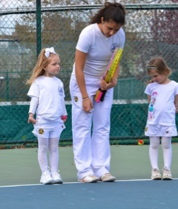
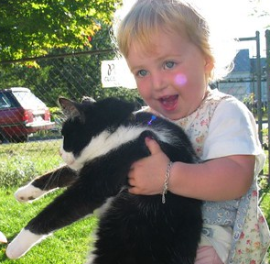
This sweet purity is in contrast to self-promoting adults seeking attention and preeminence. In the book of 3 John, verse 9, is the Apostle John’s keen observation that early in the history of God’s church, a contemporary of his, Diotrephes, a power-hungry narcisist, yearned to have the pre-eminence over other people. He was full of pride. Somehow, in his own mind, Diotrephes just knew that he was a HUGE kid…and was glad to let everybody know that. The Bible repeatedly shows that God resists the proud but gives grace to the humble. The people that get God’s attention and win God’s favor are those who have no vaunted pretense about themselves but instead are like “little children” in unfeigned humility.
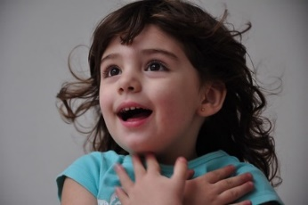

So…in God’s sight Who are the little kids and who are the truly Big Kids?
Christ puts this in accurate perspective in Matthew 18:1-3
Becoming Like Little Children
“I TELL YOU THE TRUTH, UNLESS YOU TURN FROM YOUR SINS AND BECOME LIKE LITTLE CHILDREN, YOU WILL NEVER GET INTO THE KINGDOM OF GOD”
… Not like prideful adults


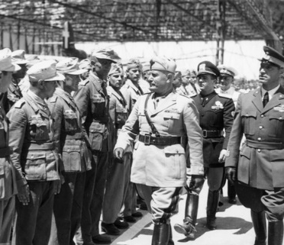
Indeed, the gateway to the Kingdom of God is through having the pure mind of a child. This is based on humility which can be so elusive as sooooo many people get lifted up with the opposite condition of pride. Too many don’t see it in themselves. Not even Job could see his own pride. But where pride exists, it separates prideful human beings from God.

.

The trusting attitude of a child shines through in this account below when a Christian family’s car refused to start at all.
Divine Intervention when the Stakes are Low..
The car seemed dead as Nancee realized that the car's engine wasn't turning over. After about fifteen minutes, her husband came back to confirm "The car is indeed dead," he said. "I've tried everything but it won't start."
"What are we going to do now?" Nancee wondered aloud. "Rebecca is going to be so disappointed."
Little Jerry looked up. "We could pray!" he suggested, his eyes bright. The adults looked at him. "Well..." Nancee began. But Jerry was already on his knees. "Please, God, make the car start!" he prayed.
Nancee's husband smiled. "I guess I'd better try it again." He went out, turned the ignition key--and the engine sprang to life. Astonished--and before the car could change its mind!--Nancy and Jerry jumped in, and they sped to school. Nancee's husband kept the engine idling, as Nancee and Jerry brought the cookies to a delighted Rebecca, then ran back to the car. Next stop, the mechanic. He would be back in a few moments, they were told, so they sat down to wait.
Soon the mechanic returned, opened the hood and looked at the car. "Who towed this in?" he asked.
"No one," Nancee's husband replied. "We drove it here."
The mechanic shook his head. "You couldn't have done that. The battery is completely dead. It's ice cold."
And Divine Intervention When the Stakes Are High…
Below we have a fabulous example of two small children, Jonathan and Robert Loveall, who matter-of-factly asked God for help in an emergency. It did not matter to them that they were not “Big Kids”. However in deep trust they were in harmony with God and expected God to help them. That is the power that any small or adult child can have with God!

Jonathan and Robert are the children of missionaries in Central America. Their parents, Andrew and Rebecca Loveall, administer a school, Escuela Integrada de Ninos Trabajadores, for kids who help support their families as shoeshine boys, souvenir sellers, tour guides and food vendors on the streets of the tourist city of Antigua in Guatemala. Elbert, Kevin and Arlyn are students at the school.
A few years ago, the three teens were babysitting Robert and Jonathan when four masked men forced their way into the Loveall home with guns. They tied up all five boys and threw them onto the kitchen floor. Then they began to ransack the house. In the middle of the robbery, Jonathan and Robert’s father, Andrew, came home. The robbers put their guns to his face and demanded all of the family’s valuables!
Usually such home invasions end with the robbers killing all the witnesses. Tied up on the floor, Kevin whispered, “Let’s all pray that Jesus will protect us and make the bad guys go away.” The five boys prayed together. Then, for reasons that no one can explain, the robbers suddenly left -- taking hardly anything. Why did they leave so abruptly? Robert, who was five at the time, says he knows. He explained to his father: “Dad, when I was tied up on the floor and we were all praying for you, Jesus told me not to worry.” This account was written up in the publication Beliefnet.

Adults Becoming like children
The power of a child lies in his or her humility before God. On Pentecost Christ’s disciples had no false pretenses about themselves. They were embarrassed that they all denied Christ at Golgotha shortly before. They were beginning to realize more of what Christ meant when He said in John 15:5 “without me you can do nothing”. In Acts 1 and 2 on Pentecost these disciples “were in one accord and in one place” in prayer. This could not happen if all 12 were lifted up with pride. Instead they were all humble with child-like humility that enabled them to work together under the guidance of God’s Holy Spirit. They recognized their frail “smallness” and became very willing to follow God’s lead instead of their own.

The end result of all of these conditions was that God was able to use the 12 disciples mightily and transform them into 12 dynamic apostles to do His work. God loves all people of all ages. However, He has a special place in His heart for innocent children who are helpless of themselves to understand and escape the dangers of this society. But they have a guardian in God that will intervene if they pray and ask God for what they need. We can expect to see God answering our prayers if we also become as little children.
----------------------------------------------

This weekend the Greenfields will be with the brethren in Tallahassee at the “farm” and I will be in Ft. Myers.
Tomorrow Paul Bidetti and Bob Orosz will speak in Ocala while Stan Braumuller will speak on Pentecost. There mid-month pot luck meal for Ocala will be on Pentecost instead of the Sabbath.
All services in all 3 congregations will begin services at 1: 30 PM. on Pentecost in their respective locations.

As should be customary now at this late date, let us strive to follow Ephesian 5: 16-17 “redeem the time” as the KJV states it, as we read in the NLT, “Make the most of every opportunity in these evil days. Don’t act thoughtlessly but understand what the Lord wants you to do”.


We will probably never know how many disasters are averted because of the prayers of children. But because their faith is so pure (and Scripture says their angels "always see the face of the Father in heaven"), wonderful things can happen.

"Jack Lane and his little kid bike" by Richard Masoner / Cyclelicious is licensed under CC BY-SA 2.0 "Little Kid, Little Cat" by clappstar is licensed under CC BY-NC 2.0 "Little Kids in Tulips" by Paul Schultz is licensed under CC BY 2.0 "Little Kid, Big Tire" by clappstar is licensed under CC BY-NC 2.0 "Little Kids' Turn In The Bouncy Castle" by Joe Shlabotnik is licensed under CC BY-NC-SA 2.0 "Little Kids At Their Tennis Lesson" by Joe Shlabotnik is licensed under CC BY-NC-SA 2.0
Adolf Hitler at Madame Tussauds in London "File:Bundesarchiv Bild 146-2006-0102, Italien, Mussolini vor deutschen Soldaten.jpg" by Unknown is licensed under CC BY-SA 3.0

