Weekly Radio program on WKDW – FM 97.5, Northport, Fl., Sundays 10-11 AM Weekly Zoom Bible Study, now in book of Mark, ch 2-4, 7:30 Wednesday Evenings Webcasting church services in Orlando, Vero Beach, Ft. Lauderdale, St.Pete & Tampa

Pastor’s Letter, May 7-2021

For Mother’s Day…This week’s Pastor’s Letter is dedicated to the
UNSUNG DREAM TEAM

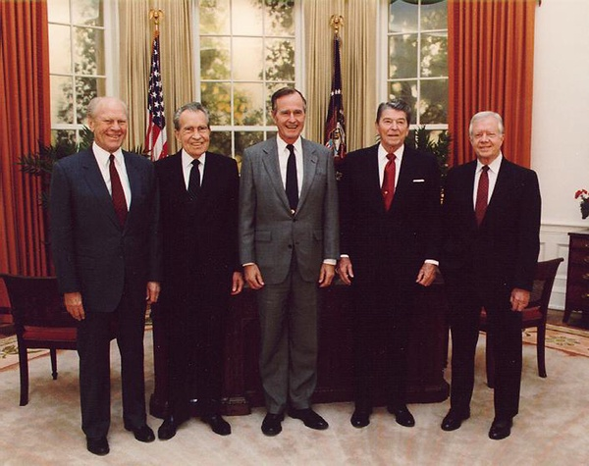
Who Raised

These People?

Answer: Dorothy, Hannah, Dorothy, Nelle & Miss Lillian

Some were rich. Some were poor. Some married well. Others married poorly. And most all endured deep and distressing trials, yet in raising their families, most passed on a deep optimism that their sons (and daughters) maintained into their adulthoods. The children of this dream team were encouraged to believe that they could accomplish anything that they set their minds to. Welcome to the unsung dream team of notable mothers who inspired their sons, against great odds, to become highly visible public servants. Five of those women have now been mentioned but there are others.
Or Else…!!!!
For example, the mother of Andrew Jackson who during the Revolutionary War learned that son Andrew and his brother were P.O.W.S. in a British camp and slated for execution. With fathomless gumption, Mrs. Jackson approached American authorities to obtain 43 British P.O.W.S. and led them to the English army and there insisted on an exchange of these 43 for her 2 sons! The Brits could have merely arrested her and ended the matter right then and there but they were intimidated by this irate mother hen and caved in to her vociferous demands.
Encouragement Goes a Long Way
In addition to the people already mentioned, other significant mothers in American History include Sara Roosevelt (FDR’s mom), Abigail Adams,(wife of one President and mother to another), Rose Kennedy (mother of one President and also close to having two other sons as President), and Ida Eisenhower. In the late 1800s, Dwight Eisenhower’s dad had to declare bankruptcy and mom Ida struggled to help out while simultaneously raising a family. Ida was God fearing and peace loving. It grieved her that her son went into the army but, like his mom, he hated war and, as President, kept the nation out of war. At the end of World War II, Eisenhower was indignant over the discovered and finally liberated concentration camps that the Germans established. It is likely that his profound sense of human rights existed because his mother Ida felt that way. It appeared to those who knew him well that his mother was his most favorite person on earth.
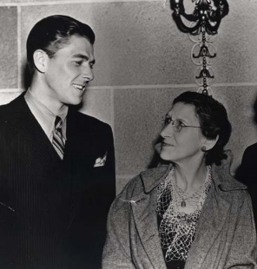
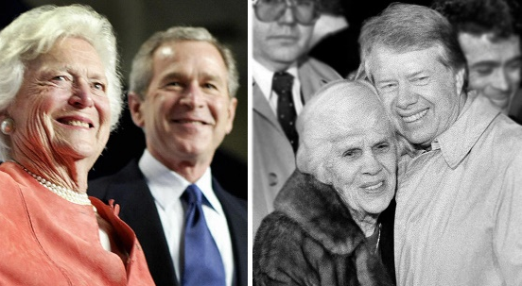
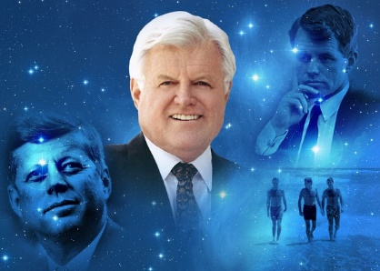
Bill Clinton’s continual confidence and perseverance in politics can be directly traced to his mother who constantly motivated and encouraged him. During his teen years, his mom Virginia was telling everybody “You know one day that boy is going to be President of the United States”. What is noteworthy here is not so much the flamboyant lifestyle of Virginia but the eternal optimism that she instilled into her son.

Rose Kennedy continually nurtured her family with one son, John, becoming President. From the time they were born she was encouraging them to achieve at anything that they were interested in doing. She had all 9 of her children reading before they entered school and they all highly valued reading.
Ronald Reagan’s mom, Nelle, inspired him to follow her footsteps in acting and also inspired him to have a high regard for the Bible. She made him memorize portions of it while growing up. He learned from his mom to be optimistic which made a difference for the country.
Hannah Nixon tried initially to encourage her son Richard to be in the ministry. Ultimately he declined but he was heavily influenced by mom instilling in him Biblical principles.
Dorothy Bush was a powerful influence on her son and future president George H.W. Bush just as Barbara Bush was a strong influence on her son and future president George W. Bush
Miss Lillian, mother of Jimmy Carter, abhorred racial segregation in the Deep South at a time when the Ku Klux Klan was alive and well. She was thrilled when Jackie Robinson became the first black man to play in major league baseball. In 1947, when he broke in by playing for the Brooklyn Dodgers, Lillian became an intense Dodger fan. And at age 69 she joined the Peace Corps and, in a sense, followed the steps of Mother Theresa. Also she passed on so many of her values to her son and future President, Jimmy. Perhaps that is why he later supported the Habitat for Humanity program and why he was motivated to help establish the Camp David Peace Accords with Menachem Begin and Anwar Sadat.

Dream Team Out of the Bible
The Bible has a great deal to say about motherhood. Great women of the Bible were mothers such as Mary, the mother of Jesus Christ, Deborah, Ruth, Lydia, and Dorcas, who breathed confidence and morality into their sons and daughters. Add to that other likely great mothers whom we may not directly know about such as Noah’s mother or Moses’s mother which likely nurtured their sons’ confidence. .
One of the critical pivotable points of Judean history occurred when God allowed 8 year old Josiah to become king. However, that appointment would be worth nothing without the firm and profound guidance of his mother Jedidah. This mother had taught her son to obey the Biblical directives from the God of Israel at a time when the nation of Judah was morally bankrupt. It was mom’s guiding force which enabled Josiah to stay the course and eradicate the country of unbridled paganism which even infiltrated Jewish temple worship. Due to Josiah’s early zeal for the true God of Israel, God delayed Judah’s punishment for being so wayward. One great mother here surely made a difference.
So… am I advocating that to be considered outstanding parents, our sons and daughters must be world famous? No, but all of us should aim to teach, mentor and inspire our children/teenagers to have a dedicated love for God and His ways. We should strive to maximize the opportunity we have to enhance the lives of those that God has entrusted to our care. Women can be in the lives of our children, or grandchildren (as opportunity permits) or students, fellow co-workers and other friends and relatives. I can think of several women in the church that I knew of that never had children themselves but adopted scores of them and made a substantial difference in their lives. If you find yourself wishing to mentor and teach more than you are at this point in time, do pray that God will find a perfect place for you to be able to do that.



..



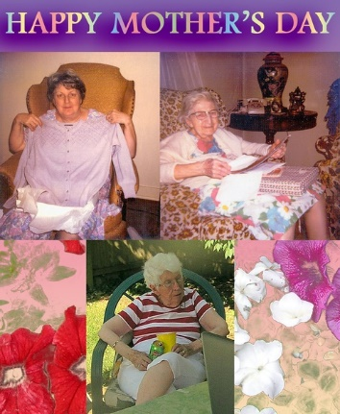

Mothers are psychologists, nurturers, coaches, chauffeurs, healers, intuitive thinkers, bakers, house keepers, interior designers, encouragers, educators, money managers, and incredibly resourceful
This letter supports the observation of others that so often “the hand that rocks the cradle rules the world”



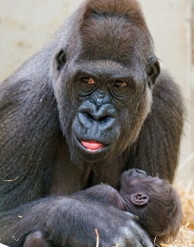

God magnificently placed an awe-inspiring maternal instinct in animals as we see here. But as much care as God would invest in maternal instinct with animals . . . how much more strongly does God invest in the power of mothers to nurture—just as Samuel’s mother Samuel, Hannah was born to nurture.

This Sabbath, Moses Summers will be in Ft. Myers, Mike McCarty will speak in Tallahassee (at the “farm”) and I will be in Ocala. Remember to pray for the church’s activities in these trying times in Africa and India as covered in the weekly newsletter from the home office which was sent separately.
BV

"In Loving Memory of U.S. Senator, Edward (Ted) M. Kennedy. Together again with his brothers, John (Jack) F. Kennedy & Robert (Bobby) Kennedy" by Beverly & Pack is licensed under CC BY-NC-ND 2.0 "1991 Five Former Presidents Gerald Ford, Richard Nixon, George H W Bush, Ronald Reagan, & Jimmy Carter" by Beverly & Pack is licensed under CC BY 2.0 "Camp Langano - Ethiopia 2014 Sean Sheridan Photo-65" by SIM USA is licensed under CC BY-SA 2.0 "today's new picture books" by your neighborhood librarian is licensed under CC BY-NC-SA 2.0 "Mother and baby" by ECohen is licensed "Mother and Child 1" by ECohen is licensed under CC BY-SA 2.0under CC BY-SA 2.0 "Mother and "Mother and Child 1" by ECohen is licensed under CC BY-SA 2.0 child" by Ian BC North is"HappyMothers Day" by Ian Sane is licensed under CC BY 2.0 "Mother gorilla with her baby II" by Tambako the Jaguar is licensed under CC BY-ND 2.0 "Mother and her silly cub" by Tambako the Jaguar is licensed under CC BY-ND 2.0 Clearly Basics North River G005-53 Glasses | Coastal "mother daughter" by alandberning is licensed under CC BY-NC-SA 2.0 "A Mother's Kiss [123/365]" by Lab2112 is licensed under CC BY-NC-ND 2.0

