Weekly Bible Study via Zoom, Wednesdays, 7: 30 PM now on opening chapters of Mark Weekly broadcast, WKDW – FM, 97.5, Northport, FL., Sundays 10-11 AM Webcast of church services from Orlando, Tampa, Miami, St. Pete & Vero Beach

Pastor’s Letter, April 30, 2021

When People in Harmony Don’t Care Who Gets the Credit…
There is no limit to how much they can produce
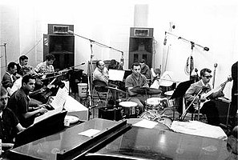

Members of the Wrecking Crew employed for a session at Gold Star Studios in the 1960s. Seated left to right: Don Randi, Al De Lory, Carol Kaye, Bill Pitman, Tommy Tedesco, Irving Rubins, Roy Caton, Jay Migliori, Hal Blaine, Steve Douglas, and Ray Pohlman
How many of you know who the “Wrecking Crew” was? Probably very few. It is because the Wrecking Crew did not seek the lime light. It knew what it had to do and it went out and did it without fanfare. It consisted of incredibly gifted (albeit unknown to the public) musicians in the Los Angeles area that collaborated together to listen to, evaluate and rewrite music of up and coming music artists.
In almost every case they knew far more than their patrons on how to make the music far more effective. They could sight read almost perfectly and they had great ears. They understood rhythm, harmony, chord progression and music innovation. Sometimes they broke precedent by additional sounds with rarely used instruments for certain sounds such as with the Beach Boys’ “Good Vibrations”. Groups like the Mamas & the Papas or the Monkees needed major help to become top tier and got unique guidance and their real starts from the Wrecking Crew. Eventually the Monkees never sang their own music. At rock concerts they lip synced to the recorded voices of the Wrecking Crew . . . and no one else knew for the longest time.
Music artists that members of this illustrious group coached to higher levels of effectiveness include but are not limited to:
Bing Crosby Frank Sinatra Nat King Cole John Denver Karen Carpenter Glen Campbell Mason Williams Elvis Barbara Streisand Nancy Sinatra Paul Simon Art Garfunkle Sonny & Cher Mamas/Papas Association The Monkees The Beach Boys Fifth Dimension Herb Alpert & TJB Righteous Bros. The Crystals The Ronettes Tina & Ike Ricky Nelson Diana Ross Temptations Smokey Robinson Brian Wilson Johnny Rivers Dean Martin Billy Joel Partridge Family

Hal Blaine, key drummer and master coordinator of the musicians, revamped enough songs of these individuals and music groups to place 140 of them into the top ten record chart and reworked many to become #1 hits, nationwide. Yet the Wrecking Crew never touted its accomplishments. Its people worked hard and always remained behind the scenes. But the ones that knew they existed were these musicians that were desperate for their expertise and they were able to pay big money to hire their services. Yes, the demand for the Wrecking Crew was intense.
According to guitarist Bill Pitman, a typical day of work was this: "You leave the house at seven o'clock in the morning, and you're at Universal at nine till noon; now you're at Capitol Records at one, you just got time to get there, then you got a jingle at four, then we're on a date with somebody at eight, then the Beach Boys at midnight, and you do that five days a week ...man you get burned out"
According to Kent Hartman, "... if a rock-and-roll song came out of an L.A. recording studio from between about 1962 and 1972, the odds were good that some combination of the Wrecking Crew played the instruments.
Wikipedia states” “No single group of musicians has ever played on more hits in support of more stars than this superbly talented—yet virtually anonymous group of men (and one woman)”
You can watch the 2 ½ minute official trailer of them by clicking on

The Wrecking Crew Official Trailer (2015) Documentary HD
According to The New Yorker, "The Wrecking Crew passed into a history that it largely created, imperfectly acknowledged but was perfectly present in hundreds of American pop songs known to all.
Glen Campbell said that …“playing music with the Wrecking Crew was like being in the studio with Michael Jordan – only that everybody there was a Michael Jordan”

Famous songs that members of the Wrecking Crew engineered and upgraded include:
Strangers in the Night, I’ve Got You Babe, Be My Baby, Up, Up and Away And the Beat Goes On, Gypsies Tramps and Thieves, Monday Monday California Dreamin’, Good Vibrations, Help Me Rhonda, Wendy, Classical Gas, Age of Aquarius, De Doo Ron Ron , La Bamba, Little Old Lady from Pasadena, MASH theme song, Wichita Lineman
People they helped include…

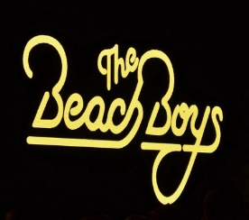
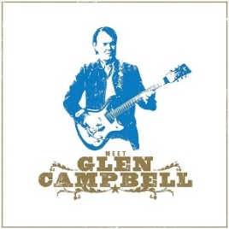
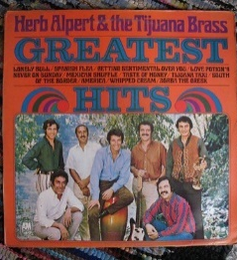
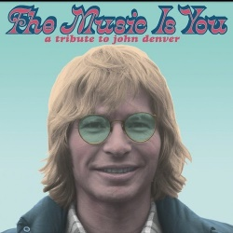
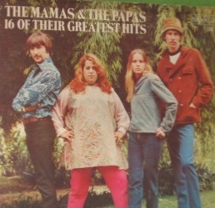

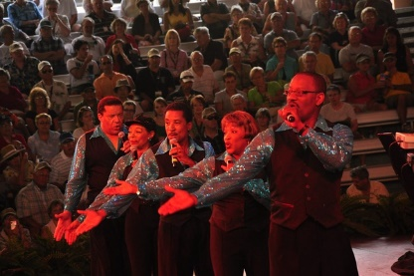
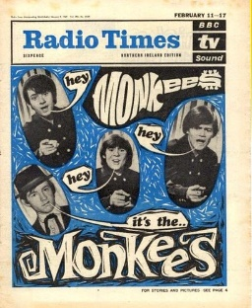

Now it is true that the wrecking crew made a lot of money and quite deservedly so…because the vast majority of recognizable music artists and bands of the 60;s and early 70’s would not have reached their fame and glory unless they got the help they needed from the Wrecking Crew to enhance and promote their music. As Carol Kaye casually admitted one time, “I make more money than the President of the U.S.” As an example of what she could do, she heard but frowned on Sonny & Cher’s song “And the Beat Goes On” thinking it was too bland so she added a base chord progression to it and transformed it into a smash hit.

Lucifer could have been a member of the Wrecking Crew – But not Satan
Now Lucifer potentially could be a special addition to the “Crew” because he was a master musician (Isaiah 14 & Ezekiel 28). However, as Satan, his attitude would make it extremely unlikely that he would join. He would be demanding the limelight just as he did in Isaiah 14 and Ezekiel 28 as he justified his attempt to dethrone God. He made it clear to Christ that he thought Christ should worship him (Luke 4: 9) and some translations indicate that Satan thought he should be ruler of the universe in place of the Most High God (Isaiah 14:14).

Other people with that same attitude tried to assert their pre-eminence such as Diotrephes (who “loved to have the pre-eminence”) over other brethren and basically demanded it. Other people who operated on that same egotistical wavelength include Nimrod, King Saul, Esau, Simon Magus, Nebuchadnezzar, Alexander the Great and Idi Amin.
So what kind of people are we? Do we work well together? Can we acquiesce when needed and support others when we have opportunity? The Bible is full of encouragement for us to do that.
Philippians 2:4-5 “Let each of you look out not only for his own interests, but also for the interests of others. Let this mind be in you which was also in Christ Jesus”

CONCLUSION This Pastor’s Letter is not an endorsement nor a criticism of all of the music generated in this time period but serves to illustrate that if people can work together in harmony and mutual respect they can achieve so much more than they can individually. The Wrecking Crew musicians incessantly worked together in harmony and making harmony for years. During that time no member seemed concerned about asserting himself/herself over the others. None asked for the limelight. No one ever thought about it…. such a stark contrast to other famous musicians who eventually could not get along with each other or band members that broke up to go their own way and ironically produce less music individually than they did when they worked together. Also this is a contrast to boastful athletes, political candidates or business tycoons shouting “We’re #1! or I’m #1!
I can still hear Mohammed Ali asserting “I’m the greatest!!! (which perhaps he was in boxing for a time but why promote this mind set? Why? Is that necessary? What’s the point? Today the great Mohammed Ali is dead (as we all will be if we live long enough). Psalm 39: 5 reminds us that “man, in his best state, is altogether vanity”
No letter “I” in the word TEAM
Fortunately there are fine examples of other endeavors in which people have banded together to achieve more than they could have by themselves. The legendary basketball coach, John Wooden of U.C.L.A., won endless basketball championships by stressing teamwork over individualism. Other leaders were effective because they were glad to feature and unselfishly employ the obvious skills of those under them. I again repeat the statement which began this letter…
When People in Harmony Don’t Care Who Gets the Credit…
There is no limit to how much they can produce
That Should Be Us
This weekend:
Randy McQuien will speak in Ft. Myers, Paul Bidetti will speak in Ocala and I will speak in Tallahassee.
Please pray for the success of the Ministerial conferences this coming week. Rick Shabi and Victor Kubik will speak tomorrow. We will play their messages in the coming weeks in all 3 churches.
I just returned from a trip to the Bahamas to meet with brethren there but I will comment on that trip in a different Letter. All the best to you all, for tomorrow and beyond. bv
"670211 - Radio Times - 11th February 1967 - The Monkees" by Bradford Timeline is licensed under CC BY-NC 2.0 "Beach Boys" by mag3737 is licensed under CC BY-NC-SA 2.0 "The 5th Dimension-Second Show" by greyhound dad is licensed under CC BY-NC-SA 2.0 "Meet Glen Campbell" by Brett Jordan is licensed under CC BY 2.0 "Hal Blaine" by northforksound is licensed under CC BY-SA 2.0 "THE MAMAS & THE PAPAS, 16 of their greatest hits" by spike55151 is licensed under CC BY-NC-SA 2.0 "herb alpert & the tijuana brass" by m g a is licensed under CC BY-NC-SA 2.0 "New John Denver tribute album? Yes please & thank you." by 46137 is licensed under CC BY-NC-SA 2.0

