Weekly Bible Study, Wednesdays, 7: 30 PM; currently on Jeremiah via Zoom Weekly Sunday broadcast on WKDW-FM, Northport, FL., 10-11 AM Webcasts Saturdays, Vero Beach, Ft. Lauderdale, Orlando, St. Pete & Tampa

Pastor’s Letter, April 16, 2021
Reaching for the Sky
15,000 & Counting

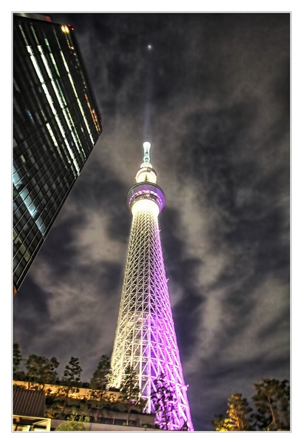
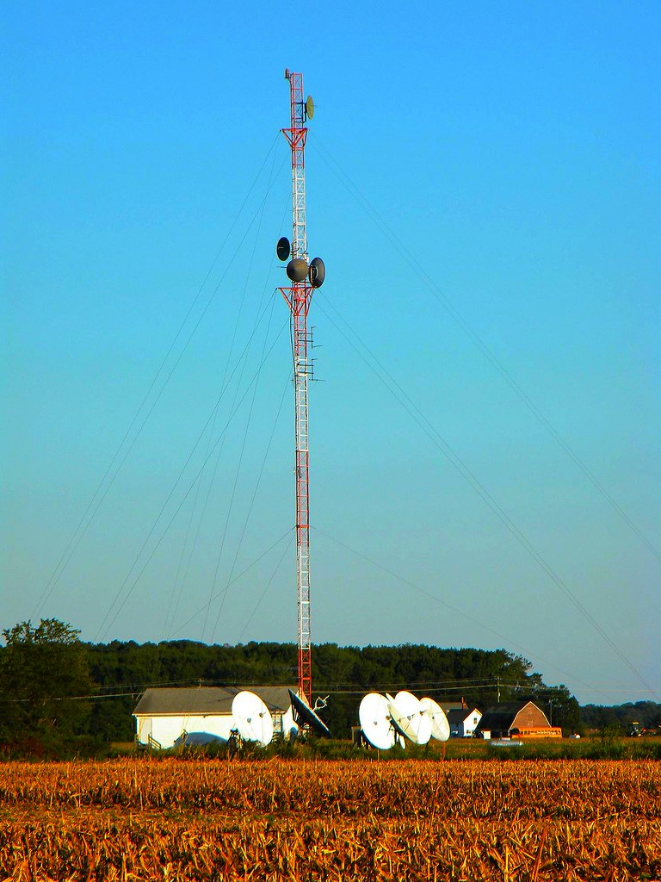
On the left is a picture of Tokyo’s ‘Sky Tree’ radio tower…the tallest in the world at 2,000 feet. On the right is a low wattage radio tower that approximates the size and power of WKDW-FM which we have contracted with. Yes, WKDW is a small radio station. Yes it only has 300 watts of power and yes, its diameter reach is only 30 miles …but it is able to be picked via internet around the world and it has a solid group of devoted local listeners. Welcome to “our radio station” or, as we lovingly say, “welcome to Northport, Florida’s blowtorch”. Even though Tokyo’s Sky Tree blowtorch is over 30 times more powerful than WKDW, our local station is definitely popular in its community. Much of the reason is because it features a variety of programs including:
Music, gardening, local political issues, municipal issues, interviews with county administrators, plus programs on hunting, fishing, cars, shopping, health and additional local issues such as religion. It also carries a wide variety of music programs. Sometimes WKDW features an “open mike” night where talented local musicians converge on the hall at the radio station to jam together and produce good music that is heard by radio listeners. Moreover WKDW has several programs in other languages (in German, Russian, Spanish and, of course, English). For example, our program is followed by a Ukrainian/Russian program. Overall WKDW has wide programming with all of its eggs “in many baskets”.
In the Spring of 2019, we contracted for an hour long show beginning at 10 AM on Sunday. After 3 months we had an estimated audience of over 3,000 listeners which was most encouraging. Then at the height of Covid 19, listenership rose 12% for the station overall and for our program, by the station’s estimates, our listener percentage at the same time rose 18%. And since then, approximately one year later, to my surprise, the regular listening audience has expanded to 15,000 listeners via internet plus several more via FM radio wave in west central Florida. At this point that means that to sustain a weekly listenership of 15,000 we are spending $25 per Sunday and averaging 6 listeners for each penny spent.
At the outset, for programming we sent in discs of sermons from local services but starting a year ago I began doing extemporaneous messages and am continually trying to improve. Of course a radio audience is nothing to take for granted…one untimely sneeze or a boring minute and you have lost people. Certainly one cannot get complacent or tired when striving to generate compelling radio.

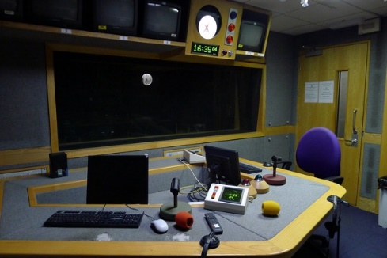

There is the challenge of generating a program in an otherwise lifeless empty studio

The future lies in uncharted water

Where it goes from here is somewhat unknown. I was told by the radio manager at the outset not to expect people to write in to ask for or accept any free offers for literature with the exception of the garden shows. But I am delighted that 15,000 people will listen each week. It is likely that by the time we are deep into the fulfillment of dire prophecies mentioned in the book of Revelation that a number of these and future listeners will recall what was forecasted internationally from WKDW and other church sources. They will have reason to hang on to hope for the future when other people will despair.
You will be like a lovely song
As I mentioned at last Wednesday’s Bible study, we must have a message of hope that attracts people just we must also carry a message of warning. The last part of Ezekiel 33 demonstrates that end-time efforts to discuss the future can ironically gain support and sympathy even if the audience eventually decides not to follow the prophets advise. We may experience rejection from some but may gain deep respect from others. Our example and our message will matter a great deal to many people from all walks of life.

LOCAL ACTIVITY

FT. MYERS The Fort Myers congregation was absolutely delighted to have Paul Bidetti come speak for his first time. Also Bud Bailey came down from the Orlando church area and gave the sermonette. It is interesting that the two men totaled 160 years in age and collectively drove round trip about 600 miles. Talk about dedication! Moses Summers will be there tomorrow.

TALLAHASSEE
Last week we had some brethren stay home because of tornados. Things seem more promising this week. Services will be at the farm and Mike McCarty will conduct them.

OCALA
We will be in Ocala this Sabbath and hope as many of us as are able will come to the Greenfield’s outdoor activity in Ft. McCoy on Sunday, beginning at 2 PM. Address is 23901 NE 187th Lane, Ft. McCoy, FL, 32134 (352-546-5843) We will provide the main course (worth the trip all by itself) and everyone who can, please bring some type of side dish. There is a large canopy that will provide protection and shade. Do bring a chair for yourself and games if you would like and pray for cooperative weather (NO Tallahassee or S. Georgia tornados!) While there is no potluck tomorrow, we can use our extra time block to discuss the sermon and sermonette.

y Daniel Mennerich is licensed under CC BY-NC-ND 2.0 “Radio Studio” by Martin Deutsch is licensed uynder CC BV-NC-ND 2.0 Radio Tower by Lee Canton is licensed under CC BY-SA 2.0

