Weekly Bible Study Wednesdays, 7: 30 PM via Zoom, This week covering Jeremiah 6-8
Weekly radio broadcast WKDW-FM 97.5 FM, Sundays 10-11 AM Ocala webcast Via Facebook, 1:30 Saturday

Pastor’s Letter April 9, 2021

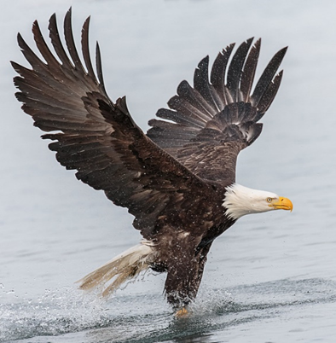

What Would You Do With The Wings of an Eagle?

Isaiah 40:31 “Those who wait on the Lord shall renew their strength; they shall mount with wings like eagles“

A year ago I gave a sermon on the impressive characteristics of an eagle and thought it would be good to illustrate them here. Eagles are absolutely amazing. They have incredibly keen eyesight, spotting minute points of interest several miles away. They can fly at speeds of up to 200 m.p.h, rivaling the speed of any race car at the Daytona 500. They are fearless and can fly off cliffs while latching on to small mountain goats or sheep or knocking off larger game for their next meal and they are adept at catching fish, poisonous snakes or other flying prey.
For centuries people have recognized the eagle as a majestic bird that can soar at great heights. Its wingspan can measure up to 8 feet and, by judiciously using the drafts and other wind currents, especially around mountain passageways, they can fly rapidly with minimal effort.
Spiritually, if we had the wings of an eagle, what else could we be doing that we may not be doing now?

- Eagles weigh only 10-14 pounds yet they have been known to kill poisonous snakes, deer, antelope, goats plus other animals considerably larger than themselves. Eagles will carry off their killed prey though the prey may be much larger or heavier than the eagle itself. Eagles will fly directly through dangerous thunderstorms when all other animals will do everything to circumnavigate around such danger. We could be living fearless lives without fretting over work, the economy, credit cards, elections, Covid 19, possible persecution, neighbors, or vehicle repair.

- Eagles always live on higher ground. Spiritually, so should we.

- Eagles are fabulous fisherman. Of men, we can be too.

- Eagles are goal oriented. Their concentration can be riveted to fixate for example on one thing alone. As an example they can hunt a rabbit by motionlessly fixating for hours at a rabbit hole where a rabbit is living. At the end of the afternoon, the rabbit finally thinks the coast is clear to come out of hiding and that is when the eagle energetically pounces. We could reprioritize our activities to rid ourselves of non-productive time-wasting on things we do not need.

- We could study and work to revitalize our health to be as healthy as an eagle.

- We could as well ask God for keen intuition, spiritual eyesight, and overall awareness of our life’s circumstances to consistently make right decisions. An eagle uses all of its characteristics and abilities…do we?

- And just as eagles physically seize opportunities to acquire what they need, we can ask God to inspire us to do the same spiritually. This probably would include seizing additional work experiences and education to enable ourselves to develop new skills that will multiply our value to God.

- An eagle may patiently wait a week for wind currents to shift and become far more favorable for eventually flying in certain directions. An eagle is not rattled by inclement weather. When the elements deteriorate, like eagles, we should maintain our composure, patience and optimism.

- Eagles are very responsible as they care for their young and build nests in remote areas that will protect these baby birds. Also they are loyal to each other.

- Eagles have eyesight 4 times greater than any man who has 20/20 vision. They can fly 1,000 feet high and see any small prey such as a rabbit as far as 3 miles away. Just imagine if our spiritual eyesight was that extraordinary!

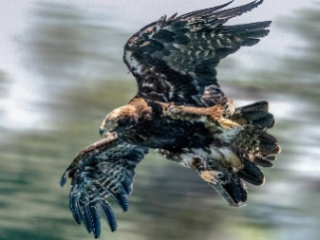
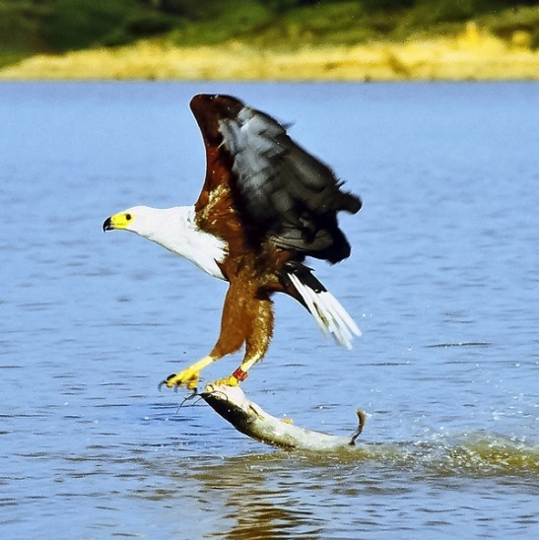
.

Resourceful At 200 m.p.h. Nobody Gets Away from Me
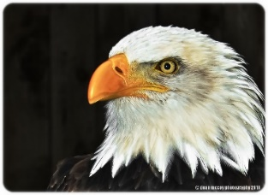

I am smiling

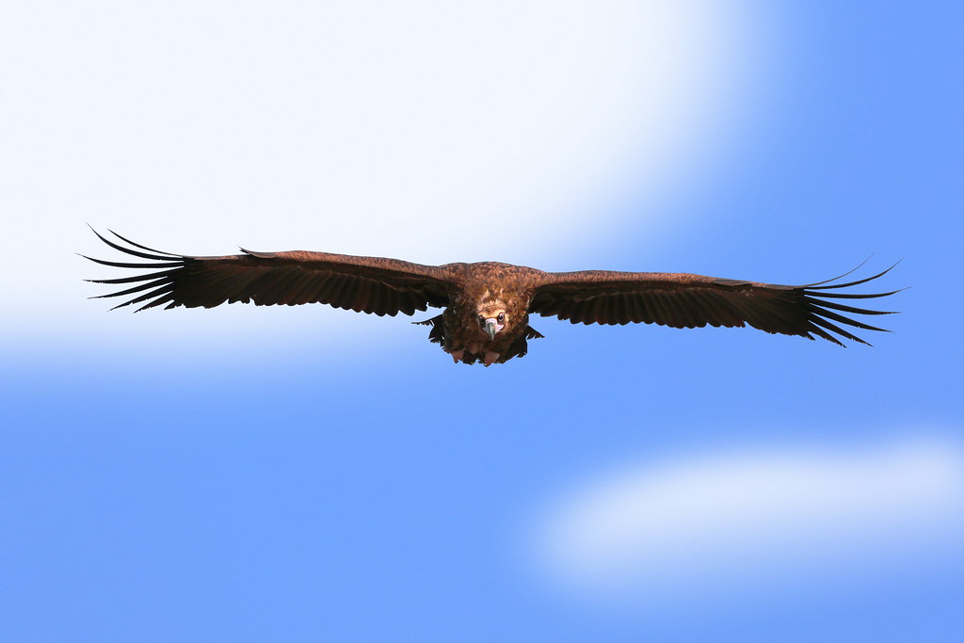

Some eagles have enormous wing spans
Are YOU my next meal ?
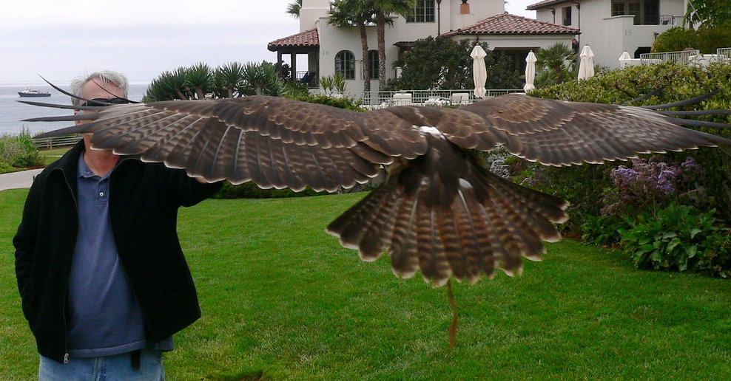

And remember, “It’s Always better to soar with the eagles rather than
to scratch on the ground with the turkeys”

There is some marvelous film footage of eagles in action that you can find on the internet.

NEWS OF THE 3 CONGREGATIONS

FT MYERS
We had an excellent attendance in Ft. Myers last Sabbath. This week we will say goodbye temporarily to our snowbird members who will return north soon. Bob Orosz was scheduled to speak this week but cannot due to being under the weather. However we will have him come in 2 weeks. Tomorrow Paul Bidetti will give the sermon.

OCALA
We had a few visitors the past several weeks who love to come here. Excitement continues as the brethren meet tomorrow with Court Greenfield giving the sermon.

TALLAHASSEE
I will be back in Tallahassee and hopefully get around to see several brethren that we missed talking with last time. Also we are happy to have a husband and wife from south Georgia come to us who say they want to be with us consistently.

CHURCH SOCIAL
Remember that everyone is invited to the Greenfield’s home on April 19 for a social featuring beef spare ribs and other home cooked dishes. Several people will bring board games and cards. Hope to see you there.

p.s. I had the opportunity to talk with Rick Shabi yesterday so I asked him, as treasurer of the church, how the church-wide income is doing. He said that it continues to exceed our expectations and feels that God is doing this for a reason. The church plans to continue to be conservative and careful about expenditures but this trend has been very encouraging.
"Bald Eagle Fishing" by Andy Morffew is licensed under CC BY 2.0 "Eastern Imperial Eagle (Aquila heliaca)" by Bernd Thaller is licensed under CC BY 2.0 "eagle" by Dean McCoy Photography is licensed under CC BY 2.0 "Eagle" by waithamai is licensed under CC BY 2.0 "Spread Eagle" by jurvetson is licensed under CC BY 2.0 "flying eagle" by Brandon HM Oh is licensed under CC BY-NC-ND 2.0 "File:African fish eagle just caught fish.jpg" by Mehmet Karatay is licensed under CC BY-SA 3.0

