Weekly Bible Study via zoom, Wednesdays, 7:30 PM, this week on Jeremiah 6-8 Weekly radio broadcast, WKDW-97.5 FM, Northport, FL., 10-11 AM Ocala Sabbath Services webcast via Facebook, 1:30 Saturdays

Pastor’s Letter, April 2, 2021

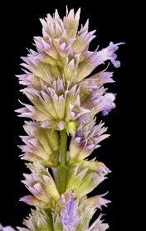

Should We Be Purged With Hyssop ?

. . .or should only David have been?

… NOT your ordinary flower
Psalm 51 .. NOT your ordinary prayer
In Psalm 51, David pleaded with God to not take His Holy Spirit away from him after his gut wrenching sins. Therefore he asked God to purge him with hyssop.
Even if we perhaps have not sinned in the same way that David did, we also need to be “purged with hyssop.” But what is hyssop? Hyssop is a three foot tall herb flower with cleansing properties that commonly appears in many parts of the world including the Middle East. Under God’s direction, the priesthood would dip the hyssop plant in blood of sacrificed lambs and paste the blood on the front door jambs so that God would pass over their homes and not strike their firstborn dead as He did with the Egyptians.
Perhaps David considered the possibility that God might take his life. But whether that was true or not, clearly David resorted to intense fasting and prayer as he asked God to mercifully “pass over” him just as He willingly passed over the first born Israelites.
In the book of Exodus the Israelites were indeed told to stay within their homes, separate from the Egyptian people and their normal routines. That night, there was to be no interaction or communication with any aspect of the Egyptian civilization. Their very lives depended on their following this command to the letter. As one Bible commentary aptly states, “The sacrificial blood, sprinkled or smeared by the bunch of hyssop, graphically represented a separation and a protection of Israel against the deadly havoc that God wrought upon Egypt that night. The blood ceremonially cleansed and protected the people inside those homes against the plague of death that struck a people who practiced the filthy abominations of godlessness.
Later, in the books of Leviticus and Numbers, hyssop was used as part of sacrificial ceremonies. The hyssop was always tied into bunches for use in sprinkling the blood of the sacrificed animal. In some sacrifices, the priest sprinkled the blood onto the person making the sacrifice.
In Numbers 19, Moses gives instructions for one who is unclean due to touching a dead body. These instructions also include taking a bunch of hyssop, dipping it into clean, running water, and sprinkling the unclean individual, his tent, and possessions. This example clearly connects the use of hyssop and clean water for cleansing.
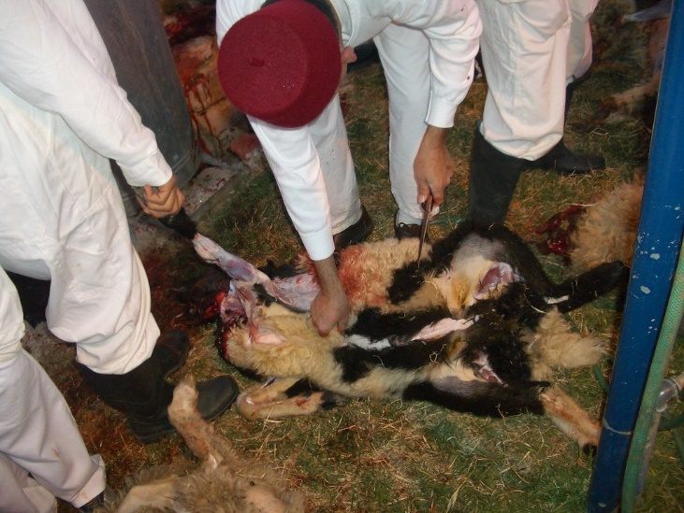



Hyssop would be dipped into the blood of this killed lamb
As we acknowledge, we all have sinned and need our Lord and Savior to pass over our sins by forgiving them. This is a unique time of self-examination and introspection to do so. The death of Jesus Christ gives us a new lease on life and a future that will allow us to be actively involved with eternally with the family of God.
Here is an interesting quote which allows Christ to be the strongest since He was the first to ask for the forgiveness of humanity at His death, “Father forgive them for they know not what they do.” (Luke 23:34)

“The first to apologize is the bravest. The first to forgive is the strongest. And the first to forget is the happiest.” – Unknown



LOCAL CHURCH ACTIVITY
FORT MYERS
It has been nice to have outside visitors come to join us in recent weeks. This included elder Johnny Lambert and tomorrow will include David Morker, an elder in Minnesota who will give the sermon. Much thanks goes to Bill Wilson who was with us last weekend.
TALLAHASSEE
We expect some new people to be with us tomorrow in Tallahassee. Coincidentally I will be there to give the sermon. Many thanks go to Mike and Judy McCarty who, among others, did a great deal of work to make the Night to Be Observed such a success. It has been such a blessing to have services at “the Farm”, a secluded cottage owned by a member who has moved to California. We have saved at least $300 per month in doing so.
Court and Pat Greenfield graciously spent Passover, Sabbath and then the First Day of UB with the Tallahassee brethren and will return soon.
OCALA All three congregations had great “chemistry” last weekend with the beginning of the holy day season. Perhaps the enthusiasm was based on brethren feeling liberation in coming through Passover. Below is a picture of a festive group of happy brethren at an Indian restaurant for the Night to Be Observed. No one wanted to go home.
The Greenfields have invited the brethren in Tallahassee and Ocala to their church picnic April 18, for food, fun & fellowship. Details will be forthcoming but all are invited to come and we ask God to provide us a beautiful day for the occasion.
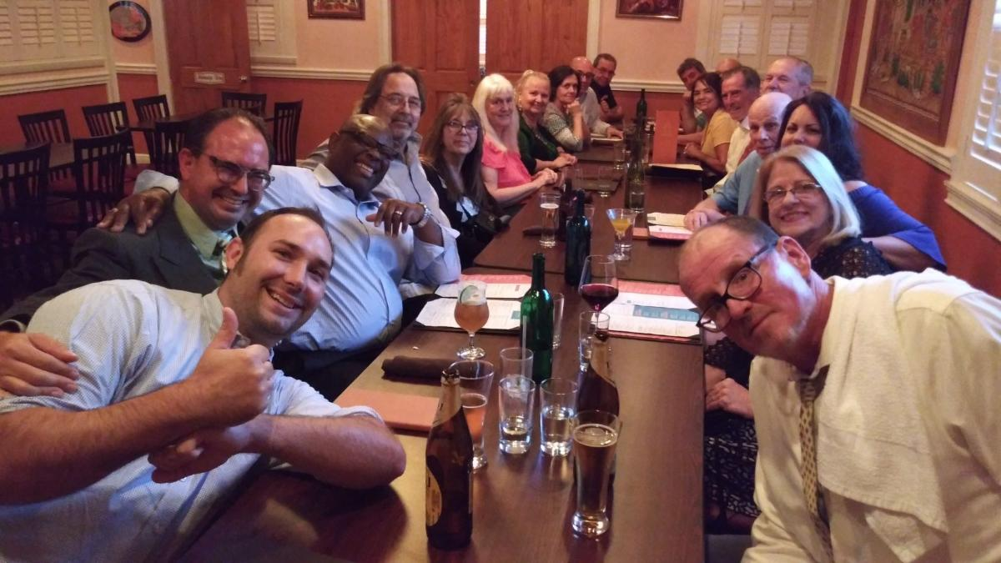

Festive Night to be Observed in Ocala, FL with many local brethren

"Blood" by mag3737 is licensed under CC BY-NC-SA 2.0 "samaritan holy site knifing" by Ben Piven is licensce "prayer at night" by mrehan is licensed under CC BY-SA 2.0 "prayer at night" by mrehan is licensed under CC BY-SA 2.0 "Agastache foeniculum 2, Anise Hyssop, GFG,
Howard County, Md_2019-03-22-19.52.40 ZS PMax UDR" by Sam Droege is marked with CC PDM 1.0 "Agastache foeniculum 2, Anise Hyssop, GFG, Howard County, Md_2019-03-22-19.52.40 ZS PMax UDR" by Sam Droege is marked with CC PDM 1.0 "“The first to apologize is the bravest. The first to forgive is the strongest. And the first to forget is the happiest.” – Unknown" by Irudayam is licensed under CC BY-ND 2.0

